

A Comparative Analysis of Hydraulic Stability Methods for Rock Protection of Subsea Cables in Nearshore Environments





Willem Pol
Version Concept 1.0
17-9-2026

Preface

Summary
Subsea power cables transport electricity from offshore wind farms to shore and between countries. Power cables are normally buried, because soil over the cable is the cheapest and most reliable protection there is. Sometimes burial is impossible. On a rocky seabed, where you can’t dig into it, or where a cable crosses another cable or a pipeline it has to pass over the top. In these places the cable lies exposed on the seabed and it is covered with a mound of quarried rock, a rock berm. The rock must be heavy enough that the waves and the currents cannot wash it away completely.

Choosing that rock size is harder than it sounds. Several stability methods exist, but none of them was made for this specific situation. Some describe the armour on a breakwater slope, some the small berm at the foot of a breakwater, and some a flat protected seabed. They also do not agree on what damage means. One method returns a rock size, another counts how many stones move, and another gives a deformation class. Because the damage measures are different quantities, the results cannot be compared directly. In practice this leads to two problems. A single method gets used everywhere, including where it is not valid, and designers stack safe assumptions on top of each other, for example by assuming that the waves and the current always come from the same direction. The result is more rock than the cable needs, which means more rock material, more vessel trips, higher cost and more pollution for every project.

This thesis builds a design framework and a computational tool that finds the best rock berm design with a method what is safe to use in the nearshore environment. The tool works in two branches. The first sizes the smallest stable rock and runs every applicable method side by side, choosing the valid one for that location through a decision tree and warning when an input falls outside a method's tested range. The second branch is the leading one. It designs the whole berm, the rock together with the height, the side slope and the crest width, using the reshaping model of the Deltares handbook. It can accept that the berm changes shape under a storm, and it sizes the berm so that enough cover remains over the cable after it has reshaped.

The framework was applied to three real projects and checked against two independent references. On the first project the tool was compared with a calculation made by a specialist consultant. There is a comparison made by checking if the computational tool works the same or close to the specialist calculation. The results were agreed within four per cent, and the required rock came out at 0.183 m against their 0.174 m, so the tool asks for a little more rock than the report did.

On the second project the tool was compared with a physical model test in a wave flume. That comparison worked by implementing the calibrated inputs what were measured in the physical model into the tool. At the local wave the tool keeps the berm almost still through the first three tests and starts to reshape it at the fourth, which is where the test report puts the change as well, and it ends the series with a crest lowering of 0.50 m against the 0.5 m that was measured.

The third project is a future one. Two designs were already on the table and both were checked and commented on. The high-density design of NKT was checked as save by the tool, but the normal-density design needed some adjustments to make it more stable.

Other important results. The rock density is a far stronger design value than the rock size. Denser rock costs about thirty per cent more per ton, but it needs about thirty per cent fewer tonnes, twenty-two against thirty-three tonnes per meter of route, so at the end, it is economically cheaper to use the high-density rock. But it also depends on where the project site is in the world. The reason the size itself is a weak lever is that a bigger stone is also a rougher bed, so raising the rock size raises the load at the same time and the two effects partly cancel. The side slope is the second lever, and it works through stability rather than through volume. A rock on the side slope moves more easily than a rock on the flat crest, because gravity already pulls it down the slope, so the slope decides whether the berm reshapes at all.

As long as the berm does reshape, more rock has to be installed to be sure that enough cover is left after the storm. The saving appears at the slope where the berm is just stable enough to stop reshaping. From there the extra height that covers the reshaping is no longer needed. On the third project that step took the berm from thirty-two to twenty-two tonnes per meter.

One limitation remains. The deformation model that carries the design was made for the offshore environment, and this thesis applies it in the nearshore, where more is going on. The comparison with the three projects shows that it holds up there, but the last chapters are clear about where the remaining uncertainty sits. It is not in the stability formula. It is in the sea state that goes into it, because the load grows with the square of the near-bed velocity and that velocity follows from the wave height, the period and the water depth at the point. Propagating the metocean data properly to the site, with a spectral wave model over the real bathymetry, is the single step that would move a design of this kind closest to the truth.

Table of Contents
Preface ii
Summary iii
Notation ix
List of Tables xii
List of Equations xiv
List of Figures xvi
1. Introduction 1
1.1 Background 1
1.2 Problem statement 1
1.3 Objective 2
1.4 Research questions 2
1.5 Approach 3
1.6 Scope and area of interest 4
1.7 Thesis outline 4
Part A – Literature Study 5
2. The Nearshore Environment 5
2.1 Definition and area of interest 5
2.2 Bed Morphology and Composition 6
2.3 The rock berm and its terms 7
3. Hydrodynamic Forcing 8
3.1 Waves 8
3.1.1 Wave data and propagation 8
3.1.2 Wave parameters 9
3.1.3 Linear wave theory 9
3.1.4 Near-bed orbital velocity 11
3.1.5 Excess dynamic pressure and effective near-bed loading 14
3.1.6 Depth-induced breaking 15
3.1.7 Relevance for the stability assessment 15
3.2 Currents 16
3.2.1 Tidal currents 16
3.2.2 Other current contributions 16
3.2.3 Velocity profile and the reference levels 17
3.3 Combined waves and currents 19
3.4 Design conditions and return periods 22
4. Stability Parameters & Criteria 23
4.1 Introduction 23
4.2 Forces on a rock and the Shields parameter 24
4.3 Stability criterion 26
4.4 Failure spectrum and the damage factor r 28
4.5 Non-uniform flow and turbulence 29
4.6 From criteria to methods 29
5. Rock Stability Assessment Methods 30
5.1 Introduction 30
5.2 Rubble-mound (breakwater) models 31
5.2.1 Hudson (1953/1959) 32
5.2.2 Van der Meer (1988) 33
5.2.3 Shallow water: why the Rayleigh assumption fails 34
5.2.4 Shallow-water stability formulas 35
5.3 Toe berm models 37
5.3.1 Van Gent and Van der Werf (2014) 38
5.3.2 Herrera and Medina (2015) 38
5.4 Flat-bed model (Van Rijn, 2019) 40
5.5 Rock berm deformation model (Deltares HaSPro/ RoBeD, 2023) 42
5.6 A method considered but not used: Thusyanthan et al. (2013) 47
5.7 Comparative summary 48
6. Extra Stability Checks 50
6.1 Scour 50
6.2 Winnowing 52
6.3 Anchor and Trawling Protection 54
Part B – Methodology 55
7. Methodology 55
7.1 Introduction 55
7.2 Scope 58
7.3 Design framework and computational approach 59
7.3.1 Route input data 60
7.3.2 Design inputs in the tool 61
7.3.3 Shared load basis 62
7.3.4 Wave-current interaction angle (optimisation) 62
7.4 Branch A: Rock sizing 63
7.4.1 Classification and the decision tree 63
7.4.2 Different type of methods, same Branch 63
7.4.3 Fitting the formulas to the rock berm 64
7.4.4 Governing stone, wash-away floor and density 65
7.4.5 Output and diagnostics 66
7.5 Branch B: berm geometry and deformation (RoBeD) 67
7.5.1 Shear, Shields number and deformation class 68
7.5.2 Reshaping and required cover 69
7.5.3 Accepted deformation 69
7.5.4 One grading over the whole route 69
7.5.5 The design figures 70
7.6 Case studies: applying the framework to real projects 72
7.7 Benchmarking Branch B against the reference cases 73
7.8 Parameters and the sensitivity analysis 74
7.8.1 Why a sensitivity analysis is needed 74
7.8.2 The inputs of the tool 74
7.8.3 What is varied and how it is read 76
7.8.4 The two methods and what they cannot do 76
7.8.5 How the analysis was run 77
Part C – Results 78
8. Results 78
8.1 The real designs 78
8.2 Branch A: comparison on the stone size 80
8.2.1 Project A 81
8.2.2 Project B 82
8.2.3 Project C 83
8.2.4 How far is Branch A from the real designs 84
8.2.5 Why the Branch A stones stay indicative 84
8.3 Branch B: the berm design 85
8.3.1 The load chain used for these results 85
8.3.2 Project A 86
8.3.2.1 Comparison with the specialist report 88
8.3.3 Project B 89
8.3.3.1 Comparison with the physical model test 91
8.3.4 Project C 95
8.3.4.1 High-density design 96
8.3.4.2 Normal-density design 98
8.3.4.3 Optimisation of design project C 99
8.3.5 How far is Branch B from the real designs 102
8.4 Sensitivity analyses 103
8.4.1 Set-up and how the indices are read 103
8.4.2 What the sea does to the stone 105
8.4.3 What the choices do to the quantity 105
8.4.4 What follows for the design 106
8.5 Combining the wave and the current on the velocities 107
9. Knowledge Gaps & Research Questions 110
9.1 Answers to the research questions 110
9.2 Open points in the loads 111
9.3 Open points in the stability model 113
9.4 Open points in the interface and the extra checks 115
9.5 Velocity on top of the rock berm 116
9.6 What the results mean for the material philosophy 117
References 118
Appendix A. Design conditions and return periods 123
Appendix B. Inputs and outputs per stability method 125
Appendix C. The Branch B calculation written out per project 127
Appendix D. How the Morris and the Sobol method work 137

Notation
This list gives the symbols and abbreviations that are used in more than one chapter. The symbols are listed in one alphabetical sequence. Symbols that occur only inside a single method are defined in the table that accompanies that method in Chapter 5, and the columns of the route data file are defined in Table 7.1.
Abbreviation | Meaning
CEM | Coastal Engineering Manual
CFD | Computational fluid dynamics
CIRIA | Construction Industry Research and Information Association, publisher of the Rock Manual
DNV-RP-F109 | DNV Recommended Practice F109, on-bottom stability design of submarine pipelines, cables and umbilicals
DOC | Depth of cover, the required cover on the cable in the route data
HAT | Highest astronomical tide
HaSPro | Handbook of Scour and Cable Protection Methods, Deltares (2023)
KC | Keulegan-Carpenter number
KP | Kilometre point, the location identifier along the cable route
LAT | Lowest astronomical tide
LMA | Light mass armour, a rock grading class of EN 13383
MOB | Relative mobility, the acting Shields number divided by the critical Shields number
MTOC | Minimum top of cover, the cover that must remain over the cable after reshaping
RoBeD | Rock Berm Deformation model, Deltares (2023)
TOPC | Top of product cover, the cover that is installed

Symbol | Meaning | Unit
Aw, ab | Wave orbital motion amplitude, or orbital excursion, at the bed | m
α | Slope angle of the armour, and the side slope parameter of the berm, written 1:α | -
B_berm | Bottom width of the reshaped parabolic berm | m
Bt, tt | Width and thickness of a toe berm | m
C | Chézy coefficient | m^0.5/s
cD | Drag coefficient | -
D50 | Sieve diameter, the mesh size that half of the mass of the grading passes | m
Dn50 | Nominal diameter, the side of a cube with the mass of the median stone | m
Δ | Relative buoyant density, (ρs − ρw) / ρw | -
Δcable | Cable position offset in the cover equations | m
η | Surface elevation | m
g | Acceleration of gravity | m/s²
γstr | Van Rijn velocity and turbulence enhancement factor near a structure | -
H2% | Wave height exceeded by two per cent of the waves | m
Hm0 | Spectral significant wave height, 4√m0 | m
Hs | Significant wave height | m
Hs,b | Effective near-bed wave height, Hs reduced by the pressure response factor | m
Hs0 | Deep-water significant wave height | m
Htr | Transition wave height of the composite Weibull distribution | m
h | Water depth | m
h_berm, h_min | Installed berm height and the minimum height that keeps the cover | m
ht | Water depth above the toe or the berm crest | m
KD | Hudson stability coefficient | -
k | Wave number, 2π / L | 1/m
ks | Nikuradse bed roughness | m
κ | Von Kármán constant, about 0.4 | -
L, L0p | Local wave length and the deep-water wave length at the peak period | m
M50 | Median rock mass | kg
N | Number of waves in the design storm | -
Nod | Damage number, displaced rocks within a strip one Dn50 wide | -
ω | Angular wave frequency, 2π / T | 1/s
P | Notional permeability of the structure | -
φ | Angle of repose of the rock, and in Section 3.3 the angle between the wave and the current | deg
r | Van Rijn reduction coefficient on the critical Shields number | -
ρs, ρw | Density of the rock and of the water | kg/m³
Sd | Van der Meer damage number, eroded area divided by Dn50² | -
Tp, Tm, Tm-1,0 | Peak period, mean period and spectral mean period | s
τc, τw | Current-related and wave-related bed shear stress | N/m²
τb,cw | Combined wave and current bed shear stress | N/m²
θ | Shields parameter, the dimensionless bed shear stress | -
θcr | Critical Shields parameter at the threshold of motion | -
uc | Depth-averaged current velocity | m/s
u*, u*c, u*w | Bed shear velocity, from the current and from the wave | m/s
Uw, ûb | Peak near-bed orbital velocity | m/s
W_TOP | Crest width of the installed berm | m
ξm | Iribarren number, the surf similarity parameter | -
z0 | Roughness length of the current velocity profile | m

List of Tables
Table 3.1: The linear wave theory quantities of Section 3.1 and the symbols under which they appear in the stability methods of Chapter 5. 15
Table 5.1: The four RoBeD deformation classes, their mobility criterion and what each means for the cover on the cable. 43
Table 5.2: The stability methods side by side, with the situation each was made for, its damage criterion and its fitness for a cable berm. 48
Table 5.3: Which method governs in which situation, with the supporting check and the reason. 49
Table 6.1: Rules of thumb for filter stability, winnowing and liquefaction, with their sources. 53
Table 7.1: Columns of the route data file that the tool reads, with their unit and source. 60
Table 7.2: The three case study projects and their governing 100-year conditions. 72
Table 7.3: Environmental inputs of the sensitivity analysis, read per route point from the survey and the metocean data. 74
Table 7.4: Design and calculation inputs of the sensitivity analysis, with their default and their range. 75
Table 7.5: Client and geometry inputs, which follow from the project requirements. 75
Table 8.1: The real designs of the three projects, and the stone size from the grading. 79
Table 8.2: All Branch A methods at KP 1 of Project A, at the design density of 3100 kg/m3. 81
Table 8.3: All Branch A methods at KP 1 of Project B, at the design density of 2670 kg/m3. 82
Table 8.4: All Branch A methods at KP 1 of Project C, at the design density of 3100 kg/m3. 83
Table 8.5: The Branch A result against the real design, with the smallest valid method in the last column. 84
Table 8.6: Project A, the recommendation of the tool and the verification of the design that was built. 87
Table 8.7: The load calculation step by step at the critical section of the specialist report, on its own water depth, berm height and rock. 88
Table 8.8: Project B, the recommendation of the tool and the verification of the design that was built. 91
Table 8.9: The flume test series against the prediction of the tool, with the measured wave height at the structure for each test. 93
Table 8.10: Project C, the two designs that are on the table. 95
Table 8.11: Project C, the two designs as the tool sees them. 96
Table 8.12: The berm at KP 1 for both gradings at a crest width of 1.0 m, before and after the class check. 99
Table 8.13: The height released by the class check, at the slope where each berm first becomes stable. 100
Table 8.14: Material against margin for the high-density design at 1.05 m. 101
Table 8.15: Step 1, the rock the tool asks for against the rock that was chosen. 102
Table 8.16: Step 2, the berm as it was built under the same design load, with the cover that is left after it has reshaped. 102
Table 8.17: Environmental inputs of the sensitivity analysis, with the range of each input and the source it is taken from. 103
Table 8.18: Design and client inputs of the sensitivity analysis, with the range of each input and the source it is taken from. 104
Table 8.19: Sensitivity of the required rock size to the sea, over the storm population of KP 1 of Project C. The first order indices sum to 0.98. 105
Table 8.20: Sensitivity of the rock quantity per metre of route to the design and client choices, at the design sea state. The first order indices sum to 0.99. 106
Table 8.21: The two combinations applied to the worked example of Schiereck and Verhagen (2019, p.155). 107
Table 8.22: The three designs under the two combinations, at the rock size of the design itself. 107
Table 8.23: Rock size and berm for the same accepted deformation under the two combinations. 108
Table 8.24: Combined bed shear stress in N/m² against the angle between the waves and the current. 108
Table 9.1: Loads on top of the rock berm. 116

List of Equations
$(3.1)$ 10
(3.1) 10
(3.2) 11
(3.3) 11
(3.4) 11
(3.5) 11
(3.6) 12
(3.7) 14
(3.8) 14
(3.9) 14
(3.10) 14
(3.11) 17
(3.12) 17
(3.13) 19
(3.14) 19
(3.15) 19
(3.16) 19
(3.17) 20
(4.1) 24
(4.2) 24
(4.3) 24
(4.4) 25
(4.5) 26
(4.6) 26
(4.7) 26
(4.8) 28
(4.9) 29
(5.1) 32
(5.2) 33
(5.3) 33
(5.4) 33
(5.5) 33
(5.6) 34
(5.7) 34
(5.8) 35
(5.9) 35
(5.10) 35
(5.11) 35
(5.12) 35
(5.13) 36
(5.14) 38
(5.15) 38
(5.16) 38
(5.17) 39
(5.18) 40
(5.19) 40
(5.20) 40
(5.21) 40
(5.22) 40
(5.23) 40
(5.24) 41
(5.25) 41
(5.26) 41
(5.27) 41
(5.28) 41
(5.29) 42
(5.30) 42
(5.31) 43
(5.32) 44
(5.33) 44
(5.34) 44
(5.35) 44
(5.36) 44
(5.37) 44
(5.38) 45
(5.39) 45
(5.40) 45
(6.1) 50
(6.2) 50
(6.3) 50
(6.4) 50
(6.5) 51
(6.6) 52
(6.7) 52
(6.8) 52

List of Figures
Figure 2.1: The zones of the nearshore environment, from the offshore zone through the shoaling zone to the surf zone (Romano, Lecture Notes Coastal and Harbour Engineering, 2026). 5
Figure 2.2: A rock berm over a cable at a crossing on a mobile sandy seabed (NKT, 2026). 6
Figure 2.3: Rock berm on bedrock (Keh-Chia, editor, Scour and Erosion IX, 2024). 6
Figure 2.4: The rock berm and the terms used in this thesis, with the top width, the side slope, the berm height, the cover on the cable, the armour and the underlayer. (W.Pol) 7
Figure 3.1: Rock berm stability analysis at a cable crossing (specialist design report, 2024). 8
Figure 3.2: Water motion in a periodic non-breaking wave, with the celerity, the pressure and the orbital motion (Schiereck and Verhagen, 2019, Fig. 7-3). 10
Figure 3.3: Near-bed orbital motion under a wave, with the excursion amplitude ab and the peak near-bed orbital velocity ûb. Own figure, after Schiereck and Verhagen (2019). 13
Figure 3.4: Velocity profile under a wave crest, with the thin rotational layer of thickness δ that carries the wave shear stress (Schiereck and Verhagen, 2019, Fig. 7-7). 13
Figure 3.5: Tides over the world (Romano Lecture Notes, 2026). 16
Figure 3.6: Logarithmic velocity profile of a steady current, with the one-metre reference height and the depth-averaged level at about 0.37 h. Own figure, after Schiereck and Verhagen (2019). 18
Figure 3.7: Combined wave-current action (Schiereck & Verhagen, 2019, Figure 7-8). 20
Figure 4.1: Steady-flow boundary layer with the logarithmic velocity profile, and the hydraulically smooth and the rough boundary. Adapted from Romano (lecture notes). 23
Figure 4.2: Moment equilibrium of a grain around its pivot point A, the drag and lift torque against the torque of the submerged weight. Adapted from Romano (lecture notes). 24
Figure 4.3: The Shields diagram, the critical dimensionless bed shear stress against the boundary Reynolds number. Adapted from Romano (lecture notes). 25
Figure 5.1: Overview of the stability methods positioned on a single cross-section (rubble-mound slope, toe berm, flat-bed rock, rock berm). (W.Pol drawing). 30
Figure 5.2: Rubble-mound armour slope with the governing inputs of Hudson and Van der Meer (Hs, Hm0, Tp, Tm-1,0, KD, P, Dn50, slope angle α). (W.Pol drawing). 31
Figure 5.3: The composite Weibull distribution against the Rayleigh distribution, with the tail above the transition height Htr chopped off (Antonini, lecture notes, TU Delft). 34
Figure 5.4: Toe berm geometry defining the water depth h, the depth above the toe ht, the berm width Bt and the berm thickness tt. (W.Pol drawing). 37
Figure 5.5: Bed protection on a horizontal bed under a current and waves, the situation of the Van Rijn method (Van Rijn, 2019). 40
Figure 5.6: Installed trapezoidal berm and reshaped parabolic profile, defining W_TOP, the side slope 1:α, h_berm, h_min, B_berm, A_berm and A_min (Deltares, 2023). 44
Figure 6.1: The mixing layer above a bed protection and the four scour phases I to IV against time. After Schiereck and Verhagen (2019).$houhsβhs/ho$ 51
Figure 7.1: Flow chart of Branch A, from the route data to the governing stone size. 56
Figure 7.2: Flow chart of Branch B, from the stone size to the berm geometry and the deformation class. 57
Figure 7.3: The graphical user interface of the tool. 61
Figure 7.4: Example of the Branch A output for a single route point. 66
Figure 7.5: Step 1, the Shields number against the stone size at the governing point, from which the smallest safe stone is read. 70
Figure 7.6: Step 2, the deformation class at every point along the route for the chosen stone. 71
Figure 7.7: Step 3, the side slope against the installed berm height. 71
Figure 7.8: Step 3b, the installed berm against the reshaped berm at the most critical point, on a true scale. 71
Figure 8.1: Deformation class at KP 1 for Project A, with the rock of the built design. 86
Figure 8.2: Side slope against installed berm height for Project A, with the built design marked. 87
Figure 8.3: Cross-section of the berm as installed for Project A at KP 1. The berm is class 0, so the as-built and the post-storm profile are the same. 87
Figure 8.4: Deformation class at KP 1 for Project B, with the rock of the built design. 90
Figure 8.5: Side slope against installed berm height for Project B, with the built design marked. 90
Figure 8.6: Cross-section of the berm as installed for Project B at KP 1, at the rock of the built design. The berm is class 0 under the design condition, so the as-built and the post-storm profile are the same. 90
Figure 8.7: Measured berm profile before and after the 100-year condition at LAT. 91
Figure 8.8: Deformation class at KP 1 for the high-density design of Project C. 97
Figure 8.9: Side slope against installed berm height for the high-density design of Project C, with the proposed design marked. 97
Figure 8.10: Cross-section of the high-density design of Project C at KP 1, before and after the storm, at the height Equation 5.36 asks for at the proposed side slope of 1:4. 97
Figure 8.11: Deformation class at KP 1 for the normal-density design of Project C. 98
Figure 8.12: Side slope against installed berm height for the normal-density design of Project C, with the proposed design marked. 98
Figure 8.13: Cross-section of the normal-density design of Project C at KP 1, drawn at the rock the tool asks for rather than at the proposed grading. See the note below Table 8.11. 99
Figure 8.14: Rock needed per metre of route against the side slope, for both gradings at a crest width of 1.0 m. Filled markers are class 0 and are built on the minimum buildable height, open markers are class 1 and are built to the height of Equation 5.36. 100
Figure 8.15: Sobol indices of the two analyses. The sea sets the stone and the choices set the quantity, and neither reaches the other. 105

Introduction

Background
Subsea power cables are a critical part of the modern energy system. They connect offshore wind farms to shore, link national grids across straits, and bring power to islands and coastal communities. As the energy transition drives a rapid growth in offshore wind and interconnectors, the number and the length of these cables increase every year, and so does the need to protect them.

A cable is most vulnerable where it approaches the coast. In this nearshore zone the water is shallow, the waves and the currents are strong, and the seabed is dynamic. Where possible the cable is buried, because burial is the most reliable and often the cheapest form of protection. Burial is not always possible. At a crossing of a third party cable or pipeline the cable must pass over the obstacle, and on a rocky seabed there is nothing to trench into. In these cases the cable rests on the seabed and is protected by a rock berm, a mound of rock built over the cable. These are among the most difficult situations to design for, because the cable is fully exposed to the hydrodynamic loading.

Problem statement
Designing a rock berm means choosing a rock size and a berm geometry that stay stable under the waves and the currents at that location. Several stability methods exist for this, but each was developed for a different type of structure and for a different range of conditions. Some describe the armour on a breakwater slope, some the toe of a breakwater, and some the protection of a flat bed under current and waves. None of them was developed specifically for a free standing rock berm over a cable in the nearshore zone.

This leads to two problems in practice. First, a single method is often applied to every situation, even when that situation lies outside the range for which the method is valid. The result cannot be trusted, and the error is not visible in the number that comes out. Second, to stay on the safe side, designers stack worst case assumptions on top of each other, for example by assuming that the waves and the current always act from the same direction. This produces rock berms that are larger than necessary, which means more rock, more vessel trips, higher cost and a larger environmental footprint. Another point is that there are a small group of specialists, so engineers often accept the design without bringing in doubt the volumes of the rock berms.

Next to that, the methods that are studied describe damage in different ways. One returns a rock size, one a number of displaced rocks and one a deformation class. These are not the same physical quantity, so the results of different methods cannot be compared directly and there is no agreed way to translate one into another.

Objective
The objective of this thesis is to develop a design framework, and a computational tool that carries it out, for sizing rock berms that protect unburied subsea cables in the nearshore zone. The framework selects the appropriate stability method for each situation and keeps every method within its own validity range. It sizes the rock for the smallest feasible rock at a controlled level of damage rather than for a stacked worst case. And it turns that rock size into a buildable berm geometry, presenting a small set of design alternatives so that the final choice can be made together with the client. In this way the design becomes faster, more consistent, more transparent and less wasteful of material.

The framework does not treat all of these methods as equal. One of them is taken as the leading design method and the others are kept next to it as an independent check on the rock size. The decision of which method is leasing will be described Chapter 5 and is not assumed beforehand.

Research questions
The main research question of this thesis is:

How can a rock berm for an unburied subsea cable in the nearshore zone be designed so that the appropriate stability method is applied within its validity range, giving the best options for the rock size and buildable geometry at a controlled and acceptable level of damage?

This is supported by the following sub questions:
- Which hydraulic stability methods are relevant for a free standing rock berm on the seabed in the nearshore zone, and within which range of conditions is each of them valid?
- These methods were derived for different structures and they express damage in different quantities, a reduction coefficient, a damage number and a deformation class. Can they be combined into one design framework that delivers both the rock size and a berm geometry that still covers the cable after it has reshaped, or must one method carry the design while the others serve as a check?
- How much can the required rock be reduced by treating the rock density and the angle between the waves and the current as design variables instead of as fixed worst case assumptions, and what does that cost in material and in installation?

The first question is answered in Chapter 5 and its comparative summary in Section 5.7, the second in Chapter 7 and in Sections 8.1 to 8.3, and the third in Sections 8.4 and 8.5. Chapter 9 returns to all three and answers them directly.

Approach
This study was carried out in six steps and here is the list what and where these steps were done.

Step 1, collecting the methods. Several method that could size the rock of a berm over a cable was studied, these where given by supervisors of NKT, they saw these methods in the past as designs, from the breakwater armour formulas of Hudson and Van der Meer and their shallow-water versions, through the toe berm formulas of Van Gent and Van der Werf and of Herrera and Medina, to the flat-bed method of Van Rijn and the rock berm deformation model of the Deltares handbook. For each approach is an explanation, formulas, limitations and its validity range were written out (Chapter 5).

Step 2, Looking critically what methods can be used for the design of a rock berm. None of them was made for a free standing berm over a cable in the nearshore, so the differences were studied, hand calculations were done, which structure the method describes, which load it uses, which damage measure it returns, and where are the methods calibrated (Section 5.7).

Step 3, Rewriting formulas. Some of the formulas, where too far from the purpose of a rock berm, in early stages of this research was discovered that the roublemound methods were over designing the rock sizes a lot. Downscaling methods, changing turbulence parameters and changing damage levels were tried to arrive at valid methods. (Section 7).

Step 4, wo different branches are used: one branch for indication (Branch A) and one branch for the method to be used (Branch B). This distinction is made because Branch B is considered to be relatively close to the final result. Branch A contains all methods that were not specifically developed for the rock berm or that are incomplete. Calculations are still performed for all methods included in Branch A. A decision tree is then used to select the appropriate method that falls within the required validity range. However, the main focus is placed on Branch B, as this branch is considered more relevant to the final result. Therefore, Branch B is further developed and elaborated in the subsequent steps.

Step 5, check the design against real projects. The framework was applied to three real NKT projects and placed next to what was installed there, next to a specialist design report and next to a physical model test. (Chapter 8).

Step 6, A Morris screening and Sobol variance decomposition were performed to identify which parameters have the greatest influence on the final rock size and berm geometry. The input parameters were derived from metocean data and the properties of the rock berm.

The contribution of this thesis is therefore not a new stability formula. It is a framework that decides which existing method applies where, keeps each of them inside its validity range, sizes the rock at a controlled and accepted level of damage instead of at a stack of worst cases, and turns that rock size into a berm that can be built and that still covers the cable after it has moved.

Scope and area of interest
This thesis focuses on the nearshore zone, from the shoaling zone up to just past the breaker line, for the case where the cable rests on the seabed rather than being buried. Two seabed types are considered: sand at a crossing and bedrock. The scope is set out in more detail in Chapter 2 and in Section 7.2.

The reason the study focuses on these two seabed types is that a rock berm is not the first choice of protection. Burial is, and a berm is built only where the cable cannot be trenched at all, which is at a crossing of a cable or a pipeline of a third party and on a rock seabed. Clay and other soft soils are therefore left out, and leaving them out also keeps the settlement of the berm into the subsoil out of the calculation.

Three things are not computed. Anchor loads and trawl gear are treated as a boundary condition on the minimum cover, because computing them as a design load would drive the berm well beyond what the hydraulic stability asks for. In addition, it is really project-based where this threat must be considered. Settlement of the berm in a soft subsoil is outside the scope. The build-up of layers of the rock berm is also outside the scope. The layers can be used when there is a risk of winnowing or when the armour rock is too heavy when it is dropped on the cable. The last thing that is not considered is the stability of the subsoil. Scour is outside the scope because there is no valid method to implement this in the code. Chapter 6 provides advice for these problems.

Thesis outline
Chapter 2 to Chapter 4 build up the nearshore environment, the hydrodynamic forcing from waves and currents, and the stability parameters and damage criteria. Chapter 5 reviews the stability methods, states the validity range of each of them and compares them side by side, and Chapter 6 covers scour, winnowing and the anchor and trawling checks. Chapter 7 presents the design framework and the computational tool, split into Branch A for the rock size and Branch B for the berm geometry and its deformation. Chapter 8 gives the results for the three case study projects, the benchmarks against a specialist design report and against a physical model test, and the sensitivity analysis. Chapter 9 collects the open points and answers the research questions.

Part A – Literature Study

The Nearshore Environment

Definition and area of interest
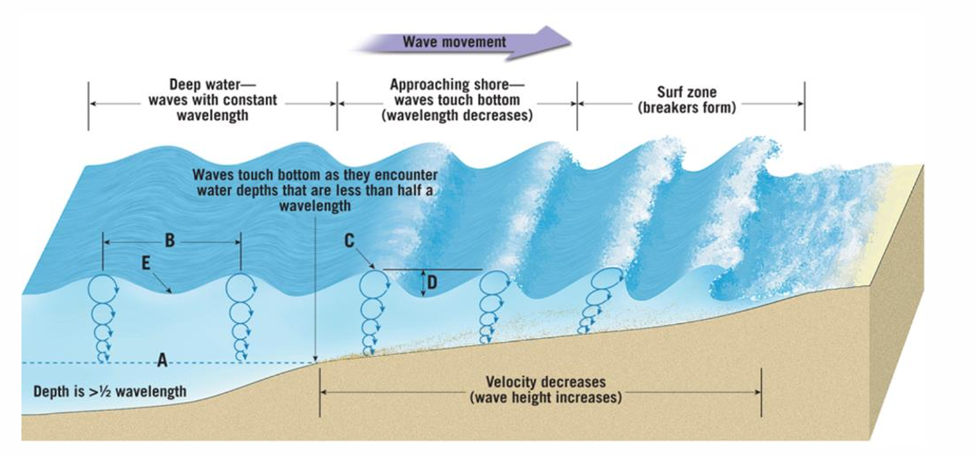
The coastal region is not uniform but has different areas, each with its own conditions and its own degree of interaction between the waves and the seabed: the offshore zone, the nearshore (shoaling) zone, and the surf zone (Figure 2.1). The area of interest of this thesis is the nearshore zone, where many cable routes are getting on land and where the loading on a rock protection is at its most complex.
Figure 2.1: The zones of the nearshore environment, from the offshore zone through the shoaling zone to the surf zone (Romano, Lecture Notes Coastal and Harbour Engineering, 2026).

Offshore, the water is deep enough that the surface waves are hardly felt at the seabed. The flow near the bed is governed mainly by tidal and large-scale currents, and protection design there is comparatively straightforward (Schiereck and Verhagen, 2019).

The nearshore, or shoaling, zone begins where the waves start to feel the seabed and ends where they break consistently. As the waves move into shallower water they change shape, and their height first grows before the depth limits it (Schiereck and Verhagen, 2019). Landward of it lies the surf zone, from the breaker line to the shoreline, where the waves have broken and the conditions are set by turbulence, longshore currents, undertow and swash. This study stays in the nearshore zone, with attention to the transition near the breaker line where breaking can already begin.

The nearshore is the governing zone because the water depth controls both how strongly the waves load the seabed and how large a wave can be before it breaks. The required protection can therefore differ strongly from one point to another along the same route. For that reason the assessment in this thesis is carried out point by point along the route rather than with one representative condition.

Bed Morphology and Composition
Burial is always the preferred protection, but this thesis deals with cables that lie on the seabed, there where a rock berm is needed for ptotection. Two situations govern the design: a mobile sandy seabed at crossings, and bedrock (Figures 2.2 and 2.3).

Sandy seabed (crossings). Where the cable crosses an existing third-party cable or pipeline, trenching is not permitted, so the cable is laid on the seabed and a rock berm provides the required cover. Fine to medium sand (D50 of 0.1 to 0.5 mm) is highly mobile under waves and current. DNV-RP-F109 (2021, Section 8.4) calls a bed mobile, or "live", when the bed shear stress from the flow exceeds the threshold for erosion of the grains present (Soulsby, 1997). This is the same combined wave-and-current loading that later sets the required rock size (Section 3.3), so a single physical reasoning governs both whether the sand moves and how large the protection rock must be. In this thesis the rock berm itself is sized first, for its own stability. The surrounding seabed, around and beneath the berm, is left out, but some advises are written in a later chapter, because the finer sand can be washed out from between and beneath the protection (winnowing) and eroded at its edges (scour) where the particles cannot withstand the applied shear. A correctly graded filter or underlayer beneath the armour limits this winnowing (Schiereck and Verhagen, 2019, Ch. 6; Chapter 6).
Figure 2.2: A rock berm over a cable at a crossing on a mobile sandy seabed (NKT, 2026).

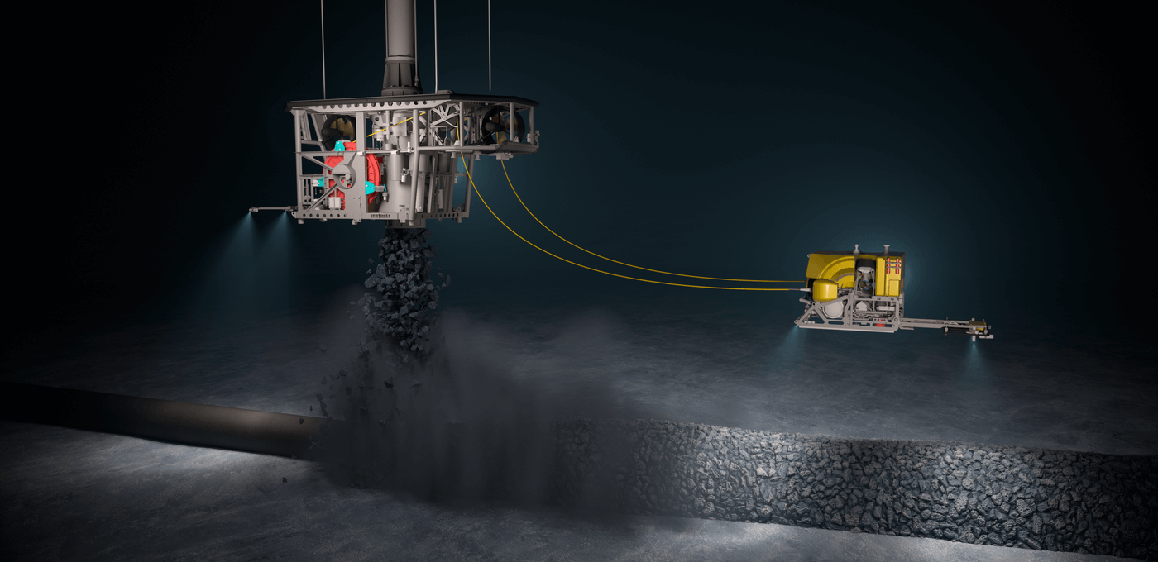
Bedrock. Where the seabed is bedrock, trenching is impossible and a berm is always required. Rocky, consolidated beds are common along steep coastlines, fjords and rocky headlands. There is little loose sediment to be lost, so winnowing and scour of the surrounding is not a big problem, bigger problems in this area are the steep seabed and the uneven rock surface can leave unsupported cable, called free span. Herrera and Medina (2015) show that steep rocky coasts, with slopes of 1/10 or steeper, behave very differently from gentle sandy slopes, so formulae developed for sand do not apply directly here.
Figure 2.3: Rock berm on bedrock (Keh-Chia, editor, Scour and Erosion IX, 2024).

The rock berm and its terms
A rock berm is a trapezoidal mound of quarried rock placed over the cable. Its shape is described by a small number of terms, which are used throughout this thesis and are shown in Figure 2.4.
- The top width W_{top} is the flat width of the crest of the berm.
- The side slope is written as 1:a, so a slope of 1:4 rises one metre over four metres horizontally.
- The berm height h_{berm} is the height of the crest above the surrounding seabed.
- The cover is the thickness of rock between the top of the cable and the crest. The minimum that the client requires is the minimum top of cover, MTOC, and the cover that is actually installed is the top of product cover, TOPC.
- The armour is the outer layer of rock that has to resist the flow. Its size is given as the nominal diameter D_{n50} or as the sieve diameter D₅₀, and the difference between the two is set out in Section 4.3.
- The underlayer is the finer rock between the armour and the seabed, used on a sandy seabed as described in Section 2.2.

The berm does not have to keep this shape. Under a storm the stones can move and the trapezoid can flatten into a lower and wider profile. How much of that movement is accepted, and how much extra cover has to be installed because of it, is the design question of Chapter 5 and Chapter 7.

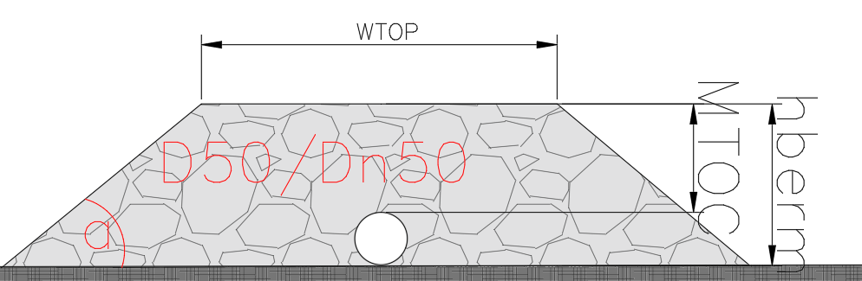
Figure 2.4: The rock berm and the terms used in this thesis, with the top width, the side slope, the berm height, the cover on the cable, the armour and the underlayer. (W.Pol)

Hydrodynamic Forcing
The hydraulic forcing is the set of hydrodynamic loads that act on the rock berm and that a stable rock must resist. Along a nearshore cable route this forcing comes from two sources, the currents and the waves, which together drive the flow close to the seabed. This near-bed flow exerts a drag force on each rock in the direction of the flow and a lift force directed away from the bed, and these destabilising forces are resisted by the submerged weight of the rock. A rock stays in place as long as its weight is enough to withstand the peak of the combined wave and current loading (Schiereck and Verhagen, 2019).

The waves are usually the dominant contribution in the nearshore, but a current, where present, adds to the load and its direction relative to the waves matters (Section 3.3). This chapter therefore describes both sources of forcing: the waves in Section 3.1 and the currents in Section 3.2. How the two are combined into a single near-bed loading, and how that loading is translated into a stability criterion, is set out in Chapter 4. Figure 3.1 illustrates this combined loading.

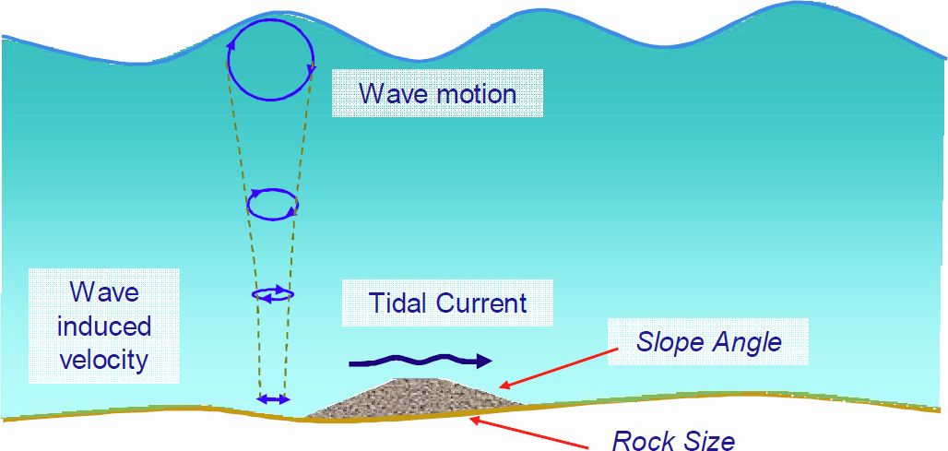
Figure 3.1: Rock berm stability analysis at a cable crossing (specialist design report, 2024).

Waves
Waves are usually the largest single hydrodynamic load in this thesis, because they generate an oscillatory motion throughout the water column and, in particular, at the seabed. The wave field is described with linear wave theory, from which both the near-bed velocity and the near-bed pressure follow, and its behaviour depends strongly on the water depth.

Wave data and propagation
The design wave conditions along a route are derived from measured, hindcast or reanalysis data at an offshore point and propagated to the site with a dedicated wave model. In this thesis these values are taken directly from the NKT route data, which give the significant wave height, the peak period and the wave direction per location, usually already chosen to represent a design return period (DNV-RP-F109, May 2021, Section 2.6). The offshore data represent deep-water conditions, while the site itself lies in intermediate to shallow water, so the derivation and propagation of the wave climate are not repeated here. This section focuses on translating the given wave conditions into the local loading at the seabed.

Wave parameters
A sea state is irregular and is described by bulk parameters. Only three of them are inputs in this thesis, and all three come straight from the route data, the significant wave height Hs, the peak period Tp and the wave direction. The direction is kept because it decides whether the wave attack is aligned with or oblique to the route, and how the waves act together with a current (Section 3.3).

Every other wave parameter used here is computed from those. The stability methods of Chapter 5 are not all written in the same period, so each one is given the period it was fitted with, converted from the peak period with the customary ratios between the periods of a wind-sea spectrum. The mean period is taken as Tm = Tp/1.15 and is used by the rewritten Van der Meer form. The spectral mean period is taken as Tm-1,0 = Tp/1.1 and is used by the modified Van der Meer form, by the shallow-water form of Scaravaglione et al. (2025) and by the toe formula of Van Gent and Van der Werf (2014). The zero-crossing period is taken as Tz = Tp/1.3, following the handbook itself (Deltares, 2023, Eq. A.19), and it drives the near-bed velocity of the load chain in Section 5.5. The wave height exceeded by two per cent of the waves, H2%, is not taken as a fixed multiple of Hs but is computed from the water depth and the foreshore slope with the composite Weibull distribution of Section 5.2.3.

One assumption belongs here rather than further on. Hs is classically the mean of the highest one third of the waves, while spectral models report Hm0 = 4√m0, and the two diverge on a shallow foreshore where the highest waves break (Schiereck and Verhagen, 2019, p.149 and Appendix 7.7.2). The formulas of Chapter 5 are written in one or the other. The route data give a single significant wave height, so Hm0 is taken equal to Hs throughout this thesis. The difference between the two is therefore carried inside the scatter of the formulas and is not resolved here.

Linear wave theory
Before the wave field can be turned into a load on the rock, two quantities have to be known at the seabed, and both come from linear wave theory. The first is the wavelength at the local water depth, which follows from the dispersion relation. The second is the orbital velocity at the bed, which follows from the velocity potential. This section derives both and says which of the methods of Chapter 5 use them.

The methods do not all ask for the same thing. Van Rijn works with the near-bed orbital velocity and its excursion, and both are computed from the wavelength. The toe formula of Van Gent and Van der Werf works with a characteristic near-bed velocity that is built in the same way. Hudson is written in a surface wave height and carries no depth decay at all, so the surface Hs is first scaled down to the value the bed feels, with the pressure response factor of linear theory. The load chain of the handbook of Deltares borrows only the wavelength, for the correction that lifts the load from the seabed to the crest of the berm.
Several methods do not rest on linear wave theory at all, and it is worth saying so plainly. Van der Meer and the four shallow-water forms run on a wave height, a period and the slope through the deep-water steepness. Herrera and Medina run on the deep-water wavelength, which is a closed expression that carries no water depth. Van Gent (2003) uses no period at all. And the near-bed velocity of the handbook chain is a spectral expression of its own rather than a linear-theory one.

Linear (Airy) wave theory gives a first-order description of the wave field. The wave motion is represented by a velocity potential (Romano, Lecture Notes Coastal and Harbour Engineering, Section 2.3),

$$φ = \frac{a g}{ω} \frac{cosh\left(k(z+h)\right)}{cosh(kh)} sin\left(kx - ωt\right)$$ | $$( STYLEREF 1 \backslash s 3. SEQ Equation \backslash * ARABIC \backslash s 1 1)$$

with a = Hs/2 the wave amplitude and z measured upward from the still water level, so z = 0 at the surface and z = −h at the bed. The velocity field (Section 3.1.4) and the pressure (Section 3.1.5) follow directly from this potential. The wave number k = 2π/L and the angular frequency ω = 2π/T are linked by the dispersion relation

$$ω^{2} = g k tanh(kh)$$ | (3.1)
which is solved iteratively for the local wavelength L at the depth h (Schiereck and Verhagen, 2019, p.151 and Table 7.1). Every wavelength in this thesis is obtained this way, at the local depth and at the period the method in question asks for.

The behaviour of the wave depends on the relative depth h/L, and linear theory distinguishes three ranges (Schiereck and Verhagen, 2019, Table 7.1). In deep water, h/L above one half, tanh(kh) tends to one and the wave does not feel the bed. In shallow water, h/L below one twentieth, tanh(kh) and sinh(kh) both tend to kh and cosh(kh) tends to one, so the whole water column feels the wave. Between the two lies intermediate water, where neither simplification holds and the full hyperbolic functions are needed. The nearshore cable routes of this study sit in that middle range, which is the reason the hyperbolic terms are carried in full everywhere below rather than replaced by a limit.

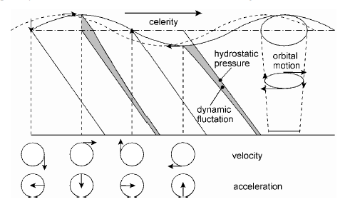
Figure 3.2: Water motion in a periodic non-breaking wave, with the celerity, the pressure and the orbital motion (Schiereck and Verhagen, 2019, Fig. 7-3).

A fair question is whether linear theory may be applied in the nearshore at all, since the shallow and steep waves fall outside its range of validity (Schiereck and Verhagen, 2019, Fig. 7-4). Schiereck and Verhagen (2019, p.152, Fig. 7-5) address this directly. Tested on a mild-slope case well outside the permissible range, linear theory still reproduces the measured maximum bottom velocities remarkably well, but it does not reproduce surface quantities such as the surface profile and the surface velocity.

This thesis uses it only for the near-bed velocity and the near-bed pressure, so it is applied exactly where this method can be used, and it gives a transparent analytical link between the sea state and the near-bed loading. The theory does break down at and inside breaking, where the flow becomes turbulent and strongly nonlinear, so points in that regime are flagged (Section 3.1.6) and assessed with the breaking-wave methods of Chapter 5, and it does not capture the onshore-offshore asymmetry of the near-bed velocity under steep, near-breaking waves. Resolving those effects needs a nonlinear or computational fluid dynamics model such as OpenFOAM, which is beyond the scope of this thesis and is recommended as a follow-up step.

Near-bed orbital velocity
This section works out the two quantities that the load model needs at the seabed, and a third that is only reported. The first is the peak near-bed orbital velocity, which Van Rijn (2019) uses directly and which Van Gent and Van der Werf (2014) use in a form of their own. The second is the orbital excursion, which Van Rijn uses as the orbital amplitude Aw in his wave friction factor. The third follows from the same equations and is the ratio between the velocity on the crest of a berm and the velocity at the seabed, which is explained is reported next to every design as a diagnostic rather than used inside it.

The velocity field follows from the potential by differentiation, u = ∂φ/∂x and w = ∂φ/∂z (Romano, Lecture Notes Coastal and Harbour Engineering, Section 2.3). The horizontal orbital velocity is

$$u(z) = \frac{a g k}{ω} \frac{cosh\left(k(z+h)\right)}{cosh(kh)} cos(kx - ωt)$$ | (3.2)
and using the dispersion relation this is the form used in the rest of this thesis,

$$u(z) = ω \frac{H_{s}}{2} \frac{cosh\left(k(z+h)\right)}{sinh(kh)} cos(kx - ωt)$$ | (3.3)

The horizontal orbital velocity is largest at the surface and decays with depth. At the bed, z = −h, the amplitude reduces to the peak near-bed orbital velocity,

$$û_{b} = ω \frac{H_{s}}{2 sinh(kh)} = \frac{π H_{s}}{T_{p} sinh(kh)}$$ | (3.4)

and the orbital excursion, the back-and-forth distance a particle travels at the bed, is

$$a_{b} = \frac{H_{s}}{2 sinh(kh)}$$ | (3.5)
(Schiereck and Verhagen, 2019, Table 7.1; Romano, Section 2.3).

Two assumptions sit in these equations. The sea state is represented by a single regular wave of height Hs and period Tp, because linear theory describes one wave and not a spectrum. And the height that enters Equation 3.4 is the significant wave height at the point, not the highest wave in the record.

This near-bed orbital velocity is the central wave quantity of this thesis, but not every method uses it. Van Rijn (2019) uses it directly, as the near-bed peak orbital velocity Uw, and uses the excursion of Equation 3.5 as the orbital amplitude Aw. Van Gent and Van der Werf (2014) use a characteristic velocity of the same shape, but evaluated with the spectral mean period Tm-1,0 instead of Tp and at the depth above the toe instead of the full water depth. Their definition also takes the wave number from the deep-water wavelength rather than from the dispersion relation at the local depth, a simplification the authors made deliberately and calibrated their coefficient with. The tool of this study evaluates that wave number at the local depth instead, which returns a smaller rock size than the published formula gives, and this is one more reason why the Van Gent results of Chapter 8 are reported as indicative. The load chain of the handbook does not use Equation 3.4 at all, since it builds a spectral near-bed velocity of its own (Section 5.5), and the slope formulas of Chapter 5 work with a wave height rather than with a velocity.
Equations 3.4 and (3.5) are evaluated at the seabed, at z = −h, so they describe the loading on a flat bed. A rock berm is not flat. Its crest stands a height hberm above the surrounding seabed, so the water depth over the crest is h − hberm. Because the near-bed orbital velocity varies as 1/sinh(kh), a smaller depth gives a larger velocity, and the ratio between the two levels follows directly as

$$\frac{û_{crest}}{û_{bed}} = sinh(k h) / sinh(k (h - h_{berm}))$$ | (3.6)

in which the wave number k is based on the ambient water depth, so that the wave keeps the length it has in the surrounding water and only the depth decay of the orbital motion is re-evaluated at the crest (Deltares, 2023, Equations A.20 to A.25).

The level at which the loading is evaluated is not a free choice. It is set by the method that uses it, because every empirical relation carries the level at which it was calibrated. Every design in this thesis is therefore computed with the load at the seabed, which is the level the reshaping model of Chapter 5 was fitted on. Equation 3.6 is implemented in the tool and reported next to each design as a diagnostic, and what it would mean to design on the crest instead is set out in Section 9.5.

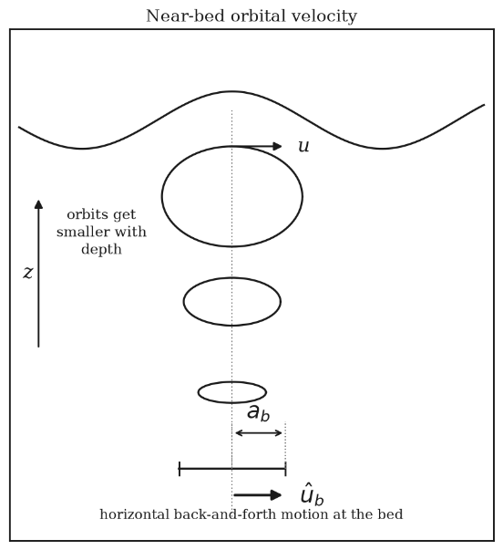
Figure 3.3: Near-bed orbital motion under a wave, with the excursion amplitude ab and the peak near-bed orbital velocity ûb. Own figure, after Schiereck and Verhagen (2019).

Its behaviour with depth follows the same three ranges. In deep water sinh(kh) is large, so ûb tends to zero and the bed hardly feels the wave, and in the shallow-water limit sinh(kh) tends to kh, so the whole column including the seabed feels the passing wave. For a given wave the near-bed velocity therefore rises as the wave moves into shallower water, which raises the load on the protection.

The orbital velocity ûb acts just outside a thin near-bed boundary layer. Within this layer the flow is rotational and carries a high wave shear stress, while above it the flow follows the irrotational wave theory (Figure 3.4). Because this layer is thin compared with the water depth, the current that is combined with the waves is taken from outside it. The route data give that current at one metre above the bed, while the two methods that use a current, Van Rijn and the rock berm model of the handbook, both ask for the depth-averaged value. Section 3.2.3 sets out how the two are related and which of them is used (Schiereck and Verhagen, 2019, p.153-154, Fig. 7-7).

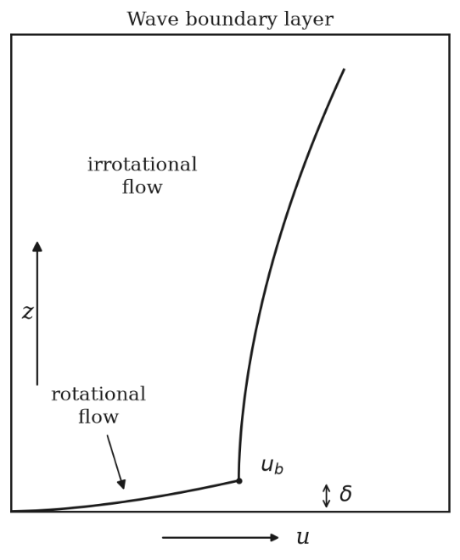
Figure 3.4: Velocity profile under a wave crest, with the thin rotational layer of thickness δ that carries the wave shear stress (Schiereck and Verhagen, 2019, Fig. 7-7).

Excess dynamic pressure and effective near-bed loading
This section works out the pressure under a wave, and it is worth saying at the outset that the pressure is not a load in this thesis. None of the stability methods balances a pressure against the weight of a stone, because they all work with a velocity or with a wave height. What is used is one quantity derived from the pressure, the response factor at the bed, and it serves one method only. That method is Hudson, which is written in a surface wave height and carries no depth attenuation of its own, so the surface Hs has to be scaled down to the value the bed feels before it is applied.

The same potential gives the pressure under a wave. The total pressure is the sum of the hydrostatic pressure pᴵ = −ρgz and an excess, or dynamic, pressure created by the wave motion. The excess pressure follows from the linearised unsteady Bernoulli equation (Romano, Lecture Notes Coastal and Harbour Engineering, Section 2.3),

$$p^{+} = -ρ \frac{∂φ}{∂t} = ρ g a \frac{cosh\left(k(z+h)\right)}{cosh(kh)} cos(kx - ωt) = ρ g η K_{p}$$ | (3.7)

where η = a cos(kx − ωt) is the surface elevation and Kp is the pressure response factor,

$$K_{p}(z) = \frac{cosh\left(k(z+h)\right)}{cosh(kh)}$$ | (3.8)

which sets how much of the surface wave signal reaches the level z. It is one at the surface (Kp = 1 at z = 0) and decreases towards the bed, where

$$K_{p,b} = \frac{1}{cosh(kh)}$$ | (3.9)

The same two limits apply. In deep water Kp decays exponentially away from the surface, so Kp,b tends to zero, and in shallow water Kp tends to one at every depth, so the excess pressure is almost constant over the depth, p⁺ ≈ ±ρ g a, and the bed feels almost the full wave (Figure 3.2). Because the excess pressure is proportional to the amplitude a = Hs/2, the near-bed response factor scales the surface wave height down to the value the bed experiences,

$$H_{s,b} = K_{p,b} H_{s} = \frac{H_{s}}{cosh(kh)}$$ | (3.10)

The effective near-bed wave height of Equation 3.10 is what Hudson is applied with, in place of the surface Hs. The velocity potential, the excess pressure and the response factor are standard linear wave theory (Romano, Section 2.3, and the same pressure appears in Schiereck and Verhagen, 2019, Table 7.1), but the step of using the near-bed response factor as an effective wave height for Hudson is a choice of this thesis and is set out in Chapter 7.

No other method is corrected in this way, and the reason differs per method. Van Rijn and Van Gent and Van der Werf work with the near-bed orbital velocity, which already carries the same attenuation through its 1/sinh(kh) term, so reducing their wave height as well would count the depth twice. The shallow-water forms of Van der Meer are used with the local significant wave height at the point, together with the wave height exceeded by two per cent of the waves from the composite Weibull distribution of Section 5.2.3, and that is where their depth dependence sits. Herrera and Medina are the exception in the other direction, because their formula is written in the deep-water wave height Hs0 and not in a local one. Where the metocean data give that offshore value it is used directly, and where they do not it is back-calculated from the local wave height by reverse shoaling, which the tool flags as unreliable when the point is close to breaking.

Depth-induced breaking
As the waves propagate land inwards, the waves will be broken due to the depth. For the significant wave height that limit is around H_{s}/h ≈ 0.4 to 0.5, well below the individual-wave limit of H_{b}/h ≈ 0.78 to 0.88, and the reason is the shape of the sea state itself. The highest waves in the record, roughly 1.5 to 2 times H_{s}, reach their own limit first and break furthest offshore, while the smaller waves in the same sea state carry on into shallower water (Schiereck and Verhagen, 2019, Section 7.3.1, Eq. 7.8). Breaking is therefore not a switch that a sea state passes through at one depth. At any point along a shoaling profile part of the wave-height distribution has already broken and the rest has not, and the ratio H_{s}/h says how far that process has gone rather than whether it has started.

For that reason the ratio is used in this thesis as a screening indicator and not as a statement about the waves at a point. A ratio above about one half means that the upper tail of the distribution is already being broken by the depth, which is the condition the shallow-water formulas of Section 5.2.4 were derived for, and it also means that the loading has begun to shift from smooth oscillatory motion towards turbulent and impulsive forcing. The tool needs a single number to branch on, so it applies the same ratio as a fixed threshold, and Section 7.4 states that this is a modelling choice rather than a physical boundary.

Relevance for the stability assessment
For the stability assessment the wave field is summarised by Hs, Tp and Tm-1,0, the wave direction and, above all, the near-bed orbital velocity at the local depth. Table 3.1 lists these quantities with the symbols under which they return in the stability methods of Chapter 5.
Linear wave theory (Section 3.1) | Symbol in the stability methods (Chapter 5)
near-bed orbital velocity ûb | Uw (Van Rijn), characteristic orbital velocity (Van Gent and Van der Werf)
orbital excursion ab | Aw (Van Rijn)
effective near-bed wave height Hs,b | Hs input to Hudson
Table 3.1: The linear wave theory quantities of Section 3.1 and the symbols under which they appear in the stability methods of Chapter 5.

Currents
Currents is the other phenomena that is considered of the flow in the nearshore. Together with the waves they raise the load on the rock berm, and the angle between the current and the waves decides how big that combined load is. Wherever a current is present in the NKT route data it is included, and of the methods compared in this thesis only Van Rijn and the Deltares rock berm model use one, since the breakwater and the toe methods were developed for wave loading alone.

Tidal currents
The tidal current is the horizontal movement of water that follows the rise and fall of the tide, and it turns around every cycle, landward on the flood and seaward on the ebb. For a rock berm this means the load arrives from both sides in turn rather than always from the same direction. The size of the current depends on the local tidal range, the water depth and the shape of the coast, and for the stability of the rock it is that size and the direction relative to the waves that matter.

The tide is taken into account for two reasons. It drives the current itself, and it also moves the water level. A lower water level means a smaller depth over the same point, and a smaller depth gives a larger near-bed orbital velocity and a larger bed shear stress. The load on a berm therefore changes over the tidal cycle even when the sea state does not, which is why every point is evaluated at both the low and the high design water level and the worse of the two is kept (Section 7.3.3).
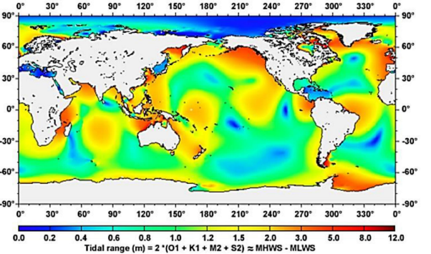
Figure 3.5: Tides over the world (Romano Lecture Notes, 2026).

Other current contributions
Wind-driven currents can reinforce the tidal current during storms but are generally a secondary contribution in the nearshore. Density-driven currents, caused by differences in salinity or temperature, are a minor and site-dependent contribution. Where waves break at an angle to the shoreline they drive a longshore current in the surf zone (Battjes, 1974, in Schiereck and Verhagen, 2019), but the surf zone itself is outside the scope of this thesis (Chapter 2), so this mechanism is only relevant in the transition region near the breaker line. In the assessment these contributions are not treated separately, and the steady current is represented by the tidal current from the route data.

Velocity profile and the reference levels
A current has no single velocity. It follows a logarithmic profile that is zero at the bed and grows towards the surface (Figure 3.6),

$$u(z) = \frac{u_{*}}{κ} ln\left(\frac{z}{z_{0}}\right)$$ | (3.11)
where u* is the shear velocity, κ the Von Karman constant and z₀ a roughness length set by the bed. The velocity gradient is largest just above the bed and smallest near the surface, so a current velocity only means something if the height at which it applies is stated with it.
The route data give the current at one metre above the bed. That height is a practical choice rather than a physical boundary. Closer to the stones the logarithmic profile does not hold at all, because the flow there runs between and behind the individual rocks and the velocity depends on exactly where a sensor is placed. One metre sits above that disturbed layer, so it is a level that can be measured and repeated on any route.
The two methods that use a current do not ask for that level. Van Rijn and the rock berm model of the handbook are both written in the depth-averaged velocity, which for a logarithmic profile is found at about 0.37 times the water depth above the bed and follows from

$$ū = \frac{u_{*}}{κ}\left[ln\left(\frac{h}{z_{0}}\right) - 1\right]$$ | (3.12)

This is not a separate step in either method but sits inside them. The handbook writes its current drag coefficient as C_D = [0.4 / (ln(h/z₀) − 1)]², and the term in brackets is exactly Equation 3.12. Van Rijn does the same through his current friction factor. Using a velocity from a different height in either expression therefore mixes two definitions.

In practice the two do not always match. Where the metocean study reports a depth-averaged value that value is used, but on most points only the one-metre value is available and it is entered as supplied. The two are linked through the same profile once the bed roughness is fixed, and for the water depth and the roughness of a rock berm the depth-averaged value is about 1.4 times the one-metre value. Entering a one-metre value where a depth-averaged one is expected is therefore not conservative, and what that choice is worth on the design stone is quantified with the results in Chapter 8.

The roughness in Equations 3.11 and (3.12) is not a property of the seabed but of the berm itself. Both methods take the bed roughness from the armour stone, as ks = 2.5 d50 with z₀ = ks/30, so the rock that has to resist the flow also sets how rough the bed is. A larger stone therefore raises the drag coefficient of the current and the friction factor of the waves at the same time, and with them the bed shear stress it has to withstand. The stone does not only resist the load, it also increases it, which is why the required size cannot be read off directly but has to be solved by iteration (Chapter 7). This roughness ks is not to be confused with the slope factor Ks of Chapter 5, which is a different quantity.

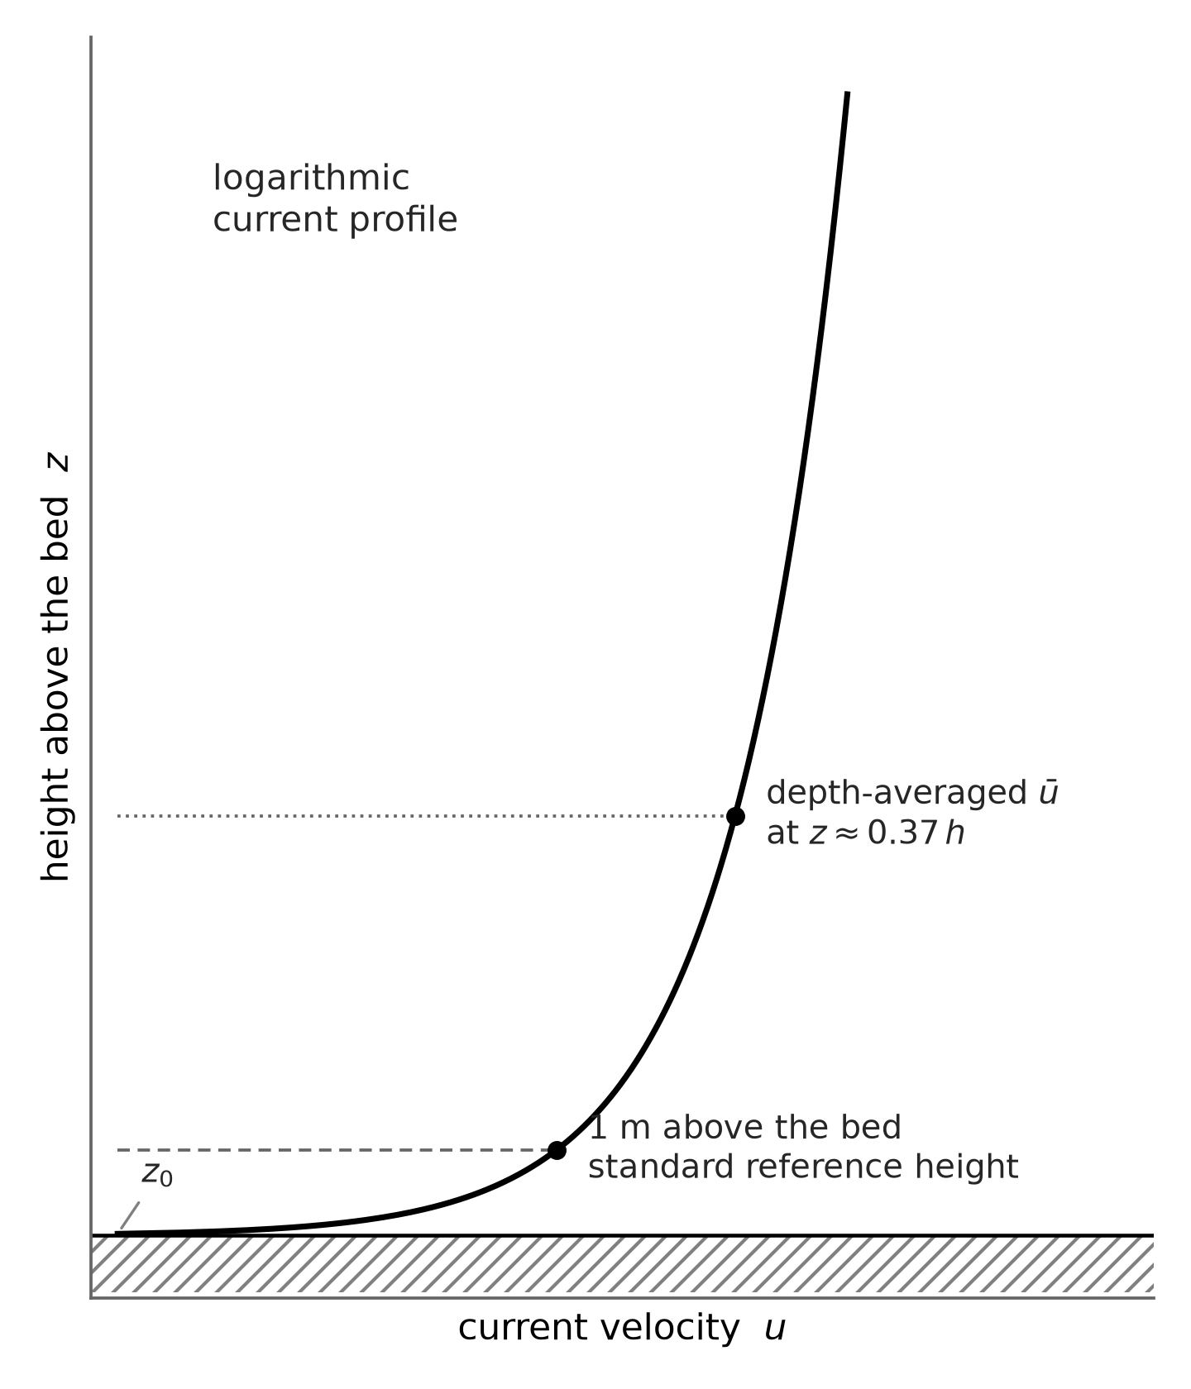
Figure 3.6: Logarithmic velocity profile of a steady current, with the one-metre reference height and the depth-averaged level at about 0.37 h. Own figure, after Schiereck and Verhagen (2019).

The near-bed current defined here is combined with the wave motion in Section 3.3, and the selection of the design wave and current condition, including their return periods, is set out in Section 3.4.

Combined waves and currents
In the nearshore a wave field and a current are usually present at the same time, so the bed feels both at once. Not every method has to deal with this. The breakwater equations were developed for wave loading alone, and only Van Rijn (2019) and the Deltares rock berm model (2023) use a current, as stated in Section 3.2. For those two the wave and the current have to be brought together into a single load at the bed, and only at the points where the NKT route data give a current. The wave is represented by its near-bed orbital velocity ûb (Section 3.1) and the current by its velocity uc (Section 3.2). This section sets out how the two are brought together into one bed shear stress, and why that combination is made on the velocities and not on the loads.

The velocities are combined, not the loads. When a wave and a current act together at the rock berm, their influence is combined by adding the current and the wave contributions vectorially at the level of the bed shear velocity, the velocity scale of the friction the flow exerts on the rocks (Bijker, 1967; Schiereck and Verhagen, 2019, p.155). Each flow defines its own bed shear velocity, from the current velocity uc and from the orbital velocity ûb, with C the Chezy coefficient and cf the wave friction factor,

$$u_{*c} = \frac{\sqrt{g}}{C} u_{c}$$ | (3.13)
$$u_{*w} = \sqrt{\frac{c_{f}}{2}} û_{b} sin(ωt)$$ | (3.14)

Added vectorially, the resulting bed shear velocity at the bed is

$$u_{*r} = \sqrt{\frac{g}{C^{2}}u_{c}^{2} + \frac{c_{f}}{2}û_{b}^{2} \sin^{2}(ωt) + 2 \frac{\sqrt{g}}{C} u_{c} \sqrt{\frac{c_{f}}{2}} û_{b} sin(ωt) sin(φ)}$$ | (3.15)

and the resulting bed shear stress is
$$τ_{r} = ρ u_{*r}^{2}$$ | (3.16)

where φ is the angle between the wave and the current direction, defined here as Schiereck does, so that φ = 90° corresponds to waves parallel to the current. The combination is made on the shear velocities and not on the shear stresses because the shear stress grows with the square of the velocity. Squaring the vector sum keeps the cross term between the two contributions, while adding the two stresses directly throws that term away, which is only correct when the wave and the current are perpendicular. That cross term is not a small correction, because the wave boundary layer stays thin and the friction factor under waves is therefore much larger than the value for uniform flow, of the order of 0.01 for a current against values up to 0.1 to 0.3 for short waves over a rough bed (Schiereck and Verhagen, 2019, p.154).

For a rock berm the maximum over the wave cycle governs the start of movement, because Schiereck and Verhagen (2019, p.155) state that the maximum value determines incipient motion. Setting sin(ωt) = 1, writing u*c and u*w for the two shear velocities of Equations 3.13 and 3.14, and using the ordinary geometric angle θ between the two directions (θ = 0 for aligned, with θ = 90° − φ), Equation 3.15 reduces to the working form used in this thesis,

$$u_{*cw} = \sqrt{u_{*c}^{2} + u_{*w}^{2} + 2 u_{*c} u_{*w} cos θ}$$ | (3.17)

The corresponding bed shear stress follows from Equation 3.16 with u*cw in place of u*r, and is written here as τcw. Because Equation 3.17 is the value at the top of the wave cycle, τcw is the maximum combined bed shear stress and not the value averaged over the cycle.

The cross term 2 u*c u*w cos θ is largest when the two are aligned, where the combined shear velocity becomes u*c + u*w, and it vanishes when they are perpendicular, leaving only the two separate contributions. Schiereck and Verhagen (2019, Figure 7-8) show the same. Their worked example, a 3 m wave with a period of 7 s in 8 m of water with a current of 1 m/s, gives a current-only shear of about 4 N/m², a wave-only shear of 47.4 N/m², a perpendicular value of 51.4 N/m², which is the plain sum of the two, and an aligned maximum of 78.6 N/m². Equation 3.17 returns both of these to within the rounding of the source. Between the two extremes lies a difference of about fifty per cent in the load for the same sea state, which is why the angle is worth carrying rather than assuming.

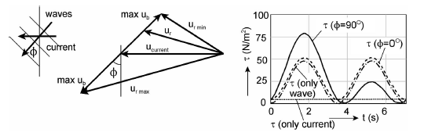
Figure 3.7: Combined wave-current action (Schiereck & Verhagen, 2019, Figure 7-8).

Three ways of adding, and which one is used. Three variants of this addition were studied for this thesis. The two bed shear stresses can be added straight together with no direction (Van Rijn, 2019), they can be combined as stresses with the angle between them and an empirical factor on the mean stress (Deltares, 2023, after Soulsby, 1997), or they can be combined as shear velocities before they are squared, which is Equation 3.17 (Bijker, 1967; Schiereck and Verhagen, 2019). The rubble-mound and the toe formulas fall outside this question, since they were derived for wave loading alone and carry no current. The shear velocity combination is taken here as the most correct, because the quantity that adds as a vector is the velocity and not its square, and it is implemented in the tool as a separate version. It is not substituted into the other two, which were each calibrated with their own combination and are therefore used as published (Sections 7.3.3 and 7.3.4).

Consistency and use in this thesis. Both velocities are the quantities used elsewhere in this thesis. The orbital velocity ûb is the near-bed peak orbital velocity of Section 3.1, which Van Rijn calls Uw. All three combinations define uc as the depth-averaged velocity, while the route data give the current at one metre above the bed, and what follows from using it as supplied is set out in Section 3.2.3. The bed friction matches as well, since the Chezy coefficient C is linked to the Van Rijn current friction factor by fc = 8g/C² and the wave friction factor is the same exponential expression in both (Schiereck and Verhagen, 2019, Figure 7-7; Van Rijn, 2019), with the one difference that Van Rijn takes the wave shear stress as the value averaged over the wave cycle where Equation 3.17 takes its maximum. Because the NKT route data give both directions, the angle term is kept rather than dropped, and how it is treated in the design is set out in Section 7.3.4.

Design conditions and return periods
The stability assessment is based on a single design condition defined by its return period. DNV-RP-F109 states that the characteristic load condition must reflect the most probable extreme response over the design period (DNV-RP-F109, May 2021, Section 2.6), which for a permanent installation means a 100-year event, an annual exceedance probability of one per cent. The extreme-value analysis behind these values is summarised in Appendix A, and the return-period values themselves are taken from the NKT route data.

Because an extreme wave and an extreme current rarely happen at the exact same time, their joint probability is usually unknown. To solve this, DNV-RP-F109 approximates the design condition by checking the most severe of two standard combinations:
- The 100-year wave combined with the 10-year current.
- The 10-year wave combined with the 100-year current.
Because the combined load depends non-linearly on the ratio between the wave and current velocities, a smaller current can sometimes be the governing factor. Therefore, lower current velocities are checked as well.

DNV-RP-F109 allows engineers to use the actual wave and current directions when they are available. If no direction data is available, the guideline forces a conservative assumption where waves and currents are omni-directional and perpendicular to the cable. This specific rule is the exact basis for treating the wave-current angle as a design variable in this thesis (Section 3.3), which avoids the over-design caused by the standard perpendicular default.

For each point along the route, both combinations are calculated, and the combination that requires the largest rock diameter is selected as the design condition for the methods in Chapter 5. Shorter, temporary installation phases follow the same approach but use lower return periods, such as seasonal 10-year and 1-year events or rely on a weather forecast for windows shorter than three days (DNV-RP-F109, May 2021, Section 2.6).

Stability Parameters & Criteria

Introduction
Chapter 3 ended with the flow at the bed, the near-bed orbital velocity of the waves and the combined shear velocity wherever a current is present. This chapter turns that flow into a load on a single rock, sets out how the rock resists that load, and defines when it starts to move, following Schiereck and Verhagen (2019, Chapter 3). Two things are needed for that. The first is the balance between the force of the water and the resistance of the stone. The second is the choice of how much movement is accepted, because a rock protection has no sharp point at which it suddenly fails. Both are taken from the literature here. The values used in this study are chosen in the methodology.

A rock stays where it is as long as the water cannot overcome its own weight. The flow pushes and drags on the stone, and the stone holds on with its submerged weight and its grip on the bed underneath. All of this chapter rests on that one balance. The rock is treated as a single stone lying on the bed, and nothing is counted for the way the stones lock into one another. That is deliberate. Interlocking depends on the shape of the rock, on how tightly it is packed and on how carefully it is placed, and none of that is known from the route data, so it cannot be put into a number here. Leaving it out is the safe side of the choice, because interlocking can only add resistance. The balance itself has no sharp limit either. A stone does not lie perfectly still up to one load and roll away just above it, so the real question is not whether anything moves but how much movement is accepted, which is the subject of Section 4.4.

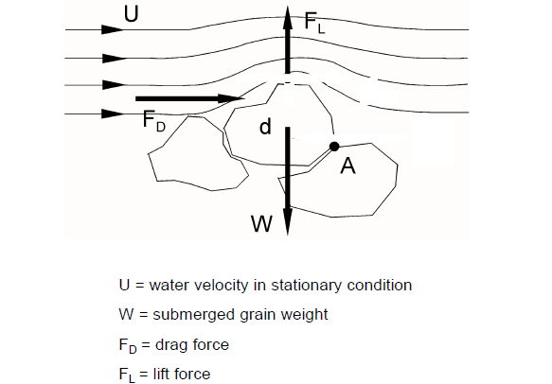
Figure 4.1: Steady-flow boundary layer with the logarithmic velocity profile, and the hydraulically smooth and the rough boundary. Adapted from Romano (lecture notes).

Forces on a rock and the Shields parameter
A rock on the seabed feels the moving water as three forces. The flow pushes it along, which is the drag force. The flow bends over the top of the stone and the pressure there drops, which pulls it upward, and that is the lift force. And the water rubs along the bed around it, which is the shear force, a picture that suits a flat bed of smaller grains better than one large stone (Schiereck and Verhagen, 2019). All three have the same form,

$$F = \frac{1}{2} C ρ_{w} u^{2} A$$ | (4.1)
so each of them grows with the square of the near-bed velocity and with the area the stone offers to the flow. That area goes with d², so the load on the stone goes with u² d².
Against this stands the weight of the stone under water, which goes with its volume and therefore with (ρs − ρw) g d³. The stone starts to move when the water wins. This can be written as a balance of the horizontal forces, of the vertical forces, or of the moments about the point A where the stone rests on its neighbour (Figure 4.2),

$$(F_{D} + F_{L}) a = W b$$ | (4.2)

with a and b the arms of the two moments. Which of the three balances is chosen does not change the answer, because the same proportion between load and strength always survives (Schiereck and Verhagen, 2019, p.49),

$$\frac{U^{2}}{Δ g d} = \frac{2b}{a c} = f(Re)$$ | (4.3)

Every formula for the stability of a single stone comes down to this one proportion. What separates the methods is the constant on the right, which cannot be derived and has to come from experiments, and that is the reason a chapter of competing formulas exists at all. Izbash (1932) filled the constant in with the velocity at the stone, uc = 1.2 √(2 Δ g d). Shields filled it in with the shear stress at the bed, and that is the route followed here.

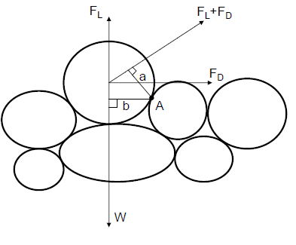
Figure 4.2: Moment equilibrium of a grain around its pivot point A, the drag and lift torque against the torque of the submerged weight. Adapted from Romano (lecture notes).
Shields (1936) wrote the load as a bed shear stress instead of a velocity and made it dimensionless with the submerged weight of the stone, which gives the Shields parameter, the load divided by the strength (Schiereck and Verhagen, 2019),

$$θ = \frac{τ_{b}}{(ρ_{s} - ρ_{w}) g d} = \frac{τ_{b}}{ρ_{w} g Δ d}$$ | (4.4)
This is the form used in this thesis, because a bed shear stress is exactly what Chapter 3 delivers. The stress τb is the combined wave and current shear of Section 3.3, τb = ρ u*cw², built from the near-bed orbital velocity of Section 3.1 and the current of Section 3.2.
The critical value of θ is not the same for every grain. The Shields curve (Figure 4.3) gives it against the particle Reynolds number, which says whether the grain sticks out into the turbulent flow or hides in the thin layer of water at the bed. For fine material the curve has to be read point by point, but for coarse material it flattens off. Schiereck and Verhagen (2019, p.51) state that above a grain size of about 7 mm the critical value can be taken as a constant of about 0.055, with no need to iterate in the diagram. Rock in a berm is measured in decimetres, so this thesis sits far inside that range and works with a constant critical value. Van Rijn (2019) takes 0.05 for coarse material on the same grounds, and that difference, together with the damage coefficient that belongs with it, is treated in Section 4.4.

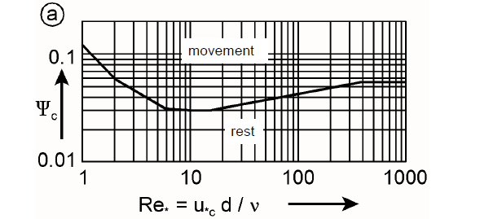
Figure 4.3: The Shields diagram, the critical dimensionless bed shear stress against the boundary Reynolds number. Adapted from Romano (lecture notes).

Stability criterion
The stability criterion can be written in different forms. Section 4.2 showed that every formula for the stability of a single stone comes back to the load against the resistance/strength. The shape of the formula only depends on the load quantity what could have been measured. Written with a velocity it becomes a critical velocity, as in Izbash. Written with a bed shear stress it becomes the Shields parameter. Written with a wave height it becomes the stability number Hs/(Δ Dn50), which is the form the slope and the toe formulas use. These forms do not contradict one another, they are the same balance in different clothing, and Chapter 5 gives each method in the form its own author fitted.

This chapter develops the Shields form. It follows directly from the bed shear stress that Chapter 3 delivers, and it is the form in which the leading method of this design is written (Section 1.5), so it is the form that carries the design in Chapters 7 and 8. The other forms return with their methods in Chapter 5, together with the way their different damage measures are brought onto one common axis.

The Shields parameter is used in two ways in design (Schiereck and Verhagen, 2019). Computed with a threshold shear stress it is the critical value θcr that marks the start of motion. Computed with the actual design load it is a mobility parameter, the acting value θ produced by the design condition,

$$θ = \frac{τ_{b}}{ρ_{w} g Δ D_{50}}$$ | (4.5)

A rock protection is stable when the acting value stays below the critical one,

$$θ ≤ θ_{cr}$$ | (4.6)

and turning that around gives the smallest stone that survives the design load,

$$D_{50} ≥ \frac{τ_{b}}{θ_{cr} ρ_{w} g Δ}$$ | (4.7)

Equation 4.7 shows what a designer can actually turn. The load τb is set by the sea and is not a choice. The critical value θcr is a choice, namely how much movement is accepted, which is the subject of Section 4.4. The relative density Δ is a choice as well, and a strong one, because the required diameter is inversely proportional to it. Going from a normal rock of 2650 kg/m³ to a dense rock of 3000 kg/m³ raises Δ from 1.59 to 1.93 and lowers the required diameter by about eighteen per cent, which is roughly a third less mass per stone for the same load. Density is therefore treated as a design variable in this thesis and not as a fixed property.

Equation 4.7 also looks like a direct calculation, and it is not. The roughness of the bed is the armour itself, so the bed shear stress on the left depends on the size of the stone on the right (Section 3.2.3). A larger stone resists more, but it also roughens the bed and raises the load it has to carry. The smallest stable stone therefore has to be solved by iteration rather than read off, which is how the tool works in Chapter 7.

Two diameters are in use for rock and they are not interchangeable. The sieve diameter D50 is the mesh size that half of the mass passes, and it is the number a quarry certificate reports. The nominal diameter Dn50 is the side of a cube with the same mass as the median stone, Dn50 = (M50 / ρs)^(1/3), and it is the one that appears in most stability formulas, because it follows from the mass that has to resist the flow. For quarried rock the two are related by Dn50 = 0.84 D50 (Rock Manual; Schiereck and Verhagen, 2019, citing Laan, 1981). Which of the two belongs in Equation 4.5 is set by the method that was fitted with it, which is treated in Chapter 5. Every rock size reported in this thesis is a nominal diameter unless it is labelled as a sieve size.

There is no sharp boundary between stable and unstable. The flow is turbulent and no two stones sit the same way, so the load and the strength are distributions rather than single values. Where those distributions overlap, stones move even though the average load stays below the average strength, and there is no value below which movement is impossible (Schiereck and Verhagen, 2019, p.53). The critical Shields value is therefore a marker on a scale and not a wall, and how much movement is accepted behind it is the subject of Section 4.4.

Failure spectrum and the damage factor r
The failure of a rock protection is a range, not an event. Breusers (Delft Hydraulics, 1969) sorted it into seven stages, from no movement at all to general transport of the grains, and the textbook Shields criterion matches stage six, continuous movement at all locations (Schiereck and Verhagen, 2019, p.53). A design that wants the berm to lie still therefore has to stay below the classical threshold and not at it.

For a rock berm over a cable three regimes matter.
- Threshold of motion, where single rocks vibrate in their place and sometimes leaves it, with θ close to θcr.
- Transport and reshaping, where the berm loses its installed shape and settles into a flatter and smoother profile while the cable stays covered.
- Continuous erosion, where the layer is carried away and the cable is exposed.

The middle one decides this thesis. Movement is not failure, losing the cover is, and a berm that reshapes into a flatter profile can protect the cable for the rest of its life.
Van Rijn (2019) turns the accepted movement into a design number with a reduction coefficient r on the theoretical threshold,

$$θ_{cr} = r ∙ θ_{cr,shields}$$ | (4.8)

with θcr,shields = 0.05 and r between 0.4 and 1.0. A low r, around 0.4 to 0.5, is a static design in which almost nothing moves under the design condition and the stone is large. An r towards 1.0 accepts limited transport and allows a smaller stone. These are two design philosophies, one that assumes the profile does not change and one that accepts movement and predicts the new profile with a deformation model (Chapter 5). Both rest on the same balance of Section 4.3 and differ only in the accepted damage. The value used here, and the same choice for the methods that do not work with r, are set in the methodology.

Non-uniform flow and turbulence
The Shields criterion is derived for uniform flow over a flat, unbounded bed (Schiereck and Verhagen, 2019, Section 3.2). A free-standing rock berm is not that situation. The berm stands above the seabed, so the flow speeds up over its crest and separates in its lee, which raises the local velocity and above all the turbulence (Schiereck and Verhagen, 2019, Section 3.4). The mean bed shear stress of Section 4.3 therefore understates what the stones on a berm actually feel.

The methods answer this in different ways, and none of them resolves the flow around the berm itself. Van Rijn (2019) multiplies the acting velocity by an enhancement factor,

$$γ_{str} = 1 + n γ$$ | (4.9)
with n between 2 and 3 and γ between 0.2 and 0.3, so a value between 1 and 2. The Deltares handbook carries no such factor and instead evaluates the wave orbital velocity at the crest of the berm rather than at the seabed. Which method does what is set out in Chapter 5, and the value adopted here is set in the methodology. A dedicated turbulence-based stability parameter also exists (Hofland, 2005), which replaces the mean bed shear stress by the peak of the turbulent fluctuations, but it is beyond the scope of this thesis.

None of these is a measurement of the turbulence. Establishing what the factor really is for a given berm would require a three-dimensional flow model that resolves the acceleration over the crest and the wake behind it, in other words a computational fluid dynamics simulation of the berm at its own height and in its own water depth. That is beyond the scope of this thesis and is recommended as follow-up research, so the factor is treated here as an explicit design parameter rather than as a known quantity.

From criteria to methods
This chapter has given the two halves of a stability criterion, the balance between the load and the strength and the choice of how much movement is accepted. Every method in Chapter 5 contains both halves, but each writes them in its own units. The load arrives either as the combined bed shear stress of Section 3.3, as the near-bed orbital velocity, or as a wave height. The accepted damage appears as the factor r for Van Rijn, the damage level Sd for Van der Meer, the number of displaced rocks Nod for the toe methods and a deformation class for the Deltares reshaping model. Hudson is the exception, because it has no damage variable at all. Its coefficient KD describes the armour unit, its shape and placement and whether the waves break, and the tabulated values belong to one fixed and small amount of damage of about five per cent, which cannot be moved. Chapter 5 sets the methods side by side on the basis established here and brings those different measures onto one common axis.

Rock Stability Assessment Methods

Introduction
Rock protection for a subsea cable can be sized with several established stability methods, but these methods were not developed for the same object. They differ in the structure they describe, in the hydraulic loading they were calibrated for, and in how they define damage. This chapter reviews the methods that are relevant to a free-standing rock berm and groups them by the structure they were made for:
- rubble-mound (breakwater) models, which size the armour on a wave-exposed slope: Hudson (1953/1959), Van der Meer (1988) and the shallow-water forms of Van der Meer and Van Gent;
- toe berm models, which size the small berm at the foot of an armour slope: Van Gent and Van der Werf (2014) and Herrera and Medina (2015);
- the flat-bed model, which sizes protection on a horizontal or mildly sloping bed under current and waves: Van Rijn (2019), built on the Shields concept of Chapter 4;
- the rock berm deformation model, developed for offshore cable-cover berms: Deltares HaSPro / RoBeD (2023).

Each method returns a different quantity (a required rock size, a damage number, or a deformation class) with a different damage definition. For this reason the methods are first described one by one, and then set side by side in the comparative summary of Section 5.7, which states which method suits which situation, which damage criterion it uses, and which inputs each formula needs. A widely used industry method, Thusyanthan et al. (2013), is discussed separately in Section 5.6 and explained why it is not carried into the comparison.

The methods also differ in the diameter they are written in, which is why Section 4.3 keeps the sieve size and the nominal size apart. Hudson, Van der Meer with its shallow-water forms, and the two toe methods are all written in the nominal diameter D_{n50}. Van Rijn is written in the sieve diameter D₅₀, which he takes as about 1.2 times D_{n50}. The Deltares handbook likewise defines its d₅₀ as the size that fifty per cent of the weight is smaller than, so a sieve size, and it uses that same value in the bed roughness k_{s} = 2.5 d₅₀. Each method is therefore applied with the diameter it was fitted with, and every result is converted back to D_{n50} so that the methods can be compared on one size.
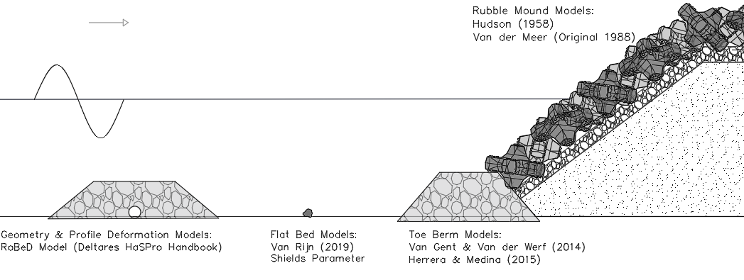
Figure 5.1: Overview of the stability methods positioned on a single cross-section (rubble-mound slope, toe berm, flat-bed rock, rock berm). (W.Pol drawing).

Rubble-mound (breakwater) models
The rubble-mound models size the armour stone on the slope of a breakwater. Hudson (1953/1959) is the oldest and the simplest of them, a single formula fitted to laboratory tests with regular waves. Van der Meer (1988) rewrote it for a real, irregular sea, and added a damage level that the designer can choose and a number of waves for the length of the storm. Separate forms were fitted later for shallow water, where some waves already break before they reach the structure.

These formulas describe a different job from the one a rock berm does. A breakwater is built to stop the wave at the surface. Its armour lies on a slope that crosses the water line, the wave runs up and down that slope and breaks on the stones themselves, and each stone has to stay in place under that direct attack. A rock berm over a cable lies flat on the seabed, below the water. Even where the waves break above it, what reaches the berm is the water motion near the bed, the back-and-forth orbital velocity together with the current, and not a wave front running up a slope. The loading is therefore different in kind and not simply a smaller version of the same thing. That is why these methods are not applied as they stand. They are carried along as a slope-based, wave-only reference, and how their surface wave height is scaled down to the load at the bed, so that they can be held against the methods that work at the bed, is set out in the methodology.

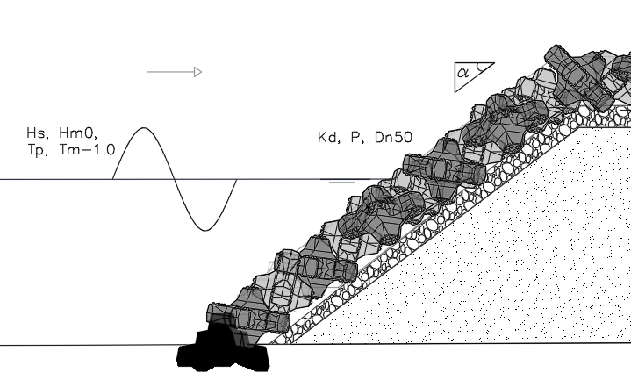
Figure 5.2: Rubble-mound armour slope with the governing inputs of Hudson and Van der Meer (Hs, Hm0, Tp, Tm-1,0, KD, P, Dn50, slope angle α). (W.Pol drawing).

Hudson (1953/1959)
Hudson was derived from regular-wave model tests at the US Waterways Experiment Station and is the classical first estimate for armour stability on a slope (Hudson, 1959; Schiereck and Verhagen, 2019, Ch. 8). It answers one question, how heavy a stone has to be so that a wave running up the slope cannot pull it out, and it does so by balancing the wave force on the stone against its submerged weight through a single stability coefficient KD. In nominal-diameter form it reads

$$D_{n50} = \frac{H_{s}}{Δ {\left(K_{D} cot α\right)}^{1/3}}$$ | (5.1)

so the stone grows in proportion to the wave height and its mass with the cube of it, while a flatter slope and a denser rock both allow a smaller stone. Everything the formula does not model is gathered in KD, which is read from a table and not calculated. It covers the shape of the armour unit, the way it is placed and the amount of damage that is accepted, and Schiereck and Verhagen (2019, p.195) call it a dustbin factor for that reason. For rough, angular natural rock in a double layer it is about 2 when the waves break on the slope and about 4 when they do not (CEM, 2003, part VI, Table 5.22).

The inputs are Hs, KD, Δ and cot α, and the output is the required Dn50. Of these only Hs describes the sea, since the other three follow from the structure and the material once the design is chosen. The wave height is therefore the only quantity through which this formula can be carried over to a berm on the seabed, and how that is done is set out in the methodology. The full list, with the meaning of every symbol and where its value comes from, is given in Appendix B.

Slope armour on a permeable core, non-overtopped, with waves that do not break at the toe. The valid slope range is about 1.5 < cot α < 4 (Schiereck and Verhagen, 2019, p.195), because outside it a slope angle on its own can no longer describe the equilibrium and the predicted stability becomes unrealistic. The formula applies from deep to shallow water but not to very shallow, depth-limited conditions. It carries no wave period, no number of waves, no permeability parameter and no current, so a storm of one hour and a storm of two days return the same stone. For an impermeable core, extra corrections to KD are needed.

The accepted damage is not a variable. It is fixed at roughly five per cent inside the tabulated KD values, and even that five per cent is not clearly defined (Schiereck and Verhagen, 2019, p.196), so the result cannot be moved to another damage level. Because the formula represents a slope and not a bed or a free-standing berm, its use here stays a quick and conservative first estimate.

Van der Meer (1988)
Van der Meer was derived from a large series of random-wave model tests at Delft Hydraulics and extends Hudson to irregular waves (Schiereck and Verhagen, 2019, Ch. 8). It adds the wave period, the number of waves N, and the notional permeability P, and splits the response into a plunging and a surging regime through the Iribarren number. Which of the two forms applies depends on the way the waves break on the slope. Short, steep waves on a gentle slope plunge onto the armour, which gives a low Iribarren number and calls for the first form. Long waves on a steeper slope surge up and down the slope without really breaking, which gives a high Iribarren number and calls for the second. The value of ξm that separates the two is given in Equation 5.5.

$$\frac{H_{s}}{Δ D_{n50}} = 6.2 P^{0.18} {\left(\frac{S_{d}}{\sqrt{N}}\right)}^{0.2} {ξ_{m}}^{-0.5}$$ | (5.2)
$$\frac{H_{s}}{Δ D_{n50}} = 1.0 P^{-0.13} {\left(\frac{S_{d}}{\sqrt{N}}\right)}^{0.2} \sqrt{cot α} {ξ_{m}}^{P}$$ | (5.3)
The damage is explicit through the damage number Sd, the eroded cross-sectional area over the square of the nominal diameter,

$$S_{d} = \frac{A_{e}}{{D_{n50}}^{2}}$$ | (5.4)
with the start of damage at Sd of about 2 to 3 and failure at higher, slope-dependent values of roughly 8 to 17 (Schiereck and Verhagen, 2019). The Iribarren number uses the mean period,

$$ξ_{m} = \frac{tan α}{\sqrt{\frac{H_{s}}{L_{m}}}}$$ | (5.5)
The inputs are Hs, Tm, Δ, cot α, the notional permeability P, the number of waves N and the chosen damage level Sd, and the output is the required Dn50. The full list is given in Appendix B.

Validity. Deep water (h > 3 Hs,toe); slope armour; cot α = 1.5 to 6; notional permeability P = 0.1 to 0.6; N up to 7500 (equilibrium damage); wave steepness som up to about 0.06; Iribarren number roughly 0.7 to 7; relative density Δ about 1 to 2.1; separate plunging and surging branches; waves only, no current. The coefficients are fitted averages with relative standard deviations of 6.5 per cent (plunging) and 8 per cent (surging).

Like Hudson, Van der Meer was developed and validated for a breakwater armour slope, not for a berm on a horizontal or mildly sloping bed, and it contains no current. It is valid in the deeper part of the domain and drops out as the waves approach breaking. Its relevance here is as a wave-only, slope-based reference.

Shallow water: why the Rayleigh assumption fails
Van der Meer (1988) is written in the significant wave height Hs, but most of the damage is done by the highest waves, for instance H2%. The tests behind it were carried out mainly in deep water, where the individual wave heights follow a Rayleigh distribution and the ratio H2%/Hs is fixed at about 1.4, so that factor is built implicitly into the fitted coefficients cpl = 6.2 and cs = 1.0. Two limits mark that range, and both are ratios rather than depths. The water counts as deep for this purpose while the depth at the toe is more than three times the wave height there, h > 3 Hs,toe, so the bottom is not yet clipping the highest waves. It counts as very shallow once the wave at the toe has fallen below about seventy per cent of the deep-water wave, Hs,toe < 0.7 Hs,0, because by then the depth has already taken a large part of the offshore sea state.

In shallow water the highest waves are depth-limited and break first, so the upper tail of the distribution is already broken and it is no longer Rayleigh (Section 3.1.6). The fixed ratio H2%/Hs = 1.4 then no longer holds, and using the deep-water formula in this range designs for a heavier wave than actually reaches the structure, which is safe but oversizes the rock. The short-term wave heights are instead described by the composite Weibull distribution of Battjes and Groenendijk (2000),

$$F(H) = 1 - exp[-{\left(\frac{H}{H_{1}}\right)}^{2}] for H ≤ H_{tr}$$ | (5.6)
$$F(H) = 1 - exp[-{\left(\frac{H}{H_{2}}\right)}^{3.6}] for H ≥ H_{tr}$$ | (5.7)
which is Rayleigh-shaped (exponent 2) up to a transition wave height Htr and Weibull-shaped (exponent 3.6) above it, so the over-predicted tail of the Rayleigh distribution is cut off, while the rest of the range rises slightly because both distributions carry the same Hrms. H1 and H2 are not measurable heights but the scale parameters of the two branches, fixed by the join at Htr and by the root-mean-square wave height. Both Htr = (0.35 + 5.8 tan α) h and Hrms = (0.6725 + 0.2025 Hm0/h) Hm0 follow from the local depth, the slope of the foreshore and the Hm0 of the metocean data, which fixes the distribution and with it H2%. Battjes and Groenendijk (2000) and the Rock Manual (Box 4.4, p. 359) give that last step as a table normalised by Hrms, while the tool used here evaluates the distribution directly.
Figure 5.3: The composite Weibull distribution against the Rayleigh distribution, with the tail above the transition height Htr chopped off (Antonini, lecture notes, TU Delft).

Shallow-water stability formulas
Four formulas extend slope-armour stability into shallow, depth-limited water. Two are shallow-water forms of Van der Meer, and two are of the Van Gent type, which drop the ratio H2%/Hs. Of those two the first also drops the wave period entirely, while the second keeps a weak dependence on it through the wave steepness. All use the same damage number Sd as Van der Meer (1988).

- Rewritten Van der Meer. The first Van der Meer form keeps the ratio H2%/Hs explicit. Pulling the implicit 1.4 out of the deep-water coefficients gives cpl = 6.2 * 1.4 = 8.7 and cs = 1.0 * 1.4 = 1.4, with the Iribarren number ξm on the mean period unchanged,

$$\frac{H_{s}}{Δ D_{n50}} = 8.7 \frac{H_{s}}{H_{2\%}} P^{0.18} {\left(\frac{S_{d}}{\sqrt{N}}\right)}^{0.2} {ξ_{m}}^{-0.5}$$ | (5.8)

$$\frac{H_{s}}{Δ D_{n50}} = 1.4 \frac{H_{s}}{H_{2\%}} P^{-0.13} {\left(\frac{S_{d}}{\sqrt{N}}\right)}^{0.2} \sqrt{cot α} {ξ_{m}}^{P}$$ | (5.9)
In shallow water the actual H2%/Hs is computed from the composite Weibull distribution above rather than taken as 1.4. Using Hs with the original deep-water formula instead is conservative.

- Modified Van der Meer (Van Gent et al., 2004). The Rock Manual gives a second Van der Meer form that recalibrates the coefficients on the original dataset together with new shallow-water data and uses the spectral period Tm-1,0 instead of the mean period,
$$\frac{H_{s}}{Δ D_{n50}} = 8.4 P^{0.18} {\left(\frac{S_{d}}{\sqrt{N}}\right)}^{0.2} \frac{H_{s}}{H_{2\%}} {ξ_{s-1,0}}^{-0.5}$$ | (5.10)

$$\frac{H_{s}}{Δ D_{n50}} = 1.3 P^{-0.13} {\left(\frac{S_{d}}{\sqrt{N}}\right)}^{0.2} \frac{H_{s}}{H_{2\%}} \sqrt{cot α} {ξ_{s-1,0}}^{P}$$ | (5.11)
with cpl = 8.4 (σ = 0.7) and cs = 1.3 (σ = 0.15), valid for 0.25 ≤ Hs0/h ≤ 1.5. These are the two shallow-water Van der Meer forms.

- Van Gent et al. (2003). The Rock Manual also gives a separate formula by Van Gent et al. (2003) for the case where there is no or insufficient information about the wave period. It is independent of the wave period Tm-1,0 and independent of the ratio H2%/Hs, and it accounts for the structure permeability through the ratio of the core to the armour diameter,

$$\frac{H_{s}}{Δ D_{n50}} = 1.75 \sqrt{cot α} \left(1 + \frac{D_{n50,core}}{D_{n50}}\right) {\left(\frac{S_{d}}{\sqrt{N}}\right)}^{0.2}$$ | (5.12)

with a standard deviation σ = 0.10 for rock slopes with a permeable core and σ = 0.12 for an impermeable core; the same expression applies to plunging and surging conditions, valid for 1.25 < h/Hs,toe < 3.

- Modified Van Gent (Scaravaglione et al., 2025). Scaravaglione et al. (2025) proposed the most recent formula, aimed at very and extremely shallow water. It uses the spectral wave height Hm0 instead of Hs, keeps a small dependence on the wave steepness sm-1,0, and remains independent of the ratio H2%/Hs,

$$\frac{H_{m0}}{Δ D_{n50}} = 3.3 \sqrt{cot α} \left(1 + \frac{D_{n50,core}}{D_{n50}}\right) {s_{m-1,0}}^{0.1} {\left(\frac{S_{d}}{\sqrt{N}}\right)}^{0.2}$$ | (5.13)

with a standard deviation σ = 0.36 for rock slopes with a permeable core, valid for 0.4 ≤ Hm0,deep/h ≤ 5.

Boundary conditions and validity. All four are slope-armour, wave-only formulas for depth-limited water. The Van der Meer forms use Sd and the spectral or mean period; the modified Van der Meer is valid for 0.25 ≤ Hs0/h ≤ 1.5. The Van Gent (2003) form is period-independent and ratio-independent, valid for 1.25 < h/Hs,toe < 3, with permeability through Dn50,core/Dn50. The modified Van Gent (Scaravaglione et al., 2025) form extends this to very and extremely shallow water, valid for 0.4 ≤ Hm0,deep/h ≤ 5.

Relevance for a cable berm. Because these forms extend slope-armour stability into the depth-limited range, they remain usable inside the breaker zone and can be placed alongside the toe-berm method of Herrera and Medina (2015) for the same breaking condition. They remain slope-based, wave-only methods.

Toe berm models
The toe berm models size the small rubble berm at the foot of a rubble-mound structure that supports the armour slope. Of all the methods in this chapter these are the closest in form to a free-standing rock berm. The object is the same, a low berm of loose rock lying on the bed, and the load arrives in the same way, as the water motion near the bed rather than as a wave breaking on a slope at the water line. They also use the same damage criterion, the damage number Nod, the number of displaced rocks within a strip as wide as one Dn50.

One difference remains. The toe stands at the foot of an armour slope, so on top of the incoming wave it also takes the run-up and the run-down along that slope. Van Gent and Van der Werf show how much that matters. Replacing the rock armour above the toe with a smooth single layer of cubes raises the damage to the toe by a factor 1.5, which is a factor 1.15 on the required rock size. A cable berm has no slope above it, so that part of the load is missing, and the two methods are considered here with that in mind: Van Gent and Van der Werf (2014) for general depths, and Herrera and Medina (2015) for very shallow water on a steep, breaking foreshore.

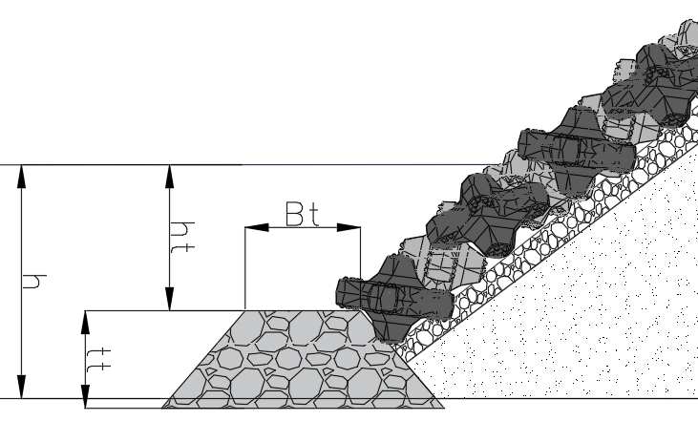
Figure 5.4: Toe berm geometry defining the water depth h, the depth above the toe ht, the berm width Bt and the berm thickness tt. (W.Pol drawing).

Van Gent and Van der Werf (2014)
Background and physics. Van Gent and Van der Werf (2014) derived a toe stability formula from physical model tests with rock toe structures. Rather than the wave height directly, it uses a characteristic near-bed orbital velocity û based on Hs, the spectral period Tm-1,0 and the water depth above the toe ht,

$$û = \frac{π H_{s}}{T_{m-1,0} sinh \left(k h_{t}\right)}$$ | (5.14)
with k = 2π/Lm-1,0 the deep-water wave number at that period, Lm-1,0 = g Tm-1,0² / 2π, as their Equation 1 prescribes. This is the same peak near-bed orbital velocity as in Chapter 3, ub = π Hs / (Tp sinh kh), but evaluated with the spectral period Tm-1,0 in place of the peak period and with the water depth above the toe ht in place of the local depth. Van Gent and Van der Werf fitted the coefficient 0.32 on that definition, so both substitutions have to be kept when the formula is applied.

Damage increases with wave height, wave period, berm width and berm thickness, and decreases with water depth above the toe and with rock size. These influences give a damage formula and its inverse sizing form,
$$N_{od} = 0.032 \left(\frac{t_{t}}{H_{s}}\right) {\left(\frac{B_{t}}{H_{s}}\right)}^{0.3} {\left(\frac{H_{s}}{Δ D_{n50}}\right)}^{3} \left(\frac{û}{\sqrt{g H_{s}}}\right)$$ | (5.15)

$$D_{n50} = 0.32 \frac{H_{s}}{Δ {N_{od}}^{1/3}} {\left(\frac{B_{t}}{H_{s}}\right)}^{0.1} {\left(\frac{t_{t}}{H_{s}}\right)}^{1/3} {\left(\frac{û}{\sqrt{g H_{s}}}\right)}^{1/3}$$ | (5.16)
The inputs are Hs, Tm-1,0, the water depth above the toe ht, the berm width and thickness Bt and tt, Δ and the chosen damage number Nod, and the output is the required Dn50. The full list is given in Appendix B.

Boundary conditions and validity. Armour slopes of 1:1.5 and 1:2 above the toe; toe within 10 to 30 per cent of the water depth in front of the structure (ht/h = 0.10 to 0.30); water depth in front of the toe of 1.2 to 4.5 times the wave height (h/Hs = 1.2 to 4.5); wave steepness sp = 0.015 to 0.04; waves only, no current; non-overtopped; tested on a fixed bed with no toe scour. A roughness factor of about 1.5 is available for smoother armour slopes above the toe.

Limitations for a cable berm. It was developed for a toe that supports a breakwater armour slope, with wave run-down from that slope acting on the toe, so it assumes a slope above the berm that a free-standing cable berm does not have. Its applicability here is indicative rather than direct.

Herrera and Medina (2015)
Background and physics. Herrera and Medina (2015) developed a formula specifically for toe berms in very shallow water on a steep sea bottom (slope m = 1/10) under breaking waves, the situation in which they show that existing formulas, including Van Gent and Van der Werf (2014), do not perform reliably. Their formula (Eq. 12) predicts Nod for a standard berm geometry (Bt = 3 Dn50, tt = 2 Dn50) directly from the deep-water wave conditions and the water depth at the toe,

$$N_{od} = \left(\frac{{\left(H_{s0}·L_{0p}\right)}^{1/2}}{Δ D_{n50}} - 5.5\right) {\left(\left(-0.2 \frac{h_{s}}{D_{n50}} + 1.4\right) exp\left(0.25 \frac{h_{s}}{D_{n50}} - 0.65\right)\right)}^{1/0.15}$$ | (5.17)
with L0p = g Tp² / 2π the deep-water wavelength at the peak period, accompanied by 90 per cent confidence intervals. Following the CIRIA Rock Manual (2007), three damage levels are used: Nod = 0.5 (start of damage), 2.0 (moderate, berm still supporting the armour) and 4.0 (failure).

The inputs are the deep-water wave height Hs0, the deep-water wavelength L0p, the water depth at the toe hs, Δ and a candidate Dn50, and the output is the damage number Nod. The full list is given in Appendix B.

Boundary conditions and validity. Standard berm geometry (Bt = 3 Dn50, tt = 2 Dn50) and slope m = 1/10 only; −0.15 < hs/Hs0 < 1.5 (negative meaning an emerged berm); −0.5 < hs/Dn50 < 5.01; wave steepness 0.02 < s0p < 0.07 for Eq. 12 (the experimental data span 0.008 to 0.08); Nod ≤ 4.0; breaking waves only, no current. The formula returns Nod for a chosen Dn50, so it is used to explore the trade-off rather than to size the rock in one step.

Limitations for a cable berm. The geometry is fixed and only waves are considered. Because it is one of the few methods explicitly validated for breaking waves on a steep bottom, it is directly relevant to the bedrock case in this thesis, in particular where the cable route lies within or close to the wave-breaking zone of Chapter 2.

Flat-bed model (Van Rijn, 2019)
Van Rijn (2019) extends the classical Shields approach of Chapter 4 to bed and berm protection with large rocks, cobbles, boulders and rocks in the range D50 = 0.03 to 3 m, under a current, waves, or both together. Among the methods of this chapter it is the only stability formula for a horizontal or mildly sloping bed that covers combined wave-and-current loading, alongside the rock berm deformation model of Section 5.5, and that makes it the most directly applicable of these formulas to the free-standing rock berm.
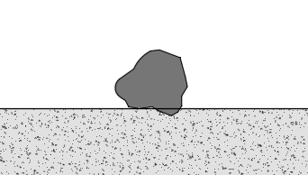
Figure 5.5: Bed protection on a horizontal bed under a current and waves, the situation of the Van Rijn method (Van Rijn, 2019).

Background and physics. The method keeps the Shields form but replaces the fixed threshold by a design threshold, the critical mobility number,

$$θ_{cr} = r · θ_{cr,shields}$$ | (5.18)

with θcr,shields = 0.05 for coarse material and the reduction coefficient r in the range 0.4 to 1.0. The coefficient r sets the accepted degree of movement, so it supports both a static design (no movement) and a dynamic design (some accepted movement), which is directly useful for the objective to avoid overdesign.

Stability criterion and required size. The rock is stable while the acting bed-shear stress stays below the critical value,
$$θ = \frac{τ_{b,cw}}{Δ ρ_{w} g D_{50}} ≤ θ_{cr}$$ | (5.19)

$$D_{50} = \frac{τ_{b,cw}}{Δ ρ_{w} g θ_{cr}}$$ | (5.20)
Van Rijn is written in terms of the sieve diameter D50 rather than the nominal diameter Dn50 used by the slope methods (D50 ≈ 1.2 Dn50). The current- and wave-related bed-shear stresses are added,

$$τ_{b,cw} = τ_{b,c} + τ_{b,w}$$ | (5.21)
each following the quadratic friction law, enhanced by the structure factor γstr,

$$τ_{b,c} = 0.125 ρ_{w} f_{c} {\left(γ_{str} u_{c}\right)}^{2}$$ | (5.22)
$$τ_{b,w} = 0.25 ρ_{w} f_{w} {\left(γ_{str} U_{w}\right)}^{2}$$ |  | (5.23)
The wave contribution uses the near-bed orbital velocity and amplitude from linear wave theory,
$$U_{w} = \frac{π H_{s}}{T_{p} sinh\left(\frac{2π h}{L_{s}}\right)}$$ | (5.24)

$$A_{w} = \left(\frac{0.5 T_{p}}{π}\right) U_{w}$$ | (5.25)
The rough-regime friction factors, and Van Rijn's explicit power-law approximations that allow a closed-form solution, are
$$f_{c} = \frac{0.24}{{[log\left(12h/k_{s}\right)]}^{2}}$$ | (5.26)
$$f_{w} = exp\{-6 + 5.2 {\left(\frac{A_{w}}{k_{s}}\right)}^{-0.19}\}$$ | (5.27)
$$f_{c,a} = 0.11 {\left(\frac{h}{k_{s}}\right)}^{-0.3}, f_{w,a} = 0.1 {\left(\frac{A_{w}}{k_{s}}\right)}^{-0.3}$$ | (5.28)
The inputs are the depth-averaged current uc, the near-bed orbital velocity and excursion Uw and Aw, the water depth h, the bed roughness ks, the turbulence factor γstr and the damage coefficient r, and the output is the required D50. The full list is given in Appendix B.

Boundary conditions and validity. D50 = 0.03 to 3 m; horizontal or mild slope; the power-law approximations of Equation 5.28 checked against the full friction factors for relative roughness h/(α D50) and Aw/(α D50) between 10 and 300; static design via θcr = r · 0.05, dynamic design via the bed-load equation of Cheng (2002); the sizing form shown is the horizontal-bed case, the full formula adds longitudinal and lateral slope factors Kα1, Kα2 (equal to one for a horizontal bed). Field calibration is comparatively sparse for the largest sizes.

Limitations for a cable berm. The structure factor γstr carries a real uncertainty, since a value between one and two changes the shear stress by up to a factor of four (γstr = 1 + n·γ with n = 2 to 3, γ = 0.2 to 0.3). The critical Shields parameter itself scatters between 0.01 and 0.12 in the field data, against 0.02 to 0.06 in the laboratory, so the method is best used with r as an explicit, honestly reported damage choice rather than a single deterministic value. Next to that its only one rock instead of a rock berm.

Rock berm deformation model (Deltares HaSPro/ RoBeD, 2023)
The Deltares HaSPro Handbook (2023) is the newest guideline for offshore scour and cable protection. Of the core sources, it is the only one made especially for rock berms that cover cables. It looks at three things a berm must do. External stability means the berm resists the wave and current loads. Interface stability means the sand under the berm is not washed out through the rock layer. Flexibility means the berm can follow changes in the seabed and edge scour without losing its function (Handbook, Section 5.1).

For external stability the handbook gives a rock berm deformation model, called RoBeD, that predicts how much the berm will deform. It uses four deformation classes, from no deformation (class 0) to full wash-away (class 3). In class 3 the rock moves even on the flat seabed. The main number is the mobility. It is the acting Shields number divided by the critical Shields number (Handbook, Appendix I),

$$MOB = \frac{θ}{θ_{cr}}$$ | (5.29)

The critical Shields number follows from the parameterization of the Shields curve by Soulsby (1997, Eq. A.6, which contains the factor 1.2 on the dimensionless grain size), and the roughness is taken as ks = 2.5 d50. The recommended threshold is MOBthresh = 0.95. A mobility of about 1 corresponds to a Shields number of roughly 0.06, which is why the complete flattening of the profile (class 3) coincides with Shields numbers larger than about 0.06. This ties the RoBeD classes directly to the Shields framework of Chapter 4 and to Van Rijn (Section 5.4).

A berm has a flat top and side slopes, so the mobility is checked at three places, each against the same threshold. On a side slope the rock moves more easily, because gravity already pulls it down the slope, so less load is needed to start the motion. The handbook uses a slope factor for this. It depends on the angle of repose of the rock and the slope angle (Handbook, Eq. 35, Appendix A.7),

$$Ks = sin(φ - α) / sin(φ)$$ | (5.30)

Here φ is the angle of repose of the rock, usually about 40 degrees, and α is the slope angle. The mobility on the slope is the flat-bed mobility divided by this factor. So the mobility on the side slope MOBtop;slope is higher than the mobility on the flat top MOBtop;flat, and both are compared with the mobility of the seabed around the berm, MOBbed;flat. A steeper side slope gives a smaller slope factor, so a higher mobility on the slope. This is why the side of a berm starts to move before the flat top. The classes look like sudden steps, but that is only because one fixed threshold is used to mark a motion that in reality starts slowly. So the class is a simple label put on a gradual process. The four classes follow from which position first exceeds the threshold (Handbook, Section 5.3, Figure 5.4).

Class | Mobility criterion | Behaviour of the berm | Cover on the cable
0 | $$MOBtop;slope ≤ MOBthresh$$ | No movement. The berm keeps its installed trapezoidal shape and no deformation is expected. | Kept, no change
1 | $$MOBtop;slope > MOBthresh$$  $$MOBtop;flat ≤ MOBthresh$$ | The side slopes reshape toward the parabolic equilibrium profile. Lowering of the top is not needed, but regression of the slope can lower the top if the berm is too narrow. | Kept if the berm is wide enough
2 | $$MOBtop;flat > MOBthresh$$ | The flat top also becomes mobile, so a lowering of the top is required to reach a stable profile. | At risk, the crest drops
3 | $$MOBbed;flat > MOBthresh$$  (θ > about 0.06) | Even the surrounding seabed is mobile, so the profile will eventually erode away. | Lost
Table 5.1: The four RoBeD deformation classes, their mobility criterion and what each means for the cover on the cable.

The handbook gives two ways to work with the mobility. The first is a set of fixed mobility-limit tables (Handbook, Section 4.4.1.4, Tables 4.8 to 4.12). These were made for scour protection around monopiles, one table for each pile diameter from 6 to 14 m. In these tables the deformation is scaled by the pile diameter and the Keulegan-Carpenter number, and it is driven by the flow speed-up and the horseshoe vortex around the pile. A rock berm over a cable has no pile and no pile diameter to scale with. So the pile method is not only less exact for a berm, it does not even apply to it.

The second way is the Rock Berm Deformation model (RoBeD, Section 5.3). It was tested against physical model tests in the Delta Flume and the Atlantic Basin. For these tests the handbook advises MOBthresh = 0.95, because that value fitted the rock-berm data best. For a rock berm it is therefore RoBeD, and not the pile tables, that the handbook itself points to.

Next to the classes, the handbook gives a clear way to find the needed Top of Product Cover (TOPC). This is the rock cover that must be installed so that, after the berm reshapes in the design storm, the cover left over the cable is still above the Minimum Top of Cover (MTOC). Rock berms reshape into a parabola shape. The ratio of its bottom width to its height depends on the Shields number (Roulund et al., 2018b, Handbook Eq. 20),

$$\frac{B_{berm}}{h_{berm}} = f(θ) = 6000 θ^{2} + 50 θ + 2.4$$ | (5.31)

In this relation θ is the Shields parameter at the ambient seabed level (Deltares, 2023, Section 5.2.1). The coefficients were fitted to model test data in which θ was determined at the seabed, so the calibration and the input belong at the same level. The position of a rock on the berm itself is not treated through the water depth but through the slope factor, which is why the deformation classes distinguish a rock on the side slope from a rock on the flat crest and from a rock on the surrounding seabed.

Here θ is the combined wave-current Shields number for the design load at the seabed,

$$θ = \frac{τ_{cw}}{\left(ρ_{s} - ρ_{w}\right) g d_{50}}$$ | (5.32)

where τcw is the combined wave-current bed shear stress. The fit of the handbook's Eq. 20 was made only from data with clear deformation. The handbook states that its design equations, Eq. 20 to 26, hold for berms that reshape, so for high Shields numbers. For lower Shields numbers the class check of Section 5.3 gives extra insight.

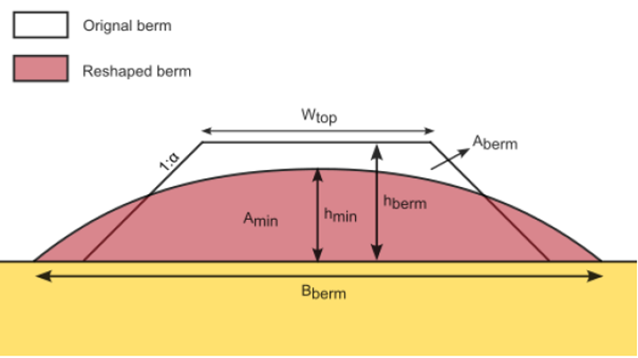
Figure 5.6: Installed trapezoidal berm and reshaped parabolic profile, defining W_TOP, the side slope 1:α, h_berm, h_min, B_berm, A_berm and A_min (Deltares, 2023).

The installed and minimum berm heights relate to the cover requirements through a cable-position offset, denoted Δcable to avoid confusion with the relative density Δ,

$$h_{berm} = TOPC + Δ_{cable}, h_{min} = MTOC + Δ_{cable}$$ | (5.33)

with Δcable = Dcable for a surface-laid cable, or Δcable = ZDOL − ZSBL for a buried or free-spanning cable. The installed trapezoidal area and the minimum reshaped parabolic area are

$$A_{berm} = W_{TOP} h_{berm} + α {h_{berm}}^{2}$$ | (5.34)
$$A_{min} = \frac{2}{3} B_{berm} h_{min}$$ | (5.35)

Setting the installed area equal to the minimum reshaped area gives a quadratic for hberm, of which the maximum root and the relations above yield the installed berm height and the required TOPC (Handbook Eq. 25 and Eq. 26),

$$h_{berm} = 0.5 [\sqrt{{\left(\frac{W_{TOP}}{α}\right)}^{2} + \frac{4}{α} \frac{2}{3} f(θ) {h_{min}}^{2}} - \frac{W_{TOP}}{α}]$$ | (5.36)
$$TOPC = 0.5 [\sqrt{{\left(\frac{W_{TOP}}{α}\right)}^{2} + \frac{4}{α} \frac{2}{3} f(θ) {\left(MTOC + Δ_{cable}\right)}^{2}} - \frac{W_{TOP}}{α}] - Δ_{cable}$$ |  | (5.37)

RoBeD works with waves and current together. The mobility follows the DNV Recommended Practice (DNV-RP-0618, 2022), with one difference that the handbook states itself. It computes the mobility on top of the protection, where the DNV practice computes it at the seabed, because the deformation was found to correlate significantly better with the mobility on top. The combined bed shear stress is found by a vector addition of the current shear τc and the wave shear τw (Handbook, Appendix A.6, Eq. A.31 and A.32). This is different from Van Rijn (Section 5.4), who adds the two in a straight way as τb,cw = τb,c + τb,w. The current shear comes from the depth-averaged current, and the wave shear from the near-bed orbital speed found with linear wave theory. If there is only current, τw = 0 and θ becomes the current Shields number. The angle α in that vector addition is the angle between the waves and the current. The handbook notes that its berm design method is independent of the orientation of the berm with respect to the waves and the current, and that it was derived for the normative case of waves and current perpendicular to one another (Handbook, Section 5.2.4).

The wave part of that shear stress is not the same quantity as the one Van Rijn uses, so it is written out here. The handbook takes a spectral near-bed velocity for a JONSWAP sea rather than the regular-wave peak velocity of Chapter 3 (Deltares, 2023, Eq. A.18 and A.19, after Soulsby, 2006),

$$U_{m} = \sqrt{2}\left(\frac{H_{s}}{4}\right)\sqrt{\frac{g}{h}} exp\left[-{\left(\frac{3.65}{T_{z}}\sqrt{\frac{h}{g}}\right)}^{2.1}\right] with T_{z} = \frac{T_{p}}{1.3}$$ | (5.38)

with Tz the zero-crossing period. The wave friction factor is the piecewise fit of Roulund et al. (2016), which joins the expressions of Dixen et al. (2008), Soulsby (1997) and Fredsoe and Deigaard (1992) into one continuous curve (Eq. A.26),

$$f_{w} = \left\{\begin{aligned}0.32 {\left(\frac{A_{w}}{k_{s}}\right)}^{-0.80} for 0.2 < \frac{A_{w}}{k_{s}} ≤ 2.92 \\ 0.237 {\left(\frac{A_{w}}{k_{s}}\right)}^{-0.52} for 2.92 < \frac{A_{w}}{k_{s}} < 727 \\ 0.04 {\left(\frac{A_{w}}{k_{s}}\right)}^{-0.25} for \frac{A_{w}}{k_{s}} ≥ 727\end{aligned}\right.$$ | (5.39)

in which Aw is the near-bed orbital excursion and ks = 2.5 d50 the Nikuradse roughness of the rock. The excursion and the wave shear stress then follow as (Eq. A.25, A.27 and A.28)

$$A_{w} = \frac{U_{m}T_{p}}{2π} τ_{w} = ρ_{w}{\left(\sqrt{\frac{f_{w}}{2}}U_{m}\right)}^{2}$$ | (5.40)

The factor one half inside the square root belongs with the spectral velocity above. It is not interchangeable with the Van Rijn pair of a peak orbital velocity and a factor one quarter (Equation 5.23, so the two load chains cannot be mixed, and which of the two is used has to follow the method it belongs to.

RoBeD is made for the reshaping case with a stable parabola shape. The mobility uses MOB = θ / θcr, with the critical Shields number from the Soulsby (1997) fit and the roughness ks = 2.5 d50. The method is set for offshore conditions. Above a Shields number of about 0.06 the berm flattens fully, which is the upper limit of the method.
The handbook covers berm shape, interface stability and flexibility together, and it is the only core source made especially for cable-cover berms. So it is the most useful design reference for the stability framework of this thesis, together with Van Rijn (2019) for the stone-size calculation itself.

The inputs are the combined wave-current Shields number, the geometry of the berm through its top width and side slope, the cable position offset and the required cover MTOC, and the angle of repose, and the outputs are the mobility, the deformation class and the installed cover TOPC. The full list is given in Appendix B.

A method considered but not used: Thusyanthan et al. (2013)
Thusyanthan, Jegandan and Robert (2013) is a paper on rock berm stability that is often used in industry, so it is worth stating why it is not used here. There are two reasons, and neither is a criticism of the paper itself. The first is that it presents two existing methods rather than a new one, the Shields framework of Soulsby (1997) and the approach of the CIRIA Rock Manual (2007), and turns them into design charts for practical use. Both of those sources are already used directly in this thesis, Soulsby through the critical Shields parameter of the deformation model in Section 5.5 and the Rock Manual through the coefficients of Section 5.2 and the damage levels of Section 5.3, so the originals are used rather than a secondary presentation of them. The second reason is that both of its methods rest on the threshold of motion. The rock is sized so that the berm does not move at all, and there is no damage parameter that can be scaled, so the design cannot be moved to a controlled amount of movement, which is the basis of this study.

Comparative summary
The methods are set side by side below. The table states the situation each method was made for, the inputs it needs, the quantity it returns, its damage criterion, its boundary conditions and validity, and how it fits a nearshore cable berm. All entries are verified against the cited sources. The applicability indications follow from the methods' own stated validity. The actual method selection and calculations for this thesis are made in the methodology, not here.
Method | Situation it was made for | Required inputs | Output | Damage criterion | Boundary conditions / validity | Fit for cable berm
Hudson (1953/59) | Slope armour, permeable-core breakwater, regular waves | Hs, KD, Δ, cot α | Dn50 / W50 | Implicit fixed (~5%), no scale | Slope armour, non-overtopped, permeable core; KD = 2 breaking / 4 non-breaking (rock); 1.5 < cot α < 4 (Schiereck); deep to shallow but not very shallow; no Tp, N, P or current | Low: first estimate only
Van der Meer (1988/98) | Slope armour, random waves, deep water | Hs, Tm, Δ, Dn50, cot α, P, N, Sd | Dn50 / Ns at chosen Sd | Sd = Ae/Dn50² (start 2-3, failure 8-17) | Deep water (h > 3 Hs,toe); slope armour; cot α = 1.5-6; P = 0.1-0.6; N < 7500; som up to 0.06; ξm ~0.7-7; Δ ~1-2.1; plunging/surging split; no current | Low-med: slope, not berm
Shallow-water slope formulas (rewritten & modified Van der Meer; Van Gent 2003; modified Van Gent / Scaravaglione 2025) | Slope armour, random waves, shallow depth-limited (breaking) | Hs or Hm0, H2%, Tm-1,0, Δ, Dn50, Dn50,core, cot α, P, N, Sd | Dn50 / Ns at chosen Sd | Sd = Ae/Dn50² (as Van der Meer) | Depth-limited breaking foreshore; uses composite Weibull H2% (Battjes-Groenendijk), not Rayleigh 1.4; modified VdM 0.25 <= Hs0/h <= 1.5; Van Gent 2003 1.25 < h/Hs,toe < 3; mod. Van Gent 0.4 <= Hm0,deep/h <= 5; no current | Low-med: usable in breaker zone, still a slope
Van Rijn (2019) | Horizontal / mild-slope bed protection, current +/- waves | uc, Hs, Tp, h, Δ, slope, α(ks), r, γstr | required D50 (+ dynamic via Cheng 2002) | r = 0.4-1.0 -> θcr = r·0.05 (static); Cheng bed-load (dynamic) | D50 = 0.03-3 m; horizontal / mild slope; h/(αD50) and Aw/(αD50) = 10-300; D50 is sieve size (~1.2 Dn50); slope factors Kα1,2 = 1 for flat bed; sparse field data at largest sizes | High: only one with combined wave+current; static and dynamic
Van Gent & Van der Werf (2014) | Toe of breakwater armour slope, waves | Hs, Tm-1,0, ht, Δ, Bt, tt, Dn50, cot α, roughness | Nod or Dn50 | Nod (displaced rocks in a Dn50-wide strip) | ht/h = 0.10-0.30; h/Hs = 1.2-4.5; slopes 1:1.5 and 1:2; sp = 0.015-0.04; waves only; non-overtopped; fixed bed (no toe scour) | Med: berm geometry fits, but assumes armour slope above + down-rush
Herrera & Medina (2015) | Toe berm, very shallow + steep (m = 1/10), breaking | hs, Hs0, L0p (Tp), Δ, Dn50 (std Bt = 3Dn50, tt = 2Dn50) | Nod (Eq. 12) + 90% CI | Nod = 0.5 start, 2.0 moderate, 4.0 failure (CIRIA 2007) | −0.15 < hs/Hs0 < 1.5 (neg. = emerged); −0.5 < hs/Dn50 < 5.01; 0.02 < s0p < 0.07 for Eq. 12 (data span 0.008-0.08); m = 1/10; standard berm; breaking waves only | Med-high for bedrock / steep breaking; fixed geometry, waves only
Deltares HaSPro / RoBeD (2023) | Loose-rock scour protection & cable-cover berms, offshore, current + waves | Shields θ (-> uc, Hs, Tp, h, Δ, D50), WTOP, MTOC, Dcable, side slope | berm geometry (Bberm/hberm, TOPC) + deformation class; external / interface / flexibility | MOBthresh = 0.95 recommended; classes 0-3; wash-away (class 3) at θ > ~0.06 | Reshaping regime; MOB = θ/θcr (App. I); θcr Soulsby Eq. A.6 (incl. 1.2 factor); ks = 2.5 D50; perpendicular wave+current assumed; offshore-calibrated | High: only one explicitly for cable berms + 3 requirements
Table 5.2: The stability methods side by side, with the situation each was made for, its damage criterion and its fitness for a cable berm.

The following table indicates, from the literature, which method suits which situation in this thesis. It is an applicability overview, not the applied method selection of the methodology.
Situation | Primary method | Supporting / check | Why
Bedrock, steep nearshore, breaking waves | Herrera & Medina (2015) | Van Gent (range check); Hudson (first estimate) | Only method for a steep bottom with breaking waves; shows that gentle-slope formulas fail here.
Mobile sand, combined waves + current (crossing / obstacle) | Van Rijn (2019) | Deltares RoBeD (deformation + interface / flexibility) | Only method with genuine wave+current on a bed; Deltares covers winnowing and falling apron on sand.
Cable berm geometry and reshaping / deformation (any) | Deltares RoBeD (2023) | Van Rijn (D50 sizing) | Provides berm geometry and a deformation class rather than only D50.
Quick first sizing / sanity check | Hudson / Van der Meer | — | Classical and fast, but without wave period or current.
Table 5.3: Which method governs in which situation, with the supporting check and the reason.

Extra Stability Checks
The rest of this thesis, and the design tool, size the rock berm itself. This chapter covers the checks around it, how the seabed next to the berm erodes, which is scour, how the sand under the berm can wash out and how the layers stop it, which is winnowing, and how the berm stays stable with anchors and trawl gear. All three are only introductions and is not in the scope of the phyton tool. Each of them needs its own study per project, and for scour a project uses a three-dimensional model to see how the hole grows.

Scour
Chapter 5 checks whether the armour stones stay in place. It does not say how the seabed next to the berm erodes. There are few edge-scour rules for long structures, so this section gives a simple estimate for scour driven by currents, following the plane-jet theory of Schiereck and Verhagen (2019, pp. 82-86). In this thesis this study is used because in the nearshore environment you have often shallow waters, if there is a rock berm in a shallow water it acts like a plane-jet.

The berm as a jet. The berm narrows the water column, so the current speeds up over the crest. From continuity, the crest speed is

$$u_{0} = u \frac{h}{h - h_{berm}}$$ | (6.1)

Here u is the normal current, h the water depth, hberm the berm height, and B = h − hberm the water left above the crest. Past the crest the flow spreads out and slows down with the distance x, like a plane jet:
$$u_{c}(x) = u_{0} \sqrt{\frac{2B}{x}}$$ | (6.2)

Why only currents. Waves move the sand back and forth, so what a crest lifts the trough brings back, and short waves mainly stir the sand up rather than dig a lasting hole. Steady tidal and background currents do dig one, because they carry the sand away for good.

Final scour depth. Erosion stops when the spreading jet drops below the speed the bed can take. From plane-jet lab tests (Schiereck and Verhagen, 2019, Eq. 4.7), the final scour depth is
$$\frac{h_{se}}{2B} = 0.008 {\left(\frac{u_{0}}{u_{*c}}\right)}^{2}$$ | (6.3)

Here hse is the depth below the natural bed, u0 the crest speed, and u*c the critical shear velocity of the bed material (from Shields). The 2B is the mirror height of a jet that runs along the bed.

How fast it forms. A full hole can take days or weeks of storm or tide. The depth grows over time as
$$h_{s}(t) = h_{se} [1 - exp\left(-\frac{t}{T}\right)]$$ | (6.4)

with T the time scale. T comes from the Breusers time scale (Schiereck and Verhagen, 2019, Eq. 4.5):
$$T_{*} = \frac{\sqrt{g Δ {d_{50}}^{3}}}{{(2B)}^{2}} T$$ | (6.5)

Here t is how long the event lasts, Δ the relative density of the bed sand, d50 its median grain size, and B is the water column above the crest of the berm. The value of T* is read from a graph in Schiereck and Verhagen (2019), set by the ratio u0/u*c.

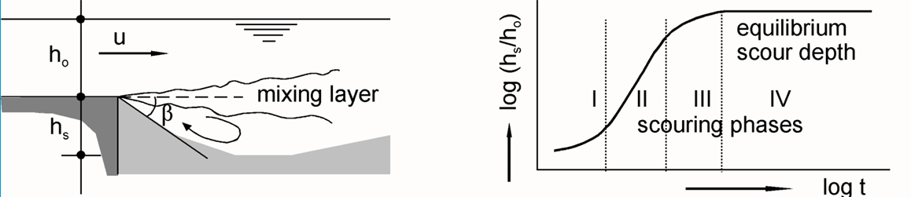
Figure 6.1: The mixing layer above a bed protection and the four scour phases I to IV against time. After Schiereck and Verhagen (2019).$h_{o}uh_{s}βh_{s}/h_{o}$

This plane-jet model is an adaptation to a berm made for this thesis and it has not been validated for that shape. It is used only to flag where scour may reach the edge of the berm, and roughly how fast, and a project confirms it with a three-dimensional model.

Winnowing
Winnowing is the sand under the berm washing up and out through the gaps between the armour rocks. It is driven by the water pressure and by the turbulence near the bed. If the sand or fine grains under the cable wash out, the berm and the cable lose their support and can sink unevenly. This is a different failure than the stone stability of Chapter 5. It is about the interface between the rock berm and the subsoil.

One layer where possible, more where necessary. A single armour layer over the cable is the simplest option, and winnowing is what forces a second one. If the sand can wash out through the armour, a finer filter layer is needed between the armour and the sand, and its grading follows from the filter rules below. The single layer then becomes an armour layer plus one or more underlayers, and interface stability comes into play. A berm can also need an extra layer for a reason that has nothing to do with winnowing, namely that the armour stone is too large to be dropped straight onto the cable. That is an installation limit and it is project bound (Section 1.6).

Two kinds of filter. The interface can be a closed or an open filter (Schiereck and Verhagen, 2019, Ch. 6). A closed filter uses the classic Terzaghi rules: each layer is fine enough to hold back the layer below it. In numbers this is a stability, a permeability, and an internal-stability rule:

$$\frac{d_{15,F}}{d_{85,B}} < 5$$ | (6.6)
$$\frac{d_{15,F}}{d_{15,B}} > 5$$ | (6.7)
$$\frac{d_{60,B}}{d_{10,B}} < 10$$ | (6.8)
F is the coarser filter layer and B the finer base layer. The first rule keeps the base grains in place, the second stops pressure building up at the interface and the third keeps each layer stable in itself. One step of these rules spans only a small size jump, so going from fine sand to coarse armour can take four or five layers.

An open filter (Schiereck and Verhagen, 2019, after de Graauw, 1983) uses coarser stone with bigger gaps. It accepts that a little sand may move, as long as the flow stays below a critical value. It needs fewer, thicker layers and is often cheaper for a berm on sand.

How to size an open filter. The key number is the critical filter velocity, and the sand stays put as long as the flow inside the filter stays below it. That velocity is higher for coarser filter stone and a thicker layer, and lower when the flow is more turbulent (Hoffmans, 2012; Den Adel, 1992). Van de Sande (2012) verified this in flume tests and proposed two adjustments. The relative layer thickness fits the data better when it is related to the median filter size df50 rather than to df15, which otherwise gives unrealistic values for the wide gradings used offshore, and the load damping coefficient of Hoffmans is too high, with values 30 to 60 per cent lower fitting the tests.

How thick the layer must be. Joustra (2013) studied the thickness of open filters. Older rules give about two to three times the median stone size df50 in steady, even flow (De Graauw et al., 1983; Klein Breteler, 1989; Bakker et al., 1994). Turbulence raises the load damping coefficient of the formula. Joustra (2013) finds about 0.86 in uniform flow and estimates 1.2 to 2.5 for flows with sill-induced turbulence, while noting that the data behind that range are scarce. Van Rijn (2024) gives general guidance for such underlayers.

Rule of thumb for a rock berm. For rock berms the Deltares handbook (2023) says winnowing is less of a problem than around a monopile, because there is no pile to speed up the flow. About four to five stone layers usually stop it (Verheij et al., 2012). Some sinking of the berm into the bed can even help.

One more risk is liquefaction. On silty or fine sandy beds a berm that is stable under large waves can still fail if the soil beneath it liquefies (Sumer et al., 2011). The liquefied soil moves with the waves and drags the stones with it, so the berm sinks into the bed. Stability is then set by a mobility number built on the density of the liquefied soil, against the Keulegan-Carpenter number (their Fig. 14). It is a separate check, only on beds that can liquefy.

What | Rule | Source
Filter stability | d15,F / d85,B < 5 | Schiereck & Verhagen (2019), Eq. 6.1
Filter permeability | d15,F / d15,B > 5 | Schiereck & Verhagen (2019), Eq. 6.1
Internal stability | d60,B / d10,B < 10 | Schiereck & Verhagen (2019), Eq. 6.1
Open filter | stable while flow uf < critical filter velocity uf,c | Hoffmans (2012); Van de Sande (2012)
Open-filter thickness | about 2 to 3 x df50 in uniform flow; thicker where the flow is turbulent | Joustra (2013); de Graauw et al. (1983)
Berm filter thickness | about 4 to 5 stone layers | Deltares (2023); Verheij et al. (2012)
Liquefaction | mobility number (with ρliq) vs KC number | Sumer et al. (2011)
Largest droppable stone | installation limit for adding an underlayer | NKT guidance, depends on what type of powercable.
Table 6.1: Rules of thumb for filter stability, winnowing and liquefaction, with their sources.

The number of layers, the stone sizes and the largest stone that can be dropped safely on the cable are fixed per project.

Anchor and Trawling Protection
A berm may also have to take hits from bottom-trawl gear and dragging anchors. These are not computed in the main tool, because designing for them by default would make the berm far larger than the hydraulic stability asks for, which is the opposite of the aim of this thesis. They are treated as extra conditions, checked per project, because the risk depends really where the cable route is:
- High-risk zones: shipping lanes, anchorages, and busy fishing grounds, where heavy gear hits often.
- Low-risk zones: deeper or restricted waters with little human activity, where the loads of Chapter 5 govern the design.
- Trawl gear: guidance (Van Kessel and Stam, 2010; CIRIA, 2007) shows that about 0.50 m of rock cover over the cable is usually enough. The sloped berm deflects dragging trawl boards (500 to 2000 kg), so they dig in less than about 0.30 m.
- Dragging anchors: to force a 3-tonne stockless anchor to break out and come loose you need a large berm, with a bottom width of about 15 m (Van Kessel and Stam, 2010).

Building a berm that stops a large anchor therefore gives a very large structure. Each project makes a Cable Burial Risk Assessment (CBRA) instead, and where the anchor risk is high the common practice is to route the cable around the danger area rather than to over-build the rock. This keeps anchors and trawling as conditions on the route and on the minimum cover, and not as loads in the tool.

Part B – Methodology

Methodology

Introduction
A rock berm over a subsea cable is not designed with one equation or calculation. The route is mostly kilometers long and the conditions change a lot along it. The subsoil changes, the water depth changes, and the waves and the current change. The methods in Chapters 4 and 5 were each made for a different structure and a different situation, and they describe damage in different ways. For that reason the tool does not use one formula for the whole route. It analyses every point, chooses the methods that fit that point, sizes the rock, and then shapes a berm that keeps enough cover on the cable after a storm.

The tool answers two questions. The first question is how big the stone must be to stay stable under the load from the waves and currents. The second question is what shape the berm must have so the cover on the cable is still there after the berm has reshaped in a storm. There is chosen for two different branches. Branch A gives the stone size by all rubble mound equations. Branch B gives first the recommended rock size and then the berm shape and checks how much it deforms. Keeping them apart makes the design clear. Branch A gives only an indicative stone size, and Branch B then sizes its own stone from the accepted deformation before it builds the berm.

Branch A and Branch B are shown in Figure 7.1 and Figure 7.2. Branch A classifies each point, picks the methods that apply, checks each one against its valid range, and gives one governing stone size with the other methods next to it for comparison. Branch B sizes its own stone from the accepted deformation, builds the berm with the RoBeD model, and gives the deformation class of every point along the route. The Branch A stone is reported next to it, and where the Van Rijn size of Branch A is the larger of the two it is the size that is carried forward. In Branch B the route stone is proposed by the tool itself, and a grading can also be entered by hand so that the tool reports what that rock does at every point.

The two branches do not carry the same weight. Most methods in Branch A were made for breakwaters and their toes, not for a low, free berm on the open bed. Their results are therefore only used as a comparison, and whether they can be used for a berm is checked in the results chapter. RoBeD, used in Branch B, is the only reviewed model made for a rock berm that reshapes, so it carries the design. This chapter first sets the shared inputs and the load at the bed (Section 7.3), then describes Branch A (Section 7.4) and Branch B (Section 7.5), and ends with the sensitivity analysis, the three case study and the limitations.
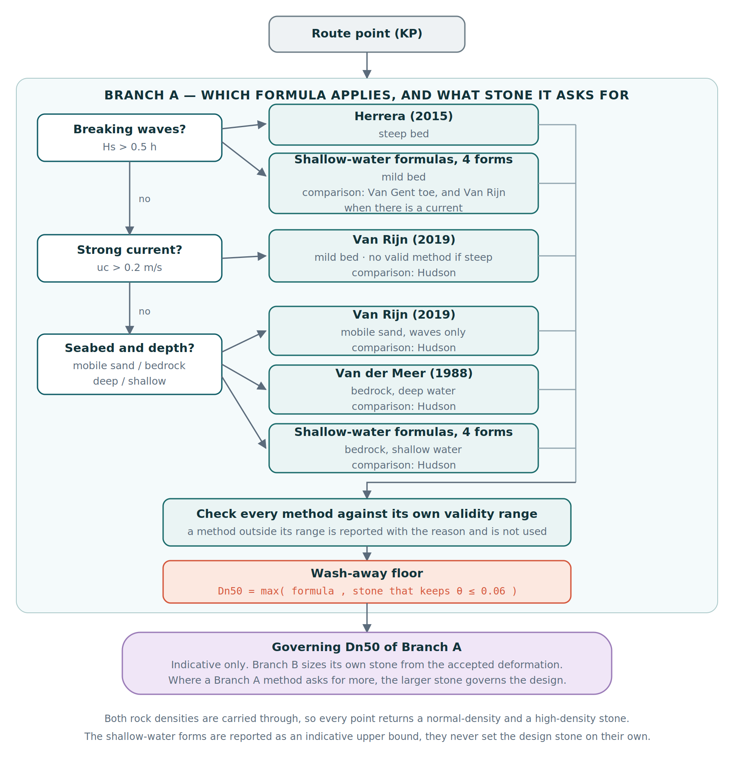
Figure 7.1: Flow chart of Branch A, from the route data to the governing stone size.
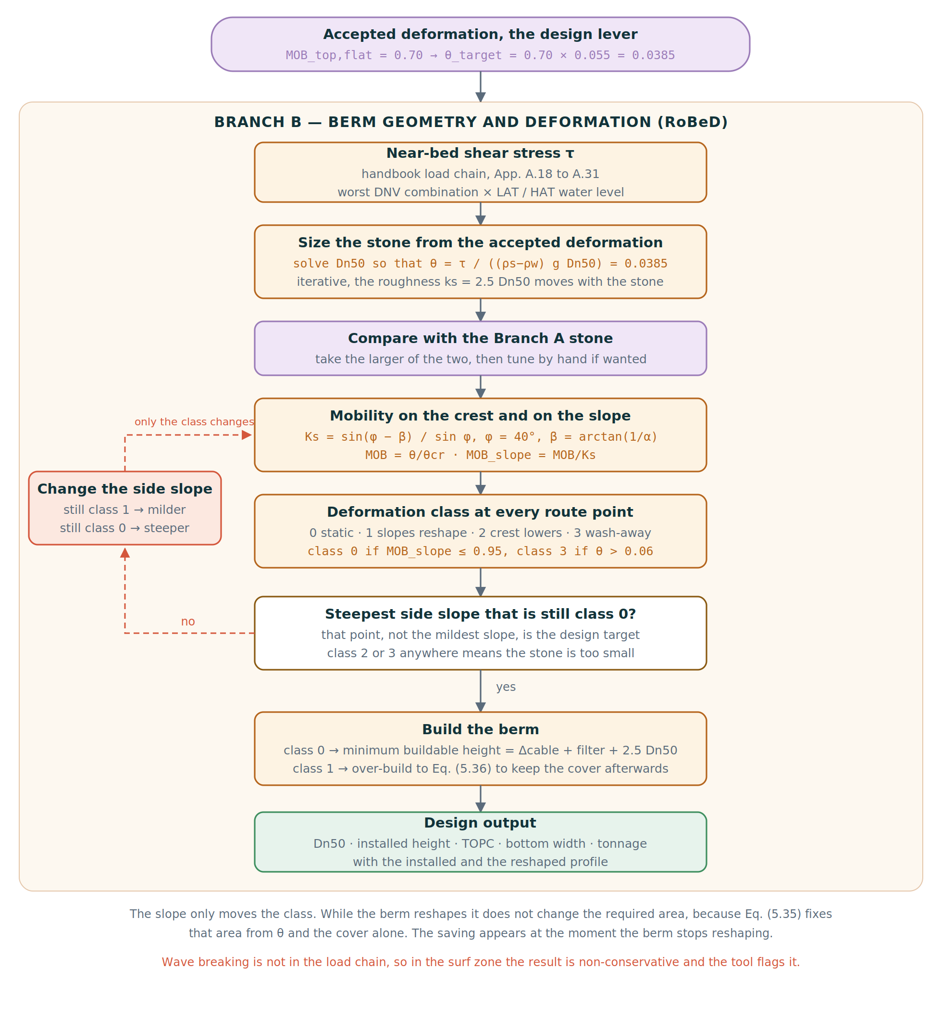
Figure 7.2: Flow chart of Branch B, from the stone size to the berm geometry and the deformation class.

Scope
The tool checks only the stability of the rock berm, and within the berm only the armour layer. It sizes this armour rock against the wave and current loading. All other design checks are done per project and are not part of the tool. The user can set a minimum cover, the amount of rock that must always stay above the cable, and the tool keeps to this in every design.

The tool does not calculate any erosion of the seabed. Winnowing, scour and damage from anchors or trawling are outside the calculations and are checked separately per project. Waves are the main load and come from the route data. The current and the combined wave and current case are set out in the shared load basis in Section 7.3.3.

Design framework and computational approach
The tool designs a whole route at once, not a single spot. The route comes in as a list of points, KP’s (Kilometer points), and every point is run through the same calculation, so the results can be compared along the cable rote and the design can be built from the point that turns out to be critical. The inputs come from two places, kept apart on purpose. Section 7.3.1 holds the route data itself: the sea and seabed conditions at each point, such as the water depths, the design waves and currents, the seabed slope and type. This is supplied data, not something the designer picks. The design choices sit separately in Section 7.3.2, where things like the rock density, the berm side slope and the accepted deformation are set.

Every point is worked out in two steps, which are the two branches of the code. Branch A sizes the stone, working out how large the rock has to be under the local load with the methods from the literature, and is described in Section 7.4. Branch B then designs the berm: it picks the stone from the accepted deformation and shows how the berm reshapes under the storm. Branch B is simply the RoBeD deformation model, and is described in Section 7.5.

Both branches take their load from the same starting point, which is set up once as a shared basis (Section 7.3.3): the sea conditions of Chapter 3 brought down to the bed, and combined following the DNV pairs of Section 3.4, the worse of the ten-year wave with the hundred-year current and the hundred-year wave with the ten-year current. Each branch then builds the exact bed load in its own way.

The sizing methods are the ones reviewed in Chapter 5. Only the flat-bed Van Rijn model (Section 5.4) was made for loose rock on a bed and comes closest to a free berm; the breakwater-armour models (Section 5.2) were built for a different job and size the rock too large. For that reason the whole of Branch A is kept as an indicative check, and the design itself comes from the RoBeD deformation model (Section 5.5) in Branch B, the only model made for a berm that reshapes. The extra failure mechanisms from Chapter 6, scour, winnowing and damage from anchors or trawling, stay outside the tool and are checked per project, as set out in Section 7.2.

One more piece sits in the framework rather than in a single branch: the angle between the waves and the current. RoBeD, in Branch B, already uses this angle in its own load combination (Section 7.5.1), so the design is not angle-free to begin with. What Section 7.3.4 studies, as an optimisation, is a second version of the tool that also brings the angle into the shared load basis, so it reaches Branch A as well and both branches feel the current from its real direction.

Route input data
The tool reads a data file with one row per route point (KP). The columns are:
- SR and SP: the seabed slope in two directions, in degrees. The tool uses the steepest of the two.
- ST: the seabed type, the soil at that point.
- WL: the water depth at the point.
- DOC: the required cover on the cable, the depth of cover.
- WHS10 and Tp10: the significant wave height and the peak period for the 10-year return period.
- WHS100 and Tp100: the same two values for the 100-year return period.
- CU10 and CU100: the current velocity for the 10-year and the 100-year return period. The route data give this velocity at one metre above the bed, which is the standard datum of the survey, while both Van Rijn (Equation 5.22 and the handbook (Eq. A.10) are written in the depth-averaged velocity. Section 3.2 sets out how the two are related and Section 7.8 states which value the analysis uses.
- Angle between current and waves (optimisation): the angle from the wave and current roses. This is used only in the second version of the tool (Section 7.3.4).

The seabed columns (SR, SP, ST, WL, DOC) come from the survey department, and the wave and current columns (WHS, Tp, CU) come from the metocean department. The angle between the current and the waves also comes from the metocean roses.

For this study the route did not have enough points. A set of representative points was therefore made to show the full process on a realistic route. The point that has real data was set as the most critical point, so the governing design uses a real point while the made points show how the design changes along the route. This is stated openly and comes back in the case study and the limitations.

Column | Meaning | Unit | Source
point_ID | Route point identifier (KP) | - | route
SR, SP | Seabed slope in two directions, the steepest is used | deg | survey
ST | Seabed type, the soil at that point | - | survey
WL | Water depth at the point | m | metocean
DOC | Required cover on the cable | m | client
WHS10, WHS100 | Significant wave height, 10-year and 100-year | m | metocean
Tp10, Tp100 | Peak wave period, 10-year and 100-year | s | metocean
CU10, CU100 | Current velocity, 10-year and 100-year | m/s | metocean
Angle | Angle between waves and current | deg | metocean
Hs0 (optional) | Offshore wave height, used when needed near breaking | m | metocean
LAT, HAT (optional) | Water depth at low and high astronomical tide | m | metocean
Table 7.1: Columns of the route data file that the tool reads, with their unit and source.

Design inputs in the tool
Next to the data file, the engineer sets the design inputs in the tool. These are design choices and not route data:
- Rock density: a normal density of about 2650 kg/m3 and a high density of about 3000 kg/m3. Every result is made for both.
- Berm geometry: the side slope, the top width and the cable diameter.
- Accepted damage per method: Van Rijn r, Van der Meer Sd, and the Van Gent and Herrera Nod.
- Accepted RoBeD deformation: the accepted mobility on the flat top of the berm.
- Load factors: the turbulence factor γstr and the current threshold$γ_{str}$.
- Client limits: the required cover MTOC when it is set as one value instead of per point, and limits on the cover and the berm width.
- Water levels: the low and high water level (LAT and HAT), either per point in the file or as an offset set here.
In the tool these inputs are grouped as general inputs, Branch A inputs and Branch B inputs, so it is clear which input belongs to which branch.

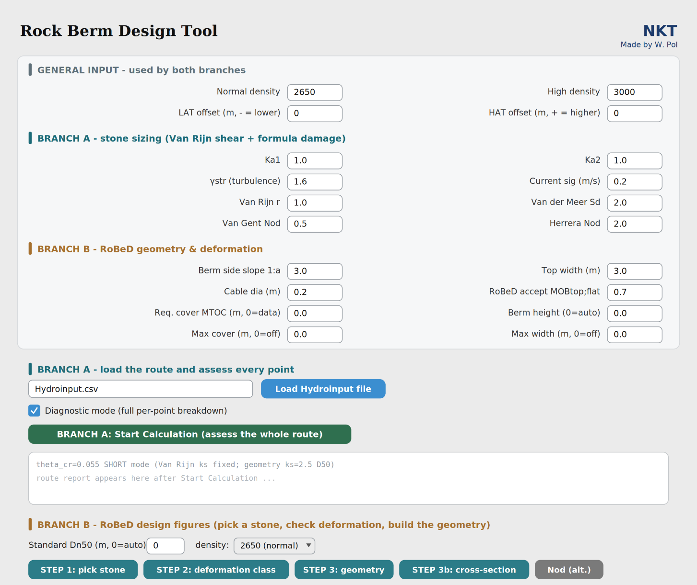
Figure 7.3: The graphical user interface of the tool.

Shared load basis
Both branches need the load at the bed. The tool brings the surface wave down to the bed through the near-bed velocity, so the effect of the depth is already in it (Chapter 3). The load follows the DNV combinations, and the worse of the two pairs is used, the 10-year wave with the 100-year current and the 100-year wave with the 10-year current. On most routes this is the 100-year wave. Each point is checked at both LAT and HAT, and the water level with the largest bed shear is taken. This is usually LAT, but the tool checks both instead of assuming it.

The two branches do not use the same load chain, and this is on purpose. Branch A has no single chain, because every method it runs carries the load it was fitted with, and only Van Rijn works from a bed shear stress. Branch B follows the Deltares handbook from start to finish, including the Soulsby combination that also uses the angle between the waves and the current. Each branch is kept on its own source, so no method is fed a load it was never calibrated on. The chains themselves are written out in Chapter 5 and per project in Appendix C. Because the tool checks every point, it also finds the most critical point of the route by itself, the point that needs the largest stone, and that point is taken as the design so the whole route is covered.

Wave-current interaction angle (optimisation)
The way the wave and the current combine at the bed depends on the angle between them. RoBeD, in Branch B, already builds this angle into its own combination (Section 7.5.1), so the leading design is not angle-free to begin with.

A second version of the tool combines the two in the other way set out in Section 3.3, adding the wave and the current as shear velocities before they are squared instead of as stresses. Both versions use the real angle f, so the only difference is how the two are combined. This second version is kept as a clearly marked step on top of the RoBeD design, applied after it has been benchmarked against the reference cases (Section 7.7), so it can be seen whether the design comes even closer to those reference projects and whether the tool becomes more accurate. How much it changes the design is shown in the results chapter.

Branch A: Rock sizing
Branch A answers the first question, how big the rock must be. It sizes the smallest stable stone at every route point and gives all the values what where calculated by a method what is valid, which is kept as an indication next to the Branch B design. The steps below follow the Branch A figure (Figure 7.1). The most important is that the branch only calculate with the methods that are valid in a specific point a long the cable route.

Classification and the decision tree
Branch A first reads every route point and calculates the first general equations before any stone is sized. The tool makes four checks at each point: is the seabed in scope, how far the point sits into depth-limited conditions, is the bed steep or mild, and is there a strong current.

The result of the checks goes into a decision tree, which picks the methods that fit that point. A tree is used instead of one formula, because the methods were each made for a different situation, so not every method is valid at every point. The tree keeps each method inside the situation it was made for. It also checks each chosen method against its own valid range. If a point falls outside all ranges, it is marked out of scope with the reason, instead of giving a number that cannot be trusted.

Order of the tree (Figure 7.1). If the point is classified as depth-limited, a steep bed uses Herrera and a mild bed uses the shallow-water formulas, with the Van Gent toe method next to them for comparison, and Van Rijn as well when there is a current. If it is not and there is a strong current, Van Rijn is used. If there is no strong current, the seabed and the depth decide: mobile sand uses Van Rijn, bedrock in deeper water uses Van der Meer, and bedrock in shallow water uses the shallow-water formulas. Hudson runs next to all the non-breaking branches as an indicative check only. For each situation the tree gives one governing method and reports the other methods next to it for comparison, not as the design value.

Different type of methods, same Branch
The methods in Branch A do not all describe the same object. Only the flat-bed method of Van Rijn (2019) was made for loose rock on a bed under waves and current, which is the closest to a free berm, so Van Rijn is the native method for the berm. The other methods were made for other structures. Hudson and Van der Meer are for the armour of a breakwater slope, Van Gent and Herrera are for the toe at the foot of such a slope, and the shallow-water formulas are for wave-exposed emergent slopes.

The tree still lets each method govern in the situation it fits best, because in its own range each is the best option available. So on many points the governing value still comes from a method that was made for another structure. For that reason the whole of Branch A is treated as indicative and not as the final design. The native method and the transferred methods are kept apart, and whether the transferred values can be used for a berm is not decided here but is checked against the case studies in the results chapter. The comparison methods are always shown next to the governing value so this check can be made.

Fitting the formulas to the rock berm
The methods that Branch A applies were written for other structures, so the load they act on has to be brought to the berm on the bed before their results can be compared. Section 5.2 announces that step for the rubble-mound formulas and Chapter 3 derives the quantities it needs. This section states which adjustment is made and with which value. It does not repeat the derivations.

Turbulence factor. Van Rijn adds the extra bed turbulence around a structure with the factor γstr, which multiplies the near-bed velocities in the current and wave shear stresses (Equations 5.22 and 5.23). It is not a fixed value. Section 4.5 writes it as γstr = 1 + nγ (Equation 4.9, with n between 2 and 3 and γ between 0.2 and 0.3, so it grows with the local turbulence and lies between 1 and 2, larger where a structure, a current or wave breaking is present and smaller on a calm flat bed. One value is used for the whole route, γstr = 1.6, and it acts in this sizing step only, so the current turbulence is not counted a second time further on. Giving the nearshore a value of its own, lower in the shoaling zone and higher near the breaker line, would be the better approach, because the berm height stays the same while the water column over it becomes much smaller. That is not done here, for the reason Section 4.5 already gives. Fixing the factor for a given berm needs a three-dimensional flow model of the berm at its own height and in its own water depth, which is outside the scope of this thesis. What the single value costs is taken up in Section 9.2.

Damage and turbulence are set together. The Van Rijn damage coefficient is left at r = 1.0 (Table 7.4), the permissive end of the range of Equation 4.8, while γstr sits at the conservative end of its own. Because the required stone grows with the square of γstr and falls with 1/r, this pair gives almost the same stone as the conservative pair γstr = 1.0 with r = 0.4. The two therefore have to be read together, since either one on its own gives a misleading picture of how safe the sizing is.

Roughness without a loop. The friction factors of Equations 5.26 to 5.28 need the bed roughness ks = α D50, with α between 1.5 and 2 (Appendix B), but D50 is the value being solved. Section 3.2.3 and Section 4.3 already name this, since the roughness of the bed is the armour itself, so the stone does not only resist the load but also raises it. Left like that the size can only be found by iteration, and the result then depends as much on the assumed roughness as on the design condition. The sizing therefore evaluates the shear once, on a fixed reference stone of D50 = 0.5 m, so that the load belongs to the design condition and not to the answer. What that reference is worth is reported with the results.

Sieve to nominal. Section 4.3 keeps the two diameters apart and Section 5.1 states which method is written in which. Van Rijn is the one method here written in the sieve diameter D50, about 1.2 times the nominal Dn50, so its result is converted back to Dn50 before it enters the comparison. Every rock size reported in this thesis is a nominal diameter unless it is labelled as a sieve size.

Near-bed wave load. Section 3.1.5 already sets out which methods need a correction to the bed and which do not, so this paragraph only records what the tool does with it. Van Rijn and the two toe methods carry the depth in their own near-bed velocity through the term 1/sinh(kh) (Equations 3.4 and 3.5), so their wave input is left untouched, and reducing it again would count the depth twice. The shallow-water forms and Herrera and Medina keep the wave height they were calibrated on. Hudson is the only method with no depth term at all. It takes the surface Hs as it stands, which is far too heavy for a low berm lying on the bed, so it is applied with the effective near-bed wave height of Equation 3.10, the surface Hs scaled down by the dynamic-pressure response factor at the bed. This is not a new rule introduced here. It is the linear wave theory of Section 3.1.5 applied to the one method that does not carry it, and Chapter 3 points forward to this section for the choice. Hudson stays an indicative comparison either way, because it remains a slope-armour formula used on a bed berm.

Governing stone, wash-away floor and density
Once the tree has run the methods, Branch A has a stone size for every method that applies at the point. The whole step is carried out twice, once for the normal rock of 2650 kg/m³ and once for the dense rock of 3000 kg/m³, because a denser stone can be smaller under the same load (Equation 4.7.

Every one of those sizes is then given a lower bound, the wash-away floor. It is a plain Shields criterion (Equation 4.6. The stone has to be large enough for the acting Shields number of Equation 4.5 to stay below θ = 0.06, which sits just above the constant critical value of about 0.055 that Figure 4.3 gives for coarse rock, and which is the level at which Section 5.5 places the complete flattening of the profile. The size carried forward is the larger of the formula value and this floor (Figure 7.1), so it can never come out so small that the whole berm would be carried away. The floor is solved with the same load model as the deformation assessment, but on the fixed reference roughness of Section 7.4.3, because at that stage the stone is again the unknown.

One point about the shallow classification has to be clear. At the points the tree classifies as shallow, the size carried forward does not come from the shallow-water forms. Those forms were calibrated on emergent wave-exposed slopes and over-predict for a berm lying on the bed, so at those points they are reported side by side as an indicative upper bound, while the size that goes on is the one that meets the accepted deformation of Section 7.5.3. Branch A therefore reports a stone at those points that follows from the accepted damage and not from a slope formula. This is a deliberate choice and not a formula result, and the tool reports for every point which of the two governs.

Output and diagnostics
Branch A gives two kinds of output. The short report gives, per point, the governing stone size for both densities, the method it came from and why, the other methods next to it for comparison, and any warning, such as a point that is out of scope or an input that sits outside a method's range. The diagnostic mode gives the full breakdown per point, with every step and every intermediate value, so that a result can be traced and checked.

A result is never presented as cleaner than it is. Where a method is applied outside its range the size is still printed, with the reason underneath, so the reader can see what was stretched. Where a formula cannot be evaluated at all its line carries the reason instead of a number. And where no Branch A formula is valid, which is the case in the breaker zone, the report says so and points to where the stone does come from, rather than recommending a formula anyway.

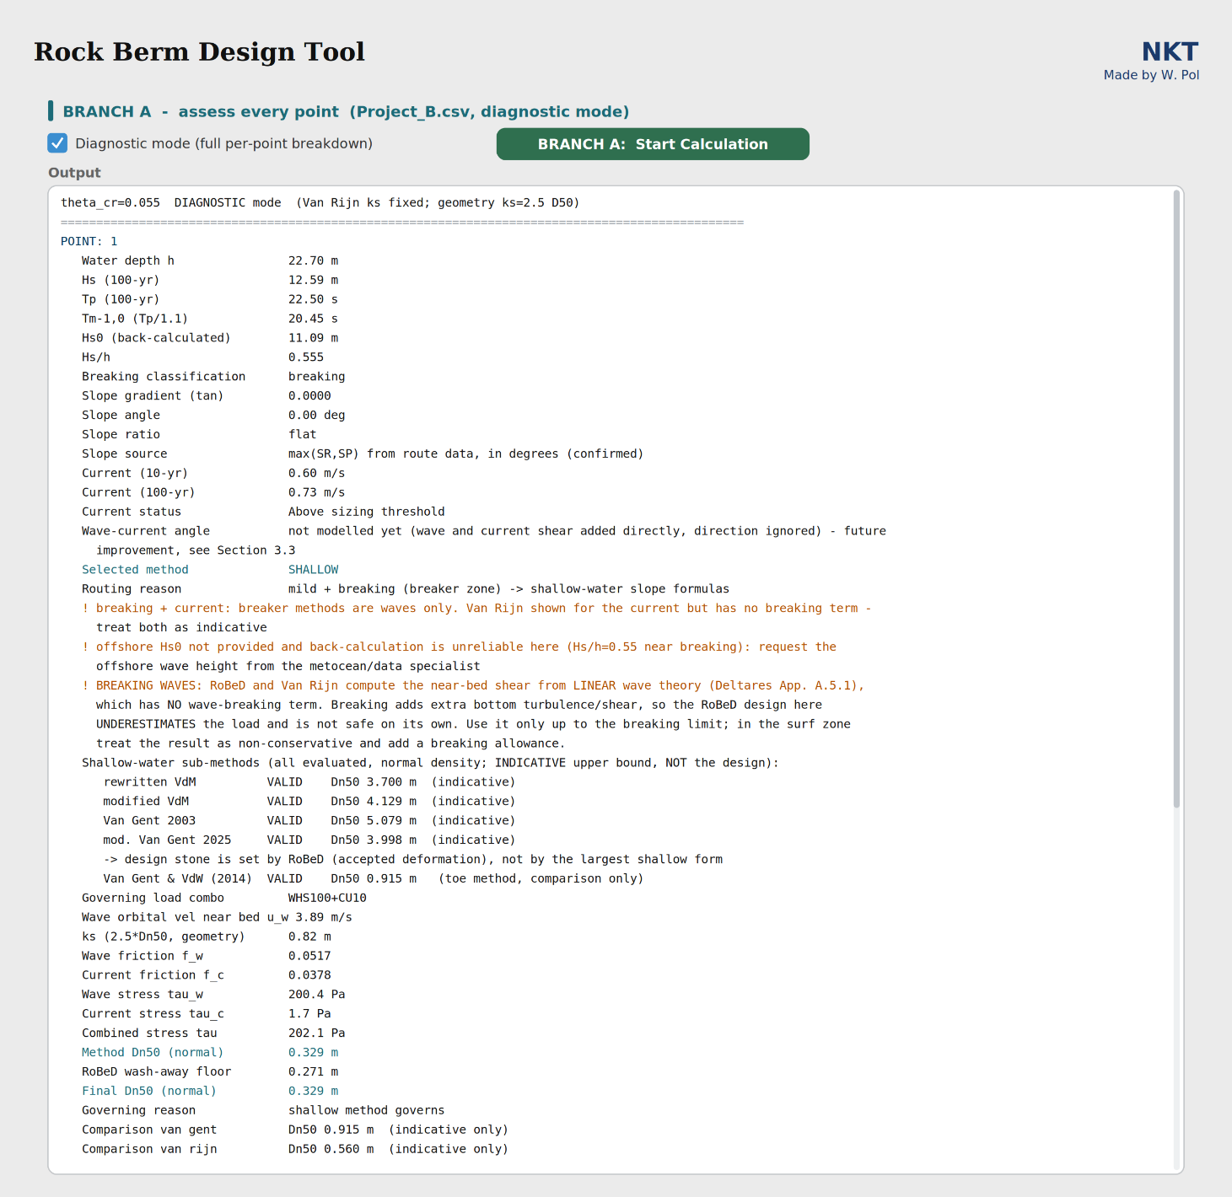
Figure 7.4: Example of the Branch A output for a single route point.

Branch B: berm geometry and deformation (RoBeD)
Branch B is a method in its own right and it does not need Branch A to work. It is the most fully developed part of this thesis, because it is the only reviewed method that was made for the object this study is about, a free-standing rock berm that is allowed to move. Section 4.4 sets the accepted failure mode as reshaping without losing the cover, and Chapter 5 shows that no other reviewed method can express that. The rubble-mound and toe formulas of Sections 5.2 and 5.3 write damage as Sd or Nod on a slope, Van Rijn (Section 5.4) sizes a stone on a flat bed against a threshold, and the one other rock berm method reviewed, Thusyanthan et al. (Section 5.6), rests on the threshold of motion with no damage parameter that can be turned. The steps below follow the Branch B flow chart (Figure 7.2).

The stone comes first, the geometry follows. Branch B starts by asking at which stone size and which rock density the stone is already stable enough under the local load, so it is sized before any berm is drawn. The target is the accepted mobility on the flat top of the berm, MOBtop;flat, with the acting Shields number of Equation 5.32 and the critical value of Section 5.5. Once that stone is known the geometry is built around it with Equations 5.33 to 5.37, and the berm is not built at the minimum height but higher, so that the cover on the cable is still there after the berm has reshaped. The over-build follows the Shields number through f(θ) of Equation 5.31, so a smaller stone gives a higher installed berm.

The side slope is where the design choice meets the physics. The user is free to set the cover, the crest width and the side slope, but those are not free numbers. A stone on a slope is less stable than the same stone on the flat top, because gravity already pulls it downward, and the handbook writes this as the slope factor Ks of Equation 5.30 with MOBtop;slope = MOBtop;flat / Ks. A steeper slope gives a smaller Ks and a higher mobility, so the same stone under the same load can end up in a different deformation class purely because of a geometry choice. The tool therefore reports the mobility on the flat top and on the slope side by side with the class that follows from them (Table 5.1). This is the point of the branch. A geometry decision is not a drawing choice, it is a stability choice, and the tool makes that visible rather than absorbing it in a margin.

The formulas are kept as they were published. The deformation model was calibrated offshore, on the Delta Flume and Atlantic Basin tests of Section 5.5, and the routes of this study are nearshore. The load chain itself carries over without trouble, because it works from the near-bed orbital velocity and converts it to a bed shear stress, and a shallower depth simply makes that velocity larger. What does not carry over automatically is the empirical part, the spectral velocity of Equation 5.38, the reshaping curve f(θ) of Equation 5.31 and the mobility threshold that was fitted on those tests. Changing them here would mean rewriting a calibrated model before knowing whether it needs rewriting. The choice made is therefore to implement the method as published, to make it usable, and to flag every point where an input leaves the calibration range of the model rather than to silently correct it. Whether the method actually fits the nearshore is a question for the results, where it is held against the benchmark projects. Only once that comparison is made does adjusting the formulas become a defensible step, and that is described as a process rather than done here.

Shear, Shields number and deformation class
This branch is built to be used and not only to be run once, so the steps follow the order a design engineer would work in. There are three here. The fourth, the cover left after reshaping, follows in Section 7.5.2.

Step 1, the load at the seabed. The waves and the current are both turned into a bed shear stress, the wave part along Equations 5.38 to 5.40 and the current part from the flow speed over that same rough bed, and the two are added as stresses with the angle between them carried through (Deltares, 2023, Appendix A.6, after Soulsby, 1997). The angle is read from the wave and current roses, and where the route data do not give it the worst case is used, waves and current in line. The step returns one number per point, the shear stress the seabed feels.

Step 2, one stone. Before a berm is drawn the tool asks what a single stone on that bed can take. The shear stress of step 1 with the stone size gives the Shields number of Equation 5.32, and against the critical value that becomes the mobility of Equation 5.29. The size is searched for rather than calculated, because a larger stone is also a rougher bed and raises its own load. The search runs for both rock densities.

What it aims at is a mobility of 0.7 on the flat top. That number is a choice of this study and not one taken from the handbook, but its reasoning comes from the model. The handbook puts its threshold at 0.95 and advises staying below a relative mobility of one at the top (Section 5.5). A flat-top mobility of 0.7 sits inside deformation class 1 at normal construction slopes, so the side slopes reshape while the top is held, and it keeps margin below the 0.95 at which the top begins to lower. That margin is deliberate, because the threshold was fitted offshore while these routes are nearshore. It is a starting point and an input, and Section 7.5.3 sets out what changing it means. What it does not do is move the yardstick. The threshold stays at 0.95 and the classes keep their definitions, so only where a design sits on that scale changes.

Step 3, from one stone to a berm. The stone of step 2 sits on a flat bed and a berm is not flat. The cover, the crest width and the side slope are entered by the user, because they follow from the project and from what the installation vessel can place. For whatever geometry is entered, the tool checks the mobility on the flat top, on the side slope and on the seabed beside the berm, using the slope factor of Equation 5.30, and the first to pass the threshold sets the deformation class (Table 5.1). The aim here is only that each lever works and can be varied without breaking the chain. Which combination gives an acceptable class at the lowest tonnage is settled in Chapter 8, not here.
The class is not a label but a consequence. A berm that reshapes loses height at the top, so it has to be installed higher than the cover alone would ask, and Section 7.5.2 works out how much.

The chain is programmed as Appendix A of the handbook writes it and checked against the worked example of Sections C.1 to C.3, where the tool reproduces the seven reported values to better than 0.4 per cent. The check is built in, so anyone who changes the load chain later can confirm in one run that it still matches its source.

Reshaping and required cover
The tool works out how high the berm has to be built. The side slope and the crest width come from the user, and the tool then looks for the height at which the berm, after it has flattened into the parabola shape of Section 5.5, still leaves the required cover MTOC over the cable (Equations 5.33 to 5.37). The extra height grows smoothly with the Shields number. It is not switched on at the moment the berm changes class, because doing it that way made the height jump for no physical reason. Two centimetres are added to the minimum height, so the cover is really met and not just reached. The berm is also never built lower than the cover on its own already asks for. And if the stone that was found still ends up in class 3, the tool does give the berm, but it marks it with a warning that a bigger stone is needed, because the reshaping relation no longer holds once the seabed beside the berm is moving as well.

Accepted deformation
How much movement a project is willing to accept is a decision for the user and not a property of the model, so the accepted mobility is an input of the tool and not a constant. Why this study starts at 0.7 is set out in Section 7.5.1. It is then held at that one value for every route point and every case study, so that all the designs are judged on the same footing, and Section 7.7 puts that choice against the reference cases.

One grading over the whole route
Branch B is applied to the whole cable route and not to one section. One rock grading is chosen for the route, while each point gets its own installed height, the over-build, so that after it reshapes under its local load the cover is still kept. The tool then shows the deformation class at every point along the route (Figure 7.6).

The route stone is proposed automatically. The tool searches for the single size at which the most heavily loaded point of the route sits at the accepted mobility, so that every milder point falls below it with the same grading. That proposal is not the end of it. The engineer can enter a grading instead, which is what matters in practice because a quarry has a limited set on offer, and the tool then reports what that rock does at every point rather than insisting on its own answer.

One grading for the whole route is the default and not a requirement. Where the class figure shows the route falling into clear groups, the input file can be split into those sections and a berm designed for each. That avoids sizing the milder parts of a route to what only the most heavily loaded part needs. In in practice there are mostly a view rock berm designs along the route, so that would work perfectly.

The design figures
Branch B produces the figures that support the design decision. Each of them can be made for the normal and for the high rock density, so the effect of the density is visible.
- Step 1, pick the stone. The Shields number for a range of stone sizes at the governing point, so the smallest safe stone can be read off. Figure 7.5 shows an example.
- Step 2, deformation class along the route. The class at every route point for the chosen stone. This is where the route is judged too small or too large. Figure 7.6.
- Step 3, geometry. The side slope against the before-storm berm height, so the effect of a steeper or a milder slope is visible. Figure 7.7.
- Step 3b, cross-section. The installed berm against the reshaped berm at the most critical point, on a true scale, with the cable and the minimum cover drawn in. The installed profile is the filled light blue shape and the reshaped profile after the storm is the dashed orange line. Figure 7.8.

These figures are made both for the engineer, to weigh the trade-off between stone size, berm volume and deformation, and for the client, to explain how the berm behaves during and after a storm.

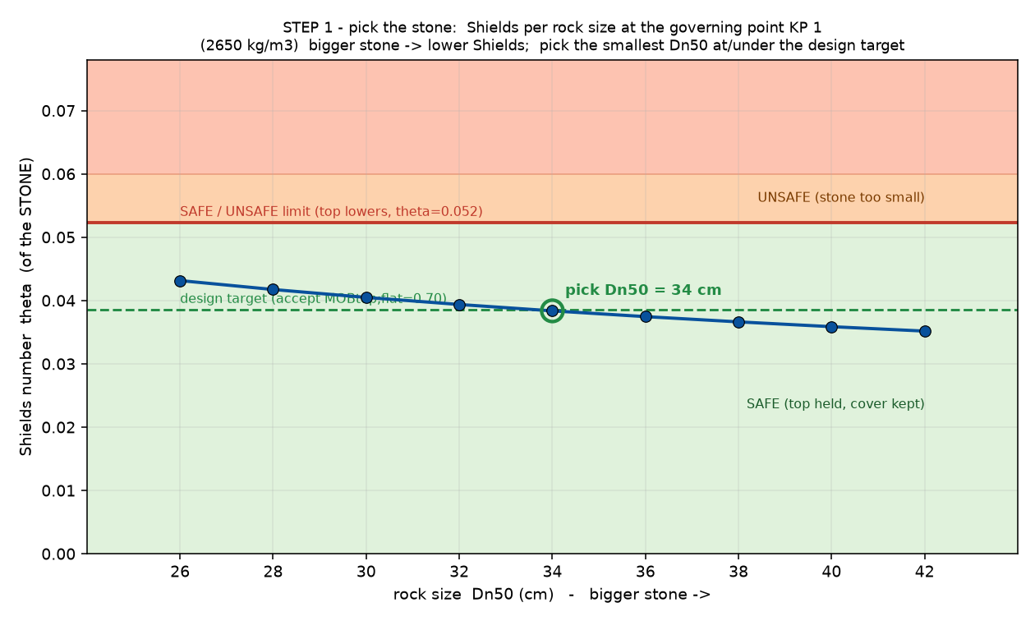
Figure 7.5: Step 1, the Shields number against the stone size at the governing point, from which the smallest safe stone is read.
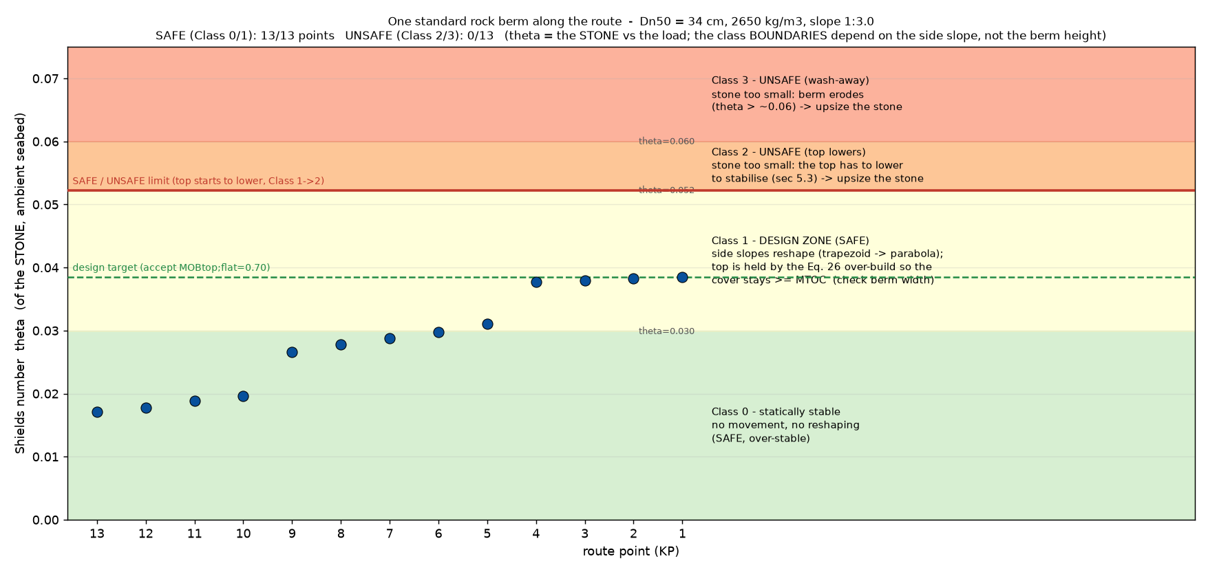
Figure 7.6: Step 2, the deformation class at every point along the route for the chosen stone.
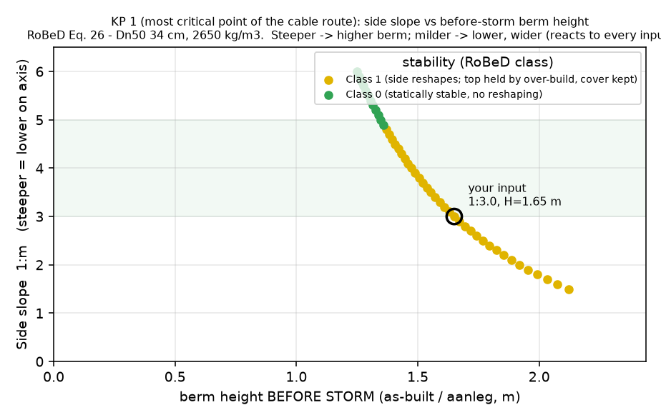
Figure 7.7: Step 3, the side slope against the installed berm height.

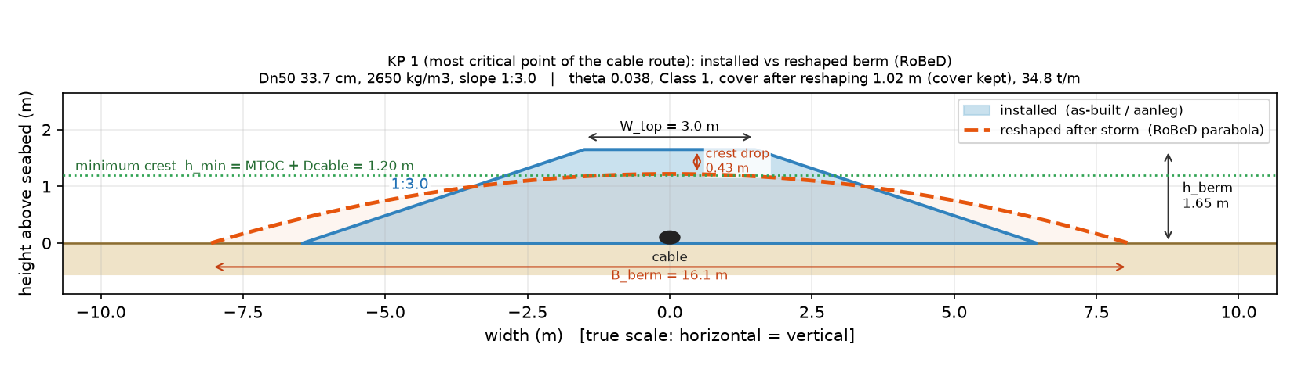
Figure 7.8: Step 3b, the installed berm against the reshaped berm at the most critical point, on a true scale.

Case studies: applying the framework to real projects
The framework is applied to three real projects. The three sites were chosen because they differ from one another: a sandy seabed with a strong current, and two rocky seabeds that sit above the depth-limitation threshold. Between them they cover both seabed types in scope and both sides of the breaking threshold, so the decision tree has to make a different choice at each of them and each method can be held against its own validity range. Branch B then delivers a complete berm design for all three.

The measured data behind them is limited. For each route only a small number of points was available, so a set of representative points was constructed around them to show how a design develops along a real route. The measured point is always set as the governing one, so every calculation is anchored to a real point rather than to an invented one. This is stated openly because it bounds what the case studies can show. They demonstrate that the framework runs end to end on real inputs, not that it has been validated over a full route.

Every point is run at both the low and the high astronomical tide and the governing condition is carried forward, so the water level is never assumed.

The inputs below are taken from the project data sheets.
 | Project A | Project B | Project C
Seabed | rippled sand | bedrock | bedrock
Water depth h (m) | 22.45 | 13.9 | 13.3
Hs, 100-yr (m) | 9.9 | 8.61 (11.95 offshore) | 7.9
Tp, 100-yr (s) | 14.1 | 19.75 | 13.8
Current, 100-yr (m/s) | 1.6 | 0.73 | 1.0
Hs/h (depth-limitation ratio) | 0.44 (no) | 0.62 (yes) | 0.59 (yes)
Table 7.2: The three case study projects and their governing 100-year conditions.

What the tool returns for these three projects, which method the tree selects at each of them and what the berm designs look like, is presented in Chapter 8. The same three cases carry the benchmark of Branch B in Section 7.7 and the reference point of the sensitivity analysis in Section 7.8.

Benchmarking Branch B against the reference cases
Branch B carries the design of this study, so it is the branch the benchmark has to test. It returns a rock together with a geometry and an amount of accepted reshaping, and the three reference cases are themselves complete berm designs, so Branch B is compared with them on the whole berm while Branch A is compared on the stone size alone.

The three cases are not equally strong and they do not test the same thing.
Project A was checked by a specialist engineering company. Its report lists the full calculation with every intermediate value, so the tool can be run on the same input and the two chains compared step by step rather than only on the final rock size. This is the strongest check of the calculation itself.

Project B was tested in a physical model, a two-dimensional flume at a scale of 1:55, with the cover remaining over the cable as the damage criterion. That is the criterion the tool works with, and the berm was allowed to reshape and still did its job. This is the strongest check of the predicted behaviour, because it is a berm that actually moved and not a second calculation.

Project C has not been built and two designs are currently on the table for it. Once the framework has been checked against A and B, and it is known where it lands against a real calculation and a real test, it can be run on those two designs and used to advise on them. Project C is therefore the application of the framework rather than a benchmark of it.

Both reports are commercial documents, so neither is reproduced here and only the comparison is given. The reshaping model was calibrated offshore and is applied here in the nearshore, and this benchmark is the only place where that extrapolation meets something real. Two cases cannot bound how far it can be trusted, but they can show whether the tool lands in the same place as an independent calculation and a tested berm, and on which side. That is read in Chapter 8 and not assumed here.

Parameters and the sensitivity analysis

Why a sensitivity analysis is needed
A rock berm design is not one formula with one answer. The load chain runs from the sea state through the orbital velocity and the friction factor to a Shields number, and the geometry then runs from that Shields number to a height, a width and a quantity of rock. Every step carries its own inputs, some measured and uncertain and some chosen by the designer, and neither the equations nor three case studies show which of them decides the answer. The analysis asks which inputs move the result, how much of it rests on the data the designer receives against the choices the designer makes, and whether the inputs act on their own or only in combination.

The inputs of the tool
The tool uses many inputs. Some are measured and carry uncertainty, such as the waves, the current and the water depth. Some are design choices, such as the rock density and the side slope, and some are set by the client. The tables below list every input with its default and its range, so it is clear what the tool needs. Not all of them are varied. The analysis is run on the design that carries this thesis, which is Branch B, so the inputs that belong to a Branch A formula only, and the ones that are fixed by a source rather than chosen, are held at their default.

Environmental inputs. These are read per route point from the metocean and geotechnical survey. They are not tuned. They define the load on the berm.
Symbol | Meaning | Unit | Source | Branch
Hs | significant wave height | m | metocean survey | A and B
Tp | peak wave period | s | metocean survey | A and B
h | water depth | m | bathymetric survey | A and B
uc | current speed, at one metre above the bed in the route data, depth-averaged where the metocean study gives it (Section 3.2) | m/s | metocean survey | A and B
theta | wave-current angle | deg | wave and current roses | B
ib | seabed slope | deg | geophysical survey | A
ST | soil type | - | geotechnical survey | A
Table 7.3: Environmental inputs of the sensitivity analysis, read per route point from the survey and the metocean data.

Rock and modelling parameters.
Symbol | Meaning | Default | Range | Source | Branch
rho_s | rock density (normal / high) | 2650 / 3000 | 2650 - 3000 kg/m3 | design choice | A and B
rho_w | sea-water density | 1025 | fixed, kg/m3 | physics | A and B
gstr | turbulence amplification | 1.6 | 1.0 - 2.0 | Van Rijn (2019) | A
r | Van Rijn damage level | 1.0 | 0.4 - 1.0 | design choice | A
Sd | Van der Meer damage | 2.0 | 2 - 8 | design choice | A
Nod | Van Gent / Herrera damage | 0.5 / 2.0 | 0.5 - 2.0 | design choice | A
P | notional permeability | 0.4 | 0.1 - 0.6 | Van der Meer | A
N | number of waves in the storm | 3000 | up to 7500 | design choice | A
cot alpha | berm side slope | 2.0 | 1.5 - 6.0 | design choice | B
a | roughness factor, ks = a. D50,ref (fixed reference) | 2.0 / 2.5 | 2.0 Van Rijn, 2.5 RoBeD | literature | B
theta_cr | critical Shields number | 0.055 | fixed | explicit choice (Ch. 5) | B
theta_wa | wash-away Shields number | 0.06 | fixed | RoBeD | B
1:m | steepest allowed side slope | 1:3 | buildability | design choice | B
Ka1, Ka2 | Van Rijn slope factors | 1.0 | up to 1.0 | Van Rijn | A and B
Table 7.4: Design and calculation inputs of the sensitivity analysis, with their default and their range.

Client and geometry inputs. These come from the project requirements.
Symbol | Meaning | Default | Source
MTOC | required cover over the cable | site value, >= 0.5 m (CIRIA) | client
Btop | berm crest (top) width | 3.0 m | design choice
Dcable | cable diameter | 0.2 m | client
max cover / max width | buildability limits (0 = off) | 0 / 0 | client / vessel
Table 7.5: Client and geometry inputs, which follow from the project requirements.

What is varied and how it is read
The ranges matter as much as the inputs themselves. A range that is too wide spends the analysis on conditions the site cannot produce, and one that is too narrow hides a risk that is real. Every input is therefore varied over the range the metocean study of the route gives for it, or over the range a designer and a client can actually choose from, and with the distribution that matches how that input occurs rather than with a flat band between two limits. The rock density is handled as a small number of separate grades for the same reason, because rock is bought in a grading and only a few densities are on offer. The ranges themselves, and the document each one comes from, are given with the results in Section 8.4.

The inputs are also of three kinds and they do not belong in one ranking. The sea state is measured, the side slope and the crest width and the density are chosen by the designer, and the required cover and the cable diameter are set by the client. Putting a client requirement next to the wave height in one index answers no useful question, because the two are not alternatives to one another. The analysis is therefore run twice, once over the sea and once over the choices, and each run is read on its own output.

One evaluation is one complete Branch B design, and two outputs are recorded, the required rock size and the rock quantity per metre of route. The two do not answer to the same inputs, and that follows from the design rule and not from the numbers. Because the stone is always sized to the same accepted Shields number, the reshaping ratio of Equation 5.31 is the same in every run, so the installed area is set by the required cover, the crest width and the side slope alone. The sea therefore reaches the stone but not the quantity, and the choices reach the quantity but, apart from the density, not the stone. Both analyses are run at the reference point of Project C, the only case study where the design choices are still open and the only one for which the full metocean study was available.

The two methods and what they cannot do
Morris is run first because it is cheap, 1 500 evaluations against 57 344 for a variance decomposition. It answers the smaller question of which inputs matter at all and which of them behave in a way a simple rule cannot describe (Morris, 1991). Its answer is a ranking and not a share, so it cannot say that one input is twice as important as another. It depends on how the inputs are stepped and on how many starting points are used, and a response that bends inside one step is not seen. And σ flags non-linearity and interaction together without saying which of the two it is.

Sobol then puts numbers on what Morris ranks, and it also says how much of the spread belongs to no single input at all (Sobol', 2001; Saltelli et al., 2008). Its indices are conditional on the ranges and the distributions chosen before the sampling starts, so an input with a wide range can outrank a stronger one that was given a narrow range. That is why every range is reported with the document it comes from. The method also assumes the inputs are independent of each other. That holds for the wave height and the period, because the period is not an independent input but follows the wave height through the steepness. It does not fully hold for the wave and the current, because a storm raises both and their joint distribution is not given in the metocean study. The assumption is named here rather than left implicit, and how much it is worth is weighed with the results in Section 8.4.

A variance decomposition is also harder to read when the model contains a switch, and this model has one at the boundary between the deformation classes. In the set-up used here that switch is not active, because the side slope is held fixed in the analysis over the sea and the sea state is held fixed in the analysis over the choices, so no run crosses a class boundary. That shows in the results as a first order sum close to one in both analyses, and it is the reason the two analyses are kept apart rather than combined. How a Morris result and a Sobol result are read is set out in Appendix D.

How the analysis was run
The interactive tool evaluates one design at a time, which is far too slow for the number of evaluations a variance decomposition needs, so the Branch B chain was re-implemented in a vectorised form with NumPy for the analysis alone. That copy is checked twice. It reproduces the worked example of the handbook (Deltares, 2023, Appendix C) to better than 0.4 per cent on every intermediate value, and it reproduces the Project C design of Appendix C to better than 0.05 per cent on the stone, the Shields number, the deformation class, the berm height and the rock quantity. The sensitivity is therefore measured on the same model that produces the designs of Section 8.3 and not on a simplified copy of it.

The work is split over four Python scripts, for the metocean input model, the vectorised design model, the two analyses and the figures. Sampling and index estimation use SALib (Herman and Usher, 2017) with the estimator of Saltelli et al. (2010). Morris uses 250 trajectories, which is 1 500 evaluations per analysis, and Sobol a base sample of 8 192, which is 57 344 evaluations. Every script writes its results to a file, so the tables of Section 8.4 are generated from those files rather than copied by hand.

Part C – Results

Results
This chapter checks whether the tool works on real cases. It first gives the real designs of the projects, then compares the Branch A stone size against them, and then makes a fuller comparison with the Branch B berm design. It closes with the sensitivity analysis and with the effect of combining the wave and the current on the velocities instead of on the shear stresses. The open points that follow from all of this are collected in Chapter 9. The three projects are the ones introduced in Section 7.6 (Table 7.2).

The real designs
A note on precision before the numbers start. The tool solves the stone size to the millimetre, because the calculation converges to a number, but rock is not bought that way. A quarry supplies a grading, and the median diameter of that grading is what a design can actually specify. Every value quoted as a design or a recommendation in this chapter is therefore rounded to the centimetre and named together with its grading. The unrounded values are kept in Appendix C, where the calculation is shown step by step, and in Section 8.4, where the stone size is a statistic over a population of storms rather than something to be ordered.

For each project a real design is available, and this is the reference the tool is compared against. The designs differ in how strong the evidence is. Project A was independently reviewed by a specialist party but not physically tested. Project B was tested in a physical model. Project C is a future project, so its design is a proposed design. What was designed, the rock grading and the berm geometry, is given below.

Two practical points apply to all three projects. The first is that each project supplied only its own governing point rather than a full route. The route based figures of Chapter 7 therefore show the method on a constructed route, and the results below are reported per point, because showing a single measured point as if it were a route would suggest data that does not exist.

The second is that Branch B computes its load with the chain of the handbook itself, following Appendix A of that document, rather than with the components of Van Rijn used in Branch A. Section 8.3.3 shows what that choice is worth against an independent calculation.

The handbook contains worked examples in its Appendix C. These show the whole load calculation with real numbers, step by step. The tool was checked against them. It returns the same value at every step, and the largest difference is less than half a per cent. The steps that were checked are the orbital velocity, the wave excursion, the friction factor, the wave shear stress, the combined shear stress and the Shields number.

This check is built into the tool as a self test, so it runs again whenever something is changed. If a change breaks the agreement with the handbook, the test fails straight away.

This matters for the results below. It means that the differences between the tool and the real designs come from the design situation, and not from a mistake in the calculation. Appendix C writes the whole chain out step by step, with all the numbers, for each of the three projects.

The rock is delivered as a standard grading, defined by its mass limits under EN 13383. The nominal diameter of a stone of mass M is

$$Dn50 = {(M50 / ρs)}^{(1/3)}$$

So a grading with a lower and an upper mass limit gives a range of nominal diameters. The single value used for the comparison is the median nominal diameter Dn50, which follows from the mass M50 at which 50 percent of the class is lighter (EN 13383), read from the grading curve of the class. For the 60/300 kg grading this gives a Dn50 of about 0.36 m at the high density and about 0.375 m at the normal density, within a range of roughly 0.27 to 0.48 m. For the 10/60 kg grading it gives about 0.21 m, within a range of roughly 0.15 to 0.27 m. The comparison uses the median Dn50, and it holds across this range, because the conclusions do not change within the width of the grading.

Benchmark input data. The real design of each project:
Project | Grading | Density  (kg/m3) | Dn50 (grading) | Side slope | Crest width W_top | Cable dia | Min cover
A  Reviewed | Armor HD LMA 60/300 kg | HD (3100) | ~0.36 m | 1:3 | 1.2 | 0.2 m | 1 m
B  Tested | Armor HD LMA 60/300 kg | ND (2670) | ~0.37 m | 1:6 | 4.0 m | 0.15 m | 1.8 m
C  Future, HD | HD 10/60 kg | HD (3100) | ~0.24 m | 1:4 | 1.0 m | 0.15 m | 0.9 m
C  Future, ND | LMA 40/200 kg | ND (2650) | ~0.36 m | 1:5 | 1.0 m | 0.15 m | 1.2 m
Table 8.1: The real designs of the three projects, and the stone size from the grading.

Branch A: comparison on the stone size
Branch A gives only a rock size, so it is compared with the real design on the rock-size axis. Every sizing method is computed at each point, and the decision tree then selects the method that is valid for that situation. Each method is checked against its own validity range, and a method that falls outside its range is marked as not valid and is not used. The valid methods that the tree does not select are kept next to the selected one for comparison.

The water depths are given relative to LAT, the lowest astronomical tide, which is the chart datum used in the source reports. The tool evaluates each point at the low water level, because that gives the highest near-bed velocity and so the largest rock. Each project is computed at its own design density, so the tool and the real design are compared on the same density within a project. The design density is 3100 kg/m3 for Project A, 2670 kg/m3 for Project B and 3100 kg/m3 for Project C, and every rock size in this section is at that density. Only one design point was released for each project, KP 1, the shallowest and most heavily loaded point, and this is the point reported below.

Project A
KP 1 of Project A is a mobile sandy seabed in 22.45 m of water below LAT, with a current of 1.35 m/s at the 10-year return period and 1.6 m/s at the 100-year return period. The design wave is Hs = 9.9 m with Tp = 14.1 s, so Hs/h = 0.44, the point sits below the depth-limitation threshold and the bed is mild. The decision tree selects Van Rijn, the flat-bed method for a combined wave and current load.
Method | Status | Reason (technical validity) | Dn50 (m)
Van Rijn (2019), flat bed | Valid, selected | made for a bed under a combined wave and current load, which is the situation at this point | 0.39
Hudson (1953/1959) | Valid | the point sits below the depth-limitation threshold, so the formula applies. It is used on the near-bed height Hs,b = Hs/cosh(kh) (Equation 3.10, which lowers it from 2.14 m on the surface Hs | 1.67
Van Gent and Van der Werf (2014), toe | Valid, uncertain | the toe geometry ht/h = 0.95 lies outside the 0.1 to 0.3 range the formula was fitted on, so its value cannot be trusted here | 0.54
Van der Meer (1988) | Not valid | the water is too shallow, h/Hs = 2.2 against the required 3. The formula assumes a Rayleigh wave-height distribution, which no longer holds on a shallow foreshore | (2.30)
Shallow-water formulas (4 forms) | Not selected | these were derived for a depth-limited foreshore. At this point the point sits below the depth-limitation threshold, so this situation is not the one they describe | 1.92 to 3.13
Herrera and Medina (2015), toe | Not valid | derived for a steep bottom with breaking waves. This point has a mild bed and sits below the depth-limitation threshold | -
Table 8.2: All Branch A methods at KP 1 of Project A, at the design density of 3100 kg/m3.

The selected method is Van Rijn, which gives Dn50 = 0.39 m. The real design uses a 60/300 grading with a median rock of about 0.36 m, so the selected method is 9 percent above the real design, on the safe side. Van Rijn is also the smallest valid method at this point. Hudson, which is valid here but was made for breakwater armour, gives 1.67 m, which is 369 percent above the real design.

Project B
KP 1 of Project B is a bedrock seabed in 13.9 m of water below LAT, the bathymetry level of the modelled section in the flume. The design wave is the one measured at the structure itself, Hs = 8.61 m with Tp = 19.75 s, so Hs/h = 0.62. Section 8.3.5 explains where that value comes from and why the 11.95 m of the offshore calibration point is not the wave that arrives here. That puts the point above the depth-limitation threshold on a mild bed, so the upper part of the wave-height distribution has already broken further offshore, with a moderate current. The tree selects the shallow-water formulas, which are the forms derived for this situation.
Method | Status | Reason (technical validity) | Dn50 (m)
Shallow-water formulas (4 forms) | Valid, selected | derived for a depth-limited foreshore, which is the regime this point sits in | 1.83 to 2.43
Van Rijn (2019), flat bed | Valid, comparison | it applies to a bed under waves and current, but it contains no term for wave breaking, so in the surf zone it does not capture the full load | 0.51
Van Gent and Van der Werf (2014), toe | Not valid | the wave steepness sp = 0.014 lies below the 0.015 to 0.04 range the formula was fitted on, and the toe geometry ht/h = 0.86 lies outside the 0.1 to 0.3 range | (0.70)
Van der Meer (1988) | Not valid | the water is too shallow, h/Hs = 1.61, below 3, so the Rayleigh distribution behind the formula no longer holds. This is exactly the case the shallow-water forms were derived for | (2.18)
Hudson (1953/1959) | Not valid | the side slope cot(alpha) = 6.0 lies outside its 1.5 to 4.0 range, and the formula uses a surface wave height that is not representative once the waves are depth-limited | (2.18)
Herrera and Medina (2015), toe | Not valid | derived for a steep bottom, while this point is mild, and the wave steepness s0p = 0.012 and hs/Hs0 = 1.61 fall outside its range | -
Table 8.3: All Branch A methods at KP 1 of Project B, at the design density of 2670 kg/m3.

The selected shallow-water formulas give 1.83 to 2.43 m, against a real design with a median rock of about 0.37 m. The smallest valid method at this point is Van Rijn with 0.51 m, which is 37 percent above the real design. The breaker formulas are still a factor of five above a berm that was built, loaded in a flume and survived, which is the clearest illustration in this study that a slope armour formula does not transfer to a free-standing berm on the bed.

Project C
Project C is a future project on a bedrock seabed. KP 1, the design reference point and the only point released for this study, lies at 13.30 m below LAT, where the design wave is Hs = 7.9 m with Tp = 13.8 s, so Hs/h = 0.59 which puts the point above the depth-limitation threshold, so the upper part of the wave-height distribution has already broken further offshore. The tree selects the shallow-water formulas.
Method | Status | Reason (technical validity) | Dn50 (m)
Shallow-water formulas (4 forms) | Valid, selected | derived for a depth-limited foreshore, which is the regime this point sits in | 1.39 to 2.16
Van Rijn (2019), flat bed | Valid, comparison | it applies to a bed under waves and current, but it contains no term for wave breaking | 0.44
Van Gent and Van der Werf (2014), toe | Valid, uncertain | the toe geometry ht/h = 0.92 lies outside the 0.1 to 0.3 range the formula was fitted on | 0.51
Van der Meer (1988) | Not valid | the water is too shallow, h/Hs below 3, so the Rayleigh distribution behind the formula no longer holds | (1.66)
Hudson (1953/1959) | Not valid | the formula uses a surface wave height that is not representative once the waves are depth-limited (on the near-bed height it would give 1.95 m) | (1.68)
Herrera and Medina (2015), toe | Not valid | derived for a steep bottom, while this point is mild, and hs/Hs0 = 1.76 falls outside its range | -
Table 8.4: All Branch A methods at KP 1 of Project C, at the design density of 3100 kg/m3.

The selected shallow-water formulas give 1.39 to 2.16 m, against a proposed grading with a median rock of about 0.24 m. The smallest valid method at this point is Van Rijn with 0.44 m, which is 82 percent above the proposed design. For the normal-density variant of the same point, where the grading is coarser and the rock lighter, Van Rijn asks for 0.559 m.

How far is Branch A from the real designs
Putting the three projects next to each other shows a clear pattern:
Project | Situation | Selected method | Dn50 selected | Smallest valid method | Dn50 smallest | Real design | Difference on the smallest
A | below the depth limit, sand, current | Van Rijn | 0.39 m | Van Rijn | 0.39 m | 0.36 m | +9 percent
B | above the depth limit | shallow-water formulas | 1.83 to 2.43 m | Van Rijn | 0.51 m | 0.37 m | +37 percent
C | above the depth limit | shallow-water formulas | 1.39 to 2.16 m | Van Rijn | 0.44 m | 0.24 m | +82 percent
Table 8.5: The Branch A result against the real design, with the smallest valid method in the last column.

Branch A sits above the real design at all three points, but how far above depends on the situation. Where the point sits below the depth-limitation threshold, at Project A, the best valid method is 10 percent above the real design. That is a workable result. Where it sits above that threshold, at Projects B and C, the best valid method is already 55 and 121 percent above. And if the design follows the method that the decision tree actually selects, which is the shallow-water formulas, the result becomes six to twelve times the real design. So Branch A moves further away from reality as soon as the waves become depth-limited. That is exactly the situation a nearshore cable berm is built for

Why the Branch A stones stay indicative
Only Van Rijn (2019) was made for loose rock on a bed under waves and current, so it is the one native method here. The others come from breakwater slopes and from toes (Chapter 5), and a slope or a toe is loaded differently from a low berm lying on the seabed, so even where they are technically valid at a point their rock size is an indication and not a design value. Hudson stays far above the native value and far above the real designs even on the near-bed wave height of Equation 3.10. Branch A on its own therefore cannot give the design rock for a nearshore berm in the breaker zone. That has to come from Branch B, which is treated next.

Branch B: the berm design
How Branch B works is set out in Section 7.5. What follows here is what it returns on the three projects. Every project is treated in the same two steps. The first asks which rock the tool recommends for the conditions and the required cover, and places it next to the rock that was actually chosen. The second enters the design that was chosen, with its own rock and its own geometry, and shows how that berm deforms under the design storm. All runs use the geometry of the real design and the design density of that project.

The load chain used for these results
Branch B is run on the load chain of the Deltares handbook, the chain the deformation model was calibrated with, and not on the chain of any other method. That matters for the numbers that follow, because the two chains do not give the same bed shear stress on the same stone, and Appendix C sets the difference out per project.

Project A
Project A is a mobile sandy seabed at KP 1 in 22.45 m of water below LAT. The significant waveheight is 9.9 m with a peak period of 14.1 s and the current reaches 1.6 m/s at the 100-year return period. With a ratio of wave height to water depth of 0.44 the point sits below the depth-limitation threshold, so the berm is loaded by a combined wave and current action on an open bed. The berm has a side slope of 1:3, a crest width of 1.2 m and a required cover of 1.0 m over a cable of 0.2 m, at a rock density of 3100 kg/m3. The route runs from 22.45 m at KP 1 to 30 m at the far end, so KP 1 is both the shallowest and the most heavily loaded point.

- Step 1, the rock. The tool recommends a rock of 0.39 m for these conditions, which is a 60/300 grading. The design that was built uses a 60/300 grading with a median rock of about 0.36 m. The tool is therefore 9 percent above the choice that was made, on the safe side, and both values fall within the same grading.

- Step 2, the berm. Entering the design that was built, with its own rock and its own geometry, gives deformation class 0 at KP 1. The Shields parameter is 0.0277 and the mobility on the flat top is 0.50, well below the threshold of 0.95, while the mobility on the 1:3 side slope reaches 0.88 and therefore also stays below it. The berm stays in place, the crest does not lower and the cover of 1.0 m is kept in full. The installed berm is 1.48 m high with a base of about 10 m, at about 26 tonnes per meter.

The second view shows how much room this design has. It gives the deformation class for every combination of side slope and installed berm height, so the whole design space can be read in one picture. With this rock the berm stays in class 0 over a wide range of slopes and heights, and the design that was built lies well inside that range and not close to its edge.

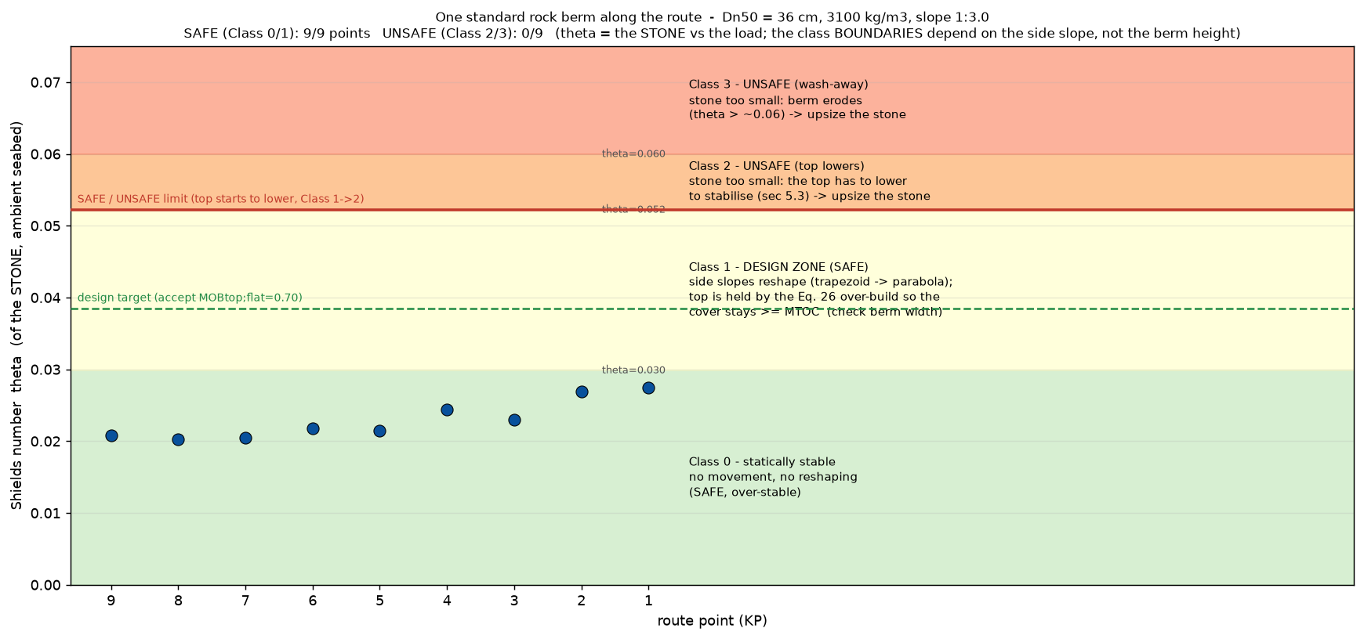
Figure 8.1: Deformation class at KP 1 for Project A, with the rock of the built design.

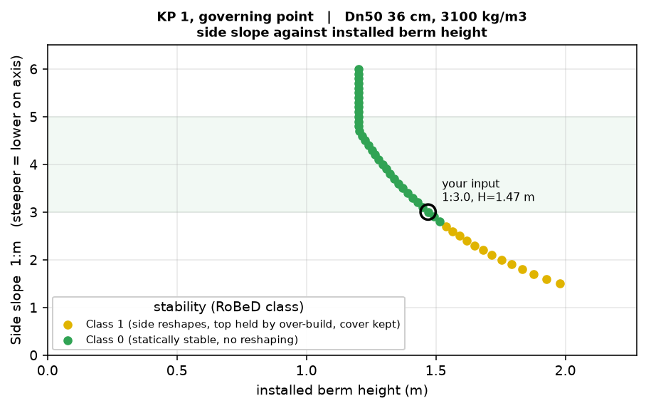
Figure 8.2: Side slope against installed berm height for Project A, with the built design marked.

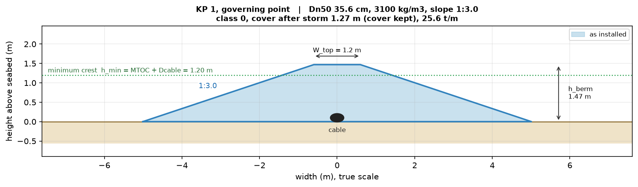
Figure 8.3: Cross-section of the berm as installed for Project A at KP 1. The berm is class 0, so the as-built and the post-storm profile are the same.

 | Rock Dn50 | Class | Installed height | Cover after storm | Tonnage
Recommended by the tool | 0.387 m | 0 | 1.44 m | 1.24 m, kept | 24.5 t/m
Design that was built | 0.36 m | 0 | 1.48 m | 1.28 m, kept | 25.8 t/m
Table 8.6: Project A, the recommendation of the tool and the verification of the design that was built.

Comparison with the specialist report
The design of Project A was checked by a specialist engineering company before it was built. That report is a commercial document, so it is not reproduced here and only the comparison is given.

Two things about it matter for this thesis. The first is that the report sizes the rock with the same approach that is used here, a Shields parameter compared against an accepted level, and that it takes damage level 2 as acceptable, which it expresses as a critical Shields parameter of 0.04. The second is that it includes a worked calculation of the load at its critical section, with all intermediate quantities listed. That makes it possible to run the tool on exactly the same input and compare the two step by step, rather than only comparing the final rock size.

The specialist report gives its full calculation, including every intermediate value, in its own Table 9.1. That makes this the strongest check available in this study, because the two calculations can be compared step by step rather than only on the final rock size. The comparison below is made at the point and the rock of the report, a water depth of 22.45 m, a berm height of 1.3 m and a rock of D₅₀ = 0.207 m as a sieve diameter.
Quantity | Specialist report | This tool | Difference
Water depth over the crest | 21.15 m | 21.15 m | exact
Zero crossing period T_{z} | 10.85 s | 10.85 s | exact
Bed roughness k_{s} | 0.520 m | 0.517 m | -0.6 %
Wave friction factor f_{w} | 0.0790 | 0.0782 | -1.0 %
Wave shear stress τ_{w} | 146.44 N/m² | 151.76 N/m² | +3.6 %
Current shear stress τ_{c} | 8.01 N/m² | 7.85 N/m² | -2.0 %
Mean combined shear τ_{m} | 16.12 N/m² | 15.86 N/m² | -1.6 %
Maximum combined shear τ_{max} | 162.56 N/m² | 167.63 N/m² | +3.1 %
Shields number θ | 0.039 | 0.040 | +2.1 %
Table 8.7: The load calculation step by step at the critical section of the specialist report, on its own water depth, berm height and rock.

Every value agrees to within four per cent and two of them are exact, and the agreement holds at every step of the chain rather than in one number cancelling another. Two independent results follow. The two calculations need the same rock, since the report sizes at D50 = 0.207 m as a sieve diameter, a nominal 0.174 m, against 0.183 m for the tool, a difference of 5.5 per cent. And they agree on how much movement is accepted, 0.039 in the report against 0.0385 here, 1.3 per cent apart. That second point matters more than it looks, because it is a design decision rather than a formula, and it was made here without knowing what the report had chosen.

The tool is the stricter of the two, about 3 per cent higher on the load and 0.0385 against 0.04 on the acceptance level, so it asks for about 5 per cent more rock, which is small against the width of a grading. Both land in the same grading class. The rock that was actually built is larger than either value, a nominal 0.36 m against the 0.174 m the report itself required, and at that rock the tool returns a Shields number of 0.0277 and deformation class 0 with 25.8 tonnes of rock per metre. The built design therefore carries a wider margin than the specialist calculation asked for.

Project B
Project B is a bedrock seabed at KP 1 in 13.9 m of water below LAT. The significant wave height is 11.95 m with a peak period of 19.75 s and the current is moderate at about 0.73 m/s at the 100-year return period. With a ratio of wave height to water depth of 0.86 the waves are strongly depth-limited and breaking, so this berm sits in the breaker zone. The berm has a side slope of 1:6, a crest width of 4.0 m and a required cover of 1.8 m over a cable of 0.15 m, at a rock density of 2670 kg/m3. The side slope of 1:6 is much milder and the crest of 4.0 m much wider than on Project A, which makes this a low and broad structure. The route runs from 13.9 m at KP 1 to 16.3 m at the far end and the wave height falls from 12.59 m to about 7.3 m along it, so KP 1 is again the most heavily loaded point.

Note on the Project B input. The water depth and the wave height used here were corrected against the physical model test report. The flume bathymetry places the seabed at -13.9 m LAT at the modelled section, and the measured incident wave height for the 100-year test was 11.95 m rather than the 12.59 m target, because the waves already broke before they reached the calibration point. One uncertainty remains. That 11.95 m was measured at SP02, about 730 m offshore of the berm, so the local wave at the structure is smaller and the ratio Hs/h of 0.86 cannot exist at the berm itself. The measured wave heights at the two gauges closest to the structure would settle this, and until they are available the Project B result is reported as a conservative upper bound.

- The rock. The tool recommends a rock of 0.39 m for these conditions, which is a 60/300 grading. The design that was built uses a 60/300 grading with a median rock of about 0.37 m. The difference is 6 percent, so on this project the tool and the design that was built ask for practically the same stone.
- The berm. Entering the design that was built, with its own rock and its own geometry, gives deformation class 0 at KP 1. The Shields parameter is 0.0396 and the mobility on the flat top is 0.72, below the threshold of 0.95, while the mobility on the 1:6 side slope reaches only 0.91 because the mild slope keeps the slope factor high. The berm stays in place, the crest does not lower and the cover of 1.8 m is kept in full. The installed berm is 2.13 m high with a base of about 30 m, at about 95 tonnes per meter.

The mild side slope is what carries this design. The mobility on the flat top is the same 0.70 that Project C also reaches, but there the steeper 1:4 slope pushes the mobility on the slope past the threshold. Here the 1:6 slope keeps it at 0.88 and the whole berm stays static. Along the route the design stays in class 0 at every point, and because the wave height falls steadily away from KP 1 the margin only grows.
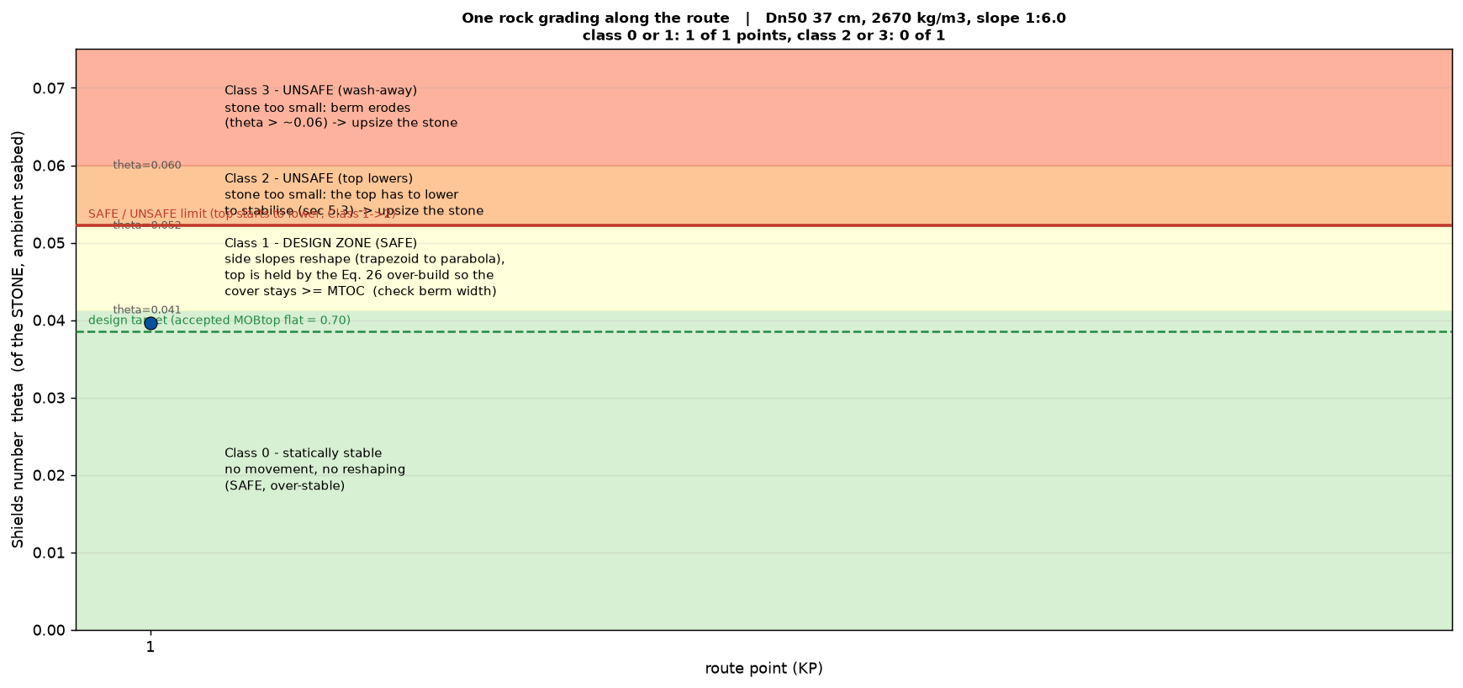
Figure 8.4: Deformation class at KP 1 for Project B, with the rock of the built design.
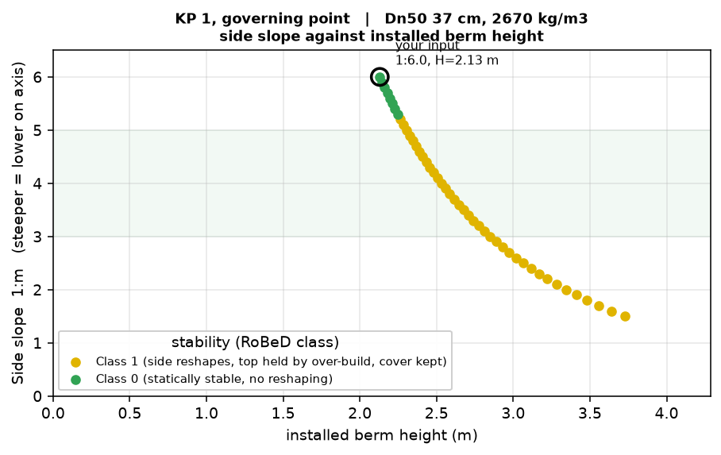
Figure 8.5: Side slope against installed berm height for Project B, with the built design marked.

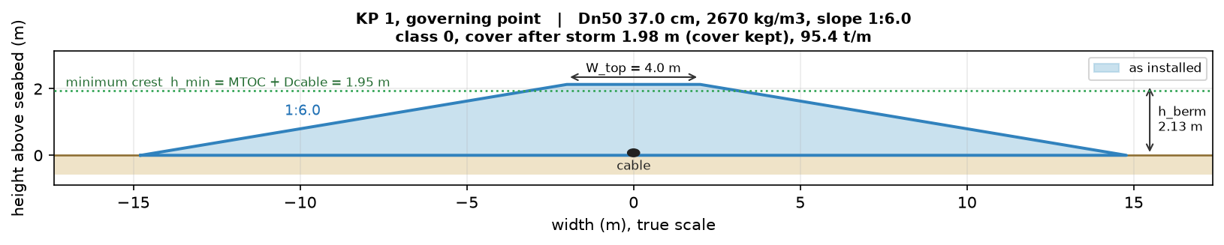
Figure 8.6: Cross-section of the berm as installed for Project B at KP 1, at the rock of the built design. The berm is class 0 under the design condition, so the as-built and the post-storm profile are the same.

 | Rock Dn50 | Class | Installed height | Cover after storm | Tonnage
Recommended by the tool | 0.393 m | 0 | 2.08 m | 1.93 m, kept | 91.3 t/m
Design that was built | 0.37 m | 0 | 2.13 m | 1.98 m, kept | 95.4 t/m
Table 8.8: Project B, the recommendation of the tool and the verification of the design that was built.

The cover after the storm is lower than the installed height because the height is measured from the seabed while the cover is measured from the top of the cable. The difference is the cable offset of 0.15 m at this project, so 2.08 m installed leaves 1.93 m of cover and 2.13 m leaves 1.98 m. Both berms are class 0, so neither of them reshapes and neither crest drops.

Comparison with the physical model test
The design of Project B was tested in a physical model before it was built. That test report is a commercial document, so it is not reproduced here and only the comparison is given.

Three things about the test matter for this thesis. The berm was tested in a two-dimensional wave flume at a scale of 1:55. A series of conditions of increasing severity was applied to the same structure without rebuilding it in between, so the damage accumulated through the series, with the early conditions at LAT and the later ones at higher water levels and for longer durations. The damage criterion was the cover that remains over the cable rather than the movement of individual rocks, which is the same criterion the tool uses.

The tool designs for the 100-year wave at LAT. In the test program that condition was run on its own before the later ones were applied, so the measured profile after it can be compared directly with the prediction.

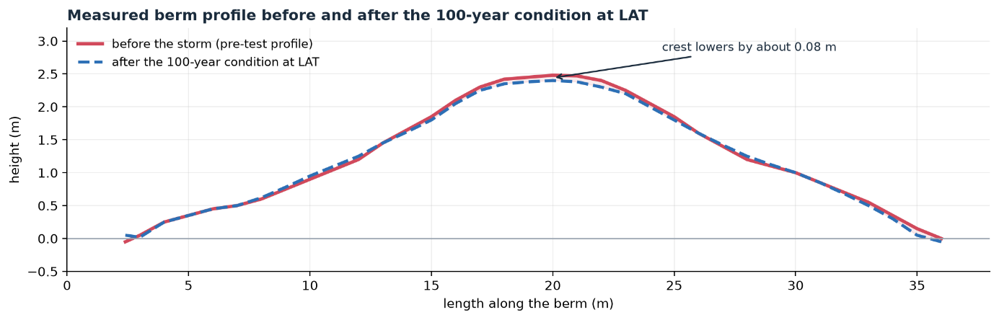
Figure 8.7: Measured berm profile before and after the 100-year condition at LAT.

The physical model test is the strongest reference available in this study, because the berm was built, loaded and scanned rather than calculated. Two things can be compared against it, the rock size and the behaviour of the berm under the design condition. The comparison below is made at the rock that was actually built in the flume, so that the behaviour is judged on the same structure rather than on the tool's own choice of stone.

The wave height at the structure was measured. The flume carried eight wave gauges. Seven recorded during the tests and an eighth, WG-08, stood at the berm location itself during the wave calibration, before the berm was built. Its readings are given in the calibration report. For the 100-year condition at low water the significant wave height fell from 14.51 m at the paddle to 12.21 m at the offshore calibration point SP02, then to 10.75 m, 10.11 m and finally 8.61 m at the structure. The seabed there is at 13.9 m below LAT, so the wave that actually reaches the berm gives Hs/h = 0.62 and not the 0.86 that the offshore value suggests.

The two numbers belong to two different places. The 11.95 m is the incident wave height at SP02, which the design review of the same report puts at 22.7 m water depth, 720 m from the exit. At that point H_{s}/h = 0.53. Pairing the 11.95 m with the 13.9 m depth at the berm combines the wave of one location with the depth of another, and that pairing is what produced the wash-away result reported in the previous revision of this chapter. The correct nearshore pairing is 8.61 m in 13.9 m of water.

The same pattern holds at every water level. The wave loses 30 per cent between SP02 and the berm at low water, 23 per cent at mean sea level and 10 per cent at the highest level, and the ratio H_{s}/h at the structure lands between 0.61 and 0.65 in all three cases. That is the depth-limited ceiling of this foreshore, and it is the reason the wave at the berm barely grows while the wave offshore does.

One point has to be made first. The report states that the berm was designed as a reshaping berm, and that two layers of armour have to remain over the underlayer after deformation. The design intent was therefore not a berm that stays put.

Run with the wave measured at the structure, 8.61 m in 13.9 m of water, the tool returns deformation class 0 for the design condition. The Shields parameter is 0.0388 without a current, the mobility on the flat top is 0.70 and on the 1:6 side slope 0.89, both below the threshold of 0.95. The berm is predicted not to move. The flume berm did not move either. After the 100-year condition at low water the report describes only minor change, and the significant reshaping is reported to start one test later.

That prediction was made before the gauge readings were found. The previous revision of this section back-calculated the local wave height that would reproduce a berm which does not move and arrived at about 8.6 m. The measured value at WG-08 is 8.61 m. The agreement is closer than the accuracy of either number, so it should not be read as a precision result, but it does mean the load chain and the acceptance level were pointing at the right wave height without being told what it was.

The whole test series can be followed in the same way, because each test has its own measured wave height at the structure and its own water level. The tool is run here without a current, since the flume had none. Adding the site current raises the Shields parameter by about two per cent and changes no class.
Test | Condition | H_{s} at the berm | h | θ | MOB_{slope} | Class | Predicted crest drop | Reported behaviour
A | 1-year, LAT | 6.65 m | 13.9 m | 0.0283 | 0.65 | 0 | none | little change
B | 10-year, LAT | 7.95 m | 13.9 m | 0.0358 | 0.82 | 0 | none | little change
C | 100-year, LAT | 8.61 m | 13.9 m | 0.0388 | 0.89 | 0 | none | little change
D | 100-year, MSL | 9.97 m | 16.3 m | 0.0421 | 0.97 | 1 | 0.25 m | reshaping increases sharply
E | 100-year, MSL+2.66 | 11.77 m | 18.96 m | 0.0471 | 1.08 | 1 | 0.41 m | shape stays stable
F | overload, MSL+2.66 | 12.31 m | 18.96 m | 0.0503 | 1.16 | 1 | 0.50 m | crest erosion about 0.5 m
Table 8.9: The flume test series against the prediction of the tool, with the measured wave height at the structure for each test.

The tool holds the berm in class 0 through the first three tests and moves it to class 1 at Test D. The report puts the jump in reshaping at Test D as well. For the strongest condition the predicted equilibrium crest drop is 0.50 m against a reported crest erosion of about 0.5 m, and the critical damage threshold of 1.2 m is not reached in either the prediction or the test.

The comparison between the last test and the final profile is the fair one, even though the tests were cumulative and the prediction is not. In the deformation model the reshaped profile is an equilibrium that depends on the load alone and not on the path taken to reach it, so the profile left at the end of the series should correspond to the strongest condition in it. The intermediate rows are what each condition would do to an as-built berm and they are not meant to be added up.

Four limits of this comparison have to be stated plainly. The wave height of 8.61 m was measured during the wave calibration, when the bathymetry was in place but the berm was not, so it is the undisturbed wave at that spot and not the wave in front of a standing structure. It is also a single gauge reading, and the incident and the reflected wave were not separated, which makes 8.61 m an upper bound rather than a lower one. The wave period at the structure could not be used at all, because breaking had shifted the peak of the spectrum into the long-wave band, so the offshore period of 19.75 s is used instead. And the tool does not count how long a storm lasts, while the low water test ran for three hours and the later ones for fifteen.

The sensitivity that this exposes is worth stating on its own. Moving the wave height at the structure from 8.61 m to the offshore 11.95 m moves the prediction from a berm that does not move to complete wash-away. The design of a nearshore rock berm is therefore governed by the wave transformation over the last kilometre rather than by the stability formula, and that is why the metocean propagation is listed first among the open points of Chapter 9.

The comparison is also evidence that the tool is correct, and it is independent of the evidence from Project A. There the load model was shown to reproduce a professional calculation to within four per cent on the same input. Here the design that follows from that load model is shown to behave as predicted when it is built and loaded in a laboratory. The two checks test different parts of the chain, the load and the resulting design, and they point the same way.

Two observations from the test do not fit the deformation model. The berm eroded along its seaward edge and the material was deposited on the lee side, so it ended up leaning shoreward, while Equation 5.36 conserves the area in place and returns a symmetric parabola. The crest level is predicted well, the shape is not, and for a cable berm the crest level is the criterion that counts. The scans also cannot separate rock that was carried away from rock that settled into the layer beneath, so part of the 0.5 m recorded at the crest may be compaction rather than damage. The report places the jump in reshaping at Test D rather than at the first tests, which points to transport rather than settlement, but that is an argument from the sequence and not a measurement.

Two things the tool does not carry had to be supplied from outside, and both return among the open points of Chapter 9. The first is the water level, since the wave loses 30 per cent between the offshore gauge and the berm at low water while at a higher level the same sea state reaches the berm almost intact. The second is how long the storm lasts, because the conditions that caused the damage ran five times longer than the design condition while the tool only looks at the strongest moment. Together they are the clearest way to make the tool better.

Project C
Project C is a future project on a bedrock seabed. KP 1 has a water depth of 13.30 m at LAT. The significant wave height is 7.9 m with a peak period of 13.8 s and the current is about 1.0 m/s at the 100-year return period. With a ratio of wave height to water depth of 0.59 the point sits above the depth-limitation threshold, so this berm sits in the breaker zone. The cable has an outer diameter of 0.15 m and the required cover over it is 0.9 m. The berm has a side slope of 1:4 and a crest width of 1.0 m. This is the smallest berm of the three and it lies in the shallowest water.

Project C is also the least known of the three. Only one design point was released for this study, KP 1, so the route cannot be followed the way it can on Projects A and B, and the figures in this section show that single point rather than a profile along the route. At KP 1 the ratio of wave height to water depth is 0.59, so the waves break there. Because this project has not been built yet, the tool is used here to advise instead of to check.

Two designs are on the table. They differ in the rock density, and that choice sets everything else. A denser rock is more stable, so a smaller grading can be used, and a smaller grading gives a thinner armour layer and a lower berm. The berm height is built up from the cable, the filter layer and the armour layer, where the armour layer is 2.5 times the nominal rock size.

 | High-density design | Normal-density design
Rock density | 3100 kg/m3 | 2650 kg/m3
Grading | LMA 10/60 | LMA 40/200
Rock Dn50 | 0.24 m | 0.36 m
Cable | 0.15 m | 0.15 m
Filter layer | 0.30 m | 0.30 m
Armour layer, 2.5 Dn50 | 0.60 m | 0.90 m
Berm height | 1.05 m | 1.35 m
Table 8.10: Project C, the two designs that are on the table.

- The rock.
For the high-density design the tool recommends a rock of 0.25 m, against the 0.24 m of the LMA 10/60 grading, so the proposed rock is 3 percent below what the accepted deformation asks for. For the normal-density design the tool recommends 0.41 m, against the 0.36 m of the LMA 40/200 grading, so that rock is 12 percent below. Neither proposed grading is quite large enough to hold the berm static at its proposed side slope, which is why both come out as class 1 below.
- The berm. The two designs behave differently.
The high-density design comes out as deformation class 1. The Shields parameter is 0.0391, the mobility on the flat top is 0.71, but on the 1:4 side slope it reaches 1.04 and passes the threshold of 0.95, so the side slopes reshape. Equation 5.36 asks for an installed height of 1.49 m at this slope. The crest then drops 0.42 m during the storm and ends at 1.07 m, which leaves 0.92 m of cover against the required 0.90 m. The requirement is met, but only because the berm is over-built for the reshaping. It takes about 32.0 tonnes per meter.

The normal-density design comes out as deformation class 1 as well. The Shields parameter is 0.0410 and the mobility on the flat top is 0.75, but on the 1:5 side slope it reaches 1.00 and just passes the threshold, so the side slopes reshape here too. Equation 5.36 asks for 1.81 m at this slope. The crest drops 0.44 m and ends at 1.37 m, which leaves 1.22 m of cover against the required 1.20 m. It takes about 48.2 tonnes per meter, half as much again as the high-density design.

 | Rock Dn50 | Class | Installed height | Cover after storm | Tonnage
High-density design | 0.24 m | 1 | 1.49 m | 0.92 m, kept | 32.0 t/m
Normal-density design | 0.36 m | 1 | 1.81 m | 1.22 m, kept | 48.2 t/m
Table 8.11: Project C, the two designs as the tool sees them.
One difference between the table and the figures has to be named, because it is visible. The table evaluates the two gradings that are actually on offer, 0.24 m and 0.36 m. The figures are drawn at the stone the tool itself asks for, 0.248 m and 0.410 m. For the high-density option the two are almost the same and both land in class 1. For the normal-density option they do not. At the proposed 0.36 m the berm reaches a mobility of 1.00 on the 1:5 side slope and reshapes, while at the 0.410 m the tool asks for it stays at 0.94 and does not. The proposed normal-density grading is therefore one step too small to hold the berm static at that slope, which is the same conclusion the class point of Section 8.3.9 reaches from the other direction.

High-density design
The high-density design is the one Project C proposes, an LMA 10/60 grading at 3100 kg/m3 with a nominal rock of 0.24 m. Figure 8.8 gives the deformation class at KP 1 for that grading. The point sits in class 1, so the side slopes reshape under the design storm and the berm has to be built higher than the cover alone would require. Figure 8.9 shows how that installed height falls as the side slope is made milder, with the proposed 1:4 marked, and Figure 8.10 draws the cross-section at that slope before and after the storm. The crest drops and the cover that is left is what decides whether the design holds.

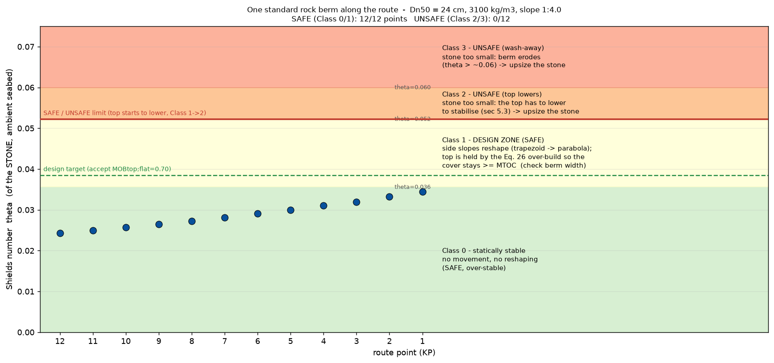
Figure 8.8: Deformation class at KP 1 for the high-density design of Project C.
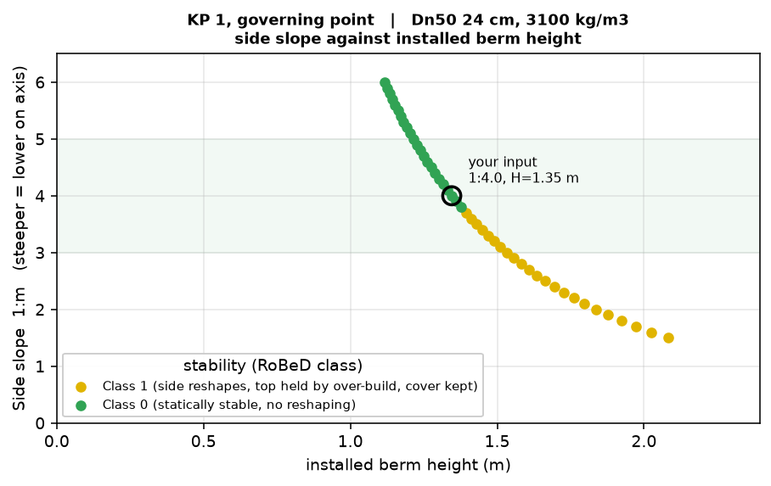
Figure 8.9: Side slope against installed berm height for the high-density design of Project C, with the proposed design marked.

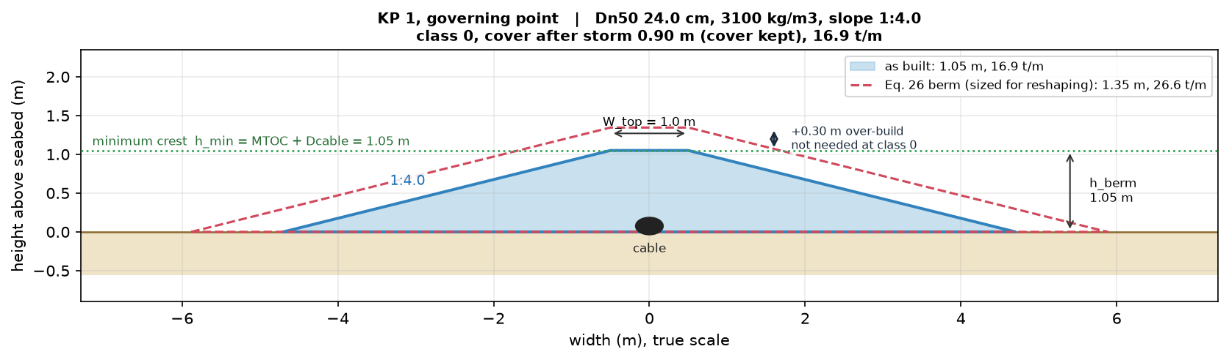
Figure 8.10: Cross-section of the high-density design of Project C at KP 1, before and after the storm, at the height Equation 5.36 asks for at the proposed side slope of 1:4.

Normal-density design
The normal-density design is the alternative, an LMA 40/200 grading at 2650 kg/m3 with a nominal rock of 0.36 m. The lighter rock has to be larger to reach the same accepted mobility, and the thicker armour layer raises the berm with it. Figure 8.11 gives the deformation class, Figure 8.12 the installed height against the side slope with the proposed 1:5 marked, and Figure 8.13 the cross-section. The three figures are drawn on the same axes as those of the high-density design, so the two can be read side by side.

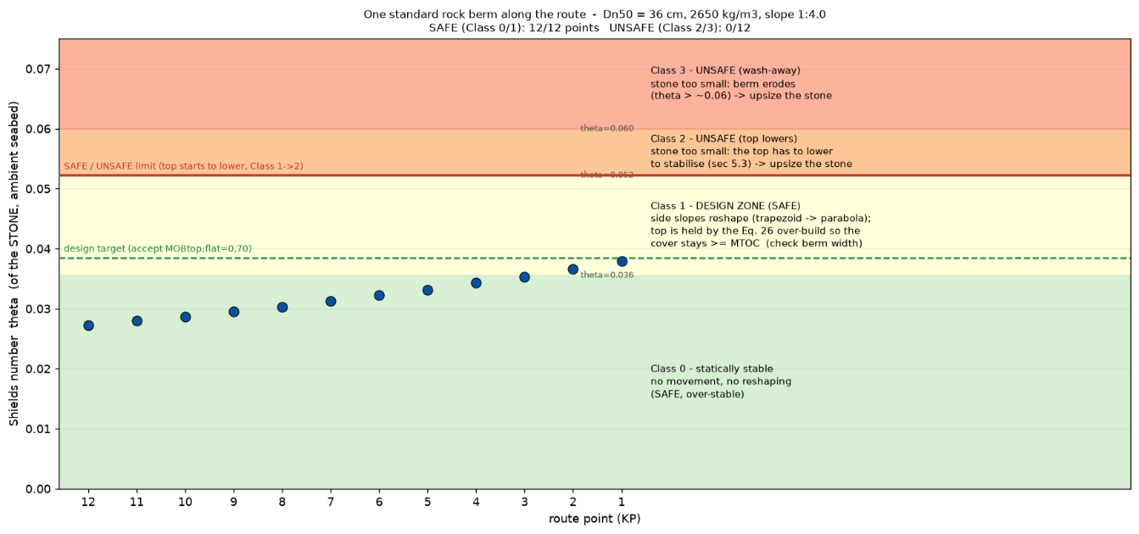
Figure 8.11: Deformation class at KP 1 for the normal-density design of Project C.

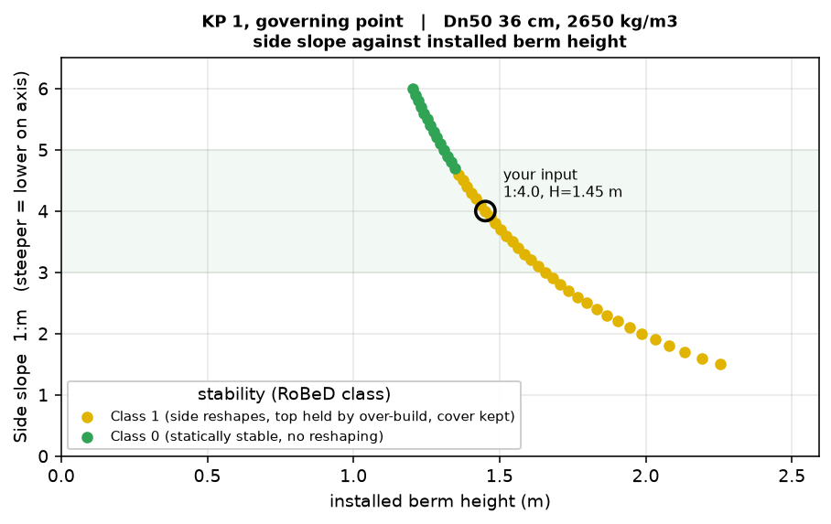
Figure 8.12: Side slope against installed berm height for the normal-density design of Project C, with the proposed design marked.
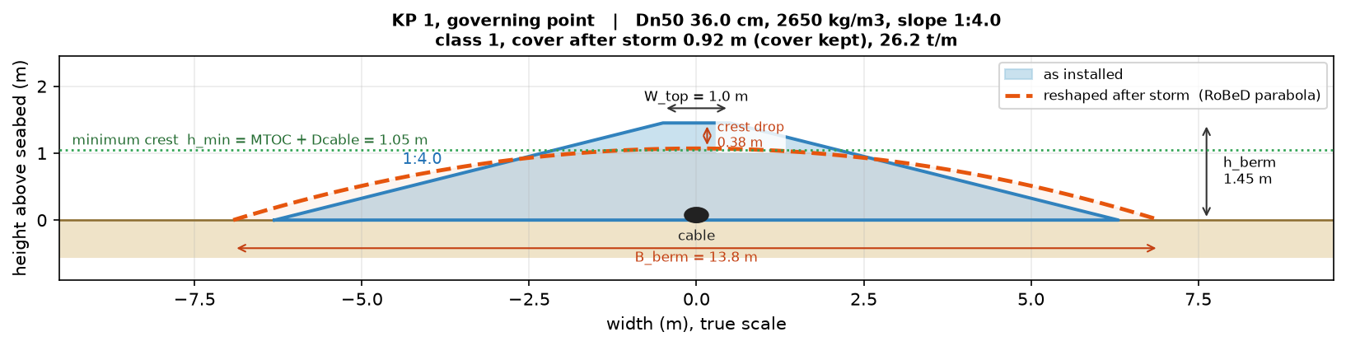
Figure 8.13: Cross-section of the normal-density design of Project C at KP 1, drawn at the rock the tool asks for rather than at the proposed grading. See the note below Table 8.11.

Optimisation of design project C
Only two gradings are available, so the rock is fixed. What is still open is the side slope, the crest width, and whether the berm can be built lower than Equation 5.36 gives. Class 1 is accepted (Section 7.5.3), so the best design is the one with the fewest tonnes per meter that still keeps the 0.90 m cover at every point of the route.

At its proposed slope each berm is class 1, so Equation 5.36 raises it until the reshaped crest still carries the required cover. That over-build is 0.44 m on the high-density design and 0.46 m on the normal-density design, and it is the whole subject of this section, because a berm that does not reshape does not need it.

Side slope | LMA 10/60 h_berm | class | built | LMA 40/200 h_berm | class | built
1:3 | 1.70 m | 1 | 1.70 m, 32.0 t/m | 2.30 m | 1 | 2.30 m, 48.2 t/m
1:3.5 | 1.58 m | 1 | 1.58 m, 32.0 t/m | 2.14 m | 1 | 2.14 m, 48.2 t/m
1:4 | 1.49 m | 1 | 1.49 m, 32.0 t/m | 2.01 m | 1 | 2.01 m, 48.2 t/m
1:4.5 | 1.41 m | 1 | 1.41 m, 32.0 t/m | 1.90 m | 1 | 1.90 m, 48.2 t/m
1:5 | 1.34 m | 1 | 1.34 m, 32.0 t/m | 1.81 m | 1 | 1.81 m, 48.2 t/m
1:6 | 1.23 m | 0 | 1.05 m, 23.8 t/m | 1.66 m | 0 | 1.35 m, 32.6 t/m
Table 8.12: The berm at KP 1 for both gradings at a crest width of 1.0 m, before and after the class check.

While the berm reshapes the shape is not worth optimising. The height from Equation 5.36 falls as the slope gets milder but the tonnage does not move, because A_min in Equation 5.35 holds only f(θ) and h_min, so neither the side slope nor the crest width is in it. The moment the berm no longer reshapes the over-build is not needed and it is built at the minimum buildable height instead. That is where the tonnage moves, and that is where the whole saving of this section sits. A lighter berm is therefore not found by changing the shape, so the slope and the crest width should be set on the footprint, on what the vessel can place and on the placing tolerance the crest must absorb. The crest width of 1.0 m follows from that tolerance and is kept.

Figure 8.14: Rock needed per metre of route against the side slope, for both gradings at a crest width of 1.0 m. Filled markers are class 0 and are built on the minimum buildable height, open markers are class 1 and are built to the height of Equation 5.36.

 | Becomes stable at | $h_{berm}$there | Minimum buildable | Released
High-density | 1:5.04 | 1.34 m | 1.05 m | 0.29 m
Normal-density | 1:5.85 | 1.68 m | 1.35 m | 0.33 m
Table 8.13: The height released by the class check, at the slope where each berm first becomes stable.

Equation 5.36 gives a lower berm as the slope gets milder, but the minimum buildable height stays where it is, because it is set by the rock itself through an armour layer of 2.5 Dn50. For LMA 10/60 that floor is 1.05 m and for LMA 40/200 it is 1.35 m. The high-density berm becomes stable at 1:5.04 where Equation 5.36 still asks for 1.34 m, so 0.29 m of over-build comes off, and the normal-density berm becomes stable at 1:5.85 where 0.33 m comes off. At their own class points the high-density berm needs 22.1 tonnes per metre and the normal-density berm 32.6, so the high-density option is thirty-two per cent lighter, while both are still reshaping the difference is 32.0 against 48.2. The larger rock is simply too big to build the small berm that its own stability would allow, and that is what the higher density buys.

Two steps follow, and they are the part of this section that carries over to other projects.
- Find the steepest side slope at which the berm is still class 0. While it reshapes there is no point in optimizing the shape, because Equation 5.35 fixes the volume.
- At that slope, build at the minimum buildable height, not at the height Equation 5.36 gives. The over-build in that height is for reshaping that no longer happens.
Side slope | MOB_{slope} | Class | Height built | Rock per metre
1:3.0 | 1.244 | 1 | 1.697 m | 32.0 t/m
1:4.0 | 1.044 | 1 | 1.487 m | 32.0 t/m
1:5.0 | 0.953 | 1 | 1.341 m | 32.0 t/m
1:5.5 | 0.923 | 0 | 1.050 m | 22.1 t/m
1:6.0 | 0.900 | 0 | 1.050 m | 23.8 t/m
1:7.0 | 0.866 | 0 | 1.050 m | 27.2 t/m

The berm needs 32.0 tonnes per metre at every slope from 1:3 to 1:5, because while it reshapes Equation 5.35 fixes the volume and the slope only moves that volume around. At 1:5.5 it reaches class 0, the over-build is no longer needed and the same berm can be built at its minimum height of 1.05 m, which takes it to 22.1 tonnes per metre, a saving of thirty-one per cent. Going milder costs material again, 23.8 tonnes per metre at 1:6 and 27.2 at 1:7, because the height is already on its floor and a milder slope only widens the footprint. The optimum is therefore the steepest slope that is still class 0. The normal-density design behaves the same way with different numbers, reaching class 0 only at 1:6 where it needs 32.6 tonnes per metre against 48.2 while it reshapes.

Side slope | MOBtop;slope | Class | Rock at 1.05 m | Margin to 0.95
1:5.04 | 0.950 | 1 | not feasible, cover 0.71 m | 0.000
1:5.1 | 0.946 | 0 | 20.7 t/m | 0.004
1:5.25 | 0.937 | 0 | 21.2 t/m | 0.013
1:5.5 | 0.923 | 0 | 22.1 t/m | 0.027
1:6 | 0.900 | 0 | 23.8 t/m | 0.050
Table 8.14: Material against margin for the high-density design at 1.05 m.

The rule points at the class boundary, but a design should not sit on it. Going from 1:5.5 to 1:5.1 saves 1.4 tonnes per metre, 6 per cent, and cuts the margin by a factor of seven, which is a poor trade, so 1:5.5 is kept. Even there the design sits at a mobility of 0.92 against the limit of 0.95, and it has no spare height left, so if the berm did reshape after all the crest would drop and the cover would fall below what the client asks. The margin on this design is in the slope and not in the height. Where to sit on this ladder is not for the tool to decide, because it depends on how much risk the project accepts and on how well the wave and current data at that location are known.

High-density rock costs about 30 per cent more per ton, but much less of it is needed, 22.1 against 32.6 tonnes per metre, so thirty-two per cent fewer tonnes. Placing fewer tonnes is usually cheaper as well, because the vessel places rock by the load. On tonnage alone the high-density design stays the cheaper one to buy until high-density rock costs more than 32.6 / 22.1 = 1.47 times the normal price, so 47 per cent more, and at the 30 per cent quoted here it is already the cheaper option on material. That covers only the rock. The full comparison needs the real price per ton and the real placing rate of the vessel, which are confidential or not yet known, so it has to be made per project.

Both alternatives are already close to the sweet spot, a berm that is just stable and uses as few tonnes as possible. The high-density design could go a little lower, since at 1:5.1 it is still class 0 and needs 20.7 tonnes per metre instead of 22.1, but that cuts the margin from 0.027 to 0.004 and is not advised, so 1:5.5 at 1.05 m is where it should sit. The normal-density design has to be laid milder, reaching class 0 only at 1:6 where it is built at its 1.35 m floor and needs 32.6 tonnes per metre. On the side slope and the crest width there is little left to gain, so both designs are fine as they stand for construction, and which of the two is built should be decided on the cost picture once the rock and placing prices are known.

How far is Branch B from the real designs
Step 1, the stone. The tool sizes the rock from the accepted deformation and from the required cover, without being told what was chosen.

Project | Rock the tool asks for | Rock that was chosen | Difference
A | 0.387 m | 0.36 m | +7.5 percent
B | 0.393 m | 0.37 m | +6.2 percent
C | 0.248 m | 0.24 m, proposed | +3.3 percent
Table 8.15: Step 1, the rock the tool asks for against the rock that was chosen.

The tool asks for a slightly larger stone on all three routes, between three and eight per cent. That is well inside one grading step, so on every project the tool and the designer would have ordered the same rock. This is the first result of the benchmark, and it is the reason the geometry comparison of step 2 is worth making at all.

Step 2, the berm as it was built. Each installed berm is now run through the deformation model at its own stone and its own height, under the same 100-year condition.

Project | Stone | Installed height | Shields number | Class | Crest drop | Cover after the storm | Required cover
A | 0.36 m | 1.48 m | 0.0275 | 0 | none | 1.28 m | 1.00 m
B | 0.37 m | 2.13 m | 0.0396 | 0 | none | 1.98 m | 1.80 m
C, high density | 0.24 m | 1.05 m, proposed | 0.0391 | 1 | 0.27 m | 0.63 m | 0.90 m
C, normal density | 0.36 m | 1.35 m, proposed | 0.0410 | 1 | 0.31 m | 0.89 m | 1.20 m
Table 8.16: Step 2, the berm as it was built under the same design load, with the cover that is left after it has reshaped.

Projects A and B come out as deformation class 0. The berm does not reshape, the crest stays where it was placed and the cover stays above what the client asked for, 1.28 m against 1.00 m and 1.98 m against 1.80 m, so the tool confirms both built designs on the berm as a whole and not only on the rock. Project C has not been built, and neither option is stable at its proposed side slope. The high-density option reaches a mobility on the side slope of 1.044 and the normal-density option 0.999, so both fall into class 1 and both lose their cover when they are built at the lowest height that can physically be placed.

Read together, the two steps say that the framework agrees with practice where practice has been tested and departs from it where it has not. On the two built projects it reproduces both the rock and the geometry. On the project that is still open it says the current proposal loses its cover in the design storm. The tool is used to check on A and B, and to advise on C.

Sensitivity analyses

Set-up and how the indices are read
The set-up is the one of Section 7.8. One evaluation is a complete Branch B design at the reference point of Project C, KP 1 of the route. The sea is varied in one analysis and the design and client choices in another, each over the ranges of Tables 8.16 and 8.17. Four numbers are reported per input. The Morris μ* is how far the answer moves when that input is changed by one step, and σ is how much that movement itself varies over the input space. The Sobol S1 is the share of the spread in the answer that the input explains on its own and ST is that share including every combination it takes part in. A first order sum close to one means the model is additive and can be read one input at a time.

Analysis 1, the sea. Every distribution comes from the metocean study of the route (metocean study of the route, 2026), which fits a Generalised Pareto distribution to storm peaks over a hindcast of 47 years, from 1979 to 2025.
Input | Range | How it is drawn | Where it comes from | Data or assumption
Significant wave height H_{s} | 5.80 to 7.88 m, the 1 to 100 year storm | return value curve, drawn uniform in annual exceedance probability | metocean study (2026), Table 6, KP 1 of Project C, GPD fit, shape parameter −0.303 | data
Wave steepness s | 0.013 to 0.037, most likely 0.025 | normal, cut at two standard deviations | metocean study scatter table, KP 1 of Project C, all sea states above H_{s} = 4 m | data
Peak period T_{p} | follows from H_{s} and s | not an independent input | metocean study (2026), Section 2.2.1 | data
Depth-averaged current u_{c} | 0.86 to 1.47 m/s, the 1 to 100 year storm | return value curve, as the wave | metocean study (2026), Table 7, KP 1 of Project C, shape parameter −0.150 | data
Water depth h | 13.3 to 16.8 m | astronomical tide, so the arcsine distribution over LAT to HAT | metocean study (2026), Table 8, KP 1 of Project C, LAT 0 m and HAT 3.5 m | data
Angle between wave and current | 0 to 90 degrees, 65 per cent above 45 degrees | mixture of two triangular distributions | not measured, see the text below | assumption
Table 8.17: Environmental inputs of the sensitivity analysis, with the range of each input and the source it is taken from.

The wave height is drawn uniformly in annual exceedance probability rather than uniformly in metres, so a storm is sampled as often as it actually occurs. Half of the samples are storms of one to two years and one per cent are storms of fifty to one hundred years. The fitted curve has a negative shape parameter, so the wave height at this location cannot pass 8.57 m however long one waits. The peak period is not varied on its own but follows the wave height through the steepness, in the same way the metocean study derives it, which also avoids assuming that the height and the period are independent.

The water depth is the tidal depth. The tidal range is 3.5 m on a chart datum depth of 13.3 m, so the tide moves a quarter of the water column, and a sinusoidal tide spends more time near high and low water than in between, which is the arcsine distribution used here.

The angle between the wave and the current is the one input that is not measured. The principal axis of the current per location was not available for this work and the wave direction at the berm cannot be propagated reliably from the offshore analysis point, so the distribution follows the physics of the site, with the waves refracting towards shore normal while the tidal current runs along the coast. Two things have to be said plainly. The relation between the two directions is strongly project dependent, so this distribution is not transferable to another route, and the angle enters the load through an absolute cosine, so a small angle is the severe one. The design condition therefore keeps the collinear worst case of zero degrees.

Analysis 2, the choices. The sea state is held at the design condition and the five inputs that a designer or a client sets are varied over the range that is genuinely available to them.
Input | Range | How it is drawn | Where it comes from | Data or assumption
Rock density ρ_{s} | 2650, 2670, 3000 and 3100 kg/m³ | four discrete grades, the two normal ones together 60 per cent | 2650 and 3000 are the presets of the scope agreement, 2670 is the grading of Project B and 3100 that of Projects A and C | data
Side slope 1:α | 1:3 to 1:7, most likely 1:4 | triangular | 1:3 is the steepest buildable slope, the case studies use 1:3 to 1:6 and 1:4 is the most common | data and choice
Crest width W_{top} | 1.0 to 4.0 m | uniform | the range of the three case studies, 1.0 m, 1.2 m and 4.0 m | data
Required cover MTOC | 0.5 to 1.8 m | uniform | 0.5 m is the minimum of CIRIA (2007), the case studies require 0.9 m, 1.0 m and 1.8 m | data
Cable diameter Δ_{cable} | 0.15 to 0.30 m, most likely 0.20 m | triangular | 0.15 m at Projects B and C and 0.20 m at Project A, 0.30 m as an upper bound for a large cable | data and assumption
Table 8.18: Design and client inputs of the sensitivity analysis, with the range of each input and the source it is taken from.

The rock density is not a continuous quantity, because rock is bought in a grading and only a few densities are on offer, so it is treated as four discrete grades. Normal density rock is the standard supply and high density rock has to be sourced deliberately, so the two normal grades together carry 60 per cent of the samples. The side slope and the cable diameter are drawn from a triangular distribution rather than a uniform one, because inside their range one value is far more common than the rest, a slope of 1:4 and a cable of 0.20 m.

What the sea does to the stone
Over the sampled storms the required stone has a median of 0.099 m and a spread from 0.063 m at the fifth percentile to 0.164 m at the ninety fifth. The indices are given below.

Input | μ* | σ | S1 | ST
Wave height | 0.083 | 0.044 | 0.60 | 0.62
Tide | 0.049 | 0.033 | 0.32 | 0.33
Angle between wave and current | 0.019 | 0.020 | 0.04 | 0.05
Current | 0.011 | 0.009 | 0.01 | 0.01
Wave steepness | 0.010 | 0.013 | 0.01 | 0.01
Table 8.19: Sensitivity of the required rock size to the sea, over the storm population of KP 1 of Project C. The first order indices sum to 0.98.

Two inputs carry the answer. The wave height explains 60 per cent of the spread and the tide 32 per cent, together 92 per cent. The angle between the wave and the current adds 4 per cent, and the current and the wave steepness are negligible at about 1 per cent each. The first order indices sum to 0.98, so the effects are additive and there is almost nothing left for interactions.

The tide is the result worth pausing on, because it is not in the input list of most designs. The near-bed orbital velocity varies with the water depth through the sinh term of Equation 3.4, so a quarter of the water column is a real lever on the load, and a storm at high water asks for a noticeably smaller stone than the same storm at low water. Any berm design in this depth range that reports a single water depth without saying which tidal level it is has left out a factor worth a third of the spread.

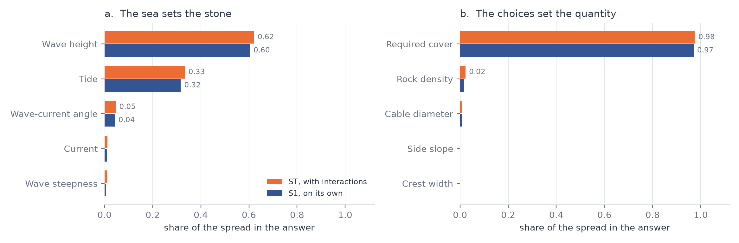
Figure 8.15: Sobol indices of the two analyses. The sea sets the stone and the choices set the quantity, and neither reaches the other.

What the choices do to the quantity
The rock quantity has a median of 47.5 tonnes per metre and runs from 16.0 to 96.8 tonnes per metre between the fifth and the ninety fifth percentile, which is a factor six across the range of choices a project can make.

Input | μ* (t/m) | σ (t/m) | S1 | ST
Required cover MTOC | 89.5 | 14.6 | 0.97 | 0.98
Rock density | 10.8 | 8.7 | 0.02 | 0.02
Cable diameter | 8.4 | 3.3 | 0.01 | 0.01
Side slope | 0.4 | 1.3 | 0.00 | 0.00
Crest width | 0.6 | 1.7 | 0.00 | 0.00
Table 8.20: Sensitivity of the rock quantity per metre of route to the design and client choices, at the design sea state. The first order indices sum to 0.99.

The required cover explains 97 per cent of the spread on its own. The rock density adds 2 per cent and the cable diameter 1 per cent. The side slope and the crest width return exactly zero, and that zero is structural rather than numerical. The installed cross-section is set equal to the area the reshaped berm needs, Equation 5.35, and that area depends on the Shields number and the required cover alone. Making the berm milder or steeper, or its crest wider or narrower, moves the shape of the cross-section but not its area. The side slope is therefore free in the rock budget, which is a useful thing for a designer to know, and it is not free in the stability, where it decides the deformation class through the slope factor of Equation 5.30.

That dominance has to be read for what it is. It is a statement about the choices only and not a statement that the cover matters more than the wave height, because a client requirement and a metocean condition were deliberately not put in the same ranking. The rock density behaves in the opposite way and is the second lever. It explains only 2 per cent of the quantity, because a denser rock is also a heavier rock and the two nearly cancel in tonnes, but it explains the stone size at a fixed sea state, so high density rock buys a smaller stone rather than a lighter berm.

What follows for the design
Three things follow. The required cover deserves the same scrutiny as a stability calculation, because it is the single largest lever on the rock quantity and it usually arrives as a number in a specification rather than as the result of a calculation. The tidal level has to be stated with the water depth, since it is worth a third of the spread in the required stone at this site and it costs nothing to report. And the side slope is free in the rock budget and decisive in the stability, so it should be chosen on the deformation class and on buildability rather than on volume.

Two limits apply to all of this. The analysis is of the design model at one route point, with one accepted deformation level, so it says which inputs that model is sensitive to and not whether the model itself is right. And the distributions are those of KP 1 of Project C. The wave and current climate, and above all the relation between the wave direction and the current direction, are strongly project dependent, so the ranking transfers to another route only after its own metocean study has been read.

Combining the wave and the current on the velocities
Section 3.3 gives two ways to put a wave and a current together at the bed. RoBeD adds the two shear stresses with the vector expression of the handbook. Schiereck and Verhagen add the two shear velocities first and square afterwards, and about that expression their book states that for bottom protections the maximum value over the wave cycle determines incipient motion, which is the form used here. A second version of the tool was built to see what happens when RoBeD is given that combination instead of its own. Only the last step changes. The near-bed velocity, the friction factors and the angle stay the same, so whatever comes out is caused by the combination and by nothing else.

Two checks come first. The chain of Schiereck and Verhagen was rebuilt from the worked example on pages 154 and 155 of their book, a 3 m wave with a period of 7 s in 8 m of water over a current of 1 m/s. The wave length comes out at 55.19 m against 55.2 m in the book, the orbital amplitude at 1.44 m against 1.44 m, the near-bed velocity at 1.292 m/s against 1.29 m/s, the friction factor at 0.0592 against 0.059, the wave shear at 49.4 N/m² against 49.3 N/m² and the current shear at 3.92 N/m² against 4 N/m². The first version of the tool was then run on the three projects and reproduces Appendix C exactly, 209.29 N/m² for Project A, 244.25 against 244.24 for Project B and 194.39 for Project C, with the same Shields numbers and the same deformation classes. What follows is therefore a difference between methods and not an error in the calculation.

On the worked example of the book the two methods do not agree.
 | wave along the current | wave across the current
Schiereck and Verhagen, Eq. 7.6 and 7.7 | 81.2 N/m² | 53.4 N/m²
Soulsby, handbook Eq. A.30 and A.31 | 57.1 N/m² | 50.0 N/m²
Table 8.21: The two combinations applied to the worked example of Schiereck and Verhagen (2019, p.155).

The book itself quotes 78.6 and 51.4 N/m² with its own rounded wave shear. Either way the velocity combination is about forty per cent higher when the wave runs with the current, and the two come together when it runs across. This is a difference between two published methods and anyone can check it on one example from a textbook.

The first question is what the second version does to the three designs as they stand, with the rock they were built with.
Project | τw/τc | τmax version 1 | τmax version 2 | factor | MOBslope version 1 | MOBslope version 2 | class
A | 19.5 | 209.3 N/m² | 285.2 N/m² | 1.36 | 0.845 | 1.151 | 0 to 1
B | 104.8 | 244.2 N/m² | 288.3 N/m² | 1.18 | 0.886 | 1.046 | 0 to 1
C | 41.6 | 194.4 N/m² | 246.8 N/m² | 1.27 | 1.028 | 1.305 | 1 to 1
Table 8.22: The three designs under the two combinations, at the rock size of the design itself.

All three cross the threshold of 0.95. Projects A and B move out of class 0 into class 1, so berms that stay in place under the first version would reshape under the second. Project C was in class 1 already and moves further into it. The size of the shift follows the ratio of the wave shear to the current shear in the first column. Project B is the most wave dominated of the three and shifts the least, Project A carries the strongest current and shifts the most. That is the behaviour the combination predicts on its own, since the difference between the two expressions is largest when the wave and the current contribute equally and disappears when one of them takes over.
The second question is what it costs to keep the same accepted deformation. The rock was resized in both versions so that the mobility on the flat top stays at 0.70 of the critical value.
Project | Dn50 version 1 | Dn50 version 2 | factor | berm height | rock per metre
A | 0.183 m | 0.343 m | 1.87 | unchanged | unchanged
B | 0.393 m | 0.552 m | 1.40 | unchanged | unchanged
C | 0.248 m | 0.401 m | 1.61 | unchanged | unchanged
Table 8.23: Rock size and berm for the same accepted deformation under the two combinations.

The berm does not change at all. The height and the rock quantity per metre follow from the reshaping ratio f(θ), and both versions are sized to the same accepted θ, so f(θ) is the same in both. The second version therefore asks for a coarser grading and not for more rock. For Project A the resized value is not the design, because its stone is set by Van Rijn at 0.387 m and not by the accepted deformation, so for that project the previous table is the one that counts.

The whole difference sits in the angle.
Project | version 1 | version 2 at 0° | 30° | 60° | 90°
A | 209.3 | 285.2 | 273.7 | 242.3 | 199.4
B | 244.2 | 288.3 | 282.1 | 265.0 | 241.6
C | 194.4 | 246.8 | 239.1 | 218.1 | 189.4
Table 8.24: Combined bed shear stress in N/m² against the angle between the waves and the current.

With the wave across the current the second version falls back to just below the first, because the cross term vanishes and what is left is the plain sum of the two stresses, while the first version keeps its enhancement on the mean stress. The three projects are all computed with the two aligned, which is the most severe assumption and the one the tool uses by default.

A third calculation goes further and puts the whole chain of Schiereck and Verhagen inside RoBeD, keeping only the roughness ks = 2.5 d50. At the same rock size the load then becomes 479.7 N/m² for Project A, 476.3 for Project B and 411.3 for Project C, which is 2.3, 2.0 and 2.1 times the first version. That result says more about the wave velocity than about the combination, because across the three projects their near-bed velocity is 1.45 to 1.53 times the spectral velocity of the handbook, since they treat the significant wave height as a regular wave and take its peak while the handbook uses a spectral velocity.

That leaves the second version, and its answer is that the load rises by 18 to 36 per cent on the three projects. That on its own is not a reason to throw it out. The reason is that RoBeD is not one formula but a calibrated model, and the four deformation classes, the threshold MOBthresh = 0.95 and the reshaping relation were fitted with the handbook's own combination inside them. None of this says that the combination of Schiereck and Verhagen is wrong. Their book gives it for the case where the current is dominant and states that a bottom protection is designed on the maximum over the wave cycle, and Section 3.3 follows that. It says that the combination cannot be moved into another model without taking that model's calibration with it.

The second version is therefore kept as an upper bound and not as a correction. The three projects are all wave dominated, with the wave shear 20 to 105 times the current shear, and there the difference stays between 18 and 36 per cent. Where it would matter is a crossing or a point with a strong current, where the two shear stresses come closer together and the difference grows towards a factor 1.9. Recalibrating RoBeD against its own tests with the velocity combination is the only way to settle that, and that remains an open point.

Knowledge Gaps & Research Questions

Answers to the research questions
The first question asked which stability methods are relevant for a free standing rock berm and within which range each of them is valid. Chapter 5 reviews seven methods and Section 5.7 sets them side by side. None of them was made for this structure. The breakwater and the toe methods describe a slope, the flat bed method describes a rock on the seabed, and only the Deltares rock berm deformation model was made for a berm that covers a cable. The validity ranges differ so strongly that no single method covers a whole nearshore route, which is why the tool selects per point and reports when an input falls outside a method's tested range. But it is clear that Deltares rock berm deformation method the most close is by calculating the rock berm in the nearshore environment.

The second question asked how methods that were derived for different structures, and that express damage in different quantities, can be combined into one design framework. The answer taken here is that they cannot be merged into one number, so they are kept apart on purpose. Branch A runs every applicable method and reports the spread as an indication. Branch B carries the design, because it uses a single damage measure, the deformation class, and because it delivers the geometry as well as the rock size. The comparison between the two is honest about what it is, a range and not a converged answer.

The third question asked how much rock can be saved by treating the rock density and the wave current angle as design variables instead of as worst case assumptions. Chapter 8 answers this with numbers. Denser rock needs thirty-two per cent fewer tonnes at about thirty per cent more cost per ton, and the sensitivity analysis of Section 8.4 shows that per per cent of change it is the strongest lever in the whole model on the rock size. Turning the current across the waves instead of along them lowers the bed shear stress by two per cent on the wave-dominated point of Project B, five per cent on Project C and nine per cent on the current-driven point of Project A, so the angle is worth carrying but it is small next to the density, and over the sampled input space it accounts for less than half a per cent of the spread in either result. The largest single saving found in this study was not in either of those two, but in the side slope, where placing the berm at the steepest slope that is still stable removed thirty-one per cent of the material.

Open points in the loads
The largest open point in this study is not a force that was left out of the formula. It is the sea state that goes into it. Every method here, in both branches, is driven by the near-bed orbital velocity, and that velocity follows from the wave height, the period and the water depth at the point. Get those three right and the rest of the chain is comparatively well behaved. Get them wrong and no amount of care in the stability formula will repair it, because the load grows with the square of the velocity.

The wave and current values used here come from the route data as they were supplied, propagated from an offshore analysis point. That step deserves more scrutiny than it received. Shoaling and refraction are easy to underestimate, and a linear interpolation between two offshore points can step straight over the breaking point, which means the most critical location on a route is exactly the one that ends up under-designed. This is the place where further effort pays off most. A spectral wave model such as SWAN, run over the real bathymetry of the route, would give the wave height and the period at each point instead of an interpolation between two distant ones, and it would put the shoaling and refraction on a computed basis rather than an assumed one. Of everything in this chapter, that single step would move the answer closest to the truth.

Breaking waves are the second point, and they matter less than they first appear. Both branches compute the bed shear from a quadratic friction law, which assumes an oscillatory boundary layer over a rough bed, and a breaking wave does something different. The closed orbital paths open up, energy is released and turbulence is injected into the water column. None of the methods used here carries that into the formula. What softens it is that the orbital velocity remains the dominant term either way, and through shoaling it reaches its largest value close to the breaking point, so the load chain already peaks where the berm is most exposed. The breaking term would add to a number that is already at its maximum, rather than reveal a load that was missed altogether.

What is not obvious is how much of the breaking turbulence reaches the bed at all. Schiereck and Verhagen (2019, p.158) state that in a non-broken wave the only source of turbulence is bed friction, while in a breaking wave the turbulent kinetic energy is produced by the friction between the surface roller and the body of water moving with it. The production therefore sits at the surface and not at the bed. The same page is equally clear that this has never been quantified for stability purposes. How far it travels down depends on the breaker type, and Ting and Kirby (1994, 1995, 1996) show that a plunging breaker drives turbulence downward while a spilling breaker does so far less. Which of the two occurs follows from the foreshore slope through the breaker parameter. The evidence for the present structure is the measurement of Section 8.3.5, where a berm on a breaking foreshore was reproduced in deformation class and in final crest level with no breaking term in the load chain at all.

The laboratory that ran the physical model takes the other side of this in its design review, and that view is set out here because it is independent of this study. The review states that if the near-bed approach is assumed to under-predict because it ignores breaking, then the toe berm approach over-predicts because it allows for breaking and for the higher local velocity that comes with it. It lists three reasons why the near-bed relation sits outside its range at this site: the ratio of wave height to water depth and to crest depth both exceed the limits of 0.5 and 0.9 on which it was fitted, the wave steepness is below the lower limit of 0.03, and the relation was fitted at a higher mobility than the present structure. The two positions are not reconciled in the literature, and this study rests on the measurement rather than on either of them.

Two further open points belong to Branch A alone. The first is the turbulence factor γstr, which is still needed to compute a Van Rijn stone and which was not narrowed down. Van Rijn's own worked example for a horizontal bed protection uses 1.0, his field data for exposed boulders are matched with 1.2, and back-calculating it from ten stability tests on one and the same monopile gives values between 1.1 and 1.6 (Van Rijn, 2019, Table 6). A rock berm sits between a flat protection and a set of isolated boulders. It is kept at 1.6 over the whole route here, while it should really be lower in the shoaling zone and higher near the breaker line, because the berm height stays the same while the water column over it becomes much smaller. Since the factor enters the load squared, its range of 1 to 2 spans a factor four in bed shear stress. Settling it would take a three-dimensional flow simulation of a berm at its own height and in its own water depth.

The second is the way Hudson is brought down to the bed. It is applied on the effective near-bed wave height of Equation 3.10, the surface height scaled by the dynamic-pressure response factor. That follows linear wave theory, but choosing to apply it to a slope-armour formula is an assumption of this thesis and not something Hudson itself provides. It makes the comparison fairer than using the surface height directly, and it remains a choice that another author could make differently.

The load is also built on linear wave theory throughout. The Ursell parameter, which measures how far a wave has moved from linear behaviour, is about 47 at the offshore end of the flume and about 162 at the berm, while linear theory is normally taken to hold below roughly 30. The waves at the structure are therefore in the cnoidal range, where the crest is higher and shorter and the trough longer and flatter than linear theory gives. The peak near-bed velocity under the crest is larger than the value the load chain computes, and the difference grows with the Ursell parameter, so it is largest exactly at the shallowest and most exposed points of a route. Both this and the breaking term act in the unfavourable direction, so the present treatment is not conservative in that respect.

Branch B itself comes out of the comparison in good shape. Against the three benchmark projects it reproduced the rock to within three to eight per cent, the deformation class of every test in the flume series and the final crest level to within a few centimetres. The open points above sit in what is fed into that chain, not in the chain itself.

Open points in the stability model
The methods express damage in different quantities, a reduction coefficient for Van Rijn, a damage number for Van Gent and for Herrera and Medina, and a deformation class for Deltares. There is no validated relation that converts one into another. This limits the method comparison of Branch A, which therefore stays indicative, rather than the berm design itself. Agreeing or deriving such a mapping would allow the methods to be placed on one axis and remains the central open point of this thesis.

The calibration base of the reshaping model needs to be stated correctly, because it is easy to get wrong. The relation between the berm width and the berm height as a function of the Shields number comes from Roulund et al. (2018b) and was validated in the handbook against its own rock berm tests in the Delta Flume and the Atlantic Basin, and the mobility threshold of 0.95 was selected because it gave the best agreement with those same tests. It is therefore a rock berm relation and not a monopile one. The parameter ranges the tool prints as a validity check, a mobility on top between 0.24 and 1.17 with a total KC number between 1.1 and 7.8, belong to Table 4.1 of the handbook, which is the database behind the monopile scour protection formula of its Chapter 4 and not behind the berm relation of Chapter 5. That printout is misleading and should be corrected in the code.

What cannot be established from the handbook is the wave climate of those calibration tests, because the underlying test reports are not public. What can be established is that the handbook nowhere treats depth-limited breaking. The terms nearshore, surf zone and depth-limited do not occur in it, its worked example stands in 30 m of water at a wave height to depth ratio of 0.27, and the load chain of its Appendix A has no breaking term. There is therefore no evidence that the calibration covers a breaking foreshore, and in the surf zone the relation has to be treated as an extrapolation. Nearshore validation with dedicated model tests remains the most valuable single piece of follow-up work that could be done, and the physical model of Project B is a first step towards it.

The physical model of Project B is a first step towards that nearshore validation and it is encouraging, since the model reproduces the class of every test in the series and the final crest level to within a few centimetres. It is one structure at one site, tested in two dimensions with long-crested waves and no current, so it confirms rather than validates. The reshaping shape is also not reproduced. The model returns a symmetric parabola, while the flume berm moved material from the seaward face to the lee side and finished leaning shoreward. For a cable berm the criterion is the crest level and that is predicted well, but any design that depends on where the seaward toe ends up should not be taken from this relation.

A second limitation of the same model is that it carries no storm duration. A sea state is treated as if it acts long enough for the berm to reach its equilibrium profile, so a three hour storm and a fifteen hour storm at the same wave height give the same answer. The flume series cannot settle whether this matters, because duration, water level and local wave height all increased together in it. What can be said is that the tool reproduces the whole series on the local wave height alone. That is not proof that duration is unimportant, only that this dataset gives no evidence that it is needed. There is a related point that matters more for a cable. The tool sizes for one extreme event. In the flume the berm kept deforming as the series went on, and if the loading simply continues the berm eventually washes away. The tool does not accumulate damage over successive storms, so it answers what one design storm does and not what a lifetime of storms does.

The physical model tests can be trusted, but they should be read for what they are. At reduced scale not every process behaves as it does at full scale, and a flume imposes boundary conditions that the sea does not have, with long-crested waves, no current, a fixed foreshore and walls on both sides. That is a reason to treat a model test as strong evidence rather than as proof, and it is also a reason to run one where it counts.

Predictability also depends strongly on the coast itself. On a mild, regular foreshore the wave transformation can be computed with confidence and the near-bed velocity along the route follows from it. On a rocky coastline with cliffs and an irregular bottom it is much harder to say what reaches the structure, because part of the wave field may already have broken somewhere upstream and the local velocity no longer follows from a smooth profile. For a route of that kind the recommendation is twofold. Spend real effort on the sea state first, with a spectral wave model over the actual bathymetry, and take the shoaling and refraction from that computation rather than from an interpolation. And for the two or three most critical points of the route, reproduce the berm in a physical model. Those are the points where the design is decided, and they are the points where a calculation alone carries the least weight.

Open points in the interface and the extra checks
The rule that the berm should carry at least four rock layers to prevent winnowing is a rule of thumb from Verheij et al. (2012) that the handbook itself notes still needs field verification for rock berms. Scour around the berm is treated qualitatively, because there is no validated way to predict the edge scour depth for this geometry, and a three dimensional flow model would be needed to do better. Anchor and trawling loads are treated as a boundary condition following a per project risk assessment, rather than being computed, which keeps them out of the sizing but also means the design does not demonstrate resistance to them.

Velocity on top of the rock berm
The load is evaluated at the seabed and not on top of the berm. This is not a shortcut taken in this thesis. The rock berm relation of the handbook, Equation 5.31, states explicitly that its Shields number is taken at the ambient seabed level, and the coefficients were fitted that way. The handbook does contain a correction for the crest, the factor K_{top} of Equation (A.23), but it applies that correction to a scour protection around a monopile in its Chapter 4 and not to the rock berm of its Chapter 5. In other words, the height of the berm does not enter the load anywhere in RoBeD.

For an offshore scour protection that is reasonable, because the layer is thin compared with the water depth. In the nearshore it is not, because the berm occupies a real fraction of a shallow water column. The size of the omission follows directly from linear wave theory, since the orbital velocity varies as 1 / sinh(kh) and the shear stress varies with the square of that velocity.

Project | Water depth | Berm height | h_{berm} / h | K_{top} | Load ratio
A | 22.45 m | 1.90 m | 0.08 | 1.110 | 1.17
B | 13.9 m | 2.08 m | 0.15 | 1.184 | 1.34
C | 13.3 m | 2.36 m | 0.18 | 1.235 | 1.54
Table 9.1: Loads on top of the rock berm.

On Project C the crest therefore sees roughly one and a half times the load that its own sizing relation assumes. The effect acts in the unfavourable direction on all three routes and it grows as the berm takes up more of the water column, which is the situation in the nearshore.

The tool contains the correction and the iteration that goes with it, because the berm height and the load become mutually dependent once the crest is used. It is deliberately switched off for the design, since feeding a crest based Shields number into a relation that was fitted on seabed values would take that relation outside the range over which it was derived. Instead the tool reports the ratio as a diagnostic, so that every design states how far it sits from the assumption its own method makes. A berm that occupies less than about five per cent of the water column can be accepted without further thought, while a berm above roughly twenty per cent should be treated as sitting outside the comfortable range of the method.

Closing this properly needs one thing that is beyond the scope of this thesis. The reshaping relation would have to be refitted against model tests in which the Shields number is evaluated on the crest rather than at the seabed. Until that is done the honest position is the one taken here, which is to design on the published relation, to report the crest ratio next to every design, and to treat a high ratio as a reason for a more careful look rather than as a number to multiply into the answer. This is recommended as the most directly useful piece of follow-up work for a nearshore application of RoBeD.

What the results mean for the material philosophy
This thesis started from the idea that accepting controlled deformation would reduce the amount of rock, because a berm that is allowed to reshape can be built with a smaller stone. The results of Chapter 8 point the other way, and this is the most useful thing to correct.

A berm that reshapes has to be built higher than the cover requires, because it has to give away height in the storm and still cover the cable afterwards. That over-build is set by Equation 5.36 and it is substantial. A berm that does not reshape needs no over-build at all and can be built at the minimum cover height. At Project C the reshaping berm needs 32.0 tonnes per meter while the stable berm needs 22.1, so accepting deformation costs forty-five per cent more material rather than saving it.

The cheapest berm is therefore the one that is just stable, and the design target is the point where the mobility on the side slope sits just under the threshold. Going further in either direction costs material. A steeper slope pushes the berm back into the reshaping regime and brings the over-build back. A milder slope keeps the berm stable but widens the footprint while the height is already on its floor. Both were quantified in Section 8.3.9.

This does not make controlled deformation useless. It remains the right regime where the rock that would be needed for a stable berm is simply not available or not placeable, and it remains the honest description of what happens to a berm that is under-designed. What it does mean is that deformation should be treated as an accepted outcome rather than as a way to save material, and that the sustainability argument of this thesis rests on finding the stability threshold accurately, not on crossing it.

References
Bakker et al. (1994). Cited via Joustra (2013) for the thickness of open filters.

Battjes, J.A. (1974). Surf similarity. Proceedings of the 14th International Conference on Coastal Engineering, Copenhagen, 466-480.

Battjes, J.A. and Groenendijk, H.W. (2000). Wave height distributions on shallow foreshores. Coastal Engineering, 40(3), 161-182.

Bijker, E.W. (1967). Some considerations about scales for coastal models with movable bed. Publication No. 50, Delft Hydraulics Laboratory.

Breusers, H.N.C. (1969). Cited via Schiereck and Verhagen (2019) for the seven stages of bed movement and for the scour time scale. Delft Hydraulics.

Campolongo, F., Cariboni, J. and Saltelli, A. (2007). An effective screening design for sensitivity analysis of large models. Environmental Modelling and Software, 22(10), 1509-1518.

CEM (2003). Coastal Engineering Manual, EM 1110-2-1100. US Army Corps of Engineers, Washington DC.

Cheng, N.S. (2002). Exponential formula for bedload transport. Journal of Hydraulic Engineering, ASCE, 128(10), 942-946.

CIRIA, CUR and CETMEF (2007). The Rock Manual. The use of rock in hydraulic engineering, 2nd edition. C683, CIRIA, London.

De Graauw, A., Van der Meulen, T. and Van der Does de Bye, M. (1983). Design criteria for granular filters. Delft Hydraulics.

Deltares (2023). Handbook of Scour and Cable Protection Methods, first edition, December 2023. Joint Industry Project HaSPro, Deltares, Delft.

Den Adel, H. (1992). Filter stability, laboratory investigation. Delft Geotechnics.

DNV (2021). DNV-RP-F109: On-bottom stability design of submarine pipelines, cables and umbilicals. DNV, Hovik.

DNV (2022). DNV-RP-0618, Recommended practice: rock scour protection for monopiles. Edition September 2022. Det Norske Veritas, Hovik.

EN 13383. Armourstone, part 1: specification. CEN, Brussels.

Herman, J. and Usher, W. (2017). SALib: an open-source Python library for sensitivity analysis. Journal of Open Source Software, 2(9), 97.

Herrera, M.P. and Medina, J.R. (2015). Toe berm design for very shallow waters on steep sea bottoms. Coastal Engineering, 103, 67-77. doi:10.1016/j.coastaleng.2015.06.005

Hoffmans, G.J.C.M. (2012). The influence of turbulence on soil erosion. Deltares Select Series 10, Eburon, Delft.

Hofland, B. (2005). Rock and Roll: turbulence-induced damage to granular bed protections. PhD thesis, Delft University of Technology.

Hudson, R.Y. (1959). Laboratory investigation of rubble-mound breakwaters. Journal of the Waterways and Harbors Division, ASCE, 85(WW3), 93-121.

Izbash, S.V. (1932). Construction of dams by depositing rock in running water. Transactions of the Second Congress on Large Dams, Washington DC.

Joustra, R. (2013). Interface stability in granular open filters in unidirectional flows. MSc thesis, April 2013.

Keh-Chia, Y. (editor) (2024). Scour and Erosion IX. Proceedings of the 9th International Conference on Scour and Erosion.

Klein Breteler, M. (1989). Cited via Joustra (2013) for the thickness of open filters.

Laan (1981). Cited via Schiereck and Verhagen (2019) for the shape factor between the sieve and the nominal diameter.

Metocean study of the route (2026). Extreme value analysis and scatter tables for the route of Project C. Confidential, not publicly available.

Morris, M.D. (1991). Factorial sampling plans for preliminary computational experiments. Technometrics, 33(2), 161-174.

NKT (2026). Project material and route data, internal. Used as the source of Figure 2.2.

Physical model test report (2026). Two-dimensional flume test of a nearshore rock berm, used as the benchmark of Section 8.3.5. Confidential, not publicly available.

Romano, A. (2026). Coastal and Harbour Engineering, lecture notes. Delft University of Technology.

Roulund, A., Jensen, P., Marten, K. and Whitehouse, R. (2018a). Scour and seabed changes at cable protection rock berms, field observations. 9th International Conference on Scour and Erosion (ICSE 2018), Taipei, Taiwan.

Roulund, A., Larsen, S., Sutherland, J. and Whitehouse, R. (2018b). Scour at cable protection rock berms, model test observations. 9th International Conference on Scour and Erosion (ICSE 2018), Taipei, Taiwan.

Roulund, A., Larsen, S., Whitehouse, R. and Crossouard, N. (2017). Hydraulic stability of cable crossing rock berms in combined waves and current. Offshore Site Investigation and Geotechnics, 8th International Conference.

Roulund, A., Sutherland, J., Todd, D. and Sterner, J. (2016). Parametric equations for Shields parameter and wave orbital velocity in combined current and irregular waves. 8th International Conference on Scour and Erosion (ICSE 2016), Oxford, UK.

Saltelli, A., Annoni, P., Azzini, I., Campolongo, F., Ratto, M. and Tarantola, S. (2010). Variance based sensitivity analysis of model output. Design and estimator for the total sensitivity index. Computer Physics Communications, 181(2), 259-270.

Saltelli, A., Ratto, M., Andres, T., Campolongo, F., Cariboni, J., Gatelli, D., Saisana, M. and Tarantola, S. (2008). Global Sensitivity Analysis: The Primer. John Wiley and Sons, Chichester.

Scaravaglione, G. et al. (2025). Rock slope stability in very and extremely shallow water.

Schiereck, G.J. and Verhagen, H.J. (2019). Introduction to bed, bank and shore protection, revised edition. Delft Academic Press, Delft.

Shields, A. (1936). Anwendung der Aehnlichkeitsmechanik und der Turbulenzforschung auf die Geschiebebewegung. Mitteilungen der Preussischen Versuchsanstalt fuer Wasserbau und Schiffbau, Heft 26, Berlin.

Sobol', I.M. (2001). Global sensitivity indices for nonlinear mathematical models and their Monte Carlo estimates. Mathematics and Computers in Simulation, 55(1-3), 271-280.

Soulsby, R.L. (1997). Dynamics of marine sands: a manual for practical applications. Thomas Telford, London.

Soulsby, R.L. (2006). Simplified calculation of wave orbital velocities. Report TR 155, HR Wallingford.

Specialist design report (2024). Independent rock berm design for the crossing of Project A, used as the benchmark of Section 8.3.3. Confidential, not publicly available.

Sumer, B.M., Hatipoglu Dixen, F. and Fredsoe, J. (2011). Stability of submerged rock berms exposed to motion of liquefied soil in waves. Ocean Engineering, 38(7), 849-859. doi:10.1016/j.oceaneng.2010.09.009

Thusyanthan, N.I., Jegandan, S. and Robert, D.J. (2013). Stability of rock berm under wave and current loading. Proceedings of the 23rd International Offshore and Polar Engineering Conference (ISOPE), Anchorage, Alaska, paper TPC_0621.

Ting, F.C.K. and Kirby, J.T. (1994). Observations of undertow and turbulence in a laboratory surfzone. Coastal Engineering, 24, 51-80.

Ting, F.C.K. and Kirby, J.T. (1995). Dynamics of surf-zone turbulence in a strong plunging breaker. Coastal Engineering, 24, 177-204.

Ting, F.C.K. and Kirby, J.T. (1996). Dynamics of surf-zone turbulence in a spilling breaker. Coastal Engineering, 27, 131-160.

Van de Sande, S.A.H. (2012). Stability of open filter structures. MSc thesis, Delft University of Technology, revised August 2013.

Van der Meer, J.W. (1988). Rock slopes and gravel beaches under wave attack. PhD thesis, Delft University of Technology, and Delft Hydraulics Publication No. 396.

Van Gent, M.R.A. and Van der Werf, I.M. (2014). Toe stability of rubble mound breakwaters. Proceedings of the 34th International Conference on Coastal Engineering (ICCE), Seoul, Korea.

Van Gent, M.R.A., Smale, A.J. and Kuiper, C. (2003). Stability of rock slopes with shallow foreshores. Coastal Structures 2003, ASCE, Portland, Oregon.

Van Kessel, T. and Stam, C.J.M. (2010). Guidance on rock cover against trawl and anchor loads.

Van Rijn, L.C. (2019). Critical movement of large rocks in currents and waves. International Journal of Sediment Research, January 2019.

Van Rijn, L.C. (2024). Stability design of coastal structures: seadikes, revetments, breakwaters and groins. www.leovanrijn-sediment.com.

Verheij, H.J. et al. (2012). Filter and winnowing stability of granular bed protections.

Appendix A. Design conditions and return periods
Section 3.4 refers to this appendix for the background to the design conditions. This appendix sets out where the wave and current values come from, why two return periods are combined rather than one, and what is and is not covered by that choice.

A.1 Why a return period is used at all
A rock berm is not designed for the sea state that occurs on an average day but for a rare one. Which rare one is a decision, and it is expressed as a return period. A 100-year condition is the condition that is exceeded on average once in a hundred years, which is the same as saying it has a one per cent chance of being exceeded in any given year. Over a design life of twenty-five years the chance that a 100-year condition occurs at least once is about twenty-two per cent, so a 100-year design is not a guarantee. It is a stated and accepted level of risk.

DNV-RP-F109 (2021, Section 2.6) states that the characteristic load condition must reflect the most probable extreme response over the design period. For a permanent installation this is taken as the 100-year event, and that is the basis used throughout this thesis. Temporary phases follow the same logic with a shorter horizon, for example a seasonal 10-year or 1-year condition, or a weather forecast where the exposure is shorter than three days.

A.2 Where the numbers come from
The wave and current values used here are taken directly from the NKT route data and are not re-derived. They are the product of a metocean study, which follows a standard sequence. A long record of sea states is assembled at an offshore point, either from measurements, from a hindcast or from a reanalysis. The extremes of that record are then fitted with an extreme value distribution, usually by taking the annual maxima and fitting a Gumbel or generalised extreme value distribution, or by taking all peaks above a threshold. The fitted distribution is then read at the required exceedance probability to give the design value. Finally the offshore condition is propagated to the site with a wave model, which is where shoaling, refraction and depth-induced breaking are accounted for.

Two consequences of this matter for the present work. The first is that the design values already carry the uncertainty of the extreme value fit, which for a 100-year value derived from a record of a few decades is not small. The second is that the propagation step is where a value can go wrong without it being visible in the number itself, and Project B in Chapter 8 is a direct example of that.

A.3 Why two combinations are checked
The berm is loaded by the waves and the current at the same time, but an extreme wave and an extreme current rarely occur together, and the joint probability of the two is usually unknown. Rather than multiplying two extremes, which would give a condition far rarer than 100 years, DNV-RP-F109 approximates the design condition with two standard combinations.
Combination | Wave | Current | Purpose
1 | 100-year | 10-year | the wave-dominated extreme, normally governing in the nearshore
2 | 10-year | 100-year | the current-dominated extreme, governing where tidal flow is strong

Both are computed at every route point and the one that requires the larger rock is taken as the design condition. Because the combined load is not linear in the two velocities, the second combination can govern even though both of its components are smaller than the first. Lower current values are therefore checked as well rather than assumed to be favourable.

A.4 Water levels
The water depth is not a single number either. A lower water level gives a larger near-bed orbital velocity, because the velocity varies as 1 / sinh(kh), and it also brings the depth-induced breaking limit closer. A higher water level allows a larger unbroken wave to reach the structure. Neither is always the worse case, so where the route data gives a low and a high astronomical tide the tool evaluates both and carries the governing one forward. Where only a single depth is given, that depth is used and the omission is reported.

A.5 What this does not cover
Three things fall outside this treatment and are named here so that they are not mistaken for included. The direction of the waves relative to the direction of the current is treated as a design variable in this thesis rather than as a worst case, which is discussed in Section 3.3 and quantified in Chapter 8. The duration of the storm is not carried through, so a condition is treated as if it acts long enough for the berm to reach its equilibrium profile. And the joint occurrence of a low water level with an extreme wave is not assessed probabilistically, but taken as a deterministic combination in the same spirit as the two load combinations above.

Appendix B. Inputs and outputs per stability method
This appendix lists, for each stability method reviewed in Chapter 5, every symbol that the method needs, what it means and where its value comes from. The methods themselves, their boundary conditions and their limitations for a cable berm are in Chapter 5, and the side-by-side comparison is Table 5.2.

Hudson (1953/1959)
Symbol | Meaning | How to determine
Dn50 | required nominal rock diameter (m) | output
Hs | significant wave height (m) | route data
Δ | relative buoyant density (ρs − ρw)/ρw | ρs = 2650 or 3000 kg/m³ (variable)
KD | stability coefficient | table value, about 2 (breaking) to 4 (non-breaking)
cot α | slope gradient | structure or berm geometry
Table B.1: Inputs and outputs of the Hudson formula.
Van der Meer (1988)
Symbol | Meaning | How to determine
Sd | damage number Ae/Dn50² | chosen damage level (start 2 to 3, failure 8 to 17)
N | number of waves in the storm | storm duration divided by Tm
P | notional permeability | 0.1 (impermeable core) to 0.6 (homogeneous)
ξm | Iribarren number | slope and wave steepness at Tm
Lm | wavelength at Tm | linear wave theory
Table B.2: Inputs and outputs of the Van der Meer formula.
Van Gent and Van der Werf (2014)
Symbol | Meaning | How to determine
Dn50 | nominal rock diameter (m) | output (or input for Nod)
Nod | damage number (displaced rocks per Dn50 width) | chosen design value
Hs | significant wave height (m) | route data
û | characteristic near-bed orbital velocity (m/s) | linear wave theory, from Hs, Tm-1,0, ht
ht | water depth above the toe or berm (m) | bathymetry
Bt, tt | berm width and thickness (m) | geometry input
Tm-1,0 | spectral wave period (s) | wave spectrum / NKT data
Δ | relative buoyant density, (ρs − ρw) / ρw | rock density (design variable) and sea water
Table B.3: Inputs and outputs of the Van Gent and Van der Werf toe stability formula.

Herrera and Medina (2015)
Symbol | Meaning | How to determine
Nod | damage number (output of Eq. 12) | computed for a candidate Dn50
Hs0 | deep-water significant wave height (m) | offshore wave data
L0p | deep-water wavelength g Tp²/2π (m) | from Tp
hs | water depth at the toe (m) | bathymetry
Δ | relative buoyant density (ρs − ρw)/ρw | ρs = 2650 or 3000 kg/m³ (variable)
Dn50 | nominal rock diameter, used as input | candidate value to test
Table B.4: Inputs and outputs of the Herrera and Medina toe berm formula.
Van Rijn (2019), flat bed
Symbol | Meaning | How to determine
D50 | required median rock diameter (m) | output
θcr,shields, r | critical Shields (0.05); reduction coefficient | r = 0.4 (static) to 1.0
uc | depth-averaged current velocity (m/s) | current data (Chapter 3), if applicable
Uw, Aw | near-bed peak orbital velocity and amplitude | linear wave theory, from Hs, Tp, h
h, Ls | water depth and wavelength (m) | bathymetry; linear wave theory
ks | Nikuradse bed roughness (m) | ks = α D50, α = 1.5 to 2
γstr | velocity and turbulence enhancement | 1 without structure, up to about 2 with a berm
Table B.5: Inputs and outputs of the Van Rijn flat-bed formula.
Deltares HaSPro, RoBeD (2023)
Symbol | Meaning | How it is determined
$$θ$$ | Combined wave-current Shields number at the seabed | $$θ = τcw / [ (ρs - ρw) g d50 ]$$
$$MOB$$ | Mobility number, with threshold 0.95 | $$MOB = θ / θcr$$
$$Ks$$ | Slope factor on the flat-bed mobility | $$Ks = sin(φ - α) / sin(φ)$$
$$TOPC, MTOC$$ | Installed and minimum top of cover (m) | TOPC is an output. MTOC is a project requirement
$$WTOP, α$$ | Top width and side-slope parameter 1:α | Geometry input
$$Δcable, Dcable$$ | Cable-position offset and cable diameter (m) | D_{cable} for a surface-laid cable, Z_{DOL} − Z_{SBL} for a buried cable
$$φ$$ | Angle of repose of the rock | Typically 40 degrees
Table B.6: Inputs and outputs of the Deltares rock berm deformation model.

Appendix C. The Branch B calculation written out per project
This appendix follows the tool step by step for the route point of each case study, so that every number in Chapter 8 can be checked by hand. The steps appear in the order in which the tool executes them.

Two things differ between the three projects and it is important to keep them apart. The berm geometry, the required cover and the rock density are project inputs, so the side slope, the crest width and the cover are not the same in the three sections below. The rock size is not an input at all. The tool starts from a first guess and then iterates, and which loop wins is not the same everywhere. At Project A the Van Rijn size of Branch A is the larger of the two and governs. At Projects B and C the accepted deformation of RoBeD governs, so the size is the one that puts the Shields number on 0.7 x 0.055 = 0.0385. The shallow-water breaker formulas are reported alongside as an indicative upper bound and never set the design stone.

All numbers below are produced with the handbook load chain switched on, which is the setting used for every Branch B result in Chapter 8. Steps 2 to 12 therefore follow Appendix A of the handbook and not the Van Rijn expressions of Branch A. The last table of each project shows what the same point would give with the Van Rijn chain, so the size of that choice is visible.

C.1 The order of the calculation
The calculation runs in three blocks. Steps 2 to 12 turn the sea state into one bed shear stress. Steps 13 to 17 turn that shear stress into a Shields number and a deformation class, which is the stability answer. Steps 18 to 22 turn the same Shields number into a berm that still covers the cable after it has reshaped, which is the geometry answer.
# | Step | Formula | Source
1 | Design conditions | the 100-year wave with the 10-year current, and the 10-year wave with the 100-year current | DNV-RP-F109 Sec. 2.6
2 | Zero-crossing period | T_{z} = T_{p} / 1.3 | Eq. A.19
3 | Near-bed orbital velocity | U_{m} = √2 (H_{s}/4) √(g/h) exp[−((3.65/T_{z})√(h/g))^{2.1}] | Eq. A.18
4 | Orbital excursion | A_{w} = U_{m} T_{p} / (2π) | Eq. A.25
5 | Bed roughness | k_{s} = 2.5 d₅₀ | Eq. A.7
6 | Wave friction factor | f_{w} = 0.32 (A_{w}/k_{s})^{−0.80} for A_{w}/k_{s} ≤ 2.92, 0.237 (A_{w}/k_{s})^{−0.52} up to 727, 0.04 (A_{w}/k_{s})^{−0.25} above | Eq. A.26
7 | Wave shear stress | τ_{w} = ρ_{w} (√(f_{w}/2) U_{m})² | Eq. A.27, A.28
8 | Roughness length and drag | z₀ = k_{s} / 30 and C_{D} = [0.4 / (ln(h/z₀) − 1)]² | Eq. A.8, A.9
9 | Current shear stress | τ_{c} = ρ_{w} C_{D} u_{c}² | Eq. A.10, A.11
10 | Mean combined shear | τ_{m} = τ_{c} [1 + 1.2 (τ_{w} / (τ_{c} + τ_{w}))^{3.2}] | Eq. A.30
11 | Maximum combined shear | τ_{max} = √(τ_{m}² + τ_{w}² + 2 τ_{m} τ_{w} cos φ_{wc}) | Eq. A.31
12 | Governing condition | take the larger τ_{max} of the two design conditions | -
13 | Shields number | θ = τ_{max} / ((ρ_{s} − ρ_{w}) g d₅₀) | Eq. 5.32
14 | Slope factor | K_{s} = sin(φ − β) / sin(φ), φ = 40°, β = arctan(1/α) | Eq. 35, App. A.7
15 | Mobility | MOB = θ / θ_{cr} and MOB_{slope} = MOB / K_{s} | App. A.34
16 | Deformation class | class 0 if MOB_{slope} ≤ 0.95, class 1 if MOB ≤ 0.95, class 2 if MOB > 0.95, class 3 if θ > 0.06 | Sec. 5.3
17 | Reshaping ratio | f(θ) = 6000 θ² + 50 θ + 2.4 | Eq. 5.31
18 | Minimum height | h_{min} = MTOC + Δ_{cable} | Eq. 5.33
19 | Required area | A_{min} = (2/3) f(θ) (h_{min} + 0.02)² | Eq. 5.35
20 | Installed height | h_{berm} = [−W_{top} + √(W_{top}² + 4 α A_{min})] / (2α) | Eq. 5.36
21 | Installed area | A_{berm} = W_{top} h_{berm} + α h_{berm}² | Eq. 5.34
22 | Cover, width and quantity | TOPC = h_{berm} − Δ_{cable}, W_{bottom} = W_{top} + 2α h_{berm}, tonnage = A_{berm} ρ_{s} / 1000 | Eq. 5.37

In these expressions α is the side slope parameter of the berm, written 1:α, and β is the angle that slope makes with the horizontal. The symbol φ is the angle of repose of the rock and φ_{wc} is the angle between the wave and the current, taken as zero so that the two loads act in line. A useful check while working through this by hand is that step 21 must return exactly the same area as step 19, because the installed trapezoid and the reshaped parabola are set equal to each other in step 20. If the two areas differ, the quadratic was solved with the wrong root.

Two properties of this chain are worth naming before the numbers start. The velocity of step 3 is a spectral velocity for a JONSWAP sea, not the regular-wave peak velocity of Chapter 3, and it belongs together with the factor one half hidden in step 7. Taking one of the two from the handbook and the other from Van Rijn would be wrong by roughly a factor of two. The depth h in steps 3, 8 and 9 is the ambient water depth at the seabed and not the smaller depth over the berm crest. The handbook does define a crest correction K_{top} in Eq. A.23, but it applies it to scour protection around a monopile in its Chapter 4, while the berm relation of Section 5.2.1 is written explicitly for the Shields number at the ambient seabed level. The tool can apply K_{top} as a diagnostic, and Chapter 9 reports how large it would be, but it is left out of the design so that the fitted relation is not used outside the range it was derived on.

C.2 Where the loops are
Steps 2 to 22 contain no iteration at all. They are one straight pass from the sea state to the berm, which is what makes the calculation reproducible by hand. The tool contains only four loops, and it is worth knowing which they are, because these are the only places where the answer depends on convergence rather than on a formula.
Loop | Where | Why it is needed | Settings
Rock size at the accepted Shields number | rock_for_theta | this is the loop that produces the rock size. The roughness k_{s} = 2.5 d₅₀ depends on the stone being solved, so the shear stress moves with the stone and the size cannot be written down directly | 200 passes, damped, tolerance 1e-4
One rock size for the whole route | route_single_stone | find the size that puts the most heavily loaded point of the route exactly at MOB = 0.95 | 80 bisection steps
Height against load | geo_keep_cover | only when the load is taken at the berm crest, because the height and the load then depend on each other. It is idle in the design runs, where the load is taken at the seabed | 30 passes, tolerance 1e-4
Wave number | wavelength | needed only for K_{top} and for the Van Rijn comparison, since the handbook velocity of step 3 has no wave number in it | fixed-point, tolerance 1e-6
The first loop is the one that matters most for understanding the result. Because a larger stone is also a rougher bed, raising the rock size raises the shear stress at the same time, and the two effects partly cancel. Over the range D_{n50} = 0.24 to 0.36 m the Shields number falls by only about a third of a per cent for each per cent of extra stone, where a fixed shear stress would give a full per cent. The rock size is therefore a much weaker lever than it looks, while the rock density, which carries no such feedback, works at full strength.

The side slope is the strongest lever of all, and it works on the stability side rather than on the quantity side. Step 14 divides the mobility by K_{s}, so a steeper slope raises MOB_{slope} without changing the shear stress or the Shields number at all. Because the deformation class of step 16 is read from MOB_{slope}, the slope alone decides whether a berm comes out as class 0, 1 or 2. The quantity, by contrast, is almost blind to the slope. Steps 19 to 21 set A_{berm} equal to A_{min}, and A_{min} does not contain α, so reshaping the same berm from 1:3 to 1:5 moves the height and the width but leaves the tonnage where it was. The saving from a milder slope only appears at the point where the class drops, because a lower class relaxes the cover the berm has to keep. This is why Chapter 8 looks for the steepest slope that is still class 0 rather than for the mildest slope available.

C.3 Project A
Project A, mobile sandy seabed, below the depth-limitation threshold, strong current. Point KP 1, seabed sand.

Input
Quantity | Symbol | Value | Unit
Water depth | h | 22.45 | m
Required cover | MTOC | 1.00 | m
Cable diameter | Δ_{cable} | 0.20 | m
Significant wave height, 100-year | H_{s,100} | 9.90 | m
Peak period, 100-year | T_{p,100} | 14.10 | s
Current, 10-year | u_{c,10} | 1.350 | m/s
Significant wave height, 10-year | H_{s,10} | 8.30 | m
Peak period, 10-year | T_{p,10} | 12.90 | s
Current, 100-year | u_{c,100} | 1.600 | m/s
Rock density | ρ_{s} | 3100 | kg/m³
Side slope | 1:α | 1:3 | -
Crest width | W_{top} | 1.2 | m

The rock size is not in this table because it is not an input. The loop starts from a first guess and converges to D_{n50} = 0.387 m, which is set by Branch A, Van Rijn (2019). The Van Rijn stone is larger than the stone the accepted deformation would allow, so it governs. The roughness that goes with it is k_{s} = 2.5 x 0.387 = 0.968 m, so a heavier stone is also a rougher bed.

Steps 2 to 12, both design conditions
Quantity | 100-year wave, 10-year current | 10-year wave, 100-year current
U_{m} (m/s) | 1.8160 | 1.4486
A_{w} (m) | 4.075 | 2.974
k_{s} (m) | 0.968 | 0.968
A_{w}/k_{s} | 4.212 | 3.074
C_{D} | 0.00520 | 0.00520
f_{w} | 0.11220 | 0.13217
τ_{c} (N/m²) | 9.72 | 13.65
τ_{w} (N/m²) | 189.64 | 142.14
τ_{m} (N/m²) | 19.66 | 25.87
τ_{max} (N/m²) | 209.29 | 168.01

The governing condition is the 100-yr wave + 10-yr current, which gives τ_{max} = 209.29 N/m². This is the value carried into step 13.

Steps 13 to 22
# | Step | Working | Result
13 | Shields number | θ = 209.29 / ((3100 − 1025) × 9.81 × 0.387) | θ = 0.02657
14 | Slope factor | β = arctan(1/3) = 18.43°, so K_{s} = sin(40 − 18.43) / sin 40 | K_{s} = 0.5718
15 | Mobility | MOB = 0.02657 / 0.055, then MOB_{slope} = MOB / 0.5718 | MOB = 0.483, MOB_{slope} = 0.845
16 | Deformation class | compare MOB and MOB_{slope} with the threshold 0.95 | class 0
17 | Reshaping ratio | f(θ) = 6000 × 0.02657² + 50 × 0.02657 + 2.4 | f(θ) = 7.9636
18 | Minimum height | h_{min} = 1.00 + 0.20 | h_{min} = 1.20 m
19 | Required area | A_{min} = (2/3) × 7.9636 × (1.20 + 0.02)² | A_{min} = 7.9020 m²
20 | Installed height | h_{berm} = [−1.2 + √(1.44 + 4 × 3 × 7.9020)] / 6 | h_{berm} = 1.4352 m
21 | Installed area | A_{berm} = 1.2 × 1.4352 + 3 × 1.4352² | A_{berm} = 7.9020 m²
22 | Cover, width, quantity | TOPC = 1.4352 − 0.20, W_{bottom} = 1.2 + 2 × 3 × 1.4352 | TOPC = 1.235 m, W_{bottom} = 9.81 m, 24.50 t/m
The area check holds: step 19 gives 7.9020 m² and step 21 gives 7.9020 m².

The same point with the Van Rijn load chain
Steps 2 to 12 above follow Appendix A of the handbook. The Van Rijn method inside Branch A uses a different load definition: a regular-wave peak orbital velocity, the Swart friction factor and τ_{w} = 0.25 ρ_{w} f_{w} û². The table below runs the same point through that chain instead, with everything after step 12 unchanged, so the effect of the choice is visible on its own.
Quantity | Handbook chain, used | Van Rijn chain | Difference
τ_{max} (N/m²) | 209.29 | 206.92 | −1.1 %
θ | 0.02657 | 0.02627 | −1.1 %
MOB_{slope} | 0.845 | 0.835 | −1.1 %
Deformation class | 0 | 0 | unchanged
h_{berm} (m) | 1.435 | 1.424 | −0.8 %
Rock quantity (t/m) | 24.50 | 24.16 | −1.4 %

C.4 Project B
Project B, bedrock, above the depth-limitation threshold, the flume condition with the wave measured at the structure. Point KP 1, seabed bedrock.

Input
Quantity | Symbol | Value | Unit
Water depth | h | 13.90 | m
Required cover | MTOC | 1.80 | m
Cable diameter | Δ_{cable} | 0.15 | m
Significant wave height, 100-year | H_{s,100} | 8.61 | m
Peak period, 100-year | T_{p,100} | 19.75 | s
Current, 10-year | u_{c,10} | 0.596 | m/s
Significant wave height, 10-year | H_{s,10} | 7.95 | m
Peak period, 10-year | T_{p,10} | 17.25 | s
Current, 100-year | u_{c,100} | 0.729 | m/s
Rock density | ρ_{s} | 2670 | kg/m³
Side slope | 1:α | 1:6 | -
Crest width | W_{top} | 4.0 | m

The rock size is not in this table because it is not an input. The loop starts from a first guess and converges to D_{n50} = 0.393 m, which is set by the accepted deformation of RoBeD. The stone is solved so that the Shields number lands on 0.7 x 0.055 = 0.0385. The roughness that goes with it is k_{s} = 2.5 x 0.393 = 0.983 m, so a heavier stone is also a rougher bed.

Steps 2 to 12, both design conditions
Quantity | 100-year wave, 10-year current | 10-year wave, 100-year current
U_{m} (m/s) | 2.3793 | 2.1454
A_{w} (m) | 7.479 | 5.890
k_{s} (m) | 0.983 | 0.983
A_{w}/k_{s} | 7.612 | 5.995
C_{D} | 0.00627 | 0.00627
f_{w} | 0.08248 | 0.09339
τ_{c} (N/m²) | 2.28 | 3.41
τ_{w} (N/m²) | 239.31 | 220.30
τ_{m} (N/m²) | 4.94 | 7.31
τ_{max} (N/m²) | 244.24 | 227.61

The governing condition is the 100-yr wave + 10-yr current, which gives τ_{max} = 244.24 N/m². This is the value carried into step 13.

Steps 13 to 22
# | Step | Working | Result
13 | Shields number | θ = 244.24 / ((2670 − 1025) × 9.81 × 0.393) | θ = 0.03851
14 | Slope factor | β = arctan(1/6) = 9.46°, so K_{s} = sin(40 − 9.46) / sin 40 | K_{s} = 0.7905
15 | Mobility | MOB = 0.03851 / 0.055, then MOB_{slope} = MOB / 0.7905 | MOB = 0.700, MOB_{slope} = 0.886
16 | Deformation class | compare MOB and MOB_{slope} with the threshold 0.95 | class 0
17 | Reshaping ratio | f(θ) = 6000 × 0.03851² + 50 × 0.03851 + 2.4 | f(θ) = 13.2246
18 | Minimum height | h_{min} = 1.80 + 0.15 | h_{min} = 1.95 m
19 | Required area | A_{min} = (2/3) × 13.2246 × (1.95 + 0.02)² | A_{min} = 34.2155 m²
20 | Installed height | h_{berm} = [−4.0 + √(16.00 + 4 × 6 × 34.2155)] / 12 | h_{berm} = 2.0778 m
21 | Installed area | A_{berm} = 4.0 × 2.0778 + 6 × 2.0778² | A_{berm} = 34.2155 m²
22 | Cover, width, quantity | TOPC = 2.0778 − 0.15, W_{bottom} = 4.0 + 2 × 6 × 2.0778 | TOPC = 1.928 m, W_{bottom} = 28.93 m, 91.36 t/m

The area check holds: step 19 gives 34.2155 m² and step 21 gives 34.2155 m².

The same point with the Van Rijn load chain

Steps 2 to 12 above follow Appendix A of the handbook. The Van Rijn method inside Branch A uses a different load definition: a regular-wave peak orbital velocity, the Swart friction factor and τ_{w} = 0.25 ρ_{w} f_{w} û². The table below runs the same point through that chain instead, with everything after step 12 unchanged, so the effect of the choice is visible on its own.
Quantity | Handbook chain, used | Van Rijn chain | Difference
τ_{max} (N/m²) | 244.24 | 208.14 | −14.8 %
θ | 0.03851 | 0.03282 | −14.8 %
MOB_{slope} | 0.886 | 0.755 | −14.8 %
Deformation class | 0 | 0 | unchanged
h_{berm} (m) | 2.078 | 1.821 | −12.4 %
Rock quantity (t/m) | 91.36 | 72.56 | −20.6 %

C.5 Project C
Project C, bedrock, above the depth-limitation threshold, the high-density design. Point KP 1, seabed bedrock.

Input
Quantity | Symbol | Value | Unit
Water depth | h | 13.30 | m
Required cover | MTOC | 0.90 | m
Cable diameter | Δ_{cable} | 0.15 | m
Significant wave height, 100-year | H_{s,100} | 7.90 | m
Peak period, 100-year | T_{p,100} | 13.80 | s
Current, 10-year | u_{c,10} | 0.900 | m/s
Significant wave height, 10-year | H_{s,10} | 7.20 | m
Peak period, 10-year | T_{p,10} | 13.10 | s
Current, 100-year | u_{c,100} | 1.000 | m/s
Rock density | ρ_{s} | 3100 | kg/m³
Side slope | 1:α | 1:4 | -
Crest width | W_{top} | 1.0 | m

The rock size is not in this table because it is not an input. The loop starts from a first guess and converges to D_{n50} = 0.248 m, which is set by the accepted deformation of RoBeD. The stone is solved so that the Shields number lands on 0.7 x 0.055 = 0.0385. The roughness that goes with it is k_{s} = 2.5 x 0.248 = 0.620 m, so a heavier stone is also a rougher bed.

Steps 2 to 12, both design conditions
Quantity | 100-year wave, 10-year current | 10-year wave, 100-year current
U_{m} (m/s) | 2.0724 | 1.8571
A_{w} (m) | 4.552 | 3.872
k_{s} (m) | 0.620 | 0.620
A_{w}/k_{s} | 7.341 | 6.245
C_{D} | 0.00535 | 0.00535
f_{w} | 0.08405 | 0.09143
τ_{c} (N/m²) | 4.44 | 5.49
τ_{w} (N/m²) | 185.00 | 161.60
τ_{m} (N/m²) | 9.39 | 11.40
τ_{max} (N/m²) | 194.39 | 173.00

The governing condition is the 100-yr wave + 10-yr current, which gives τ_{max} = 194.39 N/m². This is the value carried into step 13.

Steps 13 to 22
# | Step | Working | Result
13 | Shields number | θ = 194.39 / ((3100 − 1025) × 9.81 × 0.248) | θ = 0.03851
14 | Slope factor | β = arctan(1/4) = 14.04°, so K_{s} = sin(40 − 14.04) / sin 40 | K_{s} = 0.6811
15 | Mobility | MOB = 0.03851 / 0.055, then MOB_{slope} = MOB / 0.6811 | MOB = 0.700, MOB_{slope} = 1.028
16 | Deformation class | compare MOB and MOB_{slope} with the threshold 0.95 | class 1
17 | Reshaping ratio | f(θ) = 6000 × 0.03851² + 50 × 0.03851 + 2.4 | f(θ) = 13.2218
18 | Minimum height | h_{min} = 0.90 + 0.15 | h_{min} = 1.05 m
19 | Required area | A_{min} = (2/3) × 13.2218 × (1.05 + 0.02)² | A_{min} = 10.0918 m²
20 | Installed height | h_{berm} = [−1.0 + √(1.00 + 4 × 4 × 10.0918)] / 8 | h_{berm} = 1.4683 m
21 | Installed area | A_{berm} = 1.0 × 1.4683 + 4 × 1.4683² | A_{berm} = 10.0918 m²
22 | Cover, width, quantity | TOPC = 1.4683 − 0.15, W_{bottom} = 1.0 + 2 × 4 × 1.4683 | TOPC = 1.318 m, W_{bottom} = 12.75 m, 31.28 t/m

The area check holds: step 19 gives 10.0918 m² and step 21 gives 10.0918 m².

The same point with the Van Rijn load chain

Steps 2 to 12 above follow Appendix A of the handbook. The Van Rijn method inside Branch A uses a different load definition: a regular-wave peak orbital velocity, the Swart friction factor and τ_{w} = 0.25 ρ_{w} f_{w} û². The table below runs the same point through that chain instead, with everything after step 12 unchanged, so the effect of the choice is visible on its own.
Quantity | Handbook chain, used | Van Rijn chain | Difference
τ_{max} (N/m²) | 194.39 | 172.17 | −11.4 %
θ | 0.03851 | 0.03411 | −11.4 %
MOB_{slope} | 1.028 | 0.910 | −11.4 %
Deformation class | 1 | 0 | changes
h_{berm} (m) | 1.468 | 1.335 | −9.1 %
Rock quantity (t/m) | 31.28 | 26.23 | −16.2 %

The Van Rijn chain is the lighter of the two at every point, by 1 per cent at Project A, 15 per cent at Project B and 11 per cent at Project C. The gap grows as the water gets shallower and the waves get longer, which is exactly where this thesis works. Branch B therefore keeps the handbook chain, because it is the chain the RoBeD relation of Section 5.2.1 was calibrated with and it is also the chain the independent design check by the specialist consultant used. One practical note for anyone reading a tool printout: the diagnostic block still lists the Van Rijn intermediates, so the orbital velocity, the friction factors and the shear stresses printed there are the ones in the right-hand column of these tables. The Shields number and everything after it are computed with the handbook chain, which is why the printed shear stress and the printed Shields number do not divide into each other exactly.

Appendix D. How the Morris and the Sobol method work
Section 7.8 states which sensitivity method was used, at which sample size and in which order. This appendix explains how the two methods reach their numbers, and how the indices they return are read.

The Morris screening
The method is easiest to picture as five knobs, one for each input. Morris sets all five to a random setting, then turns them one at a time by one small step, and records how far the answer moves for that step. That number is called the elementary effect. It then starts again from a new random setting and repeats. After L of these runs every input has L measurements of what one step does, taken at L different places in the input space. Two numbers summarise them for input n:
μ* is the average size of the effect, so it says how important an input is. Taking the absolute value first, as Campolongo et al. (2007) proposed, matters. If an input raises the output in one part of the space and lowers it in another, a plain mean averages towards zero and the input looks unimportant when it is not. The price is that μ* carries no sign, so the plain mean μ is read next to it for the direction.

$$μ*ₙ = (1/L) Σ | EEₙ(l)$$

σ is the spread of those same measurements, and it says whether one notch always does the same thing. A small σ means the input behaves the same everywhere, so it is linear and additive. A large σ means the same notch does something different depending on where the other dials stand, which is either a bending response or an interaction. Morris cannot tell those two apart and cannot say which other input is involved, and that is what the second method is for.

$$σ²ₙ = 1/(L-1) Σ ( EEₙ(l) - μₙ )²$$

Plotting μ* against σ places every input in one of three groups, which is the standard way of reading a Morris result:
Position in the μ*, σ plane | What it means | What follows
low μ*, low σ | negligible effect | the input can be held fixed
high μ*, low σ | important, linear and additive | a simple rule of thumb holds
high σ | non-linear or interacting | a variance based method is needed to quantify it
Table D.1: How a Morris result is read, after Morris (1991) and Campolongo et al. (2007).

The Sobol variance decomposition
Instead of turning one dial at a time, Sobol lets all five vary at random over their ranges many thousands of times and looks at the spread in the answers that come out. It then asks two questions for each input. If this one input could be pinned down exactly, how much of that spread would disappear? That share is the first-order index S1, what the input does on its own. And if every input except this one were pinned down, how much spread would be left? That share is the total index ST, the input on its own plus every combination it takes part in. The difference ST minus S1 is therefore the part of an input's influence that appears only together with another input.

What is seen | What it means
ST is close to S1 | the input acts alone, its effect is additive
ST is clearly larger than S1 | part of its influence appears only in combination with another input
the sum of all S1 is close to 1 | the model is additive and can be understood one input at a time
the sum of all S1 is well below 1 | the remainder belongs to interactions and to no single input
Table D.2: How the first-order and the total Sobol index are read together.

