**URLConnection** must be configured before it has connected to the remote resource. Instances of URLConnection are not reusable: you must use a different instance for each connection to a resource. 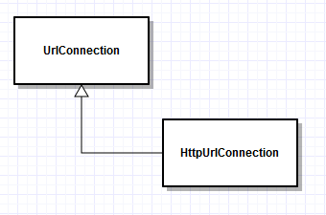

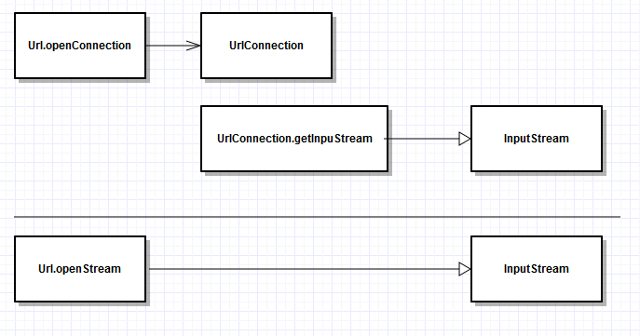

* How to make the screen to be always portrait.
* Holo theme without actionbar.
* How to use a while loop to read data from a stream.
* How to get an image from the internet.
* How to use JSONObject and JSONArray to read and array
* How to use Date, Calendar-GregorianCalendar and SimpleDateFormat.

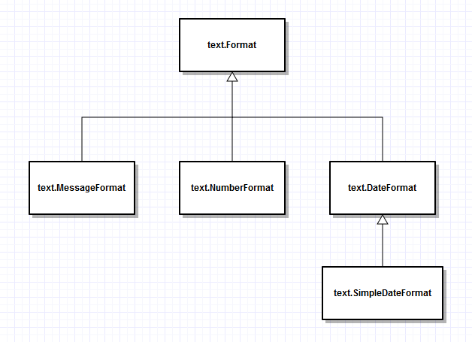

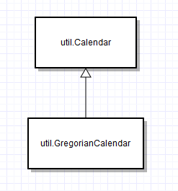

Calendar rightNow = Calendar.getInstance();

GregorianCalendar gc = (GregorianCalendar) new Calendar.Builder().setInstance(Date).build();