What is an adapter?

How to change the background colour of an item when selected.

How set the choice behaviour of the list.

Listener for the ListView.

How to add items to the list.

How to remove items from the list (long click listener).

Hide keyboard until the user touches the EditText.

How to show the button “Done” on soft keyboard and make it hide if there is not action listener.

<EditText  
 android:id="@+id/edittext"  
 android:layout_width="match_parent"  
 android:layout_height="wrap_content"  
 android:imeOptions="actionDone"  
 android:singleLine="true"  
 android:hint="add something to the list"/>

Or make it hide when there is action listener.

InputMethodManager inputMethodManager = (InputMethodManager)

getSystemService(Context.***INPUT_METHOD_SERVICE***);

inputMethodManager.hideSoftInputFromWindow(**mEditText**.getWindowToken(), 0);

Interface Adapter and class AdapterView

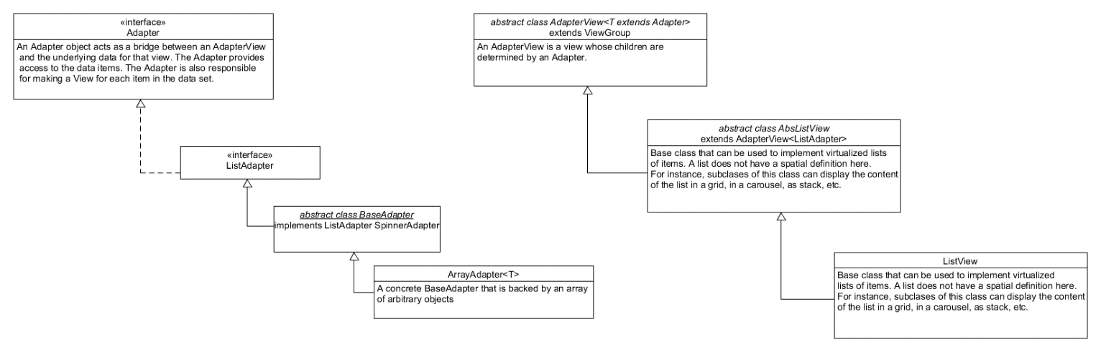

Editor Action Listener

How to keep the items of the list when rotating the screen.