2011 Club Foundation Auction Donation Form

The Club Foundation annual auctions are held in conjunction with CMAA’s World Conference on Club Management and annual exposition - The Club Business Expo. Proceeds from all the special events at Conference all provide essential funds to The Club Foundation’s Grant and Scholarship Programs.
This is a great way for your company to give back to the Association and Foundation, as well as get some
great exposure to club managers!

I/We wish to donate the following item(s):

Name of Item:___________________________________________________________________________________

Detailed Description of Donation (Please include any special instructions and/or restrictions on use or availability of donation in the description): _________________________________________________________________________________________

_________________________________________________________________________________________
_________________________________________________________________________________________

_________________________________________________________________________________________

Shipping Information/Limitations ________________________________________________________________
Please note: Do NOT send your donation at this time. You will receive shipping instructions at a later time

Fair Market Value of Donation: $___________________________ (This MUST be provided by the donor).

Donor Name (as it will appear in all printed materials):______________________________________________

Contact Name:_____________________________________ Title:______________________________________

Address:________________________________________ Telephone:___________________________________

_________________________________________________ Fax: _______________________________________

_________________________________________________ E-Mail:______________________________________

World Wide Web Address:_______________________________________________________________________

Signature:________________________________________ Date:_________________________________________

***PLEASE SEND ALL ELECTRONIC DONATION PHOTOGRAPHS
AND LOGOS TO Lindsey.Baker@clubfoundation.org***

Please complete this form and return with brochures/photographs by January 31, 2011 to:
The Club Foundation * Attn: Lindsey Baker * 1733 King Street * Alexandria, Virginia 22314
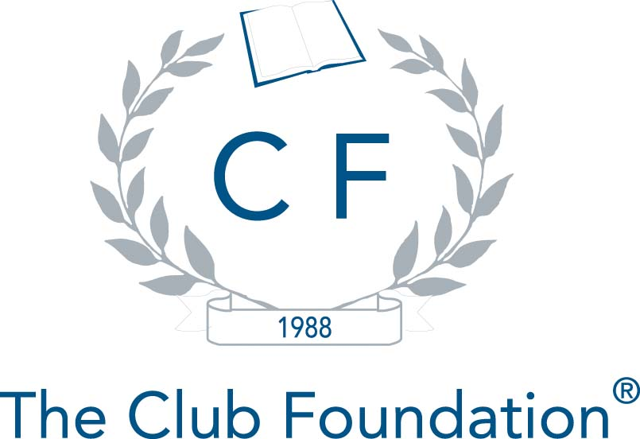
Phone (703) 739-9500 * Fax (703) 739-0124

