Student Chapter Grant Program
2016 - 2017 Application Guidelines
The Club Foundation • 1733 King Street • Alexandria, VA 22314

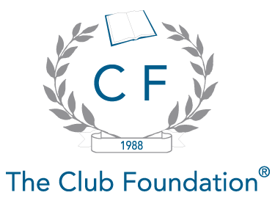

Since 1988, The Club Foundation has made annual grants to CMAA Student Chapters. Currently Conference Travel Grants are awarded to student chapters, on a matching-funds basis, which helps offset the costs associated with attending the annual Conference. The Club Foundation also awards grants that provide the President of the chapter (or another representative selected by the chapter) a complimentary registration to the CMAA World Conference on Club Management.

Conference Matching Grant
The Club Foundation will award up to $500 to a chapter if they meet the following requirements:

- Submit a completed Conference Travel Grant Application with all signatures
- Submit a completed Grantee Form verifying that the previous year’s grant was used for Conference-related expenses, as it was intended.
- Chapter conducted a fundraising event(s) (must include supporting documentation: deposit reports confirming amounts raised, advertising of the event, etc.)
- Submit a copy of the 2015-2016 President’s Annual Report
- Submit a copy of the Current Chapter Budget
- Please note: Chapters should start compiling this information so that all required documentation is available for submission by the May 1, 2016 deadline.
- Restrictions: The $500 amount must be used for expenditures related to the CMAA Annual Conference, i.e., registrations, travel, etc.

Conference Student Registration Voucher
This voucher entitles the President of a CMAA Student Chapter to one free student registration for the CMAA World Conference. If the President is unable to attend, then the voucher may be transferred to another member of the chapter. All additional travel expenses, including transportation to and from Conference, hotel accommodations, meals and entertainment are not included with this voucher and are the responsibility of the individual student.

NOTE: Funds are not to be stockpiled from one year to the next. If a student chapter had monies leftover from the previous year, then that amount is deducted from the Conference Matching Grant Amount to be awarded for the current year.

The Student Chapter Conference Grant is
supported by a generous contribution from



Student Chapter Grant Program
2016 - 2017 Conference Travel Grant Application
The Club Foundation • 1733 King Street • Alexandria, VA 22314

APPLICATION FILING DEADLINE IS MAY 1, 2016

Please note: The Club Foundation Conference Matching Grant Program will match chapter funds earmarked for Conference to a maximum of $500, based on the availability of funds. Applications will be reviewed on a case-by-case basis by the Foundation.

Chapter Name:
Mailing Address: |  |  |  |  | Contact Name:
 |  |  |  |  | Contact Phone:
 |  |  |  |  | Contact E-mail
 |  |  |  |  | Address:
Amount of funds requested for the 2017 Conference (maximum of $500): |  |  |  |  |  |  |  |  | $
Amount of current funds chapter has allocated for the 2017 Conference: |  |  |  |  |  |  |  |  | $
Please list fundraising events your chapter has held and the amount raised (records must be attached proving the amounts raised, i.e. deposit slips, bank statement, or cancelled checks):
 | Event |  |  |  |  |  |  | Amount Raised
1) |  |  |  |  |  |  |  | $
2) |  |  |  |  |  |  |  | $
3) |  |  |  |  |  |  |  | $
4) |  |  |  |  |  |  |  | $
5) |  |  |  |  |  |  |  | $
I (we) certify that the above information is complete and accurate. Please note that all signatures are required for the application to be valid:
Chapter President Signature: |  |  |  |  |  |  | Date:
Faculty Advisor Signature: |  |  |  |  |  |  | Date:
Liaison Manager Signature: |  |  |  |  |  |  | Date:

Student Chapter Grant Program
2015 – 2016 Budget Form
The Club Foundation • 1733 King Street • Alexandria, VA 22314

Student Chapter Name:
Contact Name:
Contact Phone:
Contact E-mail:

Expected Income:
 | Student Chapter Dues |  | $
 | Travel Grant from The Club Foundation |  | $
 | Sponsor Chapter Support |  | $
 | Fundraising Activities: (Describe)
 | 1) |  | $
 | 2) |  | $
 | 3) |  | $
 | 4) |  | $
 | 5) |  | $
 | Other:
 | 1) |  | $
 | 2) |  | $
 | 3) |  | $
Total Income: |  |  | $
Expected Expenses:
 | Administrative:
 |  | Telephone | $
 |  | Postage/Faxes | $
 |  | Office Supplies | $
 |  | Photocopying | $
 | Services:
 |  | Guest Speakers | $
 |  | Printing | $
 |  | Publications | $
 |  | Printed Merchandise | $
 | Events:
 |  | Banquets/Receptions/Dinners | $
 |  | Conferences/Seminars/Training | $
 |  | Student Chapter Meetings | $
 | CMAA Annual Conference:
 |  | Registration Fees | $
 |  | Lodging | $
 |  | Food | $
 |  | Air Fare | $
 |  | Other: | $
Total Expenses: |  |  | $

Student Chapter Grant Program
2016-2017 Application Checklist
The Club Foundation • 1733 King Street • Alexandria, VA 22314

Application
2015-2016 President’s Annual Report
2015-2016 Student Chapter Budget Form
Proof of Fundraising Event(s) - (Must include deposit records with amounts)
Grantee Report Form, if applicable

Please Submit All Documents to:

The Club Foundation
1733 King Street
Alexandria, VA 22314-2720

Phone (703) 739-9500
FAX (703) 739-0124

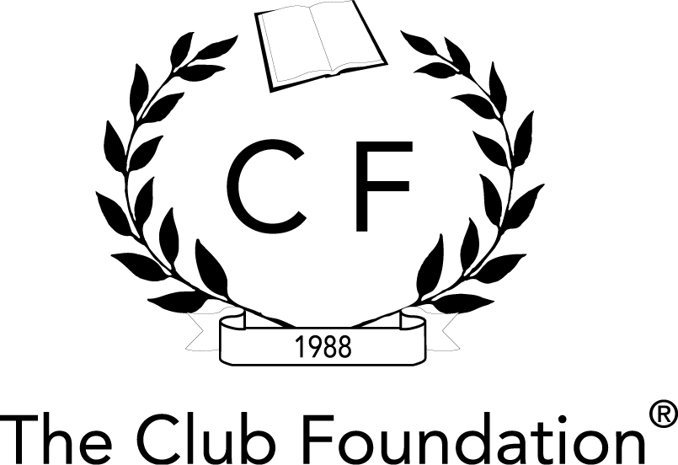

GRANTEE REPORT FORM

This form must be submitted to verify that funds granted through the Student Chapter Grant Program were used for their intended purpose of CMAA World Conference-related expenses.

In accordance with the terms of the grant from The Club Foundation, the undersigned Grantee provides the following report on the use of the grant funds:

Name and address of Grantee:

The date and amount of the Grant: _________________________________________

The requested purpose of the Grant:

Describe the progress made toward achieving the purposes of the Grant:

The amount of the Grant expended by the Grantee during the reporting period:

The undersigned Grantee attests that it has not diverted any portion of the funds from the purpose of the Grant and that it has complied with all of the terms and conditions of the Grant.

GRANTEE:

By:
Its:

BUDGET:

