William Frank
2/4/19
HW3: Game Playing

- Non-Zero-Sum Games
  - If Bob assumes Alice is an optimal agent, then he should teach a hard class. If Alice makes the same assumption of Bob she should choose to work hard. In both cases the agents will attempt to maximize their rewards, and in doing so maximize the reward for the other agent.
  - Instead of one value that is either minimized or maximized, we need a tuple of values for all agents. Each agent can then choose to maximize their own value or minimize the values of their opponents. Alternatively you could use the expectimax algorithm, which calculates a reward based on what the opponent is expected to do, instead of assuming they will minimize your reward.
  - Bob goes first and both agents are acting optimally
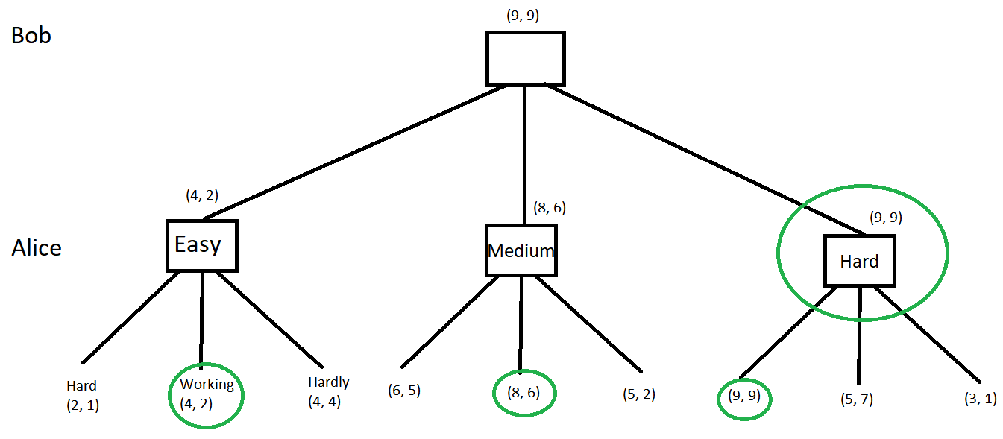
  - Expectimax for Bob. Teaching a hard class will give Bob the best expected reward, 6.85
