William Frank
1/24/20
Database Systems – Homework 2

Diagram 1:
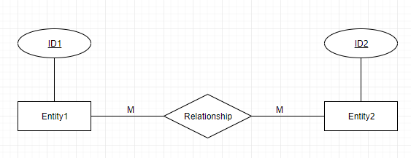
Diagram 2:
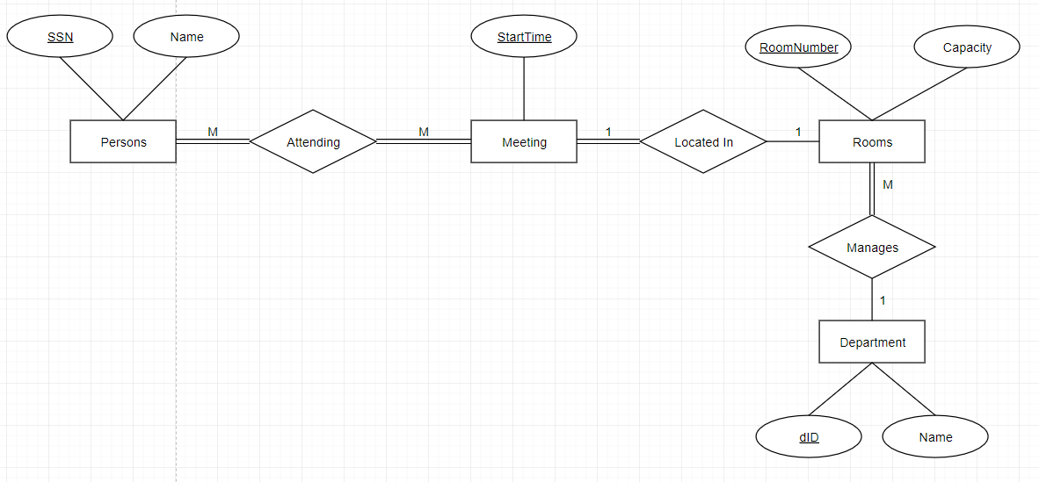

Schema SQL:

create table Persons (
SSN varchar(12) not null,
Name varchar(100) not null,
primary key (SSN)
)

create table Attending (
SSN varchar(12) not null,
StartTime DateTime not null,
RoomNumber unsigned int not null,
primary key (SSN, StartTime, RoomNumber),
foreign key (SSN) references Persons(SSN),
foreign key (StartTime) references Meetings(StartTime),
foreign key (RoomNumber) references Meetings(RoomNumber)
)

create table Meetings (
StartTime DateTime not null,
RoomNumber unsigned int not null,
primary key (StartTime, RoomNumber),
foreign key (RoomNumber) references Rooms(RoomNumber)
)

create table Rooms (
RoomNumber unsigned int not null,
Capacity unsigned int not null,
dID unisigned int not null,
primary key (RoomNumber)
foreign key (dID) references Departments(dID)
)

create table Departments (
dID unsigned int not null,
Name varchar(32) not null,
primary key (dID)
)

Diagram 3:
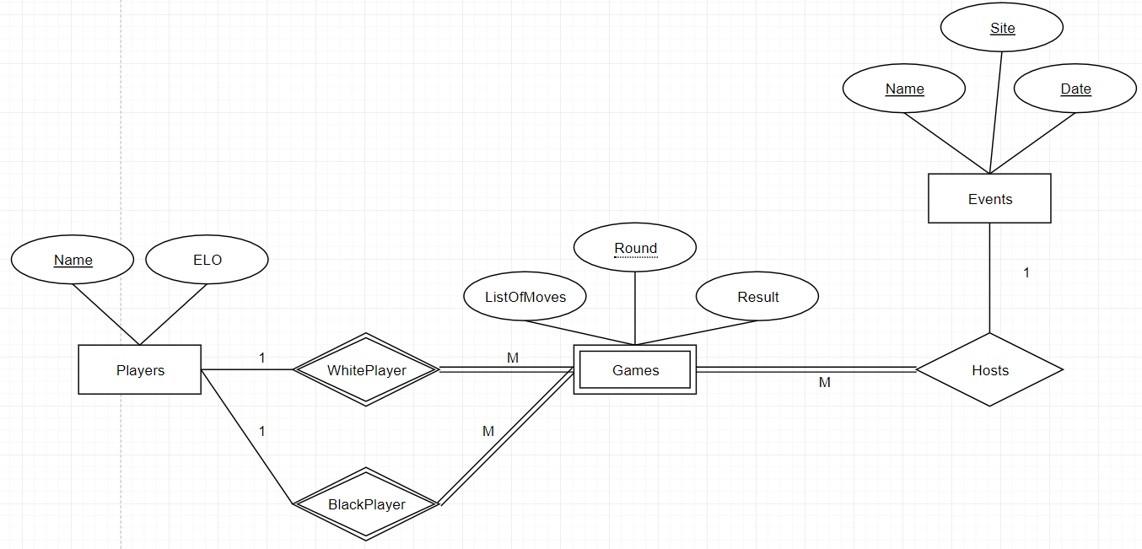
Schema SQL:

create table Events (
Name varchar(32) not null,
Site varchar(32) not null,
Date Date not null,
primary key (Name, Site, Date)
)

create table Games (
Round unsigned int not null,
ListOfMoves varchar(1000),
Result char(1),
EventName varchar(32) not null,
EventSite varchar(32) not null,
EventDate Date not null,
WhitePlayer varchar(32) not null,
BlackPlayer varchar(32) not null,
foreign key (WhitePlayer) references Players(Name),
foreign key (BlackPlayer) references Players(Name),
foreign key (EventSite, EventDate, EventName) references Events(Site, Date, Name)
primary key (Round, WhitePlayer, BlackPlayer, EventSite, EventDate, EventName)
)

create table Players (
Name varchar(32) not null,
ELO int,
primary key (Name)
)

