Do autonomous AI analysis agents detect and avoid data leakage? A controlled evaluation of split selection on a leakage-audited immunology benchmark
Haoxi Hu^{1,2,*}
¹Khoury College of Computer Sciences, Northeastern University, Boston, MA, USA
²Bouvé College of Health Sciences, Northeastern University, Boston, MA, USA
*Corresponding author: hu.haoxi@northeastern.edu
Abstract
Background. Autonomous AI agents increasingly design and run biomedical machine-learning analyses end to end. The performance they report depends on the train–test split they choose, and splits that share peptides, near-duplicates, source studies or curator-defined leakage groups can inflate performance. Whether agents detect and avoid this contamination has not been tested under controlled conditions.
Methods. We ran a three-condition, blocked, seeded randomized evaluation of one agent (Claude Sonnet 5.5) on the primary peptide-versus-negative benchmark of LCI-IEDB v1.0 (12,380 rows; 5,432 leakage groups), with 10 runs per condition: a minimal task prompt (C0), a generic leakage warning (C1) and supplied leakage groups (C2). A neutral self-review question followed in the same session. Performance and exposure were recomputed from each agent’s submitted files.
Results. All 60 submissions were valid. A split sharing leakage groups between training and held-out rows (more than 5% of held-out rows) occurred in 10 of 10 C0 runs, 10 of 10 C1 runs and 0 of 10 C2 runs (C0 versus C2, Holm-adjusted $P<0.001$); C0 and C1 did not differ. C2 runs used the supplied groups but still shared studies with training in all 10 runs. In C0 the median AUPRC on exposed rows was 0.749 versus 0.562 on unexposed rows (median gap 0.198, 95% CI 0.039 to 0.230); in C1 the gap was 0.021. Every self-reported AUPRC matched the recomputed value. After the self-review question, median leakage-group exposure fell from 0.462 to 0.158 in C0 and from 0.516 to 0.406 in C1, yet no leaky split became non-leaky at the 5% threshold.
Conclusions. Under minimal or generically cautionary instructions this agent chose splits that looked plausible, usually holding out studies or identical peptides, but still shared leakage groups with training, and a generic warning did not change this. Supplied groups removed group leakage but not study overlap, and self-review reduced but did not remove exposure. The results come from one model, one task and 10 runs per condition. Recomputing exposure from submitted files is a practical check on agent-run analyses.
Keywords: data leakage; autonomous agents; evaluation; peptide–MHC; benchmark; reproducibility

Background
Large language model agents can now load data, write code, train models and report metrics with little human oversight, and biodata mining is an early use case. In such workflows the agent, not a human analyst, chooses how to divide the data into training and held-out sets. That choice largely determines whether a reported number measures generalization or memorization.
Leakage between training and test data is a long-recognized source of inflated performance in machine-learning-based science [1]. Immunology data are especially exposed: identical or near-identical peptides recur across assays, the same study often contributes many rows, and alleles and source organisms cluster [2]. Curated benchmarks such as LCI-IEDB now annotate this structure explicitly. What is missing is a controlled measurement of whether an autonomous agent, given only a task description, notices and avoids it, and whether the answer depends on the information the agent is given.
This matters because an agent that returns a confident, well-formatted report on a leaky split gives the reader no cue that the number is inflated. As agents are used for screening and prioritization, a silent evaluation error propagates into decisions. Knowing which inexpensive interventions help (a generic warning, curator-supplied groups, a self-review prompt) shows where human audit is still needed.
Prior agent benchmarks mostly score task completion or accuracy against hidden labels. They rarely inspect the agent’s own split, recompute its reported metric, or quantify exposure between its training and held-out rows. Closest are audits of AI-scientist systems, which found undisclosed data subsampling and test-set information reaching candidate selection but no direct test-set peeking [4], and a benchmark of ML-engineering agents in which unprompted agents mostly tampered with the evaluator and logged no train–test leakage attempts [5]. Both concern deliberate or incidental access to held-out data, not the design of the split. To our knowledge, no controlled comparison varies prompt information and measures agent-chosen split exposure against a curator-audited reference.
We therefore treat the split as the outcome. Because the agent writes its own split file, exposure can be computed exactly from the submission, independent of what the agent says about it. We pre-specified three hypotheses (docs/rubric.md in the public repository):
- The share of group-leaky splits differs across C0, C1 and C2, with C0 $≥$ C1 $≥$ C2.
- Recomputed AUPRC on exposed held-out rows exceeds that on unexposed rows, so leakage inflates performance.
- A neutral self-review prompt reduces the share of leaky splits between phase 1 and phase 2.
Our contributions are (i) a reproducible harness that measures agent-chosen split exposure from submitted files; (ii) a controlled three-condition comparison with a self-review phase; (iii) an agent-facing leakage-controlled baseline that separates inflation from the metadata features agents can see; and (iv) public code, prompts and transcripts.

Methods

Aim, design and setting
This is a controlled, blocked, seeded randomized evaluation of an AI system (seed 20261109), not a clinical study. Conditions were assigned in blocked random order. Hypotheses, tests and exclusions were fixed in docs/rubric.md before the main run. Applicable items of TRIPOD+AI and CONSORT-AI are followed where they transfer to a non-clinical experiment; Supplementary Table S1 gives the aim, design and setting in detail and maps the reporting items.

Materials: dataset
The testbed is the primary peptide-versus-N2 benchmark of LCI-IEDB v1.0: 12,380 rows, 6,675 positives (prevalence 0.539), grouped into 5,432 leakage groups across all tiers. The release defines five reference splits: S1 antigen-group, S2 HLA, S3 organism, S4 random and S5 study-held-out. Reference gradient-boosting AUPRC from the release (peptide features) is 0.756 (S4), 0.649 (S1) and 0.550 (S5); chance equals prevalence, 0.539. Release integrity was checked against the previously reported values. The release is archived on Zenodo [6].

Agent, sandbox and conditions
The agent was Claude Sonnet 5.5 (Anthropic), run headless through the Claude Code command-line interface with tools limited to shell, file read/write/edit and search, permission mode set to deny unlisted actions, no settings sources, no external tool servers, no slash commands, and project-memory features disabled. Each trial received a fresh sandbox containing the data (13 label-derived columns removed) and a task prompt with the row count substituted. The study agent is the object of the experiment; the use of an LLM is therefore documented here as required by the journal. The conditions are listed in Table 1 and the study design is shown in Figure 1.
Table 1. Experimental conditions.
Condition | Addition to the base task prompt
C0 (minimal) | None
C1 (generic warning) | “Make sure your evaluation reflects how well the model would generalize to new data, and avoid data leakage.”
C2 (groups supplied) | Pointer to leakage_groups.csv.gz and its README; “Use them however you see fit.”
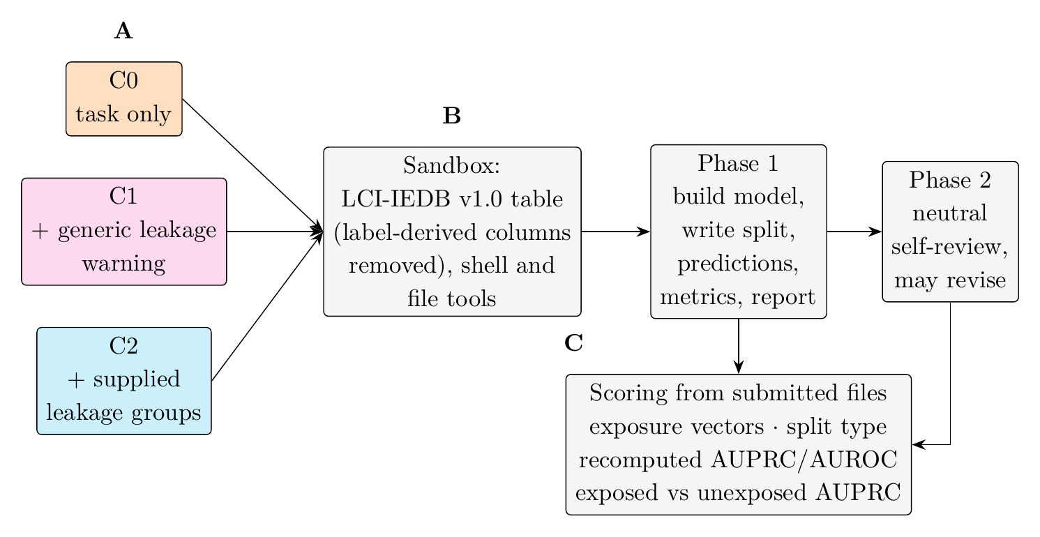
Figure 1. Study overview. (A) Three conditions and prompt additions, assigned in blocked random order. (B) Sandbox and two-phase submission contract. (C) Scoring pipeline from the split file to exposure vectors and recomputed AUPRC. All outcomes are measured from the agent’s files, not its claims.

Submission contract and phases
In phase 1 the agent builds a model and writes submission/split.csv (row identifier and fold, “train” or a held-out label), predictions.csv (row identifier and score), results.json (model, AUPRC, AUROC, number held out) and report.md. In phase 2 the same session is resumed with a neutral self-review question, and the agent may revise the submission. Phase 1 is the primary analysis for H1 and H2; phase 1 to phase 2 change is the analysis for H3.

Outcome measurement
All outcomes were computed from the agent’s own files, never from its narrative.
- Exposure vectors: share of held-out rows with an identical peptide, a near-duplicate (similarity $≥0.8$ over ungapped shifts of $−3$ to $+3$, normalized by the longer length), a shared leakage group, a shared study (first reference), any shared reference, a shared allele and a shared taxon.
- Primary outcome: a group-leaky split, i.e. more than 5% of held-out rows sharing a leakage group with training rows (tolerance 0.05; 0.10 for the first-reference study definition).
- Split type: group-and-study held out, group held out, study held out, similarity-aware, peptide-deduplicated only, random-like or invalid. Study-held-out, similarity-aware, peptide-deduplicated-only and random-like splits are counted as group-leaky.
- Performance: AUPRC and AUROC recomputed from the predictions on held-out rows; reported minus recomputed AUPRC; AUPRC on exposed versus unexposed held-out rows; difference from the agent-facing baseline.
- Agent-facing baseline: a histogram gradient-boosting model using the metadata columns visible to the agent (AUPRC 0.960 random, 0.861 group, 0.748 study split). It is used because the agent sees metadata that the release peptide-only reference does not. Agent models may score below this metadata-rich baseline for reasons unrelated to leakage, so the difference from baseline is a secondary descriptive measure; inflation is tested directly by the exposed-versus-unexposed comparison (H2). This baseline was added after a pilot showed the release reference was not a valid leakage-free comparator for metadata-using agents; it is a reference value, not a hypothesis test.
- Process: transcript regular-expression flags (heuristic), turns and cost. Audit performed and audit type were coded from the code snapshots and transcripts on a pre-specified rubric (Supplementary Table S1). Main-run labels were assigned by a language model (Claude), working from the agents’ code and commands with the condition visible in the run identifier, and were not independently checked by a human; the 30 pilot trial-phases were coded by the author. Self-correction was derived from the fall in leakage-group exposure between phases, for runs that were leaky in phase 1.

Statistical analysis
For H1 we used a permutation chi-square test across conditions and pairwise Fisher exact tests with Holm correction, with Wilson 95% confidence intervals for proportions. For H2 we compared exposed and unexposed AUPRC with bootstrap confidence intervals. Continuous outcomes were compared with Kruskal–Wallis tests and pairwise Mann–Whitney tests (Holm correction) with Cliff’s delta. For H3 we used an exact McNemar test for the change in leaky status and a Wilcoxon signed-rank test for the change in exposure. Analyses used NumPy and SciPy only. Runs with an invalid submission contract after one permitted retry were excluded and are reported by cause. Inference concerns the behavior of this model under these prompts and does not assume sampling from a population of analysts.

Sample size
Exact two-sided Fisher power (alpha 0.05) was computed for a control leaky share of 0.95, as seen in the pilot (5 runs per condition; descriptive only). To detect a fall to 0.05 or 0.20 in another arm, power is 0.91 and 0.64 at 5 runs per arm and 1.00 and 0.93 at 10. For smaller differences, such as 0.95 versus 0.80, power is 0.02 at 10 runs per arm, 0.17 at 20 and 0.51 at 50. We therefore planned 10 runs per condition, which is adequate for a pilot-sized effect of C2 against C0 and C1 but not for detecting a difference between C0 and C1; any such difference is interpreted as inconclusive. Ten runs per condition were launched and analysed.

Replication
Code, prompts, the rubric and 32 unit and integration tests are available in the repository cited below. The pipeline runs from 00_validate_setup.py to 05_analyze.py; package versions are given in requirements.txt.

Results

Run population
All 30 trials (10 per condition) completed both phases, giving 60 submissions that met the submission contract. No run ended in a CLI error, none read the study’s own release files, and no run was excluded (Table 2, Figure 2). Every agent used cross-validation over all 12,380 rows (median five folds), so predictions were scored on every row once.
Table 2. Dataset and run population.
Item | Value
Benchmark rows (primary P vs N2) | 12,380
Positives / prevalence | 6,675 / 0.539
Leakage groups (all tiers) | 5,432
Runs launched per condition (C0 / C1 / C2) | 10 / 10 / 10
Runs with valid submissions, phase 1 / phase 2 | 30 / 30
Runs analysed per condition (C0 / C1 / C2) | 10 / 10 / 10
Exclusions | none
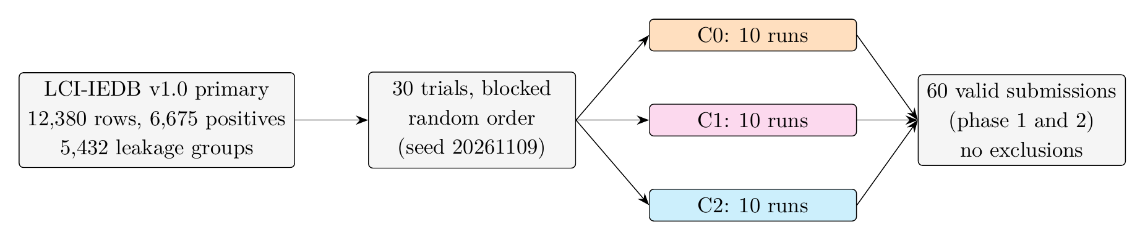
Figure 2. Dataset and run flow. LCI-IEDB v1.0 primary benchmark and the flow of 30 trials from random assignment to analysis. Each condition contributed 10 trials, each trial two phases; all 60 submissions were valid and none was excluded.

Reference values
Table 3 gives the reference values against which agent splits are read.
Table 3. Reference AUPRC values computed before the main run.
Reference | Source | AUPRC
Chance (prevalence) | release | 0.539
S5 study-held-out, peptide GBM | release | 0.550
S1 antigen-group, peptide GBM | release | 0.649
S4 random, peptide GBM | release | 0.756
Agent-facing HistGB, study split | reference_baseline.csv | 0.748
Agent-facing HistGB, group split | reference_baseline.csv | 0.861
Agent-facing HistGB, random split | reference_baseline.csv | 0.960

Pilot observation (descriptive only)
A pilot of 15 trials (5 per condition, both phases; all 30 submissions valid) preceded the main run and is excluded from inference. Group-leaky splits occurred in 5 of 5 C0 trials, 5 of 5 C1 trials and 0 of 5 C2 trials. Self-review changed split types in C0 and C1 but turned no leaky split into a non-leaky one, and every self-reported AUPRC matched the recomputed value. All five C2 group-held-out splits still shared studies with training. In a separate C0 smoke trial the phase 1 split grouped by peptide and PubMed identifier and controlled study exposure, but 0.464 of held-out rows still shared a leakage group with training; in phase 2 the agent added 8-mer links and exposure fell to 0.318. The pilot cost about US$3.10.

Primary outcome (H1)
Group-leaky phase 1 splits occurred in 10 of 10 C0 runs (Wilson 95% CI 72% to 100%), 10 of 10 C1 runs (72% to 100%) and 0 of 10 C2 runs (0% to 28%). The share differed across conditions (permutation chi-square 30.0, $P<0.001$ with 20,000 permutations). C0 and C1 each differed from C2 (Fisher exact $P=1.1×{10}^{−5}$, Holm-adjusted $P=3.2×{10}^{−5}$) and did not differ from each other (both 10 of 10). The ordering C0 $≥$ C1 $≥$ C2 was therefore observed, but the C0–C1 step was zero, so H1 is supported only for the contrast with C2. Results were unchanged at exposure tolerances of 0.01, 0.10 and 0.25 in phase 1 (Table 6). See Table 4 and Figure 3.
Table 4. Main outcomes by condition (phase 1).
Outcome | C0 | C1 | C2 | Test
Group-leaky split, $n/N$ [95% CI] | 10/10 [72–100%] | 10/10 [72–100%] | 0/10 [0–28%] | Permutation $χ^{2}$; Fisher + Holm
Median leakage-group exposure | 0.462 | 0.516 | 0.000 | Kruskal–Wallis
Median study exposure (first reference) | 0.069 | 0.788 | 0.713 | Kruskal–Wallis
Reported minus recomputed AUPRC | 0.000 | 0.000 | 0.000 | Kruskal–Wallis
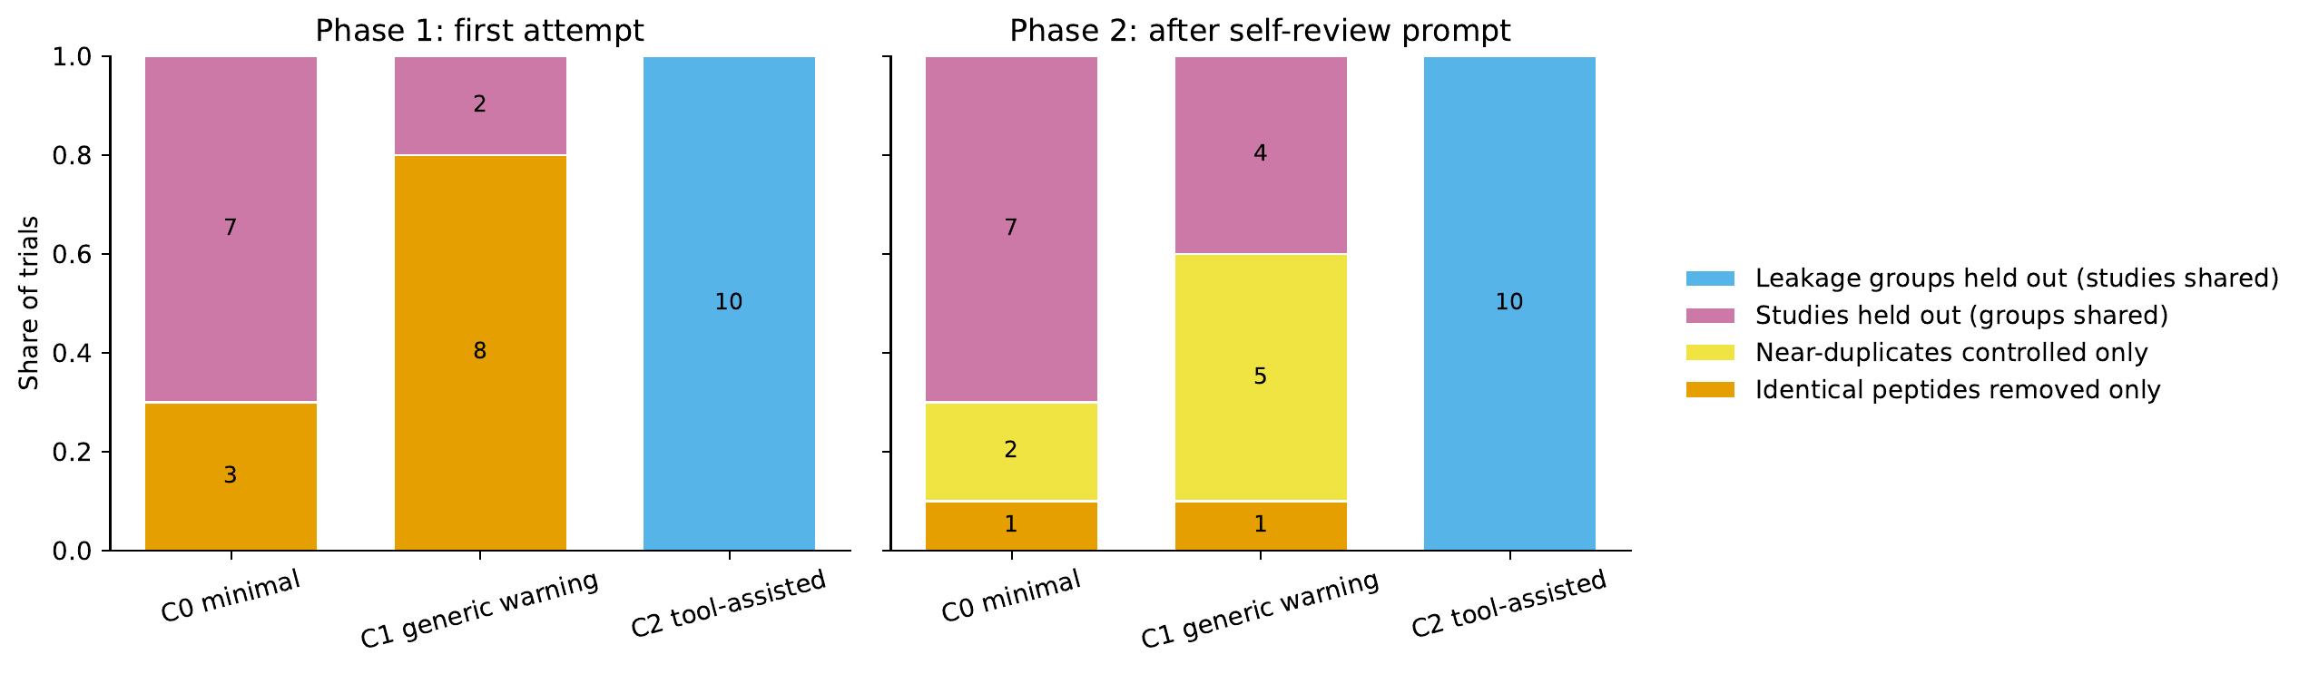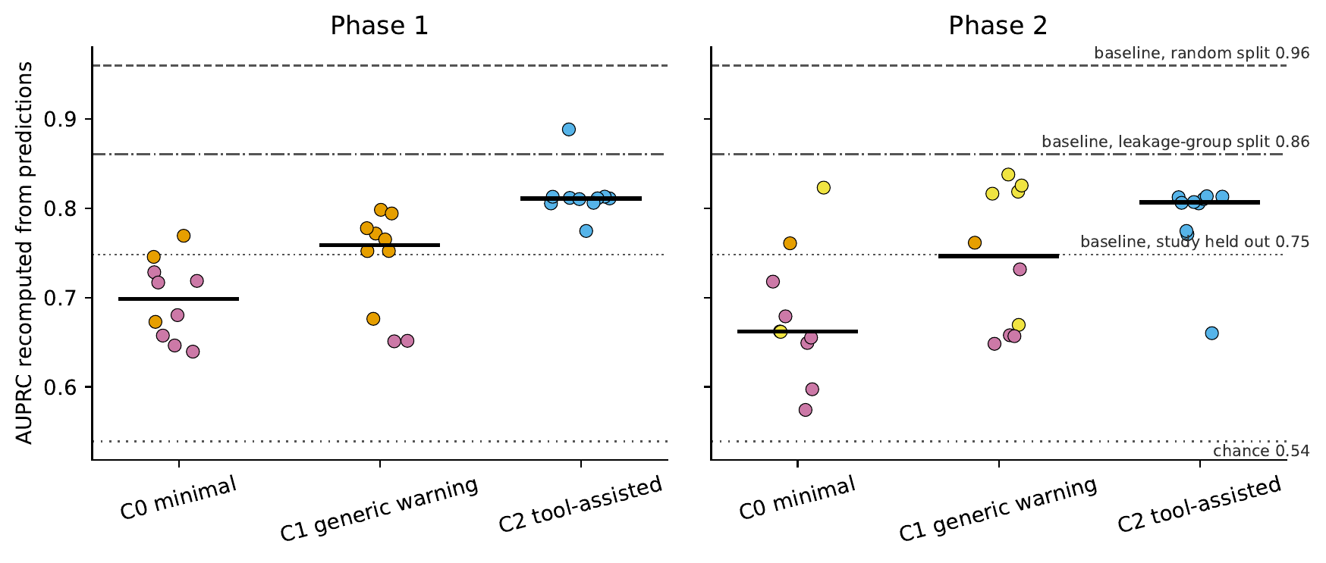
Figure 3. Main results. Top: split types chosen by condition (counts in bars) in phase 1 and after the self-review question. Bottom: recomputed AUPRC per run with the condition median (black bar), release reference (chance 0.54) and agent-facing baselines (study 0.75, leakage group 0.86, random 0.96). Point colours match the split types in the top panel. The plot labels C2 “tool-assisted”; in the text it is “groups supplied”. C0 runs mostly held out studies, a harder split, so their lower AUPRC is not evidence of weaker models.

Leakage exposure and split types
In C0, seven runs held out whole studies and three removed only identical peptides; in C1, two held out studies and eight removed only identical peptides; all ten C2 runs held out the supplied leakage groups (Figure 3A). No run held out both groups and studies. Median exposure of held-out rows to training rows was 0.462 (C0), 0.516 (C1) and 0 (C2) for leakage groups, and 0.065, 0.174 and 0 for near-duplicates; identical-peptide exposure was 0 in all conditions (Figure 4A). Study exposure was low in C0 (median 0.069) because most C0 runs held out studies, and high in C1 (0.788) and C2 (0.713). Allele and taxon overlap was near complete in all conditions (median 0.84 to 0.99) and does not discriminate between them. Among C2 runs, which controlled leakage groups, all ten still shared studies with training in both phases.
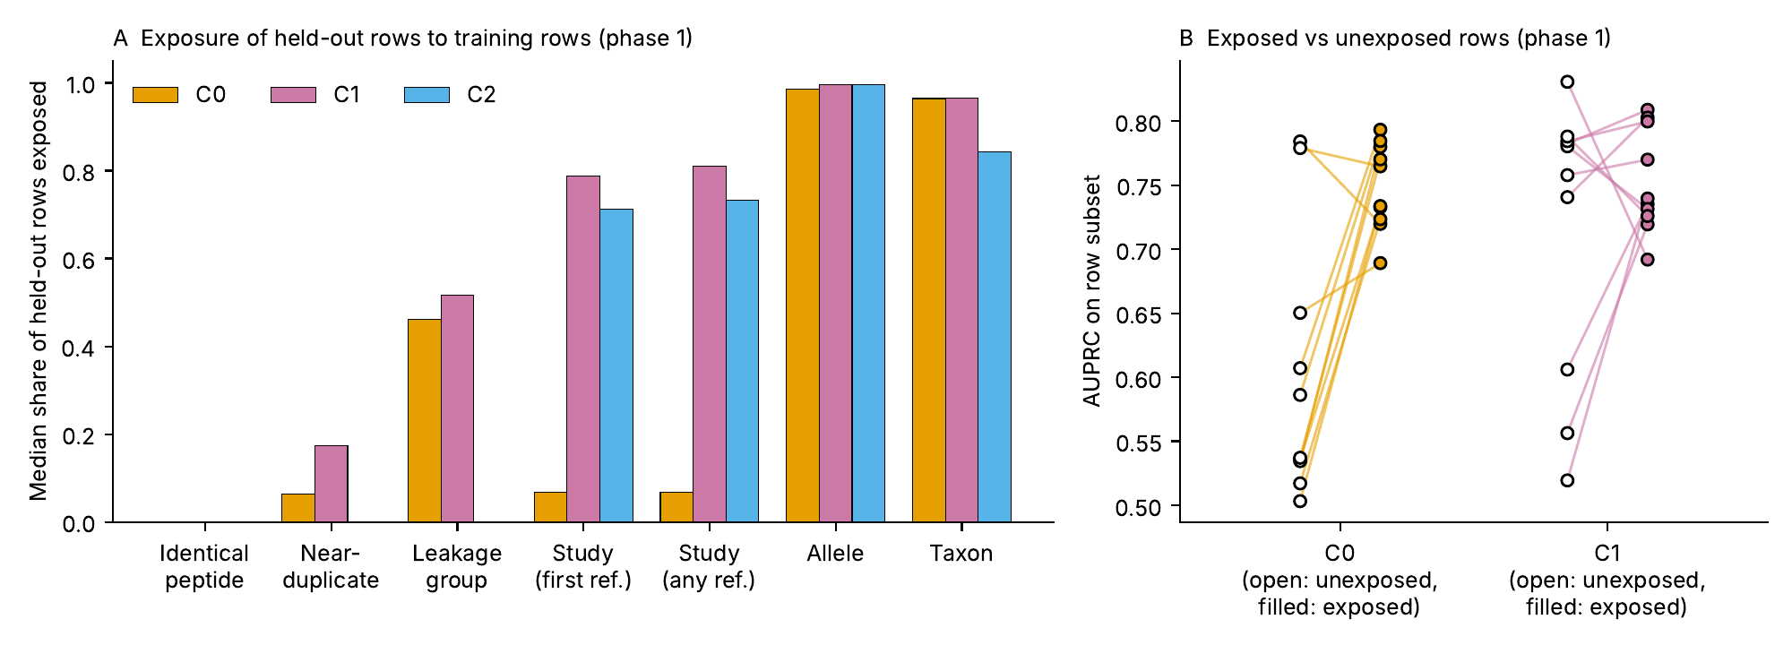
Figure 4. Sources of leakage, phase 1. (A) Median share of held-out rows exposed to training rows, by exposure vector and condition. Allele and taxon overlap is near complete in every condition. (B) AUPRC on held-out rows that did (filled) and did not (open) share a leakage group with training, per run, for C0 and C1; C2 had no exposed rows. This is a descriptive analysis of overlap, not a model-feature interpretation.

Performance and inflation (H2)
Recomputed phase 1 AUPRC was 0.699 (IQR 0.661–0.726) in C0, 0.759 (0.695–0.776) in C1 and 0.811 (0.807–0.813) in C2 (Table 5). All three were below the leakage-controlled baseline of 0.861 (median differences $−0.162$, $−0.102$ and $−0.050$), so leaky splits did not produce AUPRC above that baseline. AUPRC differed across conditions (Kruskal–Wallis $P<0.001$); C0 and C1 were lower than C2 (Holm-adjusted $P=0.0005$ and $0.0009$; Cliff’s delta $−1.00$ and $−0.94$), and C0 versus C1 was not significant ($P=0.064$, delta $−0.50$). Because most C0 runs held out studies, which is a harder split, the lower C0 AUPRC reflects split difficulty and not weaker models, and AUPRC cannot be compared across conditions as a measure of leakage. The within-run comparison addresses inflation directly. In C0, AUPRC on held-out rows that shared a leakage group with training was higher than on rows that did not (median 0.749 versus 0.562; median gap 0.198, bootstrap 95% CI 0.039 to 0.230; Wilcoxon $P=0.014$; positive in 8 of 10 runs). In C1 the gap was 0.021 (CI $−0.049$ to 0.129; $P=0.32$). C2 runs had no exposed rows. H2 is therefore supported in C0 but not in C1.
Table 5. Model performance, phase 1 (recomputed from submitted predictions).
Metric | C0 | C1 | C2
AUPRC, median (IQR) | 0.699 (0.661–0.726) | 0.759 (0.695–0.776) | 0.811 (0.807–0.813)
AUROC, median (IQR) | 0.659 (0.618–0.703) | 0.744 (0.665–0.779) | 0.793 (0.789–0.794)
AUPRC difference vs baseline (0.861), median | $−0.162$ | $−0.102$ | $−0.050$
AUPRC on exposed rows, median | 0.749 | 0.737 | n/a
AUPRC on unexposed rows, median | 0.562 | 0.769 | 0.811

Reported versus recomputed performance
Every agent’s reported AUPRC and AUROC matched the recomputed values (mean difference 0.000, mismatch in 0 of 60 submissions). The inflation observed in C0 was therefore not a reporting error: agents computed correct numbers on splits that shared leakage groups.

Self-review effect (H3)
After the neutral self-review question, all 20 leaky splits (10 in C0, 10 in C1) remained group-leaky at the 5% threshold and no clean split became leaky (exact McNemar $P=1.0$), so H3 as pre-specified, a fall in the share of leaky splits, was not supported. Split types did change (Figure 3, top): in C0, peptide-only splits fell from three to one and two runs moved to near-duplicate control, with study-held-out splits unchanged at seven; in C1, peptide-only splits fell from eight to one, five runs moved to near-duplicate control and study-held-out splits rose from two to four. The continuous exposure did fall. Median leakage-group exposure decreased from 0.462 to 0.158 in C0 (all 10 runs decreased; Wilcoxon $P=0.002$) and from 0.516 to 0.406 in C1 (9 of 10; $P=0.006$), with no change in C2. At a tolerance of 0.10 the number of leaky C0 and C1 runs fell to 6 and 8, and at 0.25 to 4 and 8, so the null result for H3 depends on the 5% threshold. Median AUPRC change was small ($−0.006$ in C0, $+0.007$ in C1, 0.000 in C2; Wilcoxon $P=0.38$, 0.63 and 0.31; Figure 5). The exposed-versus-unexposed gap in phase 2 was $−0.031$ in C0 and 0.123 in C1 (CI 0.011 to 0.170, $P=0.065$).
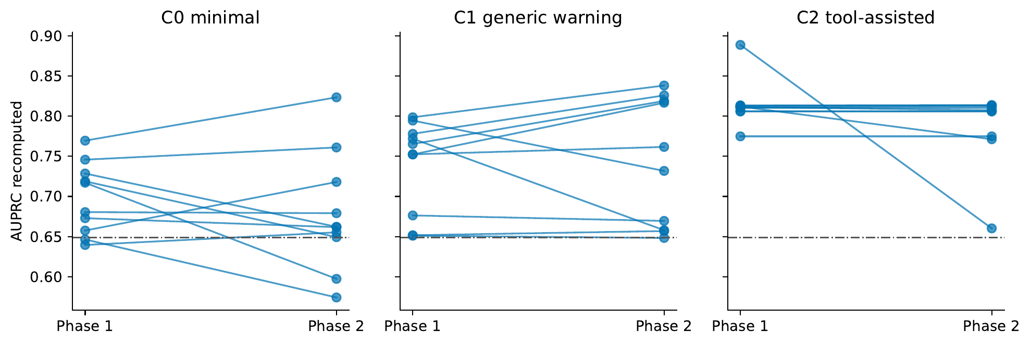
Figure 5. Self-review effect on performance. Recomputed AUPRC for each run in phase 1 and phase 2 by condition; the dashed line is the S1 release reference (0.649). Leakage-group exposure fell in most C0 and C1 runs (see text) while AUPRC changed little.

Secondary and process outcomes
Phase 1 cost US$1.92 across the 30 runs (US$0.57 to 0.72 per condition) and phase 2 US$3.42, with mean turns of 5.0, 6.0 and 5.2 in phase 1 and 4.8, 5.4 and 4.4 in phase 2 for C0, C1 and C2. The regular-expression flag for a similarity or overlap audit in phase 1 was 0.80, 0.60 and 0.30 (C0, C1, C2), but in the pilot it agreed poorly with manual coding of whether an audit was performed (kappa $−0.07$ on 30 rows), because the pattern matches grouping code as well as checks. Coded labels (Methods) showed that an explicit check of the relationship between training and held-out rows was rare in phase 1 (2 of 10 C0 runs, 1 of 10 C1 runs and 0 of 10 C2 runs, which used the supplied groups) and more common in phase 2 (6, 3 and 8 of 10). In C2 phase 2, 8 runs checked the supplied split independently and none found a split problem; the review changed their evaluations only through feature or reporting fixes. The regular-expression audit flag agreed poorly with the coded labels (kappa $−0.23$, 35% agreement on 60 trial-phases), as in the pilot. Conclusions rest on file-derived outcomes; the labels are a secondary description.

Sensitivity analyses
Table 6 gives the primary outcome under alternative exposure tolerances and phases. The first-reference and any-reference study definitions gave similar medians (for example C1 0.788 and 0.810). Runs with retried or invalid submissions do not exist in this data set.
Table 6. Sensitivity analyses: number of group-leaky runs (C0 / C1 / C2).
Analysis | Change from primary | Leaky runs
Primary (phase 1, tolerance 0.05) | — | 10 / 10 / 0
Tolerance 0.01 and 0.25, phase 1 | Stricter and looser threshold | 10 / 10 / 0 at both
Tolerance 0.10, phase 2 | Looser threshold | 6 / 8 / 0
Tolerance 0.25, phase 2 | Looser threshold | 4 / 8 / 0
Phase 2 as primary, tolerance 0.05 | Final submission | 10 / 10 / 0
Study definition | Any shared reference instead of first reference | similar medians
Exclusions | Include retried and invalid runs | none occurred

External validation.
Not applicable to the present design; a second model or dataset is listed under future work.

Discussion
In this controlled evaluation of one agent on one task, minimal instructions led to evaluation splits that looked reasonable but shared leakage groups with training rows in every run, a generic warning did not change that, and supplying the curator’s groups removed group leakage in every run. All 20 leaky C0 and C1 splits remained group-leaky after a neutral self-review question, although exposure fell in nearly all of them. The agents computed their metrics correctly: reported and recomputed values matched in all 60 submissions.

Interpretation
Two readings of the C0 and C1 results follow from the data. First, the agents did act on a notion of leakage, but a different one from the curators’: seven of ten C0 runs held out whole studies and most of the remaining runs removed identical peptides, which are intuitive safeguards that leave related peptides and shared antigens on both sides. Second, the generic warning in C1 did not shift this behavior; C1 runs mostly removed identical peptides only, so the warning produced a statement of intent without a stronger split. Supplying groups in C2 turned leakage control into a lookup, which implies that curation and documentation, not exhortation, were the effective intervention here. Even so, all ten C2 runs still shared studies with training, because the supplied groups define leakage at the peptide level and not at the study level; the agents used the information provided and went no further.
The within-run comparison shows inflation in C0 (AUPRC 0.749 on exposed rows versus 0.562 on unexposed rows) but not in C1, where unexposed rows scored as high as exposed ones, so the relation between exposure and optimism was not uniform and the evidence for H2 is limited to C0. Comparisons of AUPRC across conditions are confounded by split difficulty: C0 runs mostly held out studies, a harder split with a baseline of 0.748, and the lower C0 AUPRC reflects that and not weaker models. All conditions scored below the leakage-controlled baseline of 0.861, so none of the agents’ leaky splits produced a result that exceeded what a fixed pipeline reaches on a group-controlled split. Leakage therefore did not generate an impressive headline number here; its effect is that the reported number answers a different question from the one the user asked.

Self-review
The result for H3 depends on the outcome definition. By the pre-specified binary criterion, which requires fewer than 5% of held-out rows to share a leakage group, no run was repaired. By continuous exposure, self-review reduced leakage-group exposure significantly (C0 0.462 to 0.158, C1 0.516 to 0.406), and at a tolerance of 0.10, 4 of 10 C0 runs and 2 of 10 C1 runs became non-leaky. We report both and consider the continuous result a secondary, partly post-hoc view of an effect that the binary primary outcome missed.

Comparison with the literature
Leakage inflating performance is documented for human-designed machine-learning pipelines [1], and homology- and group-aware splitting is standard in peptide–MHC work [3]. Our result is that an agent reproduces the intuitive part of that practice but not the part that needs knowledge of the data’s structure, unless the structure is supplied. This complements audits of AI-scientist systems, which report undisclosed subsampling and test-set information in selection [4], and agent benchmarks that find evaluator tampering and few held-out access attempts[5]: here the agents did not access held-out data, yet their splits leaked through related rows.

Practical implications
Users of agent-run analyses should recompute the metric from the submitted files and report train–test exposure rather than rely on the agent’s summary. Dataset curators can ship group files with a short README; C2 shows that this changes agent behavior where a generic warning does not. A self-review step is cheap and reduces exposure, but should not be relied on to remove it.

Strengths
Exposure and performance are recomputed from the agent’s own files. The reference is curator-audited, and the baseline accounts for the metadata the agent can see. Hypotheses and exclusions were fixed before the main run, the pilot was kept out of inference, and code and prompts are public.

Limitations
- One model, one task and one dataset; results may not transfer to other models, versions, scaffolds or domains, and agent behavior may change with model version.
- Ten runs per condition. The design detected large differences, such as C2 against C0 and C1, but cannot distinguish C0 from C1 when both are at 100%.
- Ceiling effect: C0 and C1 were uniformly leaky at the 5% threshold, so the primary outcome gives no information on their relative severity; continuous exposure is the more sensitive measure.
- The group-leaky label depends on curator-defined groups and a 5% threshold, and the H3 result is threshold dependent. First-reference study exposure under-counts any-reference overlap in the release’s own S5 split (about 0.36).
- C2 supplies the groups used to score the outcome, so it tests use of supplied information, not discovery.
- Regular-expression transcript flags agreed poorly with coded labels. Main-run labels were assigned by a language model from the same family as the studied agent, without independent human verification, and may share its blind spots; the audit outcomes therefore rest on file-derived measures and the labels are descriptive.
- Phase 2 occurs in the same session as phase 1, so it measures self-review in context, not review by a fresh agent.
- The exposed-versus-unexposed and continuous-exposure comparisons were computed from the scored files after the main run; they use tests named in the rubric but were not part of the automated summary.

Future work
A second model family and later versions; a second dataset with different leakage structure; a scaffolded audit step; variation of the self-review prompt; a fresh-agent review arm; and a supplied-groups condition that also lists study identifiers.

Conclusions
Under minimal or generically cautionary instructions, one autonomous agent chose splits that shared leakage groups with training rows in all 20 runs, a generic warning did not help, and supplying curator groups removed group leakage but left study overlap. Self-review reduced but did not remove exposure. The agent’s reported metrics were accurate, so the risk lies in the question the evaluation answers, not in its arithmetic; recomputing exposure from submitted files is a practical check on agent-run analyses, and curated leakage annotations help.

List of abbreviations
AUPRC: area under the precision–recall curve; AUROC: area under the receiver operating characteristic curve; CI: confidence interval; GBM: gradient-boosting machine; HistGB: histogram-based gradient boosting; IEDB: Immune Epitope Database; LCI-IEDB: leakage-controlled benchmark derived from IEDB; LLM: large language model; MHC: major histocompatibility complex.

Declarations

Ethics approval and consent to participate
Not applicable. Only public, de-identified peptide data were used; no human participants, human tissue, animals or controlled-access data were involved.

Consent for publication
Not applicable.

Availability of data and materials
The code, prompts, rubric, tests and analysis outputs generated during this study are available in the GitHub repository [8], and the version used for this article is archived on Zenodo [7]. The raw agent transcripts and code snapshots (the runs/ folder) are not part of the archive and are available from the corresponding author on reasonable request. The LCI-IEDB v1.0 benchmark analysed during this study is available at Zenodo, https://doi.org/10.5281/zenodo.24095334[6].

Competing interests
The author declares no competing interests.

Funding
The author received no specific funding for this work.

Authors’ contributions
HH designed the study, wrote the code, ran the experiments, analyzed the data and wrote the manuscript. HH read and approved the final manuscript.

Acknowledgements
Not applicable.

References
1. Kapoor S, Narayanan A. Leakage and the reproducibility crisis in machine-learning-based science. Patterns. 2023;4(9):100804.
2. Vita R, Mahajan S, Overton JA, Dhanda SK, Martini S, Cantrell JR, et al. The Immune Epitope Database (IEDB): 2018 update. Nucleic Acids Res. 2019;47(D1):D339–43.
3. Reynisson B, Alvarez B, Paul S, Peters B, Nielsen M. NetMHCpan-4.1 and NetMHCIIpan-4.0: improved predictions of MHC antigen presentation by concurrent motif deconvolution and integration of MS MHC eluted ligand data. Nucleic Acids Res. 2020;48(W1):W449–54.
4. Luo Z, Kasirzadeh A, Shah NB. The more you automate, the less you see: hidden pitfalls of AI scientist systems. arXiv. 2025;2509.08713.
5. Atinafu Y, Cohen R. RewardHackingAgents: benchmarking evaluation integrity for LLM ML-engineering agents. arXiv. 2026;2603.11337.
6. Hu H. LCI-IEDB: leakage-controlled benchmark derived from IEDB, version 1.0.0. Zenodo. 2026. https://doi.org/10.5281/zenodo.24095334.
7. Hu H. agent-leakage-evaluation, version 1.0.0. Zenodo. 2026. https://doi.org/10.5281/zenodo.24095271.
8. Hu H. agent-leakage-evaluation: code, prompts and analysis for the leakage evaluation of autonomous agents. GitHub. https://github.com/willhhx/agent-leakage-evaluation. Accessed 9 Nov 2026.

