Qs: 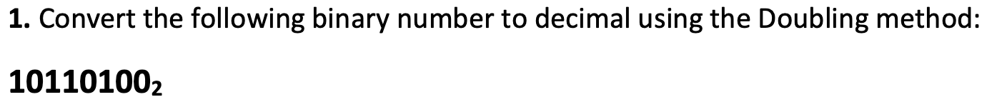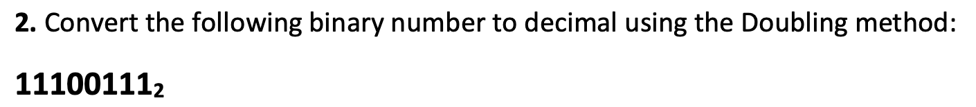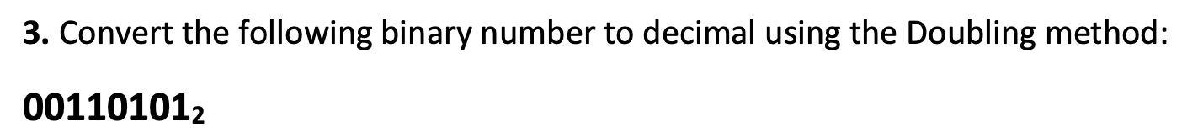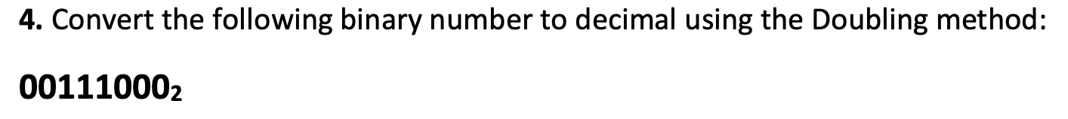

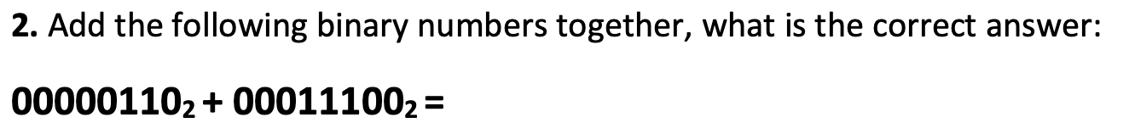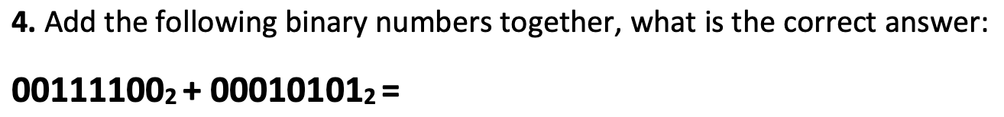



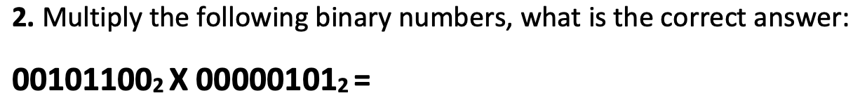

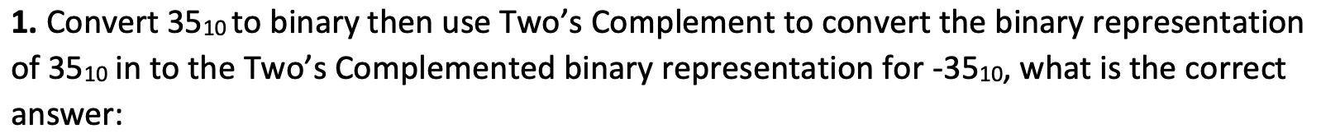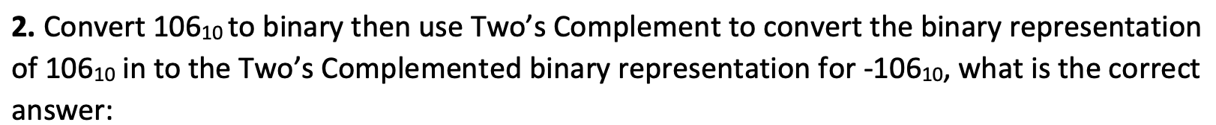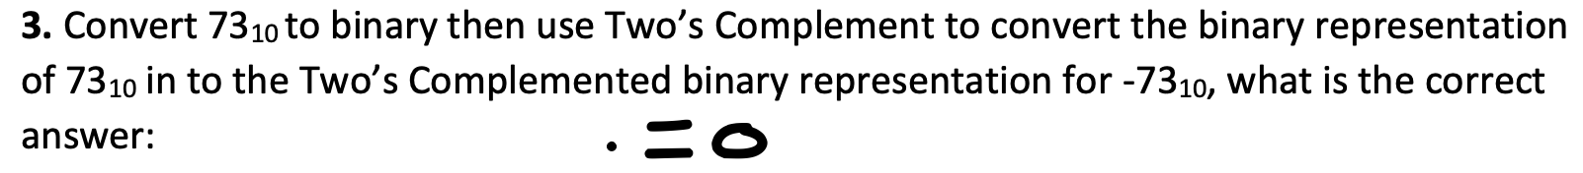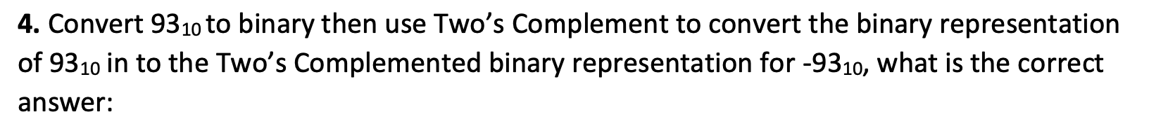

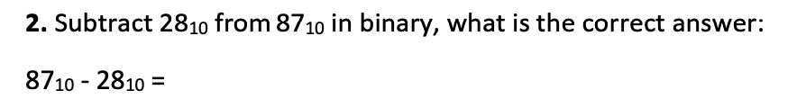

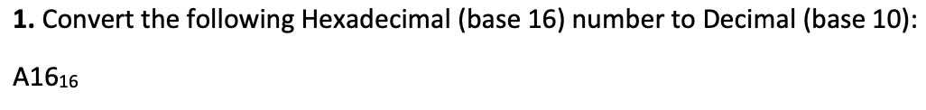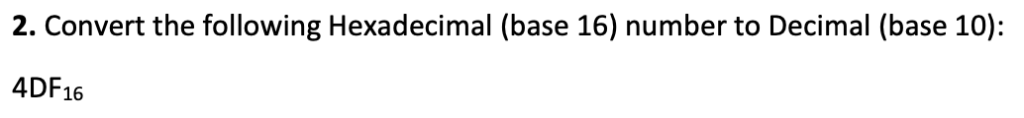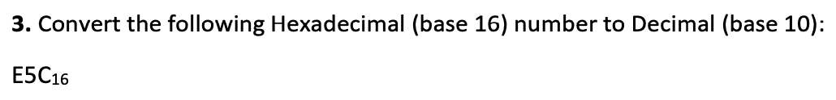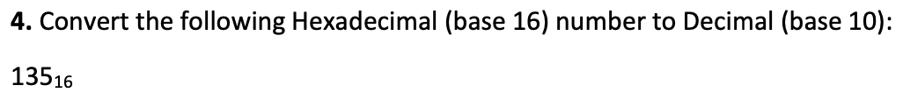

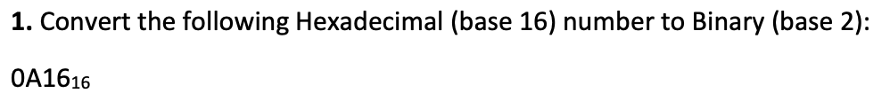

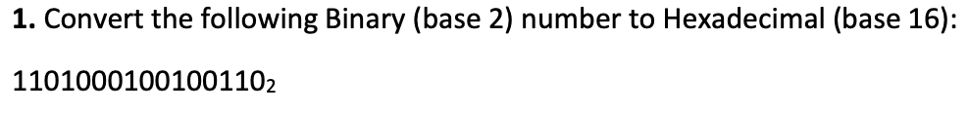

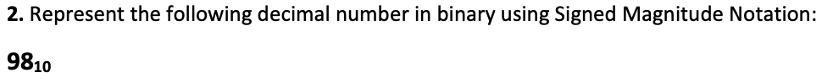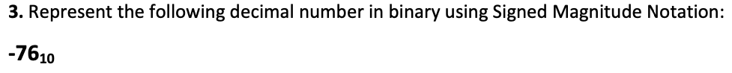





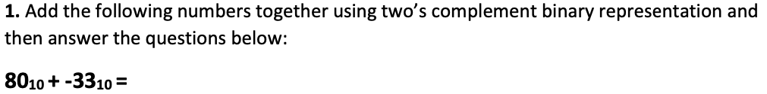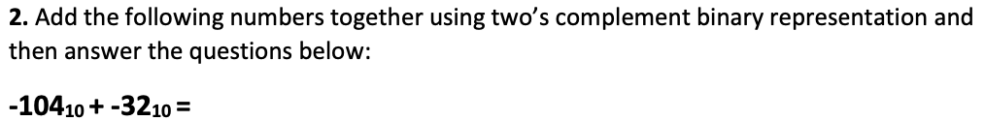



















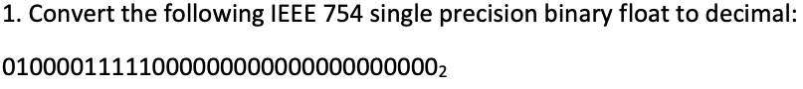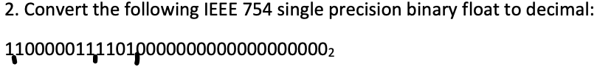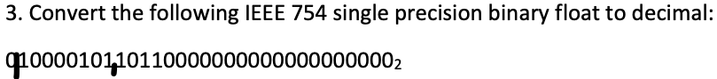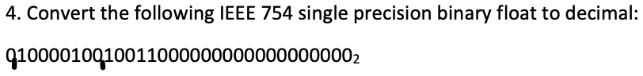

24.5 in IEEE (010000100110001)

-63.75 in IEEE (11000010111111111)

