**R_HW1_YOLO**

**Q1.**

**(b)**

Mean=25.04348

Median=25

Min=51

Max=0

Range=0 51

**(c)**

Standard deviation=14.27164

5 percentile=1.1

95 percentile=46.8

**(d)**

Mode=30

Frequency=3

**(e)**

30 30 30

**Q2.**

<skip>

**Q3.**

**(b)**

4

**Q4.**

Sigma(500)=6.792823

log(500)+0.6= 6.814608

Compare: the sigma equotation - the log equotation = -0.02178467

Sigma(2000)=8.178368

log(2000)+0.6=8.200902

Compare: the sigma equotation - the log equotation = -0.02253436

Sigma(8000)=9.564475

log(8000)+0.6=9.587197

Compare: the sigma equotation - the log equotation = -0.02272184

**Q5.**

x=-10000

count=1

**Q6.**

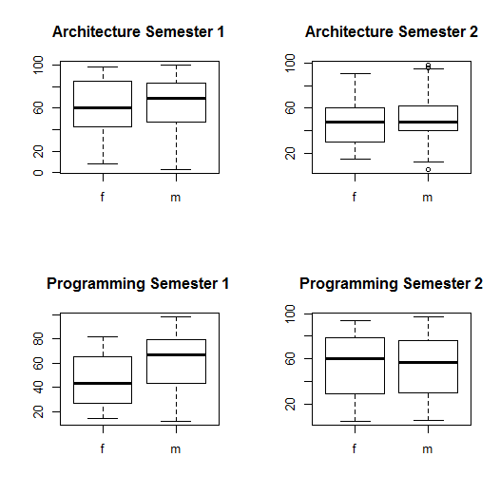

**Q7.**

**(a)**

4!=12

50!= 3.041409e+64

5000!= Inf

**(b)**

$$C_{2}^{4}=6$$

$$C_{20}^{50}=4.712921e+13$$

$$C_{2000}^{5000}=Inf$$

**(c)**

5000! = e^37591.14

$C_{2000}^{5000}$ = e^3360.594

**Q8.**

**(a)**

k=144

**(b)**

n=12

**(c)**

all=1, 1, 3, 5, 8, 13, 21, 34, 55, 89, 144

**Q9.**

2, 3, 5, 7, 11, 13, 17, 19, 23, 29, 31, 37, 41, 43, 47, 53, 59, 61, 67, 71, 73, 79, 83, 89, 97

**Q10.**

