Q1

Answer: 0.04235393

Q2

(a)

$$l\left(p\right)=log⁡(\prod_{i=1}^{n}{p^{x_{i}}}{(1-p)}^{1-x_{i}})$$

已知 l’ = 0 ，表示將此方程式微分後可得解

$$\log{l(p)}= \sum_{i=1}^{n}{x_{i}}\log{p}+\left(n-\sum_{i=1}^{n}{x_{i}}\right)\log{(1-p})$$

微分

$$\frac{d(\log{l(p))}}{dp}= \frac{\sum_{i=1}^{n}{x_{i}}}{p}- \frac{n-\sum_{i=1}^{n}{x_{i}}}{1-p}=0$$

$$\sum_{i=1}^{n}{x_{i}}-p\sum_{i=1}^{n}{x_{i}}=np-p\sum_{i=1}^{n}{x_{i}}$$

得解

$$\hat{p}=\frac{\sum_{i=1}^{n}{xi}}{n}$$

(b)

bernoulli.MLE(50) #answer is 0.08

bernoulli.MLE(5000) #answer is 0.003

bernoulli.MLE(500000) #answer is 0.000362

(c)

求exponential distribution的 $\hat{λ}$

$$l\left(λ\right)= \prod_{i=1}^{n}{{λe}^{-λx_{i}}}=λ^{n}e^{-λ\sum_{i=1}^{n}{x_{i}}}$$

取ln 消e

$$\ln{l(λ)}=n*\ln{λ}-λ\sum_{i=1}^{n}{x_{i}}$$

又得知 一階微分 = 0 有極值

$$\frac{d lnl(λ)}{dλ}= \frac{n}{λ}- \sum_{i=1}^{n}{x_{i}}=0$$

得解

$$\hat{λ}=\frac{n}{\sum_{i=1}^{n}{x_{i}}}$$

求 exponential distribution 的 memory less property (在指數和幾何分配才有)

$$P\left(X>s+t | X>s\right)= \frac{P(X>s+t ∩ Y>t)}{P(X>s)}=\frac{P(X>s+t)}{P(X>s)}$$

$$P\left(X>s+t\right)=\int_{s+t}^{∞}{{λe}^{-λx}dx}= -e^{-λx}|\begin{matrix}∞ \\ s+t\end{matrix}= e^{-(s+t)λ}$$

$$P\left(X>s\right)=\int_{s}^{∞}{{λe}^{-λx}dx}= -e^{-λx}|\begin{matrix}∞ \\ s\end{matrix}= e^{-(s)λ}$$

$$P\left(X>s+t | X>s\right)=\frac{P(X>s+t)}{P(X>s)}=\frac{e^{-(s+t)λ}}{e^{-sλ}}=e^{-tλ}=P(x>t)$$

(d)

exponential.MLE(50) #answer is 0.01947052

exponential.MLE(5000) #answer is 0.01026765

exponential.MLE(500000) #answer is 0.0004299465

Q3

(a)

car.accident = c(rep(0,109),rep(1,65),rep(2,22),rep(3,3),rep(4,1))

(b)

# lambda = 0.61

# loglik = -206.1067

(c)

#200*P(X= 0 |lambda)= 108.6702

#200*P(X= 1 |lambda)= 66.28881

#200*P(X= 2 |lambda)= 20.21809

#200*P(X= 3 |lambda)= 4.111011

#200*P(X= 4 |lambda)= 0.6269291

#200*P(X> 4 |lambda)= 0.08499439

(d)

#200*P(X= 0 |n,p)= 108.5689

#200*P(X= 1 |n,p)= 66.42965

#200*P(X= 2 |n,p)= 20.22141

#200*P(X= 3 |n,p)= 4.083024

#200*P(X= 4 |n,p)= 0.6151976

#200*P(X> 4 |n,p)= 0.08178472

Q4

(a)

X= 0 Binomial= 0.01152922 Poisson = 0.01831564 Normal = 0.02699548

X= 1 Binomial= 0.05764608 Poisson = 0.07326256 Normal = 0.0647588

X= 2 Binomial= 0.1369094 Poisson = 0.1465251 Normal = 0.1209854

X= 3 Binomial= 0.2053641 Poisson = 0.1953668 Normal = 0.1760327

X= 4 Binomial= 0.2181994 Poisson = 0.1953668 Normal = 0.1994711

X= 5 Binomial= 0.1745595 Poisson = 0.1562935 Normal = 0.1760327

X= 6 Binomial= 0.1090997 Poisson = 0.1041956 Normal = 0.1209854

X= 7 Binomial= 0.05454985 Poisson = 0.05954036 Normal = 0.0647588

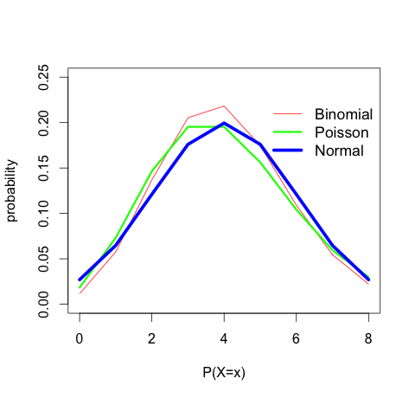X= 8 Binomial= 0.02216088 Poisson = 0.02977018 Normal = 0.02699548

(b)

Q5

(a)

0.03714103, 0.20062868, 0.16510514, 0.93295083, 0.40116581

(b)

0 1 1 3 1

(c)

7.428205e-02 4.012574e-01 3.302103e-01 8.659017e-01 8.023316e-01

4.375744e-01 5.280313e-01 6.140324e-01 2.774438e-01 6.490677e-01

9.153417e-01 9.707938e-01 4.560381e-01 9.983520e-01 9.943846e-01

1.660512e-01 8.432264e-02 6.206549e-01 3.370464e-01 1.854915e-01

7.431562e-01 4.211249e-01 5.090182e-01 4.751732e-01 2.857753e-01

7.885678e-01 6.869716e-01 4.449599e-02 1.516160e-01 5.166173e-01

7.232887e-01 2.423170e-01 8.997467e-01 9.917295e-01 9.347819e-01

6.296274e-01 2.565081e-01 1.703238e-01 2.840663e-01 7.086703e-01

4.517655e-01 7.986084e-01 9.063692e-01 5.133213e-02 4.712058e-01

4.574419e-01 7.068392e-01 2.233039e-01 7.608875e-01 6.103702e-05

(d)

1 3 3 6 6 4 4 4 3 5 7 8 4 11 10 2 2 4 3 2 5 3 4 4 3 6 5 1 2 4 5 3 7 10 7

5 3 2 3 5 4 6 7 1 4 4 5 2 5 1

table 結果

|  |  |  |  |  |  |  |  |  |  |  |
| --- | --- | --- | --- | --- | --- | --- | --- | --- | --- | --- |
| 數字 | 1 | 2 | 3 | 4 | 5 | 6 | 7 | 8 | 10 | 11 |
| 總數 | 4 | 6 | 9 | 11 | 8 | 4 | 4 | 1 | 2 | 1 |

(e)

two-people tables customers: 10

four-people tables customers: 20

six-people tables customers: 12

private room tables customers: 8