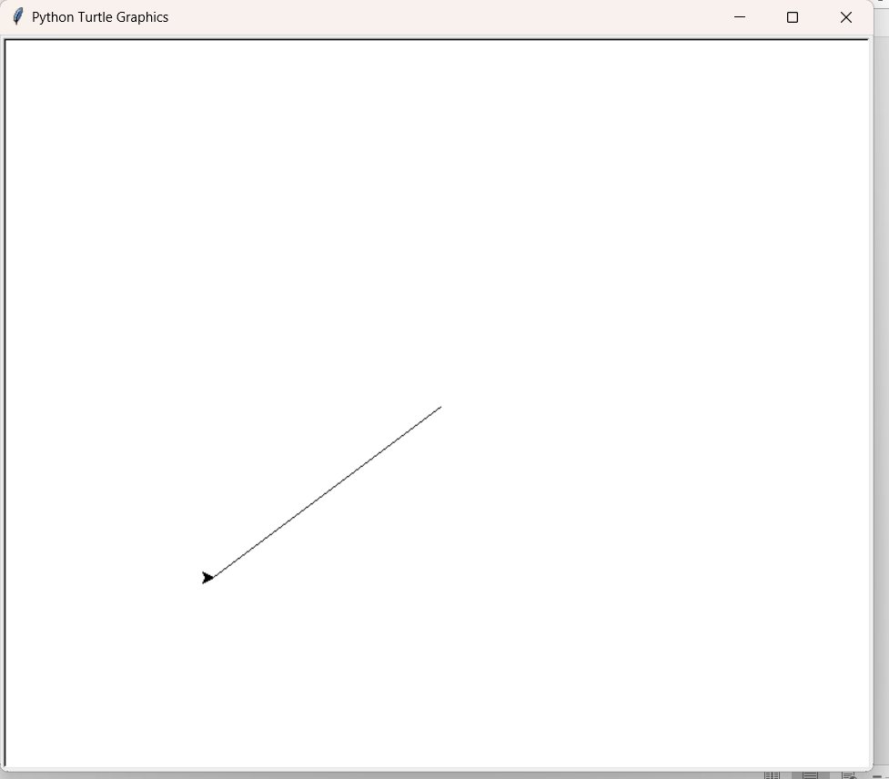
canvas_size = 400, 300
pointer = -200, - 150
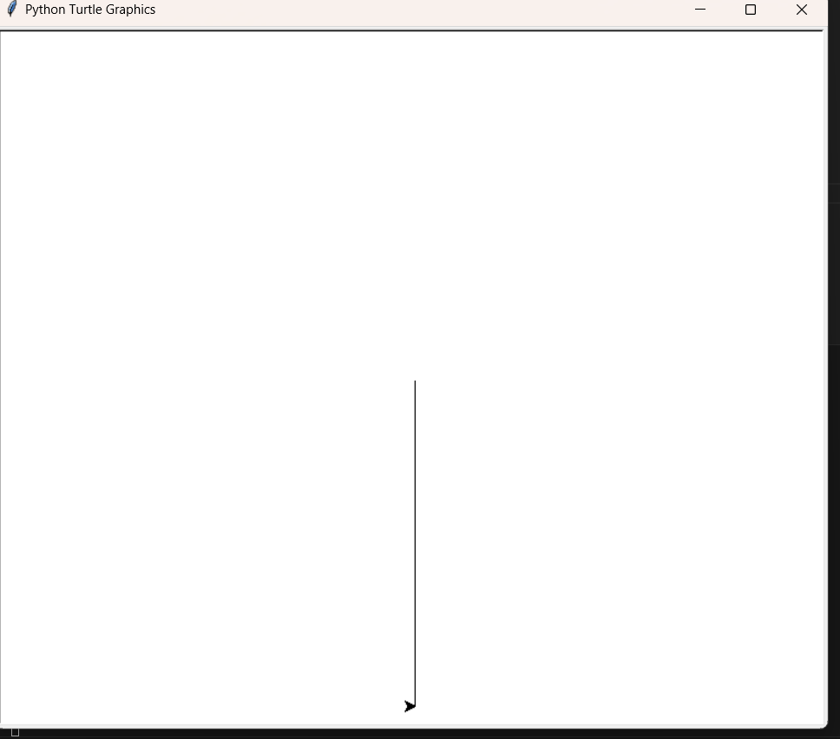
canvas_size = 400, 300
pointer = 0, - 300

Differences between changing drawable area with setworldcoordinate and screensize?
The relationship between logical units and pixel units in the Turtle library is crucial for understanding how the canvas behaves. Let me break it down for you with a clear explanation and the factors that govern this relationship.

🧠 Key Concepts:
- Logical Units: These are the coordinate units in the logical coordinate system that you set using screen.setworldcoordinates(left, bottom, right, top). Logical units define where the turtle moves relative to the origin (0, 0), and they can be scaled based on your world coordinate settings.
- Pixel Units: These refer to the actual physical screen pixels (the individual dots on your screen). The pixel unit is the measurement used by the actual display of the Turtle window. When you get the canvas size with canvas.winfo_width(), you get it in pixels.

🌍 Relationship Explained:
The relationship between logical units and pixel units is controlled by your coordinate system settings and canvas size. Specifically:
- Default Setting:
If you haven't altered the world coordinates using setworldcoordinates(), then by default:
  - 1 logical unit = 1 pixel
  - The coordinate system directly maps to the screen pixels.
- Changing Coordinate System: When you use screen.setworldcoordinates(left, bottom, right, top), you are scaling the logical coordinate system. This means that 1 logical unit no longer directly corresponds to 1 pixel.

🧮 How the Relationship Works:
Let's say you set the world coordinates like this:
python
CopyEdit
screen.setworldcoordinates(-1000, -1000, 1000, 1000)
This means your logical coordinate system is now a "world" that ranges from -1000 to 1000 along both the x and y axes.

Example 1:
- Your window size might be 800 x 600 pixels.
- But your logical coordinate system spans from -1000 to 1000 on both axes, making it 2000 x 2000 logical units.
- In this case:
  - 1 logical unit ≠ 1 pixel
  - To convert between them, you would scale:
    - Width in logical units: 2000 units = 800 pixels
    - Therefore, 1 logical unit ≈ 0.4 pixels.

Example 2:
If you have this setup:
python
CopyEdit
screen.setworldcoordinates(-500, -400, 500, 400)
- The logical coordinate system spans 1000 x 800 units, and your canvas is still 800 x 600 pixels.
- In this case:
  - 1 logical unit ≈ 1 pixel for the x-axis, but since the height is stretched, it will scale differently on the y-axis.
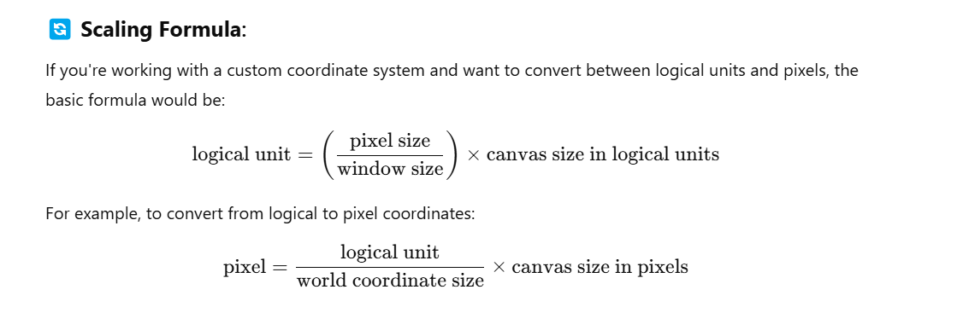
Example Code to Visualize the Relationship:
import turtle

screen = turtle.Screen()
screen.setup(800, 600) # Set window size in pixels
screen.setworldcoordinates(-500, -400, 500, 400) # Set logical coordinates

print("Screen size in pixels:", screen.screensize()) # Logical units in pixels

canvas = turtle.getcanvas()
print("Canvas pixel size:", canvas.winfo_width(), "x", canvas.winfo_height()) # Canvas pixel size

t = turtle.Turtle()
t.penup()
t.goto(-500, -400) # Move to the bottom-left of logical space
t.pendown()
t.goto(500, -400) # Move to the bottom-right of logical space
t.goto(500, 400) # Move to the top-right of logical space
t.goto(-500, 400) # Move to the top-left of logical space
t.goto(-500, -400) # Back to bottom-left
t.hideturtle()

turtle.done()

Expected Behavior:
- If world coordinates are set as (-500, -400, 500, 400) and the canvas is 800 x 600, then:
  - The logical units will stretch across the screen.
  - 1 logical unit ≠ 1 pixel, so drawing shapes will look stretched or compressed depending on the aspect ratio.

🏁 Key Takeaways:
- 1 logical unit can be smaller or larger than 1 pixel, depending on how you've set up the coordinate system with setworldcoordinates().
- By default, 1 logical unit = 1 pixel if you don't change the coordinate system.
- When you scale the logical space, Turtle will automatically scale the drawing area to fit, so you might see non-1:1 mappings between logical units and pixels.

I hope this clarifies the relationship between logical units and pixel units! Let me know if you want further examples or details!

Purpose of screensize():
- screensize() is meant to define the scrollable area (the area the turtle can draw in) on the canvas in terms of canvas units (logical coordinates), not pixels.
- It does not change the coordinate system or the mapping of logical units to pixels. It just sets the drawable area.
When you call screensize(width, height), you're just specifying the scrolling region for drawing, not the coordinate system itself.

Coordinate System: setworldcoordinates():
- To change the logical coordinate system (where the turtle operates and how the drawing is mapped), we use setworldcoordinates(left, bottom, right, top).
- This function maps the world of your logical coordinates to the screen's pixels — for instance, changing the origin (0, 0), scaling, or stretching the coordinates.
This is the function you need when you want to reshape how the turtle moves and scales the drawing area, which screensize() can’t do.

Confusion giữa các AI về đơn vị của screensize()
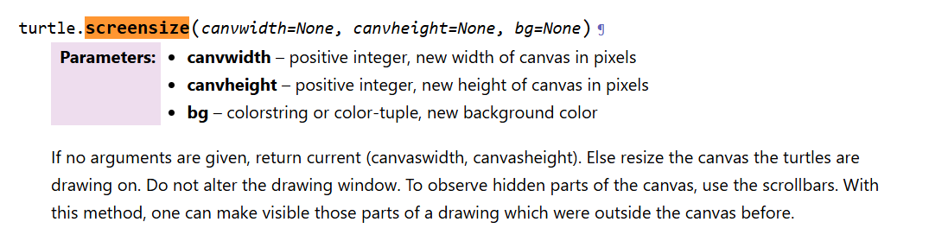

Test setworldcoordinate()
import turtle

screen = turtle.Screen()

# Set custom coordinate system
# screen.setworldcoordinates(-150, -200, 150, 200)
screen.setworldcoordinates(-1000, -1000, 1000, 1000)

# Create a turtle and move to the home position (0, 0)
t = turtle.Turtle()
t.setpos(0, 0) # Home position in new coordinates

print(screen.screensize())

screen.exitonclick()

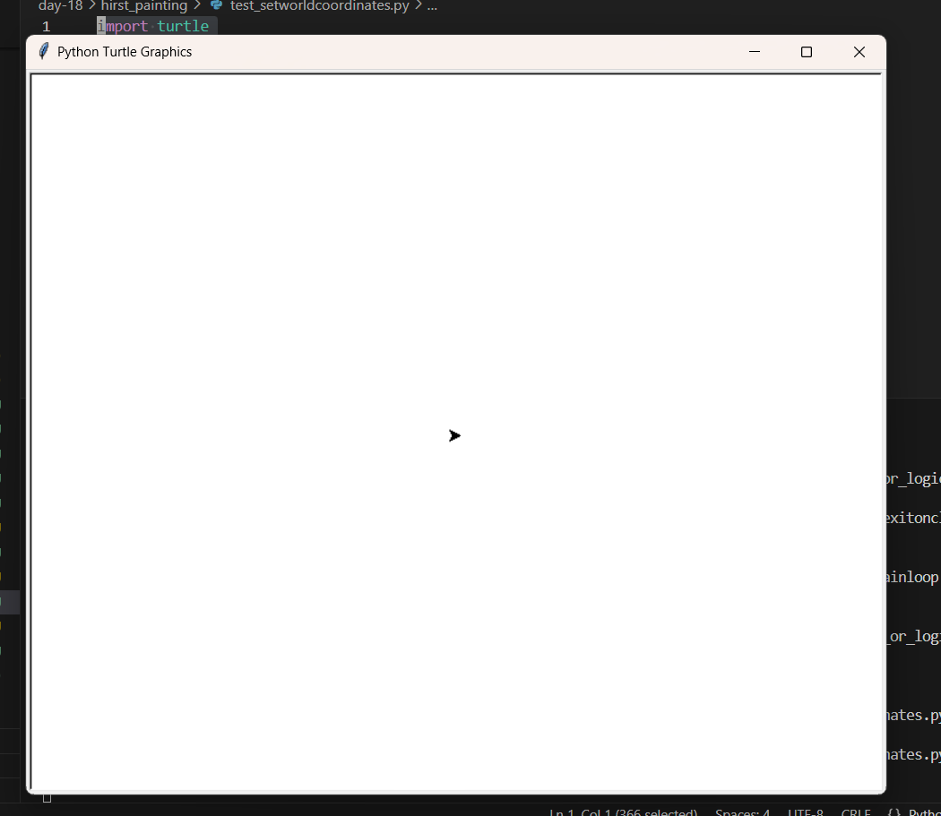
It doesn’t change the size anything -> just change the logical coordinates

Test screensize()
Now we have the scrolling bars, when we try to change screensize()
