Requirement:
1. With reference to the lectures, which search strategy did you use? Discuss implementation
details, including choice of relevant data structures, and analyse the time/space complexity
of your solution.

2. If you used a heuristic as part of your approach, clearly state how it is computed and show
that it speeds up the search (in general) without compromising optimality. If you did not use
a heuristic based approach, justify this choice.

3. Imagine that all Blue tokens had to be removed from the board to secure a win (not just one target coordinate). Discuss how this impacts the complexity of the search problem in general, and how your team’s solution would need to be modified in order to accommodate it.

Your report can be written using any means but must be submitted as a PDF document. Your report should be between 0.5 and 2 pages in length, and must not be longer than 2 pages (excluding references, if any). The quality and readability of your report matters, and marks won’t be given where discussion is vague or irrelevant to topics discussed in the subject.

Report in short:
- We use A* search
- We initially used PlaceAction as node and implement a search to find the shortest path towards the goal.
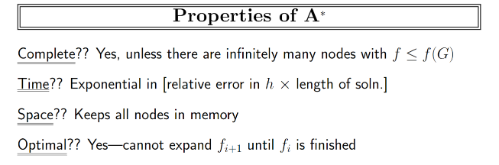
- Find that has limited information about the board -> make boards as frozenSet then use them as keys
- Time/Space Complexity
Average & worst cases
- Heuristic: shortest distance to closest point on goal line (of all reds) + empty space on goal line. It does not compromise optimality since it does not overestimate the total distance…
- Remove all blues from board, how and complexity

