Auction Project

Database schema diagram

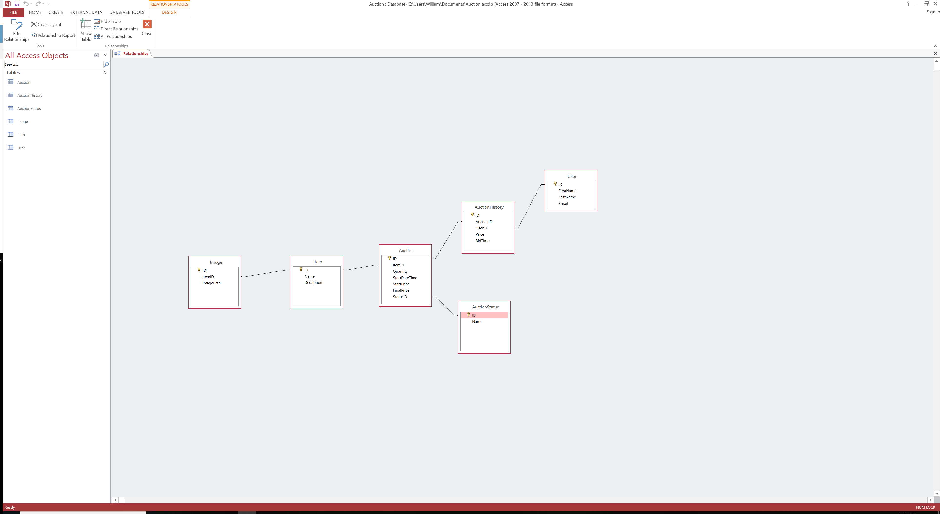

Too many expandable features, such as item category, item description, user payment, etc.

Item auction status flow diagram

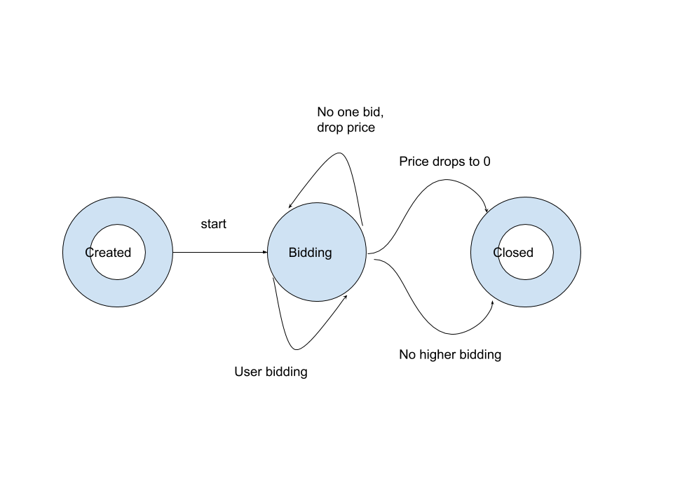

Entity framework does not compatible with .NetCore.