Data Schema

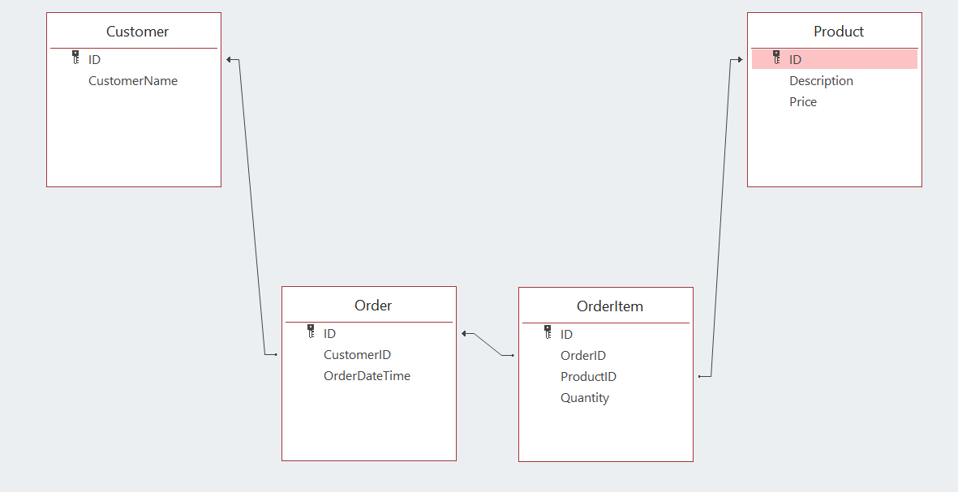

Get all customers

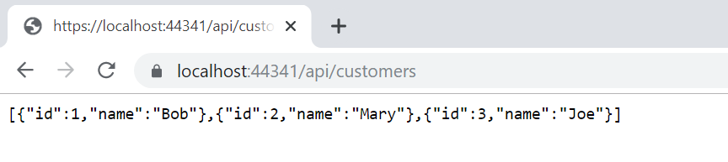

Get all orders

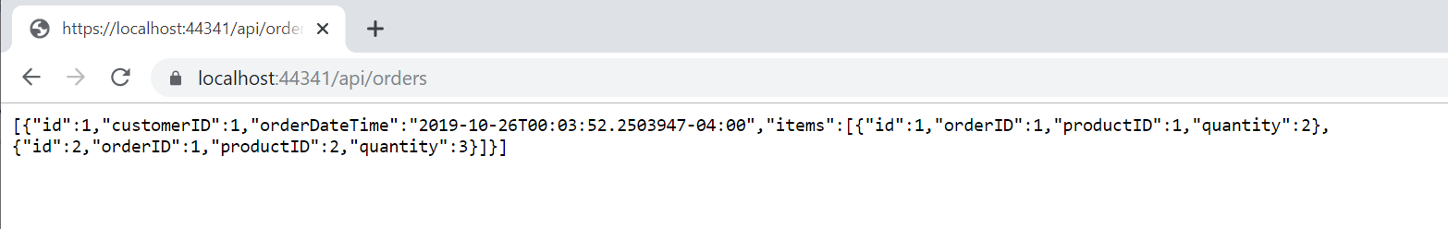

Get all products

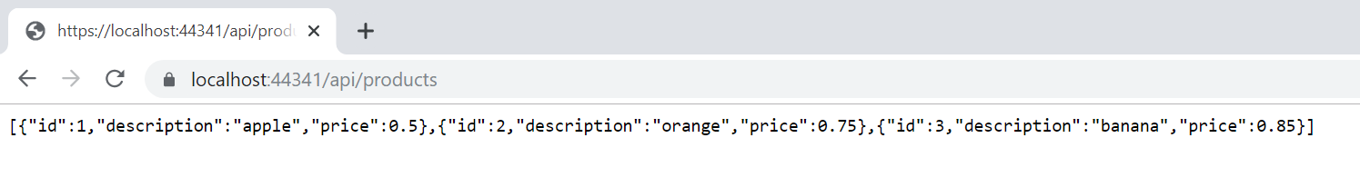

There are 10 test cases

