The project uses Angular 8, user may need to install Angular before try to run it.

Start the application, ng serve -o (the server start at localhost:4200)

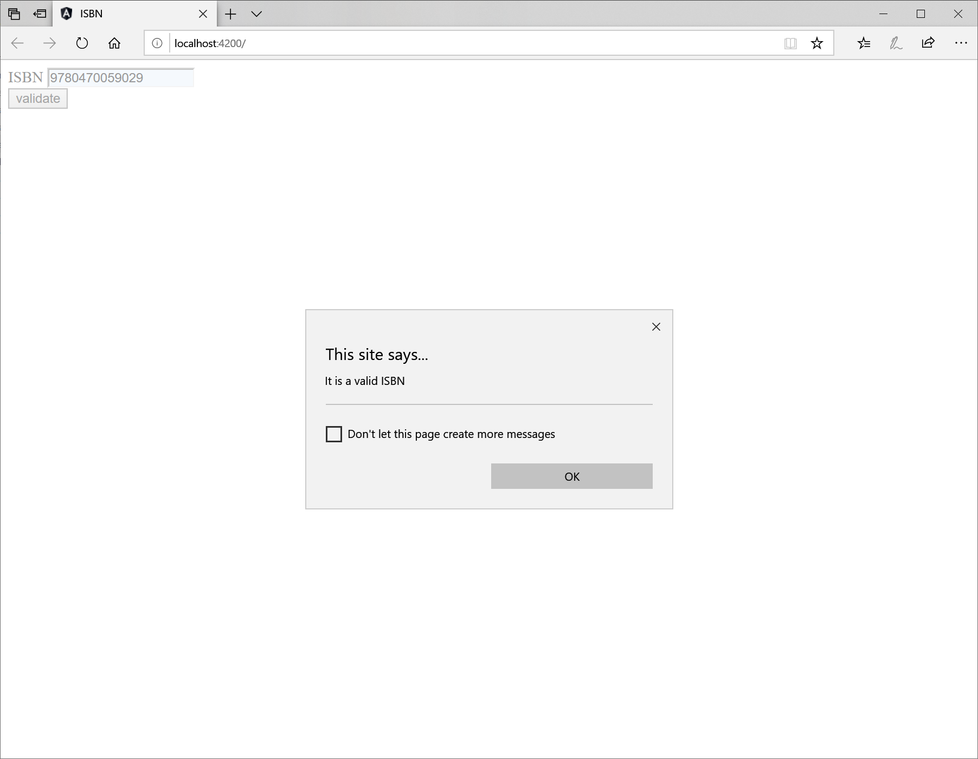

‘app.component.html’ contains HTML code of the web page above.

‘app.component.ts’ contains angular form and javascript function ‘checkISBN’ that checks ISBN-13

‘app.component.spec.ts’ contains test cases, all the ISBNs in the ‘dev_skill_check_dsc.docx’

The file structure

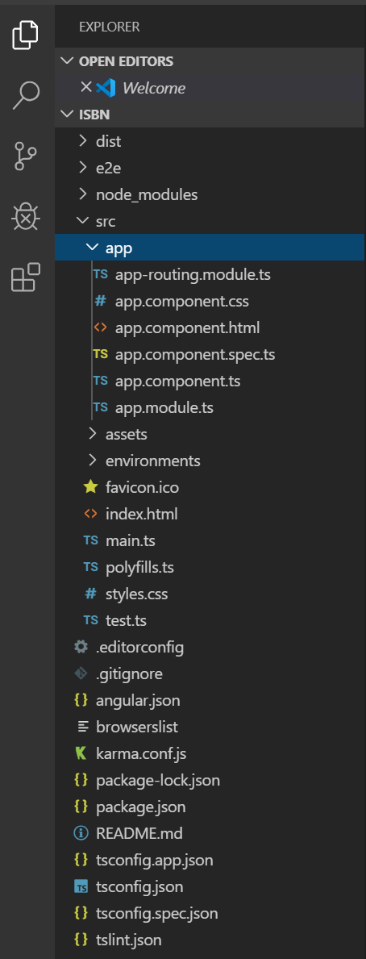

The test cases is in ‘app.component.spec.ts’. To run the test cases, ng test

