This project name is “PosiTrace”, use Visual Studio 2022, so it runs on .Net 9. The new version Visual Studio 2026 just comes out, runs on .Net 10. Since the Nuget packages of .Net 10’s cannot run .Net 9, so current version “PosiTrace” runs on .Net 9.

“PosiTrace” runs on localhost:5244, use sqlite database positrace.db as cache. Nominatim API user agent is hardcoded “PosiTrace/1.0 (william_zwd@outlook.com)”.

As requested, “PosiTrace” only exposes a single POST endpoint that accepts a list of addresses. It can be tested use API client such as “Rest Client”
- The address is first processed by normalization, remove Apartment, Unit, or Suite number as shown, “5172 Kingsway, Unit 250, Burnaby” is normalized to “5172 Kingsway, Burnaby”
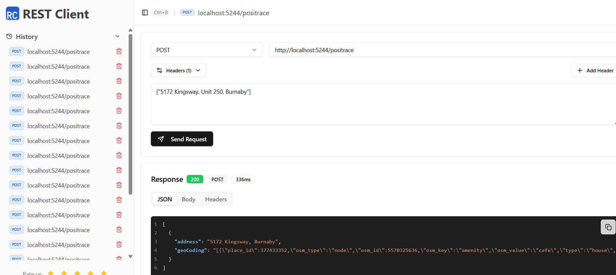
- I am not sure about the 2nd requirement. Since geocoding is the result from Nominatim API while the address exists. If the address does not exist, there will be no geocoding data coming back, will not have postal code data either. As alternative, my program looks for Canadian postal code in address. If the address does not provide geocoding data, then use the postal code (if exists) to try again, the result inside geocoding would display “Using PostalCode”
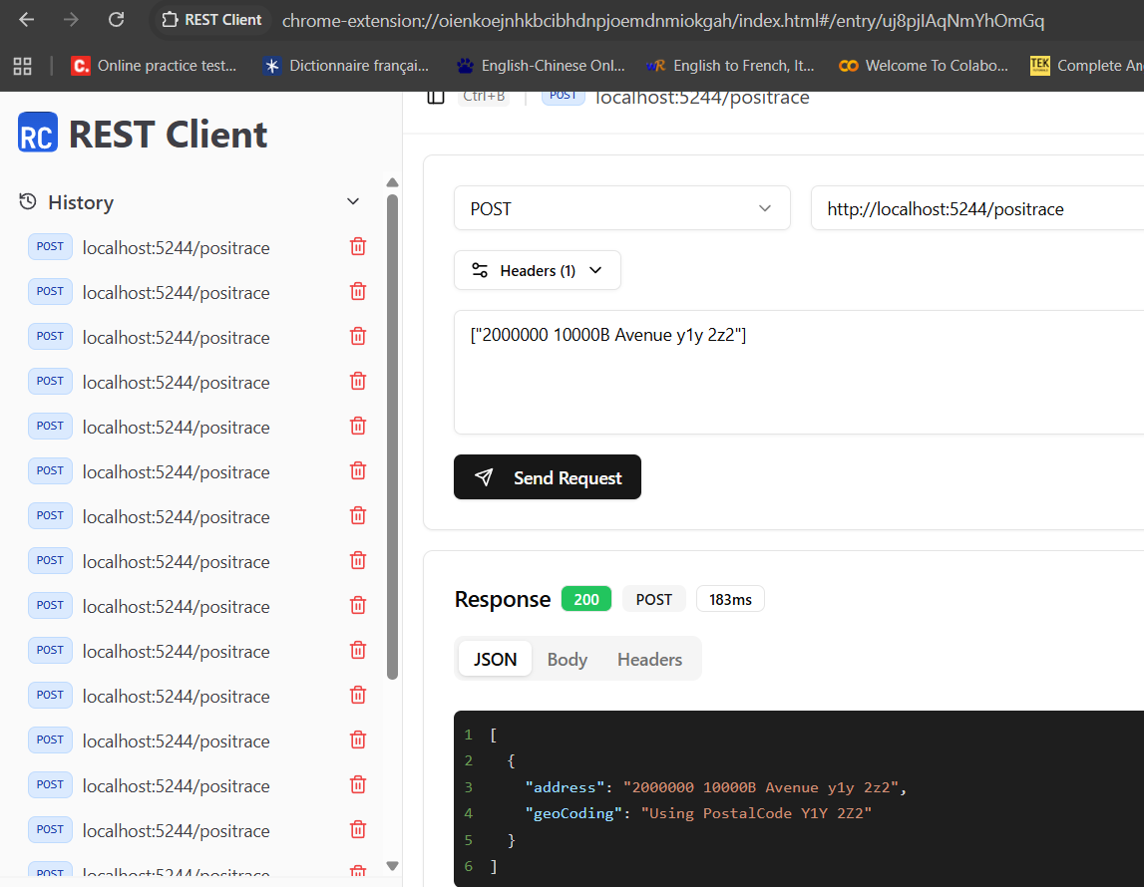
3, 4 and 5. Normalize address is saved in sqlite database. So repeated request of the same address does not go through Nominatim API, instead directly get result from sqlite database. Between each request go through Nominatim API, there would be 1 second delay. So, if all the items inside the list are new addresses, the API client may Not be able to display the correct result at first try, since there would be multiple delays of 1 second.
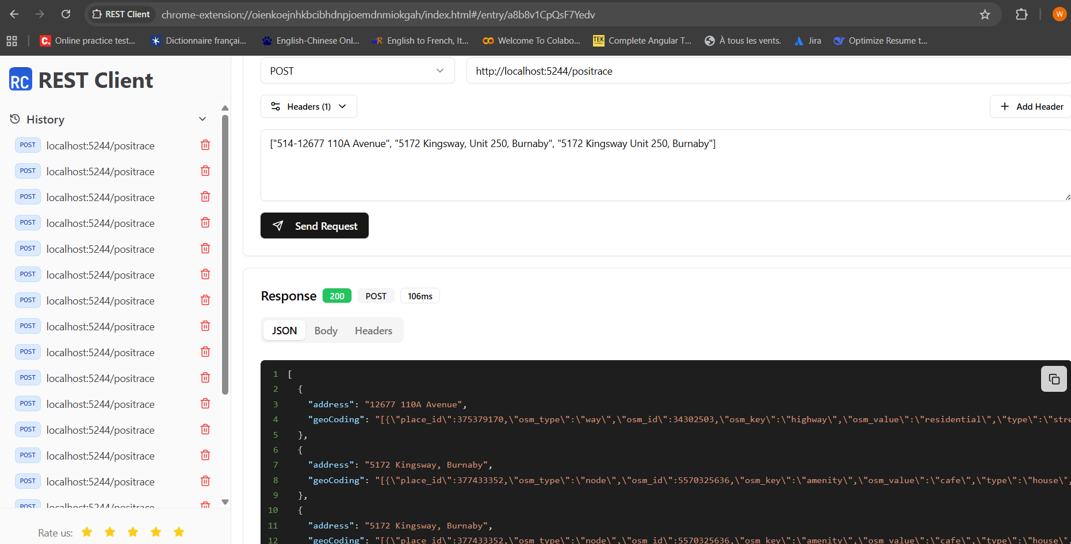

The project is uploaded to https://github.com/william-zwd/PosiTrace.git, I set it to be public, should be able to access by any 3rd party.

