The project uses Angular 8, user may need to install Angular before try to run it.

Start the application, ng serve (the server start at localhost:4200)

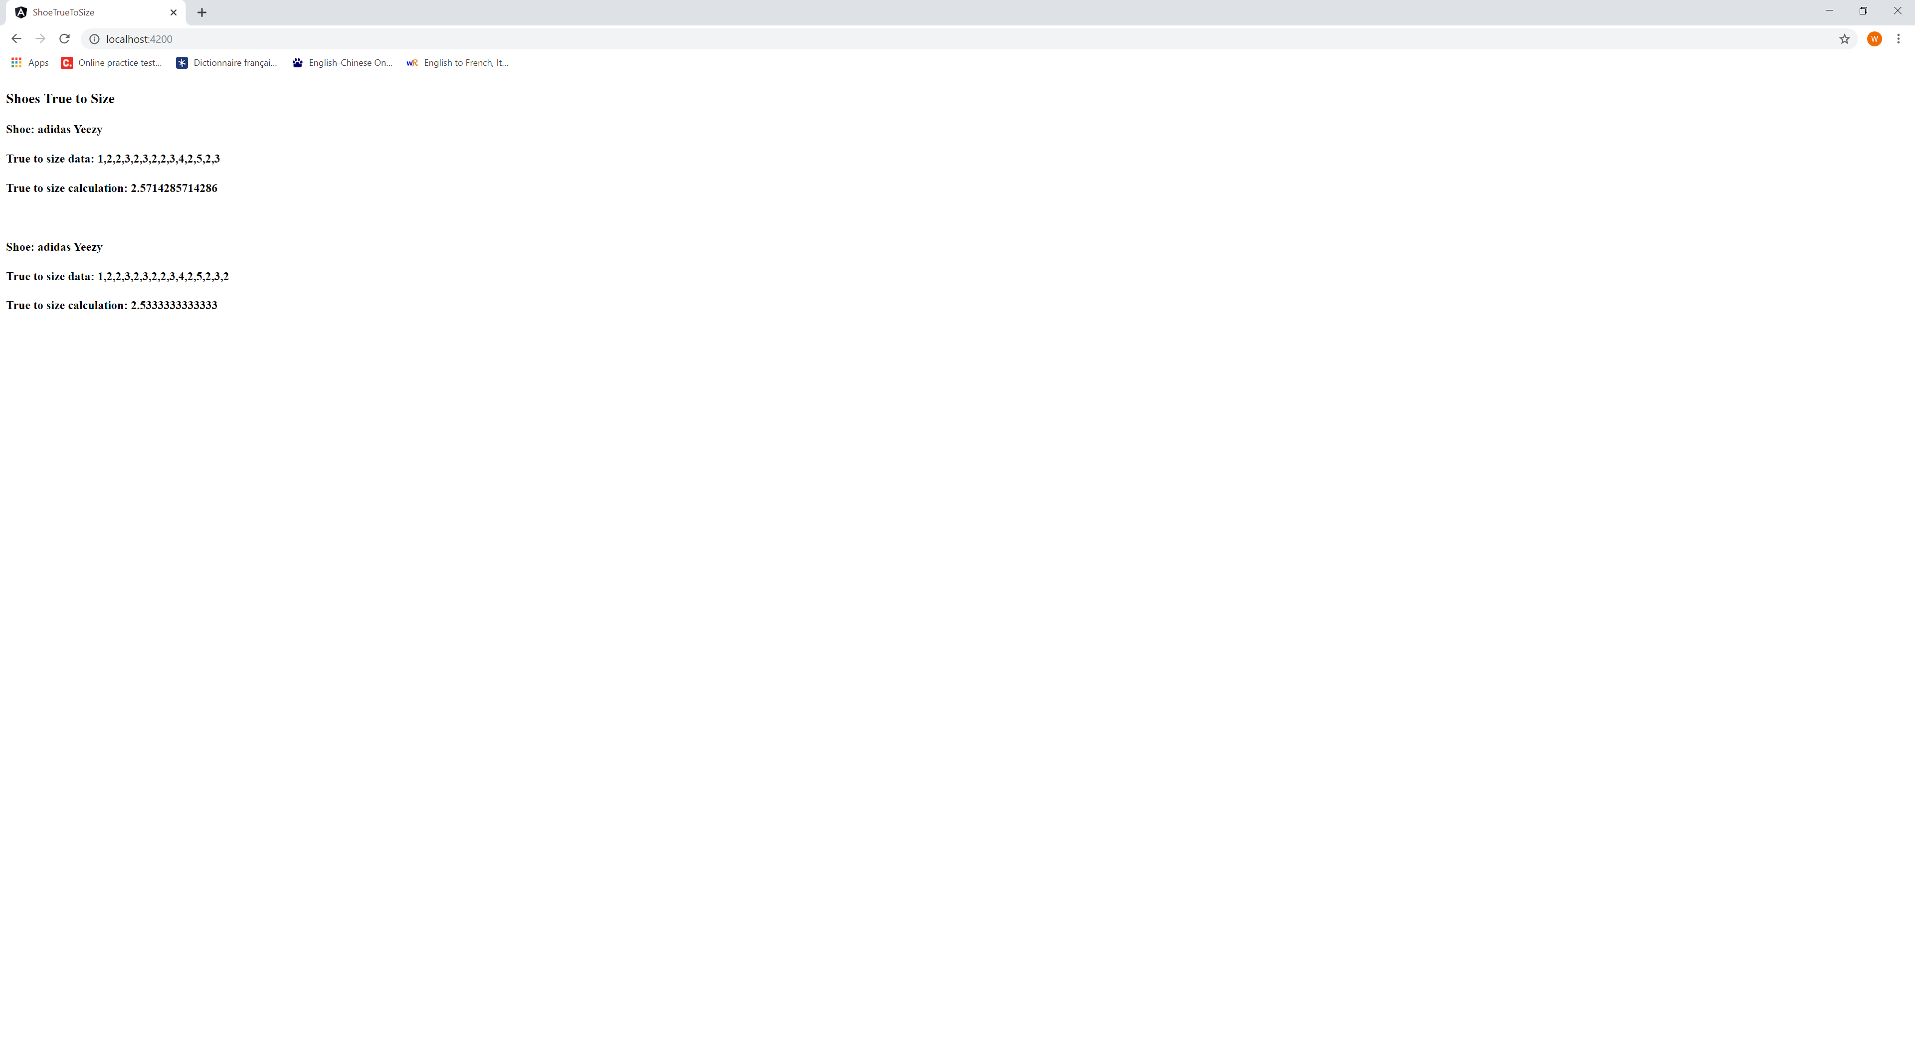

The data is store in ~src/assets/data.json

Created ‘ShoeService’ that loading ‘data.json’ data as dependency injection to component ‘ShoeListComponent’

‘ShoeListComponent’ display the list above.

The file structure

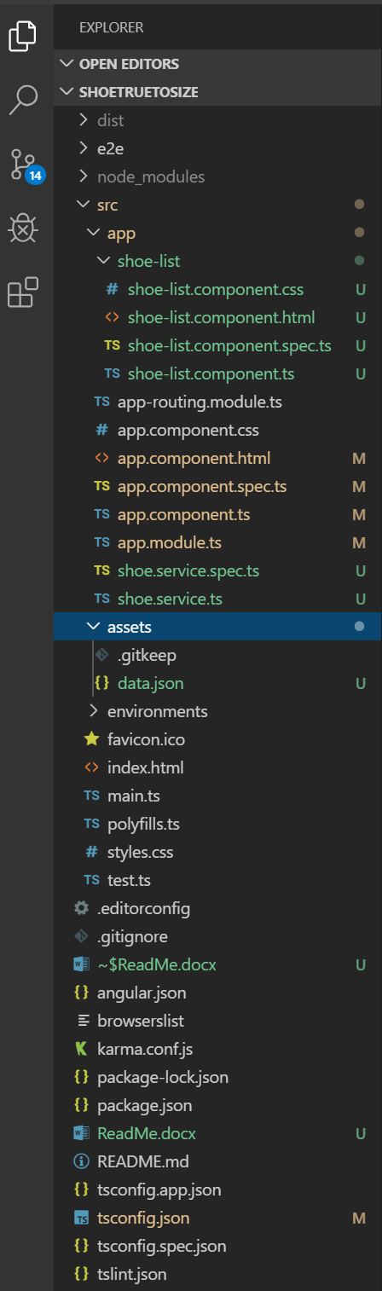

The test cases of ‘ShoeListComponent’ is in ‘shoe-list.component.spec.ts’. To run the test cases, ng test

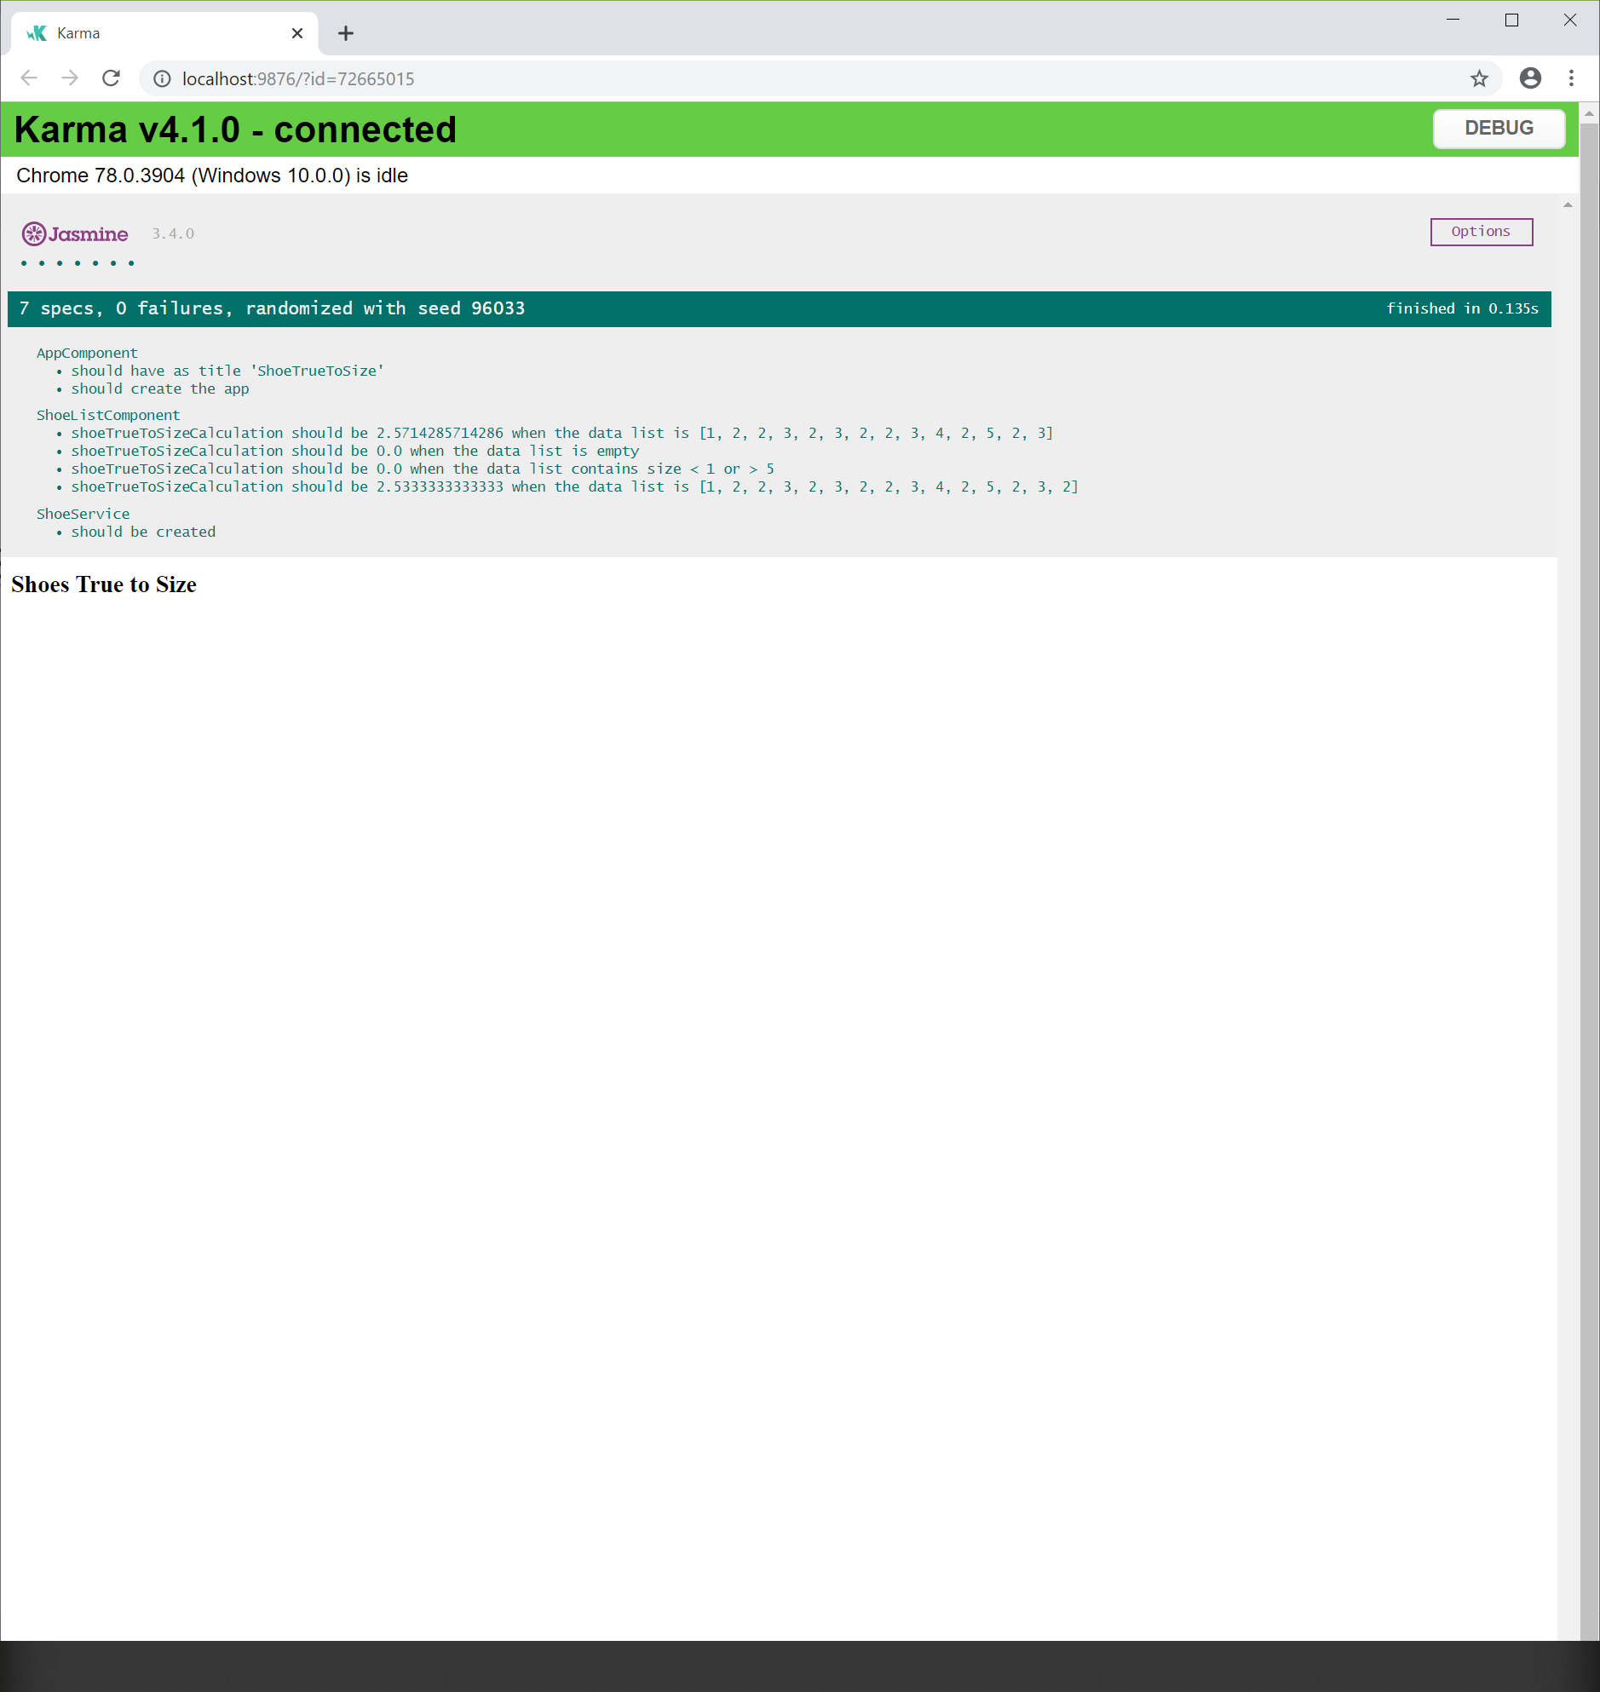

There are 4 test cases of “ShoeListComponent”

1. Empty list of true to size, the average size is 0
2. True to size list [1, 2, 2, 3, 2, 3, 2, 2, 3, 4, 2, 5, 2, 3], the average size is 2.5714285714286
3. True to size list with small change by adding another data point 2 [1, 2, 2, 3, 2, 3, 2, 2, 3, 4, 2, 5, 2, 3, 2], the average size is 2.5333333333333
4. True to size list contain error data point that < 1 or > 5, the average size is 0