**Diagram Arsitektur**



**Presentation Layer**

**Presentation Layer**

**HTTPS**

**HTTPS**

**TCP/IP**

**Service Layer**

Database : sqlite3

**Data Layer**

Application Backend

REST API

Client Browser

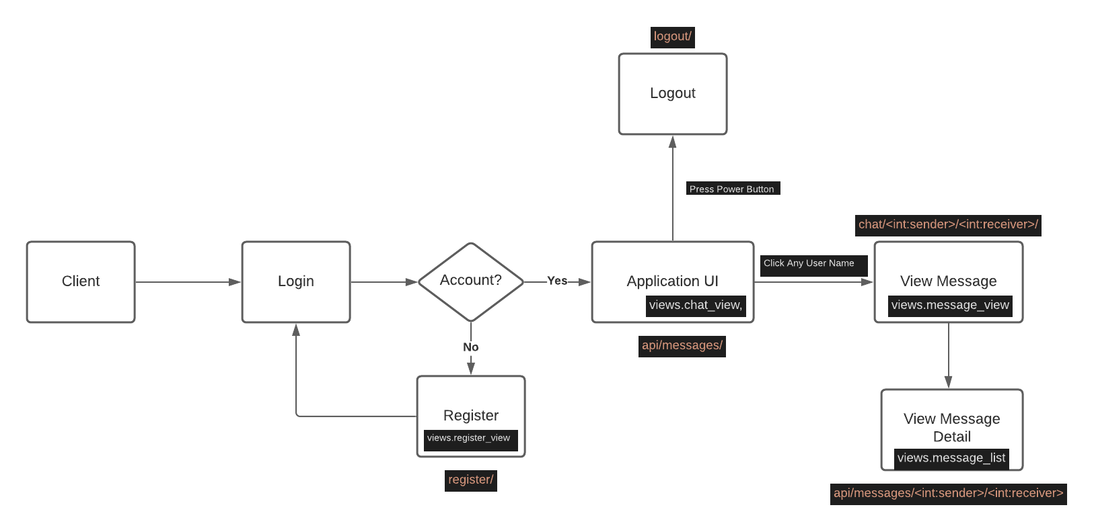**Sequence Diagram**