Efficient modes, not load shifting, deliver most of the grid value of flexible AI computing
William Wei^{1,2,*}, Lanlan Liu (刘岚岚)³
¹ School of Computer Science, Faculty of Engineering and Physical Sciences, University of Leeds, Leeds, UK
² Spatial Computing (Fujian) Technology Co., Ltd., Fuzhou, China
³ School of Public Administration, Fujian Normal University, Fuzhou, China
* Corresponding author: qkfp0742@leeds.ac.uk

Abstract
Artificial intelligence (AI) clusters can lower power via operating modes or shift work in time; which lever creates power-system value, and whether firms deliver it, is unresolved. We combine measured graphics processing unit (GPU) power modes, workload traces, joint investment–dispatch modelling and firm behaviour in a 2030 public-data scenario for three Chinese provinces. For the same work, coordination lowers AI load’s incremental system cost by 13.6–28.5% relative to rigid operation in islanded provinces; efficient modes alone deliver almost all of it, which a bill-minimising firm captures under both tariff shapes modelled (time-of-use and marginal-cost-shaped). Remaining shifting value is 0.1–4.4% of incremental cost there, below 0.4% with interprovincial exchange, avoiding gigawatts of gas turbines only where capacity is scarce. Current tariff shapes make shifting counterproductive in 14 of 18 islanded settings; a marginal-cost-shaped price stays within 2.6% of the optimum everywhere and recovers shifting value in all but one setting.

Main
AI computing load can modulate power and shift execution in time, and grid-interactive operation of AI clusters has been demonstrated in the field [1]. Earlier work priced spatial and temporal load shifting of data centres in electricity markets [2,3,4], showed in capacity-expansion models that flexible data centres can lower system cost while raising emissions [5], assessed China’s regional migration of computing [6], treated inference flexibility as a resource-adequacy asset with exogenous accreditation [7], proposed net-grid-benefit tests for interconnection [8] and reported diminishing returns to flexibility in grid interconnection [9]. These studies treat flexibility as a single quantity. Measured GPU clusters, however, offer two distinct levers: operating at a lower power cap, which reduces energy per unit of work at the cost of longer run time, and shifting execution in time. Their value to a power system, and the share a firm delivers, depend on the service constraints under which tasks must complete, on whether the system has scarce or surplus hours, and on the price signal the firm faces. We connect these links in one framework and quantify, for three Chinese provinces, how the incremental system cost of serving a fixed amount of AI work changes across six operating scenarios: rigid full-speed operation (S0), energy-efficient modes without shifting (S0e), a firm minimising its bill under the official time-of-use tariff shape (S1), an event-based commitment contract (S3), a firm minimising its bill under an hourly price shaped like the system’s marginal cost (S1rt) and full system coordination (S2). All results are scenario results built from public data; their evidence basis and limitations are stated in Methods.

Service constraints and measured power modes
Re-analysis of measured GPU power–throughput modes [1] shows that lowering the GPU power cap reduces energy per unit of work: for the fine-tuning configuration used here, energy at equal work falls to 70% of the full-speed value at the 200 W cap while run time rises to 1.24 times (Fig. 1a). Whether a cluster can use such modes depends on its deadlines. Three public production traces indicate that a large share of GPU-hours sits in jobs longer than one day (68% in the Helios clusters [10], 30% in the Alibaba PAI cluster [11] and 90% in the Philly clusters [12]), while observed queueing waits longer than one hour cover 18% of GPU-hours in Helios, 15% in Philly and almost none in Alibaba PAI (Fig. 1b). These waits are lower bounds on the delay users tolerated, not deadlines; deadlines are therefore assumptions with sensitivity analysis. Node-level alternating-current power logs from MLPerf Training v4.0 [13] put idle power at 35–41% of the peak reading across three benchmarks on eight-GPU nodes (Fig. 1c); the base case uses 41%, which bounds the share of load that any mode change can move.

Efficient modes deliver most of the value
For the same computing work and the same reliability, system coordination lowers the incremental system cost of the AI load relative to rigid full-speed operation by 13.6–21.1% in Gansu, 14.9–28.5% in Jiangsu and 14.1–23.7% in Guizhou when each province is modelled as islanded, across AI shares of 5–20% of the 2030 provincial peak and two deadline-slack settings. Fig. 2 shows the 6 h-slack subset: 13.6–13.9% in Gansu, 14.9–20.4% in Jiangsu and 14.1–16.0% in Guizhou across the three AI shares. Running at the energy-efficient modes without any shifting (S0e) already lowers it by 13.5–21.0%, 14.5–27.7% and 12.8–22.7%. The value that remains for temporal shifting, the difference between S0e and S2 expressed as a share of the coordinated incremental cost, is 0.1% in Gansu, 1.2–1.5% in Guizhou and 0.4–4.4% in Jiangsu. It is largest where capacity is scarce: at an AI share of 20% of the 2030 Jiangsu peak with 6 h of slack, rigid operation requires 9.5 GW of new gas turbines and 0.97 GW of batteries, efficient modes alone still require 6.3 GW of gas turbines, and coordination requires 0.6 GW; with 24 h of slack, efficient modes alone avoid all new gas turbines. With interprovincial exchange, represented either by a fixed-price external market or by an aggregate node of directly connected provinces, the total reduction is 13.2–20.6%, almost entirely from efficient modes, and the shifting value falls below 0.4% because imports supply the islanded province’s scarce hours (no-AI curtailment in Gansu falls from 7% to 0%).

Firms capture the efficiency value under both tariff shapes tested, but current tariff shapes make shifting counterproductive
A firm minimising its bill under the official provincial time-of-use tariff shapes [14,15,16] (S1) captures 76–98% of the total coordination value in the islanded cases; the efficient-mode component is captured by a bill-minimising firm under both the official time-of-use tariff (S1) and the marginal-cost-shaped price (S1rt) tested here. The shifting component is different. Defining the share of shifting value realised as the cost reduction from S0e to a scenario divided by that from S0e to S2 (Fig. 3), the tariff-driven firm realises a negative share in 14 of the 18 islanded settings, that is, its shifting raises system cost above no-shifting operation: -7.40 to -3.74 in Gansu, -0.62 to 0.14 in Jiangsu and -0.11 to 0.34 in Guizhou. The tariff valleys (for example 00:00–08:00 in Guizhou and 02:00–04:00 and 11:00–17:00 in Gansu) do not coincide with the hours in which the modelled systems have surplus or slack, so load is moved into hours that are cheap for the firm but not for the system. An event-based commitment contract layered on the tariff (S3), in which the system declares the top 5% of hours whose marginal cost exceeds the weekly median by more than 20% and the firm commits the maximum reduction deliverable relative to its tariff-optimal schedule at a compensation of at least its opportunity cost, realises a shifting share of -7.40 to 0.25 and is negative in 14 of 18 settings. A firm minimising its bill under an hourly price whose shape follows the coordinated solution’s marginal cost (S1rt), rescaled to the same mean as the tariff, realises 0.13 to 0.87 in Gansu, -1.24 to 0.92 in Jiangsu and 0.42 to 0.87 in Guizhou, and its total cost is within 2.6% of the coordinated optimum in every islanded setting (within 2.6% including the exchange cases). Because S1rt uses the ex-post dual prices of the coordinated solution, near-closure is expected by construction for a price-taking firm with foresight; the informative comparison is between that benchmark and the tariff or contract, which shows that the shape of the hourly price, not a contract layered on the tariff, determines whether shifting adds or destroys value and how much of the shifting value is recovered.

Mechanism design: event contracts versus continuous prices
Two settlement designs were compared under identical tasks and reliability (Methods). The event contract declares events only in the Jiangsu winter week and the Guizhou summer week; relative to S1 it raises the system cost by 295 thousand euros per representative week in Jiangsu and 3 thousand euros in Guizhou while its compensation floor is 459 and 20 thousand euros. It is also exposed to baseline manipulation: if settlement used a full-speed baseline instead of the firm’s own tariff-optimal schedule, the measured reduction during the event hours would be inflated by 3,709 MW on average in Jiangsu and 690 MW in Guizhou without any change in delivered flexibility. A continuous hourly price shaped like the system’s marginal cost, settled on metered consumption without a baseline, lowers the system cost relative to S1 by 47, 280 and 77 thousand euros per representative week in Gansu, Jiangsu and Guizhou and leaves a residual gap to the optimum of 0.05%, 0.13% and 0.29% of the incremental cost. It has no baseline and therefore no baseline-inflation rent; other strategic exposures of a large price-taking load, such as forecast gaming or price influence, are outside the model, and the ex-post dual price is a benchmark for the shape of an implementable price, not a published tariff.

Robustness
Ten weather years (2015–2024) of wind and solar profiles derived from the ERA5 reanalysis [17,18] at the twenty largest sites per province and technology give total reductions from rigid to coordinated operation of 13.5–14.3% in Gansu, 14.4–15.5% in Jiangsu and 14.1–15.3% in Guizhou at an AI share of 10% (islanded, all ten years feasible) (Fig. 4a), and shifting values of 0.1–0.7%, 0.4–0.7% and 1.0–1.8%; the S1rt gap to the optimum stays below 0.36% in every year (Fig. 4c), and the tariff-driven shifting share remains negative in Jiangsu in every year and in Gansu in nine of the ten weather years, turning marginally positive (+0.01) in 2024. With idle power at 25% of nameplate instead of 41%, the total reductions are 15.2–16.1%, 15.7–16.9% and 15.7–17.5%. A cost-parameter Monte Carlo (fuel prices 0.7–1.5×, investment costs 0.7–1.3×, idle power 25–45% of nameplate, utilisation 50–80%; 20 feasible draws per province) gives 10th–90th percentile total reductions of 9.5–24.8% (median 21.2%), 10.3–26.7% (median 19.3%) and 10.8–27.0% (median 17.4%) (Fig. 4b) and shifting values of 0.1–1.0%, 0.2–1.1% and 0.9–2.5%; the three provinces overlap in total reduction, and Guizhou’s shifting value exceeds Gansu’s and Jiangsu’s at the median and the 90th percentile but not in every draw. A peak-adjusted sensitivity in which the 2020 Gansu peak is set to the 2021 official maximum load of 17.66 GW and the Guizhou peak to 29 GW, with annual energy conserved, changes the islanded shifting value at an AI share of 10% from 1.37% to 1.12% in Guizhou and from 0.08% to 0.05% in Gansu, and the total reduction by less than one percentage point.

Limitations and outlook
Hourly provincial load shapes derive from a 2018 reconstruction [19] anchored to official 2020 annual electricity [20] and checked against published peaks; the Gansu and Guizhou peaks are overstated, which biases scarcity upward, and metered hourly load would be required to move the results from scenario to empirical estimate. The islanded case is a bounding assumption for exchange-constrained hours, not a representation of the physical grid; the exchange representations are a fixed-price proxy and an aggregate neighbour node, both built on a compiled interconnection list with known internal inconsistencies. Hydro and load shapes are single-year; coal commitment is a heuristic held fixed across scenarios; AI pool size and deadline slack are assumptions; switching, checkpoint and cooling overheads, task migration and non-anticipative control are not represented; interactive inference with sub-hourly service constraints [21] is not treated as shiftable; only one event rule was tested. These features could change the magnitudes reported here, in particular the size of the efficient-mode effect, which rests on one set of measured power modes and on deadlines long enough to absorb the longer run time. The tested sensitivities (weather years, cost parameters, idle power, peaks, deadline slack) do not change the finding that efficient modes account for most of the value, that current tariff shapes give shifting a negative value in most islanded settings (14 of 18: all six Gansu settings, five of six Jiangsu settings and three of six Guizhou settings), or that a marginal-cost-shaped price keeps total system cost close to the coordinated optimum and recovers a positive share of the shifting value in all but one modelled setting (more than half of it in 12 of the 18).

Figure legends
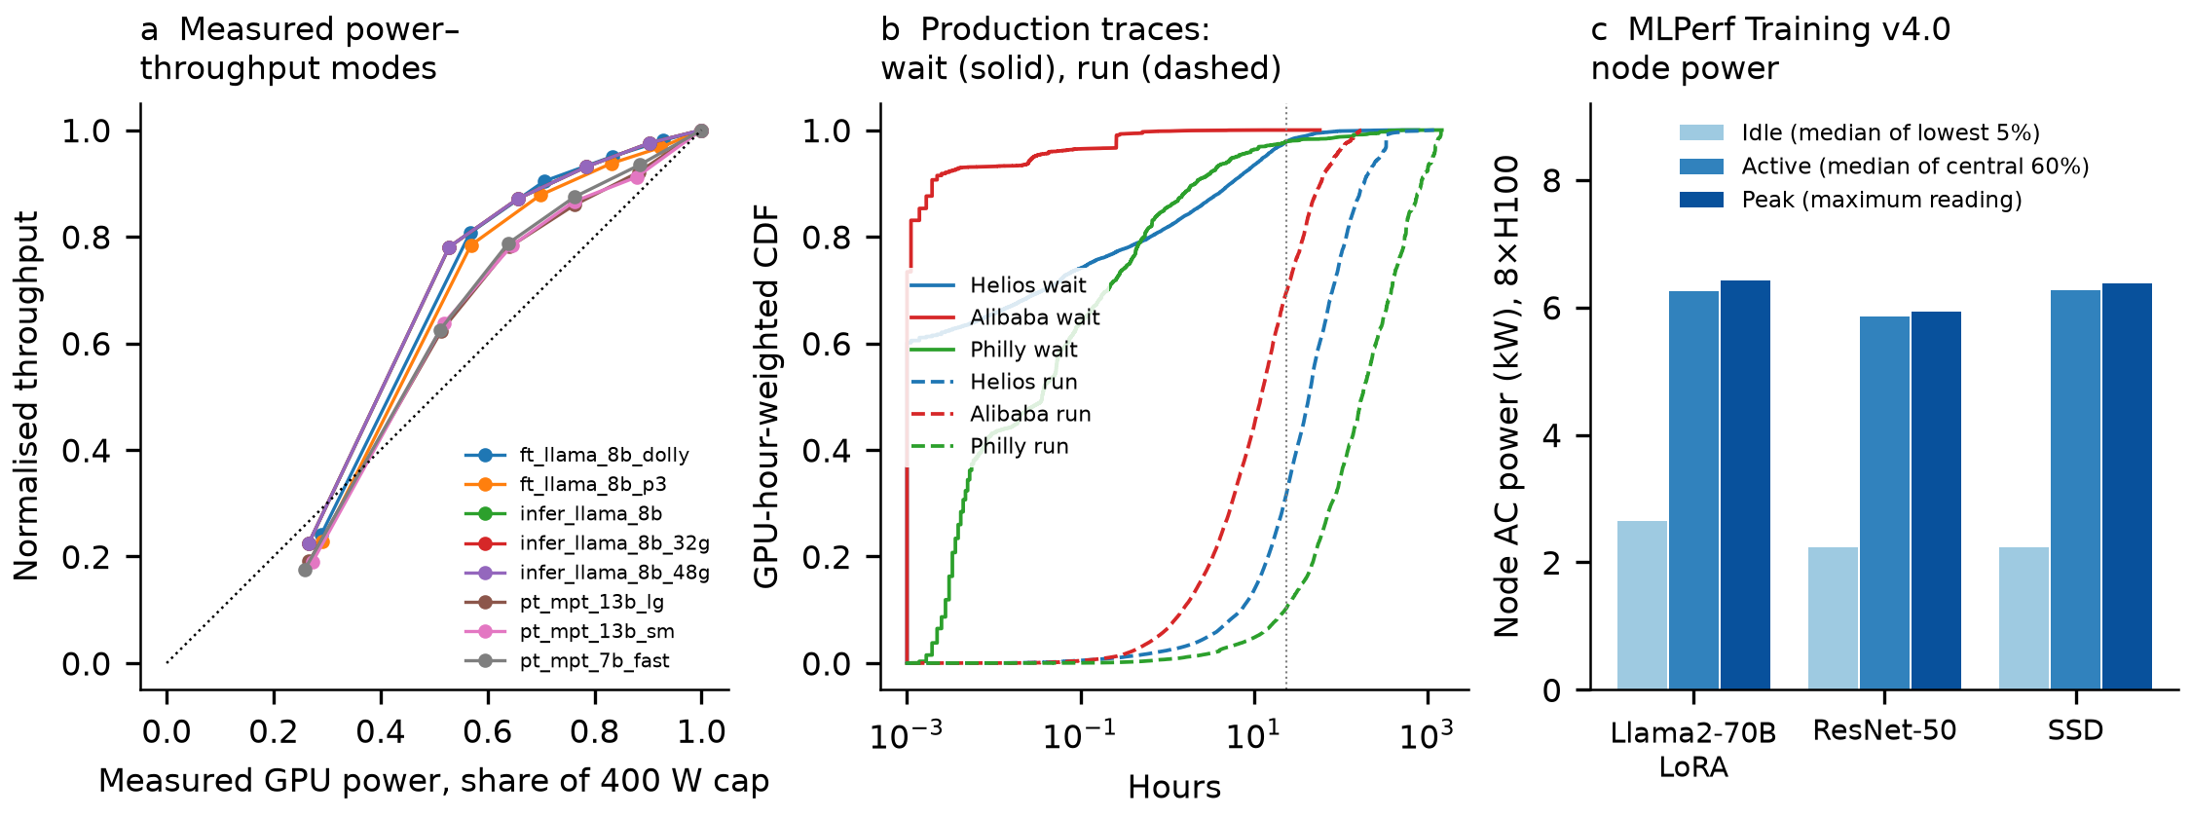
Fig. 1 | Service constraints and measured power. a, Measured GPU power–throughput modes for eight workload configurations at six power caps, normalised to the 400 W cap (re-analysis of ref. 1); the dotted diagonal marks proportional power and throughput, so points above it use less energy per unit of work than full speed. b, GPU-hour-weighted cumulative distributions of observed scheduling wait (solid) and job run time (dashed) in three public production traces: Helios [10], Alibaba PAI [11] and Philly [12]; the dotted line marks 24 h. c, Node-level alternating-current power of eight-GPU H100 nodes in MLPerf Training v4.0 [13] for three benchmarks: idle (median of the lowest 5% of readings), active (median of the central 60%) and peak (maximum reading).
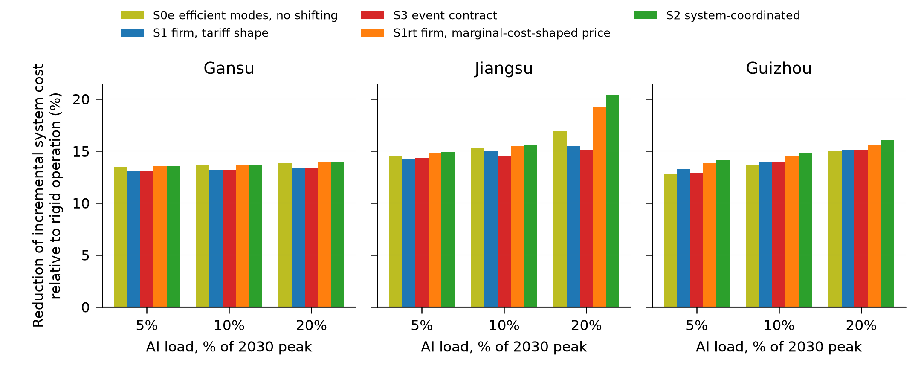
Fig. 2 | Reduction of the incremental system cost of AI load relative to rigid operation. Three provinces modelled as islanded, 2030 public-data scenario, deadline slack equal to the job’s observed queueing wait plus 6 h, idle power 41% of nameplate, AI load equal to 5, 10 and 20% of the 2030 provincial peak. Incremental cost is the total system cost with the AI pool minus that of the same system without it, for the same completed computing work in every scenario. Scenarios: S0e energy-efficient modes without shifting; S1 firm minimising its bill under the official time-of-use tariff shape; S3 event-based commitment contract; S1rt firm minimising its bill under an hourly price shaped like the system’s marginal cost; S2 system-coordinated.
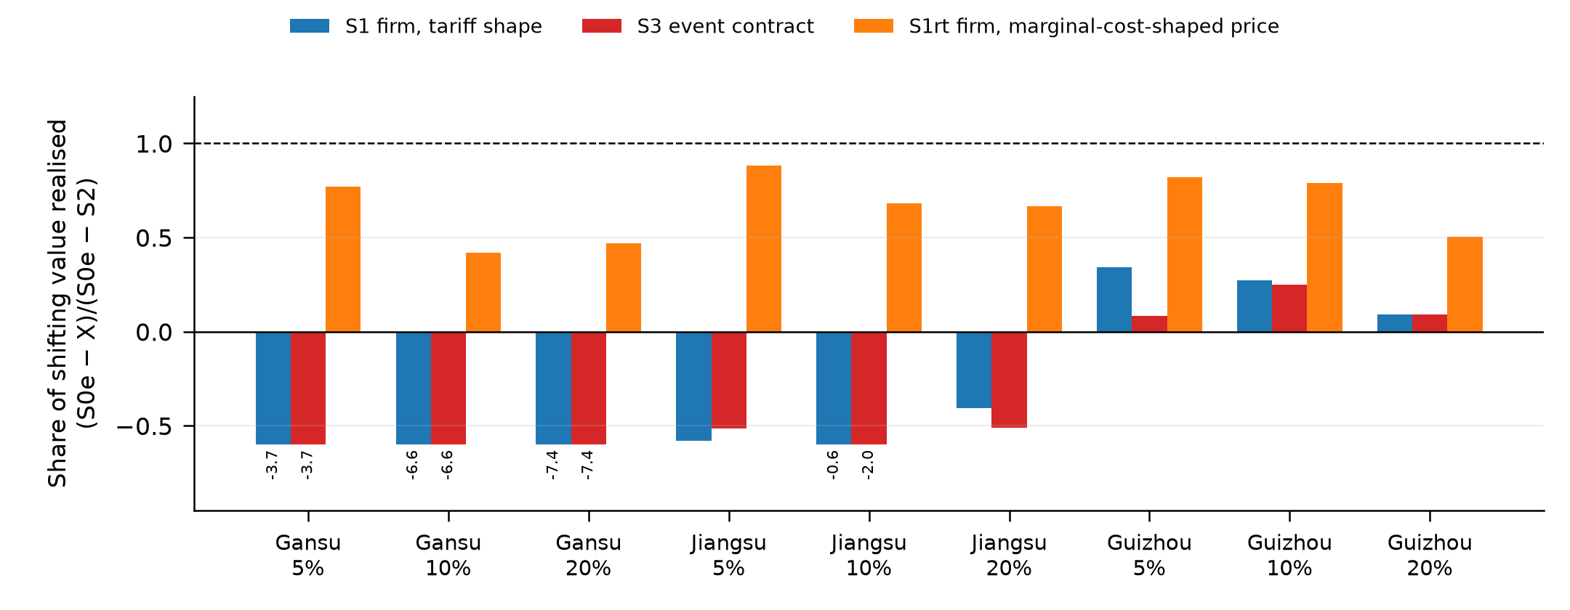
Fig. 3 | Share of the shifting value realised. (cost S0e − cost X)/(cost S0e − cost S2) for X = S1, S3 and S1rt, same settings as Fig. 2. A value of 1 means the firm’s shifting delivers all of the value that coordination adds beyond efficient modes; negative values mean shifting raises system cost above no-shifting operation. Bars below −0.6 are clipped for display and annotated with their value.
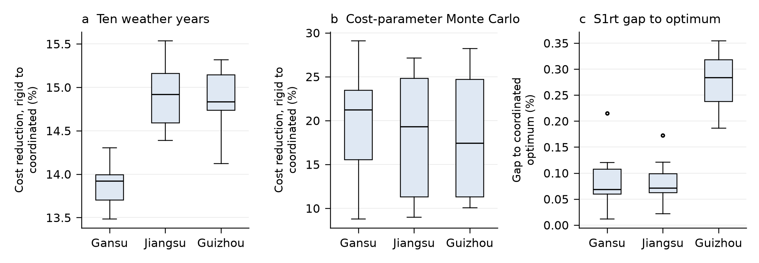
Fig. 4 | Robustness. Box plots across a, ten ERA5-derived weather years, 2015–2024 (n = 10 per province) and b, 20 cost-parameter Monte Carlo draws per province, of the reduction of incremental system cost from rigid to coordinated operation (islanded, AI share 10%), and c, the gap of the S1rt outcome to the coordinated optimum across the weather years. Centre line, median; box, interquartile range; whiskers, 1.5 × interquartile range; points, outliers.

Methods

Task–power model
Each compute pool $p$ runs batches $j$ with release $r_{pj}$, deadline $d_{pj}$ and work $w_{pj}$ measured in full-speed pool-hours. Execution shares $y_{pjtm}∈[0,1]$ of the pool in hour $t$ and operating mode $m$, with normalised throughput ${\overset{‾}{q}}_{m}$ and power $P_{m}$, satisfy j,m​ypjtm≤1, $y_{pjtm}=0$ outside $[r_{pj},d_{pj})$ and t,m​qmypjtmΔt=wpj with $Δt=1$ h; no work may be dropped or deferred beyond the horizon. Pool power is $P_{pt}=P^{\rm idle}_p+\sum_{j,m}(P_m-P^{\rm idle}_p)y_{pjtm}$. Modes are the six GPU power caps of the fine-tuning configuration measured in ref. 1; modes whose measured power lies below the node idle power plus a 2-percentage-point margin are excluded (to avoid numerically marginal modes), leaving five modes in the base case. Idle power is 41% of nameplate in the base case, the ratio of idle to peak node power in MLPerf Training v4.0 logs [13] for the Llama-2-70B fine-tuning benchmark (35–41% across three benchmarks); 25% is a sensitivity. Switching, checkpoint and cooling overheads are not represented. Batches are sampled from completed GPU jobs of the Helios trace [10] by hour of submission, keeping GPU count and run time and scaling total work to a pool utilisation of 70%; the deadline is the run time plus the job’s own observed queueing wait times a multiplier (1 or 3) plus a base slack (6 or 24 h). A greedy full-speed reservation guarantees joint feasibility, extending deadlines where necessary and truncating work at the horizon end; surviving work is rescaled to the target and the reservation repeated (capped at 6 rounds) until truncation is below 1%, which every scenario configuration reached within at most 5 rounds (83 configurations); in the cost-parameter Monte Carlo, where utilisation is drawn from 50–80%, 16 of 60 draws stopped at the cap with a residual truncation of up to 2.3% of target work, giving realised utilisations of 0.693, 0.697, 0.700, 0.699 in the winter, spring, summer and autumn weeks. The same batch sets are used for every province and scenario.

Joint planning–operation model
A linear programme (LP) shares investment in generation, lines and storage across scenarios (four representative weeks of 2020 beginning on the second Monday of January, April, July and October, equal probability) and dispatches chronologically within each: nodal balance with a transport network with 3% losses, storage with 95% charge and discharge efficiency and cyclic state of charge, generator availability profiles, an optional must-run fraction, and a cap on expected unserved energy, set to zero for non-AI load. The implementation also supports an optional emissions cap, which is not invoked in any of the reported provincial scenario runs (S0/S0e/S1/S1rt/S2/S3/NOAI) and is exercised only in the separate oracle validation suite (Supplementary Information). Investment coefficients are annualised at 5% over technology lifetimes and scaled to the weekly horizon using a 365.25-day average year (52.18 weeks yr⁻¹), applied uniformly to all four representative weeks regardless of their placement on the model’s 2020 (leap-year, 8784-hour) calendar. The implementation was verified in 118 checks, including 100 independent oracle cases (60 screening-curve capacity cases and 40 enumerated task-assignment cases); a reservoir-cascade extension, verified in 74 further checks, is not used in the provincial runs (Supplementary Information). Unit commitment, alternating-current power flow, task migration and non-anticipative control are not represented.

Scenarios and metric
S0 fixes the pool to a work-conserving earliest-deadline full-speed schedule. S0e fixes it to the schedule that minimises energy at a flat price with a small penalty on delay, that is, efficient modes with earliest execution and no incentive to shift. S1 fixes it to the schedule that minimises the firm’s bill under the official time-of-use tariff shape of the province (Jiangsu [14]; Gansu [15], effective 2021; Guizhou [16], the nearest official structure, from 2023); the tariff level is set to 1.5 × the coal marginal cost because only the shapes are official. S1rt repeats S1 with the hourly shape of the coordinated solution’s nodal marginal cost rescaled to the same mean. S2 leaves the task variables free in the joint LP. In S3 the system declares as events the top 5% of hours whose S1 marginal cost exceeds the weekly median by more than 20%; the firm commits the maximum reduction deliverable relative to its own S1 schedule with all batches still completed, is compensated at least its opportunity cost, and the committed trajectory is fixed in the joint LP. A reference case without the AI pool defines the incremental system cost, which is the total expected system cost (annualised investment plus operation) with the pool minus that without it; because every scenario completes the same batches, incremental costs are compared directly rather than per unit of energy, which differs across scenarios (the rigid pool uses 13–24% more energy than the coordinated pool for the same work). Compensation is treated as a transfer, not a resource cost.

Provincial inputs
Hourly load is the 2020 provincial series of PyPSA-China V3.0 [22], a 2018-derived reconstruction [19], anchored to the official 2020 annual electricity of each province [20]. A plausibility check against published peaks shows Jiangsu consistent (summer and winter peaks above 100 GW), Gansu about 11% above the 2021 official maximum load and Guizhou above the 2026 record, so a peak-adjusted sensitivity is reported in which deviations from the annual mean are compressed to a target peak with annual energy conserved. The 2030 load scales the shape by the 2030/2020 provincial ratio of the same model. Thermal, nuclear and hydro fleets in 2030 are unit-level from the Global Energy Monitor (GEM) Global Integrated Power Tracker, July 2025 release, as redistributed in ref. 23: operating plus under-construction units with start year up to 2030 and retirements applied; size thresholds make the totals lower bounds. Existing wind and solar capacity is the 2020 value of the model archive; new onshore wind, solar, batteries and open-cycle gas turbines are investable at the archive’s 2030 costs (offshore wind capacity is held fixed at its 2020 archive value, with no investment allowed, both in-province and in the neighbour-aggregate node), and new coal is not allowed. Nuclear is available at 90%; hydro is a zero-marginal-cost generator whose hourly maximum output is the GEM 2030 capacity times the archive’s normalised run-of-river profile, without an energy budget or must-run. That profile is documented in the archive audit as covering only non-reservoir ‘other’ hydro, with major dam reservoirs excluded, yet it is applied to the full GEM 2030 hydro fleet; in Guizhou, large-dam reservoir capacity in the archive dam list is 11,385 of the 18,235 MW fleet (62%), so this simplification may overstate hydro’s hourly dispatchability and could bias the Guizhou scarcity and shifting-value results; splitting hydro into a reservoir component with its own seasonal dispatch and an other-hydro component is a suggested extension (the archive dam list has no Gansu or Jiangsu entries). Coal commitment is a heuristic: for each week the committed capacity is the maximum residual load (load plus the rigid AI trajectory minus wind, solar, nuclear and hydro availability) divided by 0.85, capped at the fleet; committed units must run at or above 40% and cannot exceed the committed capacity, and the commitment is held fixed across all scenarios, including the reference without AI, so coordination cannot reduce it. Interprovincial exchange is represented in three ways: islanded (interconnection capacity zero), which produces the headline ranges; an external node with a fixed load of 60% of the province’s interconnection capacity supplied without limit at 1.1 × the coal marginal cost; or an aggregate node of the directly connected provinces (Gansu: Hunan, Shaanxi, Qinghai, Ningxia, Xinjiang; Jiangsu: Shanxi, Inner Mongolia, Hubei, Sichuan; Guizhou: Chongqing, Guangdong, Yunnan) with their own anchored 2030 load, GEM 2030 fleets, archive renewables, coal must-run at 20% of the fleet, investable gas turbines, wind, solar and batteries at the same costs, no exchange with third provinces and a backstop supply at 3 × the gas marginal cost. The interconnection capacity is the sum of the high-voltage direct-current (HVDC) and alternating-current (HVAC) line lists compiled in ref. 19, which we rebuilt from the published appendix; the list has known internal inconsistencies (three edge conflicts between list and matrix and reversed sheet labels) and is used only as an exchange bound; line investment is not allowed. Weather-year profiles use hourly 100 m wind speed, global horizontal irradiance and temperature from the ERA5 reanalysis [17] through the Open-Meteo archive [18] at the twenty largest operating wind and solar sites per province from the GEM tracker, converted with a generic power curve (cut-in 3 m s⁻¹, rated 12 m s⁻¹, cut-out 25 m s⁻¹, 0.85 availability) and an irradiance model (0.85 performance ratio, −0.4% K⁻¹ above 25 °C), capacity-weighted and scaled so that the 2020 mean equals the archive profile mean; correlations with the archive 2020 hourly profile are 0.97 (Jiangsu solar), 0.80 (Jiangsu wind), 0.96 (Guizhou solar), 0.95 (Guizhou wind), 0.94 (Gansu solar) and 0.66 (Gansu wind). The Monte Carlo draws fuel prices, investment costs, idle power and utilisation independently from uniform distributions and drops draws that are infeasible or exceed a 150 s solve limit. Costs are in euros from the archive cost tables [22]. Provinces were chosen from a screening of the 31 provinces by national computing-hub status [24], renewable share and hydro share.

Statistics and reproducibility
No statistical tests are used; ranges report minima and maxima across scenario settings, box plots report medians and interquartile ranges, and Monte Carlo statistics report percentiles across feasible draws. All analyses can be reproduced from the public sources listed in the Supplementary Information with the deposited code.

Data availability
All inputs are public. The Supplementary Information lists every dataset with its source, version, checksum, licence and limitations. Processed inputs, run metadata and result tables are deposited with the code (see Code availability). Raw external archives are not redistributed; the registry gives retrieval instructions.

Code availability
Model, audit and figure code, with the run order and independent verification records, is available at https://github.com/william19307/ai-grid-flexibility-research (public) and archived on Zenodo at https://doi.org/10.5281/zenodo.22804057 (release v1.0.2; concept DOI 10.5281/zenodo.22803800 resolves to the latest version).

Author contributions
W.W. conceived the study, developed the task and joint planning models, curated the public datasets, performed the analyses and wrote the manuscript. L.L. contributed to the research design, supervised the analysis and revised the manuscript. Both authors approved the final version.

Competing interests
The authors declare no competing interests.

Ethics
This study uses only public datasets and published benchmark results; no human-subject or proprietary data were used.

References
- Colangelo, P. et al. AI data centres as grid-interactive assets. Nat. Energy 11, 254–261 (2026).
- Zhang, W. & Zavala, V. M. Remunerating space–time, load-shifting flexibility from data centers in electricity markets. Appl. Energy 326, 119930 (2022).
- Zheng, J., Chien, A. A. & Suh, S. Mitigating curtailment and carbon emissions through load migration between data centers. Joule 4, 2208–2222 (2020).
- Fridgen, G., Keller, R., Thimmel, M. & Wederhake, L. Shifting load through space: the economics of spatial demand side management using distributed data centers. Energy Policy 109, 400–413 (2017).
- Senga, J. R. L., Wang, S. & Knittel, C. R. Flexible data centers reduce power system costs but can increase emissions. iScience 29, 116497 (2026).
- Zhang, Y., Li, H. & Wang, S. Decarbonizing data centers through regional bits migration: a comprehensive assessment of China’s “Eastern Data, Western Computing” initiative and its global implications. Appl. Energy 392, 126020 (2025).
- Dunlap, C. Quantifying AI data center flexibility as a resource adequacy asset. Preprint at Research Square https://www.researchsquare.com/article/rs-9829457/v1 (2026).
- Birahim, S. A. A net-grid-benefit test for interconnecting AI data centres. npj Environ. Soc. Sci. 1, 8 (2026).
- Chen, Y. & Zheng, X. To defer or to shift? The role of AI data center flexibility on grid interconnection. In Proc. 2026 ACM Sustainability Week 322–327 (ACM, 2026). https://doi.org/10.1145/3765611.3815593
- Hu, Q., Sun, P., Yan, S., Wen, Y. & Zhang, T. Characterization and prediction of deep learning workloads in large-scale GPU datacenters. In Proc. Int. Conf. High Performance Computing, Networking, Storage and Analysis 1–15 (ACM, 2021). https://doi.org/10.1145/3458817.3476223
- Weng, Q. et al. MLaaS in the wild: workload analysis and scheduling in large-scale heterogeneous GPU clusters. In Proc. 19th USENIX Symp. Networked Systems Design and Implementation 945–960 (USENIX, 2022).
- Jeon, M. et al. Analysis of large-scale multi-tenant GPU clusters for DNN training workloads. In Proc. USENIX Annual Technical Conference 947–960 (USENIX, 2019).
- MLCommons. MLPerf Training v4.0 results, including power submissions. https://github.com/mlcommons/training_results_v4.0 (2024).
- Jiangsu Provincial Development and Reform Commission. Notice on transmission–distribution and retail tariffs of the Jiangsu grid for 2020–2022, Su-Fa-Gai-Jia-Ge-Fa [2020] No. 1183, Annex 3 (2020).
- Gansu Provincial Development and Reform Commission. Notice on adjusting retail tariffs and optimising time-of-use tariffs, effective 1 January 2021 (2020).
- Guizhou Provincial Development and Reform Commission. Notice on improving the time-of-use tariff mechanism, Qian-Fa-Gai-Jia-Ge [2023] No. 481 (2023).
- Hersbach, H. et al. The ERA5 global reanalysis. Q. J. R. Meteorol. Soc. 146, 1999–2049 (2020).
- Zippenfenig, P. Open-Meteo.com weather API. Zenodo https://doi.org/10.5281/zenodo.7970649 (2024).
- Wu, H. & Kan, X. Hourly electric power load and transmission data at the provincial level in China. Zenodo https://doi.org/10.5281/zenodo.8322210 (2023).
- National Bureau of Statistics of China. China Statistical Yearbook 2021, Table 9-14: Electricity consumption by region (China Statistics Press, 2021).
- Stojkovic, J., Zhang, C., Goiri, Í., Torrellas, J. & Choukse, E. DynamoLLM: designing LLM inference clusters for performance and energy efficiency. In Proc. IEEE Int. Symp. High-Performance Computer Architecture 1348–1362 (IEEE, 2025).
- Zhou, X. PyPSA-China: V3.0. Zenodo https://doi.org/10.5281/zenodo.13987282 (2024).
- Potsdam Institute for Climate Impact Research. Data bundle PyPSA-China-PIK: rasters and basic cutout, v1.1 (contains the Global Energy Monitor Global Integrated Power Tracker, July 2025, China subset). Zenodo https://doi.org/10.5281/zenodo.16810831 (2025).
- National Development and Reform Commission, High-Technology Department. Interview: Eastern Data, Western Computing fully launched, eight hubs energise data (in Chinese). https://www.ndrc.gov.cn/fzggw/jgsj/gjss/sjdt/202203/t20220321_1319862.html (2022).

