# Docker 部署Nginx

这里使用的版本是nginx:1.25.3

docker pull nginx:1.25.3



将上面的配置文件复制到/home/nginx/conf

# 创建挂载目录

mkdir -p /home/nginx/conf

mkdir -p /home/nginx/logs

mkdir -p /home/nginx/html

将上面的配置文件复制到/home/nginx/conf

docker run --privileged --name nginx_01 --restart always -itd -p 8080:80 -v /home/nginx/html:/usr/share/nginx/html -v /home/nginx/conf/nginx.conf:/etc/nginx/nginx.conf -v /home/nginx/conf/conf.d:/etc/nginx/conf.d -v /home/nginx/logs:/var/log/nginx nginx:1.25.3

引用链接

<https://blog.csdn.net/BThinker/article/details/123507820>

部署项目时建议使用非docker版本的nginx.conf

docker run --privileged --name nginx_01 --restart always -itd -p 8082:80 -v /home/nagr/nginx/html:/usr/share/nginx/html -v /home/nagr/nginx/conf/nginx.conf:/etc/nginx/nginx.conf -v /home/nagr/nginx/logs:/var/log/nginx nginx:1.27.5

# Docker 部署Redis

Redis 的配置文件下载地址

https://download.redis.io/redis-stable/



docker pull redis:6.2.6

创建 /home/redis/conf/ /home/redis/data/ 文件夹

将redis.conf复制到/home/redis/conf/

docker run --privileged \

--restart=always \

--log-opt max-size=100m \

--log-opt max-file=2 \

-p 6379:6379 \

--name redis_01 \

-v /home/redis/conf/redis.conf:/etc/redis/redis.conf \

-v /home/redis/data:/data -itd redis:6.2.6 redis-server /etc/redis/redis.conf

引用链接

<https://www.cnblogs.com/lzp110119/p/17869310.html>

# Docker 部署Mysql

Docker pull mysql:8.0.19

创建 /home/mysql/conf/ /home/mysql/logs/ /home/mysql/data/



将 my.cnf拷贝到 /home/mysql/conf/

docker run --privileged -itd --restart=always --name mysql_01 -p 3306:3306 -p 33060:33060 --privileged=true -v /home/mysql/mysql-files:/var/lib/mysql-files -v /home/mysql/conf/my.cnf:/etc/my.cnf -v /home/mysql/logs:/var/log/mysql -v /home/mysql/data:/var/lib/mysql -e MYSQL_ROOT_PASSWORD=123456 mysql:8.0.19

windows

docker run --privileged -itd --restart=always --name mysql_slave_3307 -p 3307:3306 -p 33070:33060 --volume=F:\home\slave_mysql_3307\mysql\mysql-files:/var/lib/mysql-files --volume F:\home\slave_mysql_3307\mysql\conf/my.cnf:/etc/my.cnf --volume F:\home\slave_mysql_3307\mysql\logs:/var/log/mysql --volume F:\home\slave_mysql_3307\mysql\data:/var/lib/mysql -e MYSQL_ROOT_PASSWORD=123456 mysql:8.0.40(my.cnf要设置为只读模式)

-- 如果用户已存在

ALTER USER 'root'@'%' IDENTIFIED BY 'pass$000';

-- 授权访问

GRANT ALL PRIVILEGES ON *.* TO 'root'@'%' WITH GRANT OPTION;

FLUSH PRIVILEGES;

# Docker 部署Java应用



首先需要编辑上面的Dockerfile，

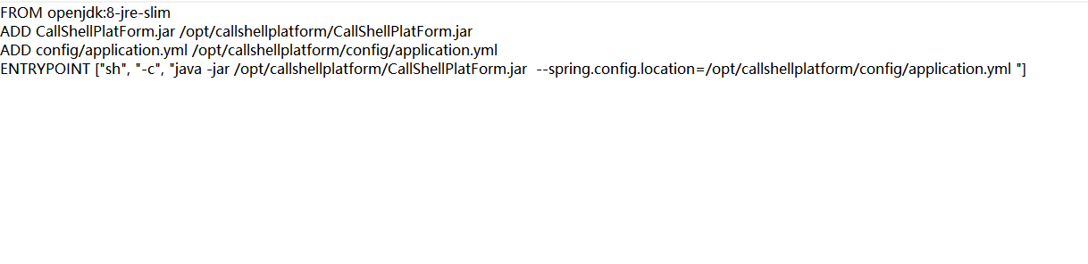

可以自己修改图中的配置



然后执行

docker build --no-cache -t {imagename}:v1.0 .

docker run --privileged --name={processName} --restart always -itd -p 8082:8082 –v {logpath}:/logs #{imagename}:v1.0