## STEPS：

1. **Install software or packages（on Windows, Mac , or Linux）**
   1. python 3.8.5
   2. pytorch 1.11.0
   3. tqdm 4.50.2
   4. sklearn 0.23.2
   5. tensorboardX 2.6
2. **Prepare code and data**
3. Download code from <http://XXXXX>. Unzip the files.
4. Download the base model file <https://s3.amazonaws.com/models.huggingface.co/bert/bert-base-chinese.tar.gz> . Unzip it，and then put it under the folder **bert_pretrain/**.
5. Prepare data and put data under the folder **zongdiaosolution6/data/**. See **Section 4** for details, please.
6. If you are about to test using our data (The work order text data contains sensitive information, so it is not published on the network.), please send an email to contact us ###@XXXX.XXXX
7. **Run**

**python** run_MLIF_BERT.py

Before running the model, you can update parameters in the file run_MLIF_BERT.py：

### parameters settings

parser = argparse.ArgumentParser(description='the MLIF-BERT Model')

parser.add_argument('--model', type=str, default="MLIF_BERT", help='choose a model，models are put in the models folder')

parser.add_argument('--num_epochs', type=str, default="3", help='set epoch')

parser.add_argument('--batch_size', type=str, default="128", help='set batch size')

parser.add_argument('--pad_size', type=str, default="32", help='set pad size')

parser.add_argument('--learning_rate', type=str, default="5e-5", help='set learning rate')

parser.add_argument('--dataset_folder', type=str, default='zongdiaosolution6', help='set the folder where data is（must have a data sub-folder）')

parser.add_argument('--layercount', type=str, default="12", help='the number of top CLS')

1. **Data format**

Users need to prepare four files.

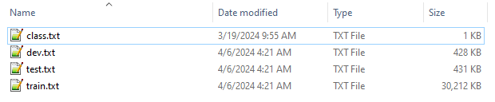

In the **class.txt** file, one category name per line (demo in Chinese).

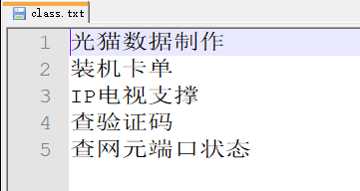

In the **dev.txt/test.txt/train.txt** file, each line is a sample. First is the text content, then the *tab* separator, and then the category number.

