My Colab notbook:
https://colab.research.google.com/drive/1wSXVfmn4JYcJW6ws6oaNKuDfvHhgFfId?usp=sharing

- Generate a correlation matrix with the same data, but this time without using the confounds when masking. How does that impact the correlation matrix? Why do you think it affects the matrix this way?
Matrix without using the confounds when masking is as matrix_nocon.
Compare with matrix using confounds(left)
As you can see, in the matrix with confounds, the diagonal values are zeros, which is results from normalization. In contrast, the diagonal values of matrix without confounds are +1.

Overall, the matrix without confounds shows a stronger color—reds are more reder and blues are bluer. It indicates a stronger positive or negative correlation, which may be driven by noise such as head motion.

Additionally, the distributions of the two matrices are not similar. This suggests that the noise removed by confound regression has a serious impact on the final results, and also highlights that the signal-to-noise ratio in FC is low.

Matrix with confounds | Matrix without confounds
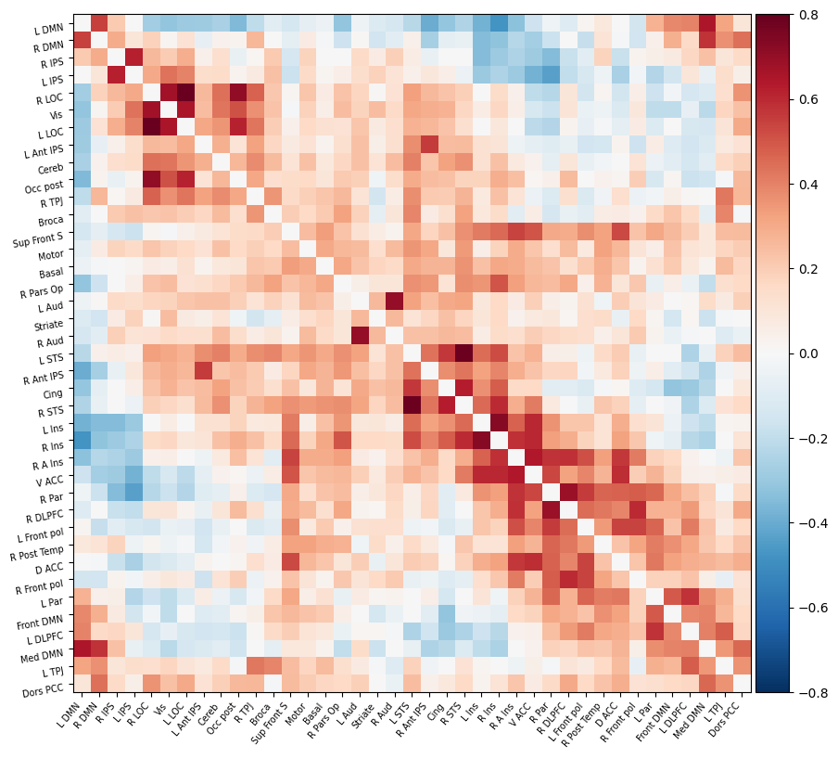 | 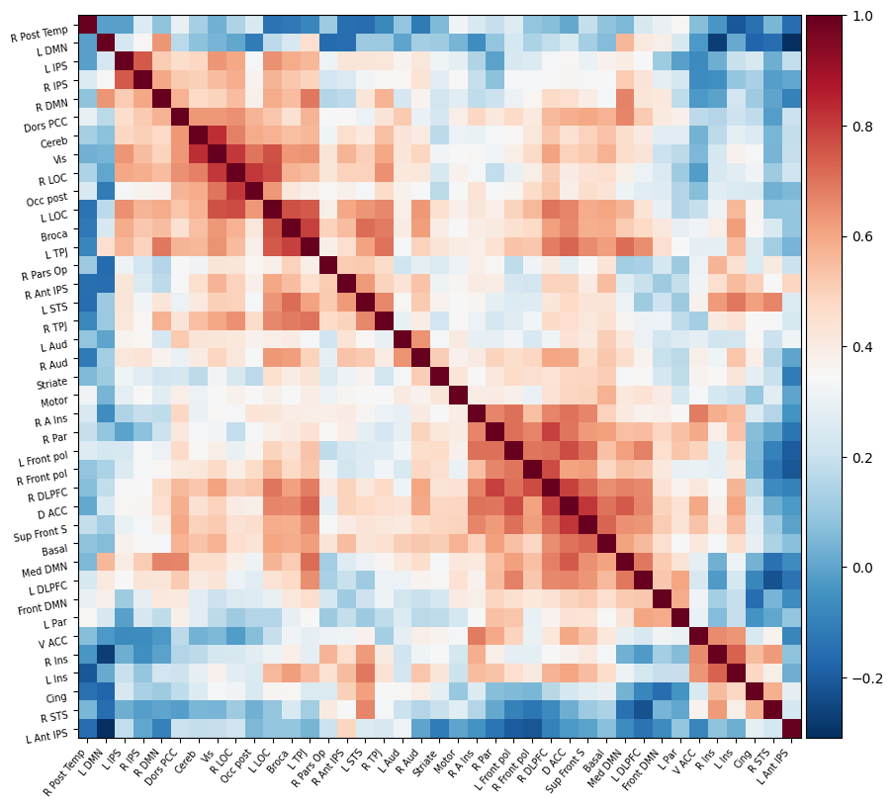

- Plot the obtained connectome in 3D using nilearn.plotting.view_connectome
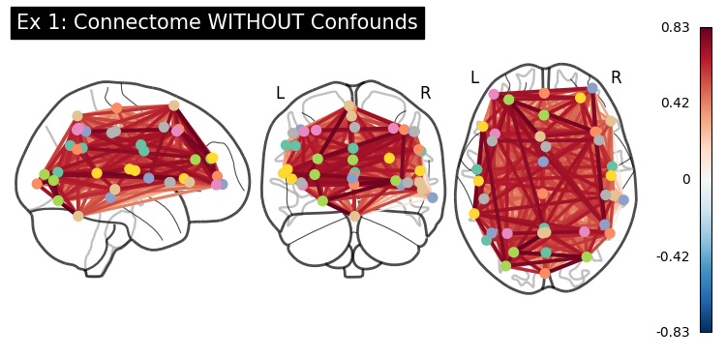

- Visualizing the atlas and a specific time point. Use view_img to visualize the 5th ROI of the atlas.
As cell (3-1), Image can scroll around
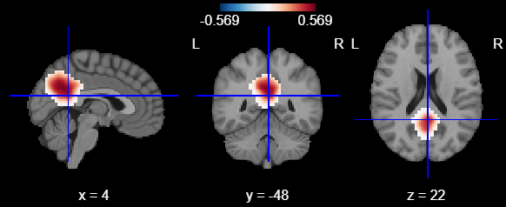

- Use plotting.plot_prob_atlas to show all the ROIs with filled contours.
As cell (3-1)
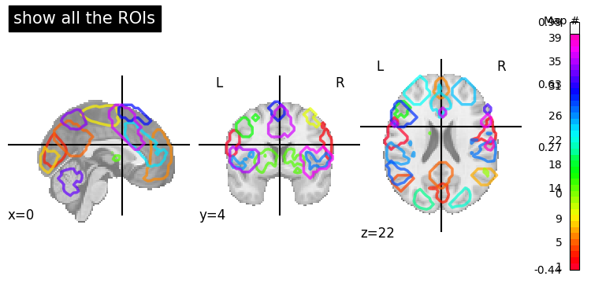

- Earlier we used view_img to plot the mean volume of our fmri_img data because view_img doesn't accept 4D images but only 3D ones. Find a way to generate a 3D Nifti image with the 84th time point in fmri_img and plot it with view_img.
My code allows user to chose which volume to check.
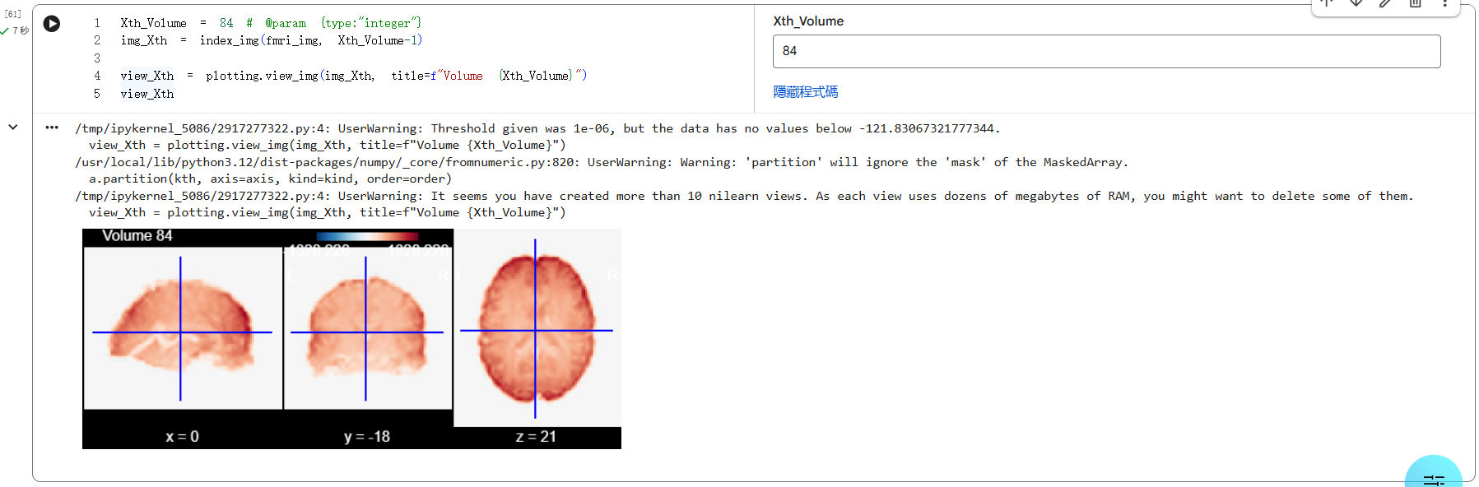

- Using the information provided in this nilearn tutorial, plot the seed-to-voxel correlation map of our fmri_img for the seed of coordinates (-16, -74, 7) and with a sphere mask of radius of size 10.
Radius set 4.5mm (search about 9 voxel)
If you set correlation threshold to 0.5, there are several ROIs.
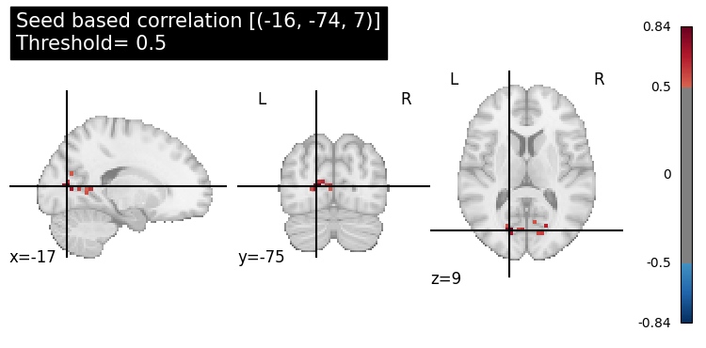
If the threshold is 0.7, there is a clear ROI.
