My Colab notbook:
https://colab.research.google.com/drive/1hkPwqDuEOUfFQG5hR30oTJakQ3yJ-pNk?usp=sharing

I chose three different atlas
1. AAL3v1 (Automated Anatomical Labeling 3 Version 1)
2. Harvard-Oxford Cortical Atlas
3. Yeo 2011 Functional Networks (7 Networks)

First, I chose the AAL3 atlas because it is the atlas used in my thesis research. AAL3 is like your standard, traditional city map. It divides the brain based on strict, physical landmarks.
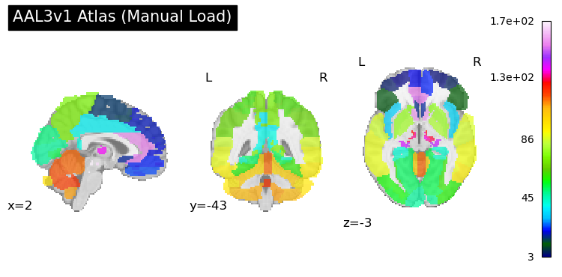
Second is the Harvard-Oxford atlas. Reather than a one-fits-all boundary. Harvard–Oxford atlas is more like segmentation. Its regions are defined based on probabilistic tissue and anatomical boundaries.

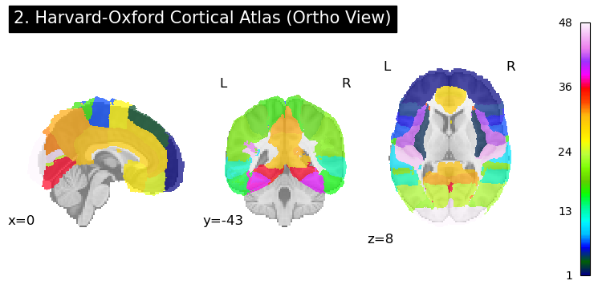

Finally, Yeo 2011 atlas is completely different. Also used in my thesis, It completely ignores physical anatomy and instead separated purely at functional network.
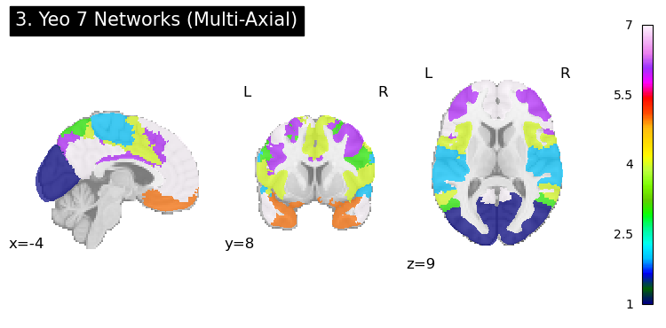

Compare the atlas parcellations and discuss your observations below. What might be some reasons that parcellation could affect your functional connectivity results?
If we set the target coordinates to (10, 10, 30) mm, clear differences among the three atlases become apparent. Why did I choose this coordinate? The reason is that at (10, 10, 30), the anatomical structure of the hippocampus can be identified by bare eyes.

Among the three atlases, the AAL3 atlas appears to correspond most closely to the visible anatomy, providing a relatively complete delineation of the hippocampal structure.
The Harvard–Oxford atlas is somewhere in between. Its boundaries are less distinct, and it does not further subdivide structures within the hippocampus.
Finally, the Yeo 7 Networks atlas shows the greatest difference. Since it is based on functional network organization rather than anatomical landmarks, the hippocampus is not clearly identifiable, and its anatomical boundaries are largely absent in the parcellation.
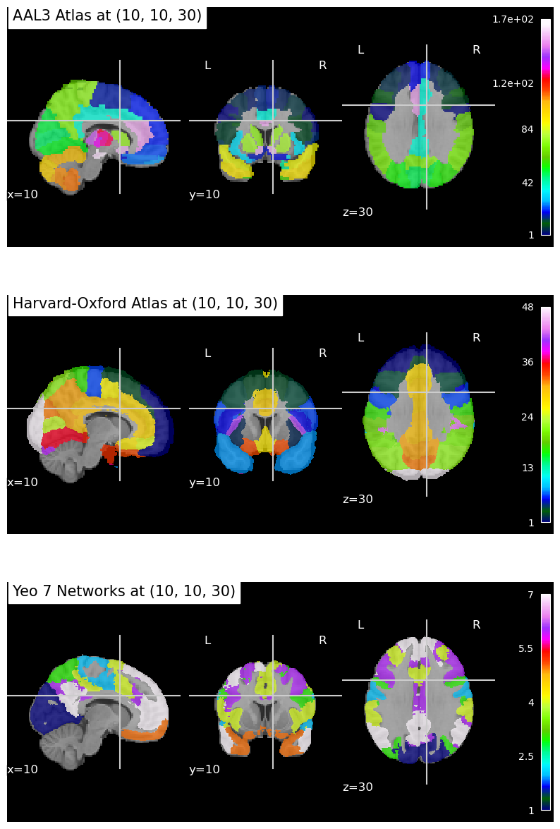
Moreover, If we use the coordinates (10, 10, 30) mm to identify the corresponding region in each atlas, we can see that the results differ substantially across the three atlases.
At the MNI coordinates (10, 10, 30):
AAL3: Precentral_R
Harvard–Oxford Atlas: Cingulate Gyrus, Anterior Division
Yeo Atlas: Background (no corresponding network assignment)
This illustrates that the same MNI coordinate can be assigned to different regions depending on the atlas we used, reflecting differences in parcellation principles among these three atlas.
