Claude-William N’Silou

Assignment #1 Wi-Fi Diagnosis

Design
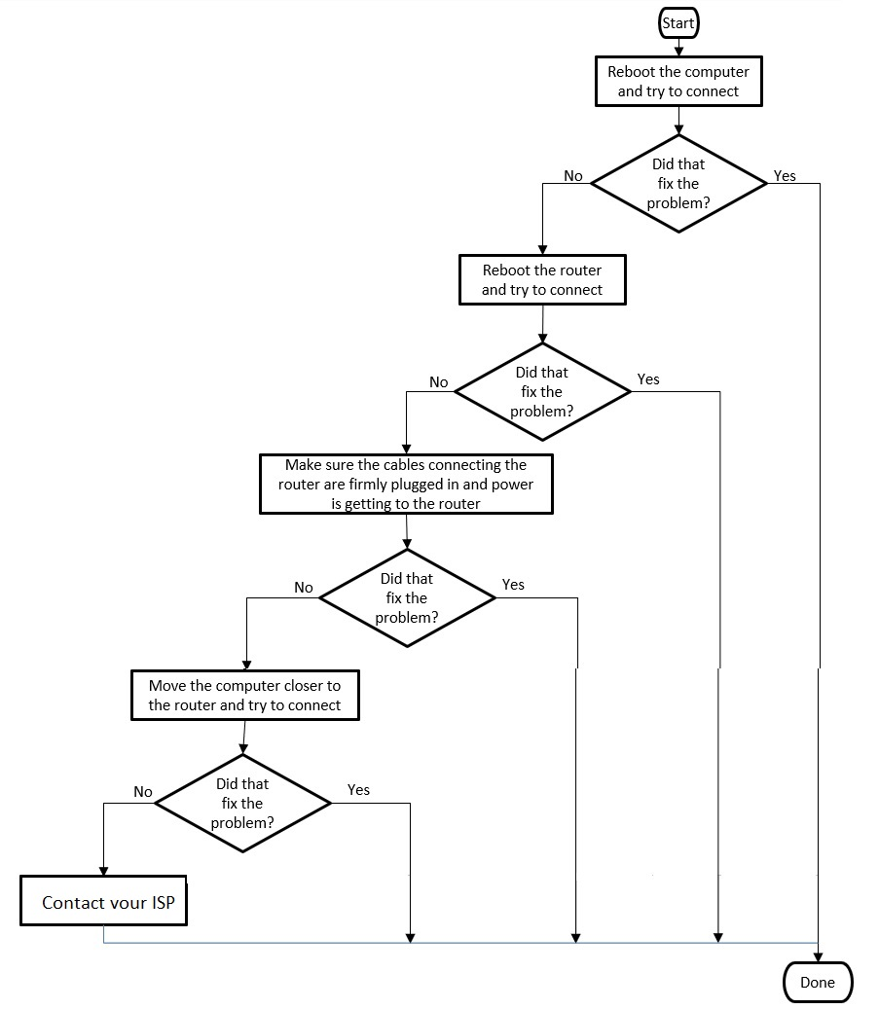

Pseudocode:
prompt purpose of this program
Create a new object of type Scanner that reads from the keyboard
prompt first step
Read in the line that the user types
if user input “yes” terminate program
prompt second step
Read in the line that the user types
if user input “yes” terminate program
prompt third step
Read in the line that the user types
if user input “yes” terminate program
prompt fourth step
Read in the line that the user types
if user input “yes” terminate program
prompt fifth step
close scanner
terminate the program

Tests:
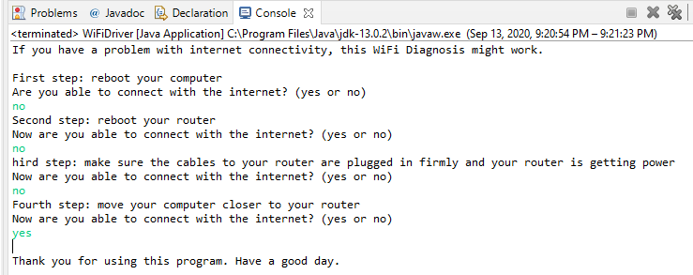

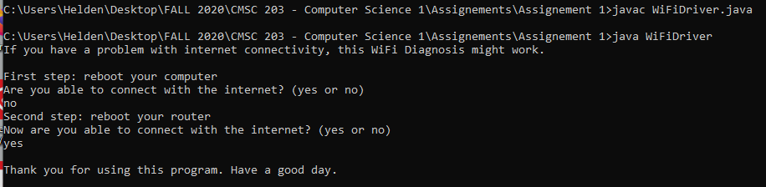

GitHub repository picture:
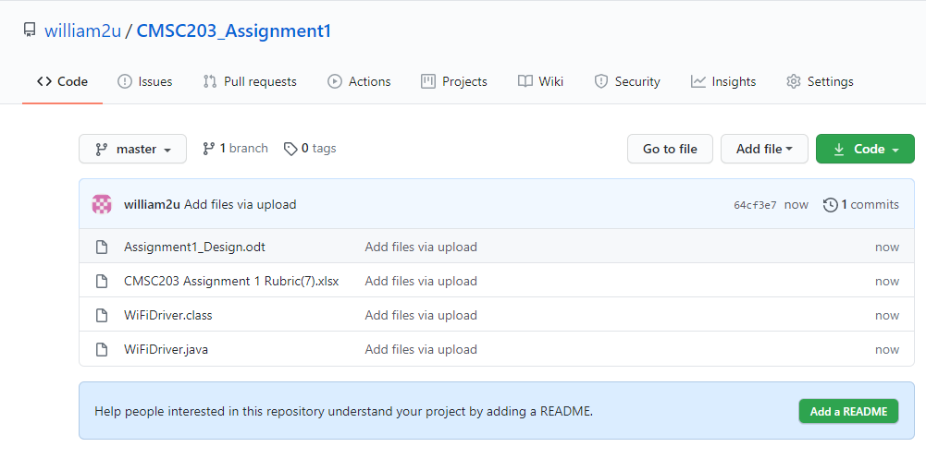

Experience learned:
This assignment, based on nested if statement, was relatively simple. Only basic concepts were necessary and the transition from C++ went smoothly. The use of command lines to compile and execute a java program was inconvenient but not hard, on the condition to be well organized. I wrote down the pseudocode as comments in the source file then use it as skeleton and write the code arround it. It was a valuable practice.

