Claude-William N’Silou

Assignment #1 Wi-Fi Diagnosis

Design
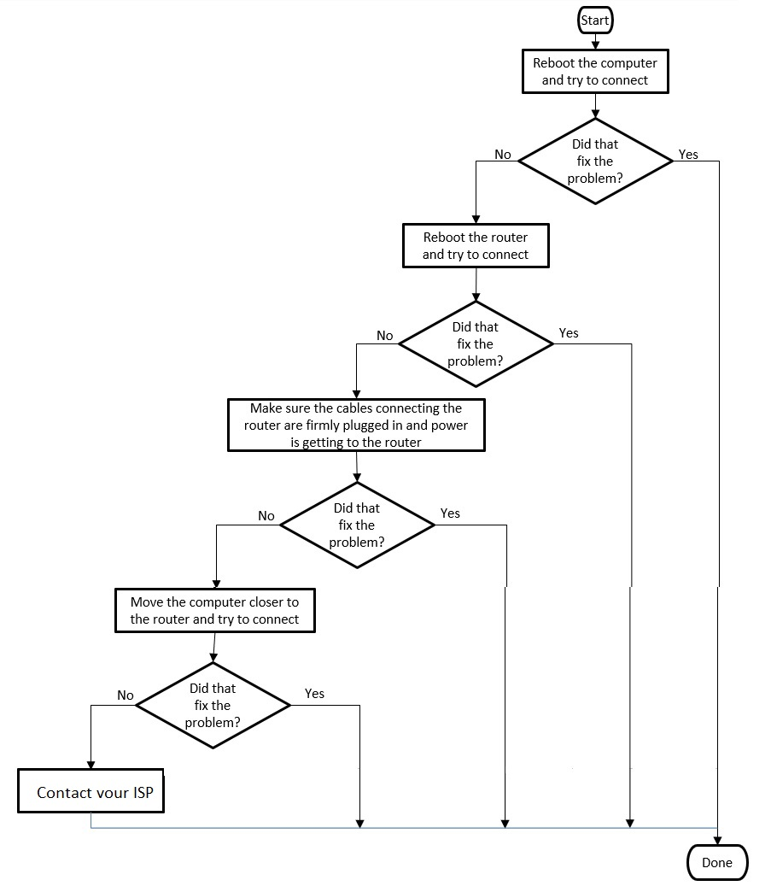

Pseudocode:
prompt purpose of this program
Create a new object of type Scanner that reads from the keyboard
prompt first step
Read in the line that the user types
if user input “yes” terminate program
prompt second step
Read in the line that the user types
if user input “yes” terminate program
prompt third step
Read in the line that the user types
if user input “yes” terminate program
prompt fourth step
Read in the line that the user types
if user input “yes” terminate program
prompt fifth step
close scanner
terminate the program

