Claude-William N’Silou

Assessment 2: Random Number Guesser

Design:
Create a new object of type Scanner that reads from the keyboard
Loop keep playing
reset the number of guesses
generate a random number
reset parameters
prompt user to guess number generated
Loop till correct answer
check validity of the input
check if user's answer is not correct
if not correct ask for another input
output congratulation
Ask user if he/she want to play again
if user don’t want to play again
terminate the program

Test 1:
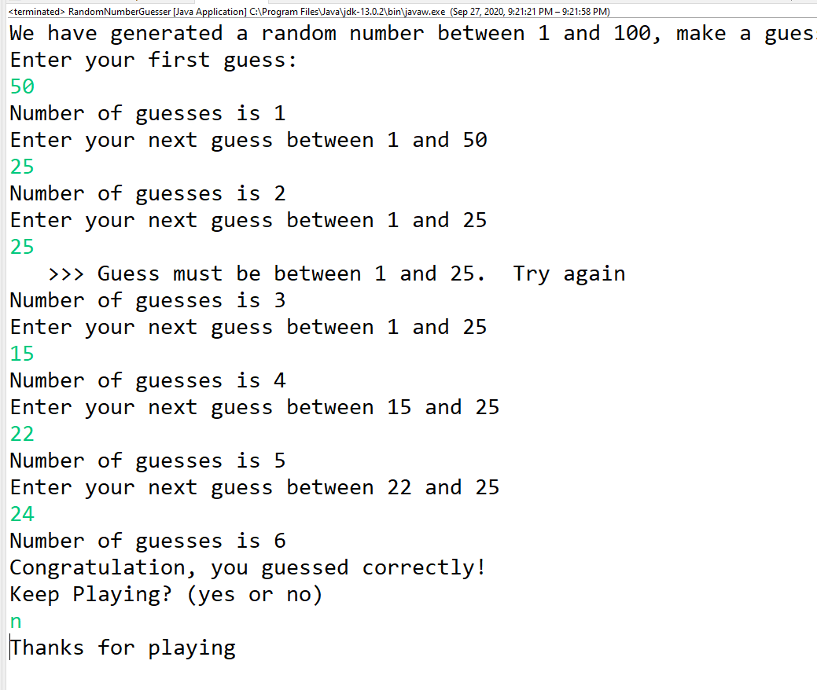

Test 2:

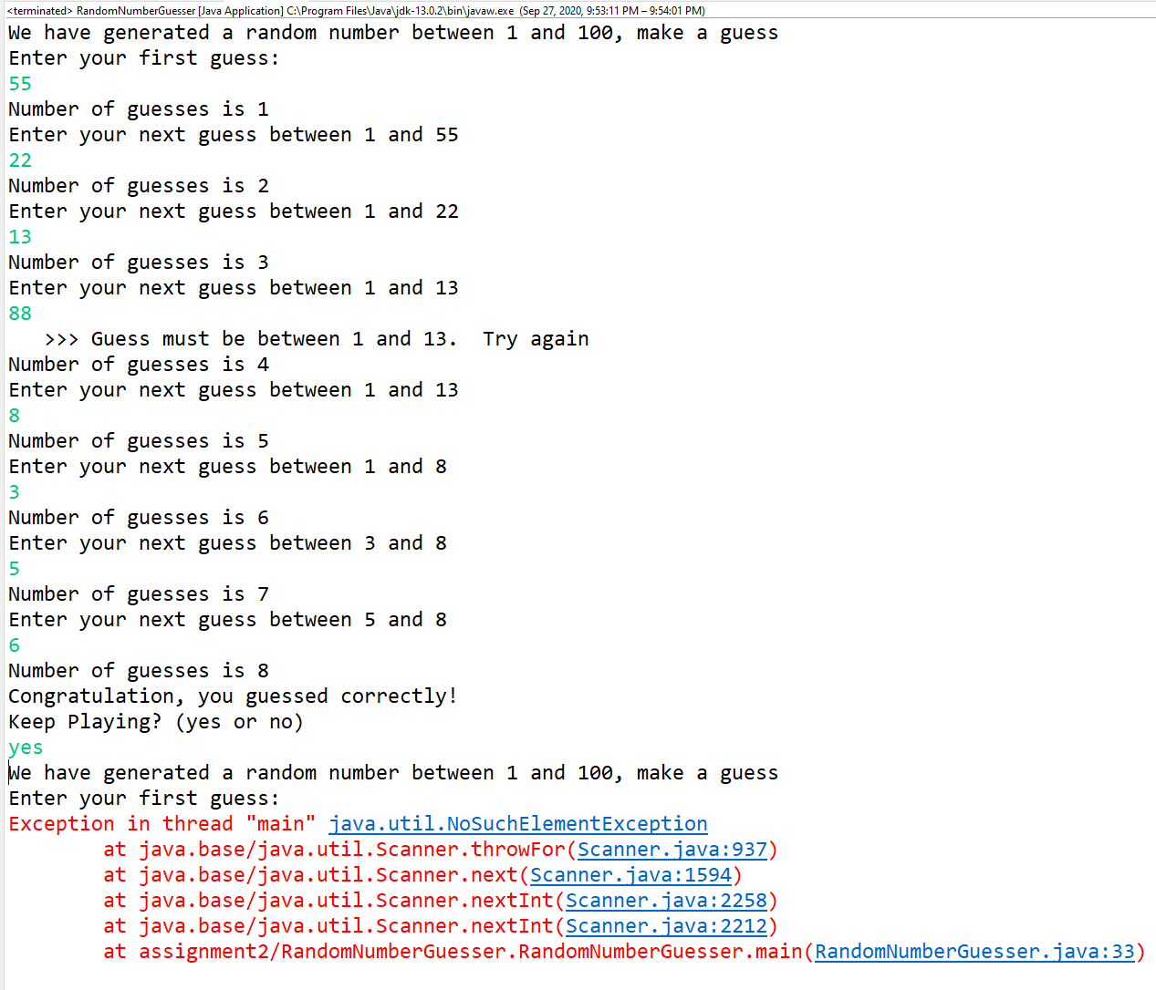

Reflection:
It was a simple program involving a nested do-loop. The main issue was a recuring error message (runtime error) involving Scanner objet:
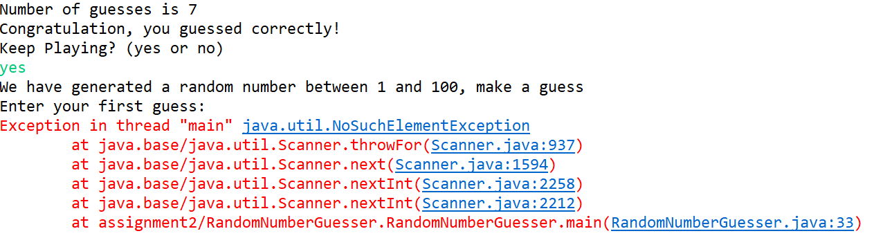
This error keep the program from restarting the game if the user want to replay.

