Claude-William N’Silou

Task #1 Correcting Syntax and Run-time Errors in Formulas

NumericTypes.java, without correction:

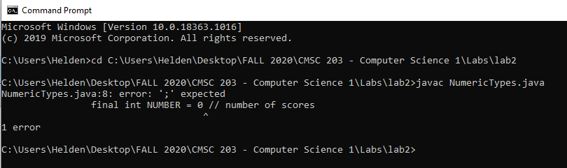
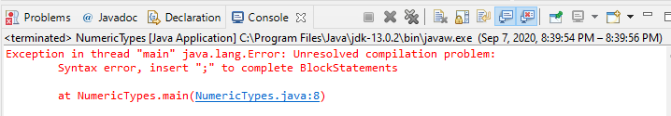

NumericTypes.java, with syntax error correction:

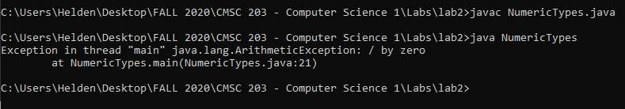

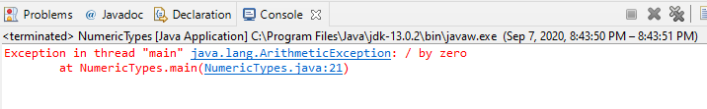
NumericTypes.java, with run-time error correction:

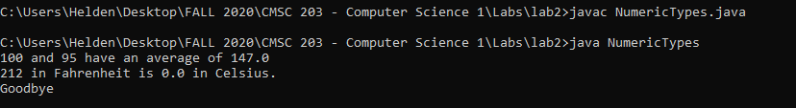
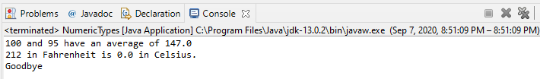

Task #2 Correcting Logic Errors in Formulas
NumericTypes.java, with logic errors in the average formula correction and changing the data type of the scores ( from int to double):
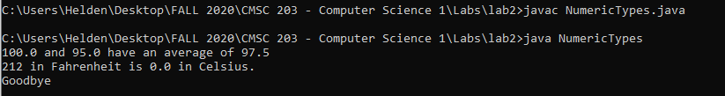
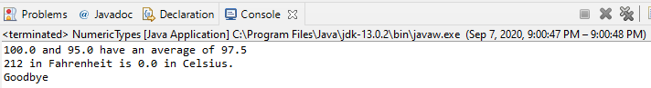
NumericTypes.java, with logic errors in the convertion formula correction:

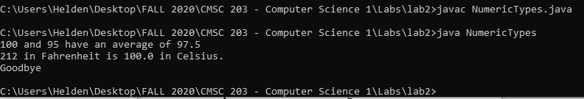
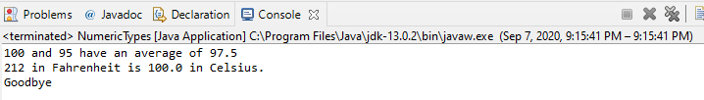

Task #3 Using the Scanner Class for User Input
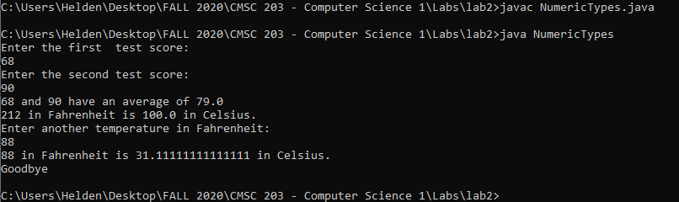
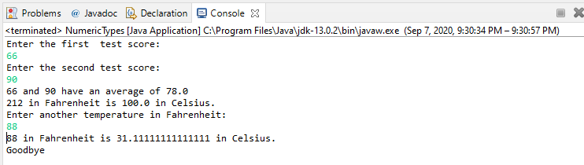
Task #4 – Create a program from scratch using predefined Math Functions

Diameter | Volume (hand calculated) | Volume (resulting output)
2 | 4.188790205 or 4π/3 | 4.1887902047863905
25.4 | 8580.246646 or (π/6)x(25.4)^3 | 8580.24664605096
-5 | -65.44984695 or 15625π/6 | -65.44984694978736

Test 1:
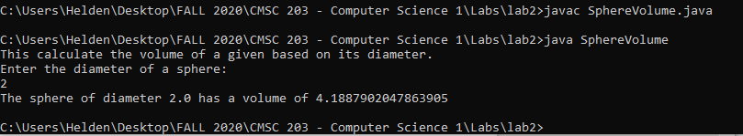
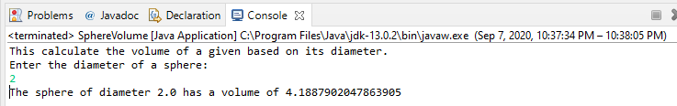
Test 2:
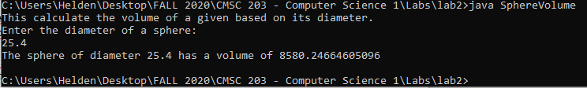
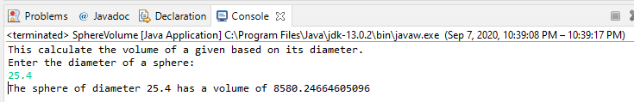
Test3:
