Victorian Population Health Survey 2017 summary

# Introduction

This is a summary of data for the City of Moonee Valley, from the Victorian Population Health Survey 2017. The survey was conducted by the Department of Health and Human Services. More information about the survey can be found here: <https://www2.health.vic.gov.au/public-health/population-health-systems/health-status-of-victorians/survey-data-and-reports/victorian-population-health-survey/victorian-population-health-survey-2017>

# Comparison against other local government areas

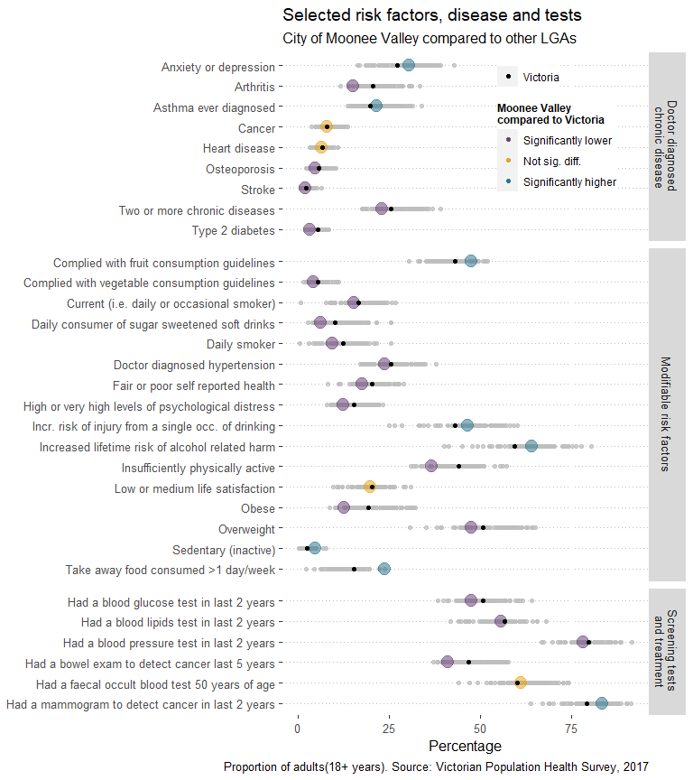

# Data for Moonee Valley

## Modifiable risk factors

| **Indicator** | **Percentage** | **Lower limit** | **Upper limit** |
| --- | --- | --- | --- |
| Obese | 12.5 | 9.3 | 16.8 |
| Overweight | 47.6 | 41.7 | 53.7 |
| Daily consumer of sugar sweetened soft drinks | 6.4 | 4.3 | 9.4 |
| Take away food consumed >1 day/week | 23.7 | 17.9 | 30.7 |
| Sedentary (inactive) | 4.7 | 2.3 | 9.3 |
| Insufficiently physically active | 36.7 | 31.0 | 42.7 |
| Complied with vegetable consumption guidelines | 4.4 | 2.8 | 6.9 |
| Complied with fruit consumption guidelines | 47.5 | 41.6 | 53.4 |
| Daily smoker | 9.3 | 6.3 | 13.6 |
| Current (i.e. daily or occasional smoker) | 15.3 | 11.2 | 20.7 |
| Increased lifetime risk of alcohol related harm | 64.2 | 58.5 | 69.5 |
| Incr. risk of injury from a single occ. of drinking | 46.6 | 40.7 | 52.7 |
| Fair or poor self reported health | 17.7 | 13.7 | 22.5 |
| Low or medium life satisfaction | 19.9 | 15.3 | 25.6 |
| High or very high levels of psychological distress | 12.4 | 8.9 | 17.1 |
| Doctor diagnosed hypertension | 23.8 | 19.9 | 28.3 |

## Doctor diagnosed chronic disease

| **Indicator** | **Percentage** | **Lower limit** | **Upper limit** |
| --- | --- | --- | --- |
| Anxiety or depression | 30.4 | 25.0 | 36.4 |
| Arthritis | 15.2 | 12.5 | 18.5 |
| Asthma ever diagnosed | 21.5 | 17.0 | 26.7 |
| Cancer | 8.0 | 6.0 | 10.7 |
| Type 2 diabetes | 3.3 | 2.0 | 5.2 |
| Heart disease | 6.6 | 4.8 | 9.0 |
| Osteoporosis | 4.8 | 3.5 | 6.5 |
| Stroke | 2.1 | 1.2 | 3.7 |
| Two or more chronic diseases | 23.0 | 19.0 | 27.6 |

## Screening tests and treatment

| **Indicator** | **Percentage** | **Lower limit** | **Upper limit** |
| --- | --- | --- | --- |
| Had a blood lipids test in last 2 years | 55.6 | 50.0 | 61.2 |
| Had a blood pressure test in last 2 years | 78.2 | 72.6 | 82.9 |
| Had a blood glucose test in last 2 years | 47.6 | 41.8 | 53.5 |
| Had a faecal occult blood test 50 years of age | 61.2 | 52.6 | 69.1 |
| Had a bowel exam to detect cancer last 5 years | 41.2 | 34.6 | 48.1 |
| Had a mammogram to detect cancer in last 2 years | 83.5 | 74.5 | 89.7 |