Moonee Valley Health Profile 2020

# Executive summary

Some sort of infographic like the previous health tracker

# Introduction

# Population

## Current and projected

The population of the City of Moonee Valley is forecast to increase from about 130,000 in 2019[1], to around 170,000 in 2040[2].

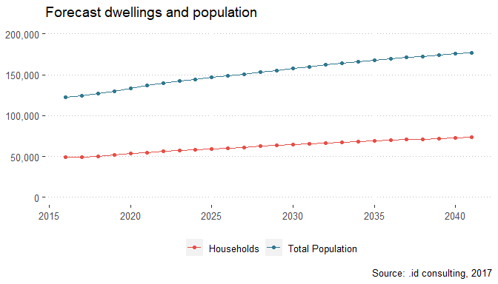

## Age breakdown

The population structure of the City of Moonee Valley is not forecast to change greatly between 2020 and 2040. There will be an increase in all age groups, though there will be a slight increase in the median age and a greater proportion of older residents.

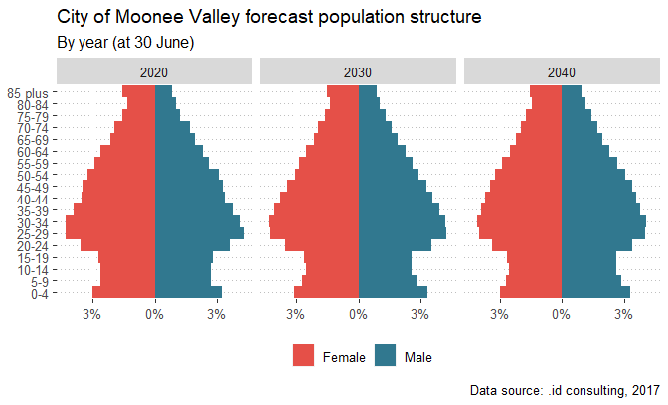

* Location of young/old

# Environmental factors

## Socio-economic disadvantage

Data from the Socio-Economic Indexes for Areas (SEIFA) Index of Relative Socio-economic Disadvantage (IRSD) shows that there is great economic diversity in Moonee Valley households. There are pockets of disadvantage in neighbourhoods like Flemington, Ascot Vale, Avondale Heights and Milleara. In contrast, Strathmore and Strathmore Heights are the least disadvantaged neighbourhoods.

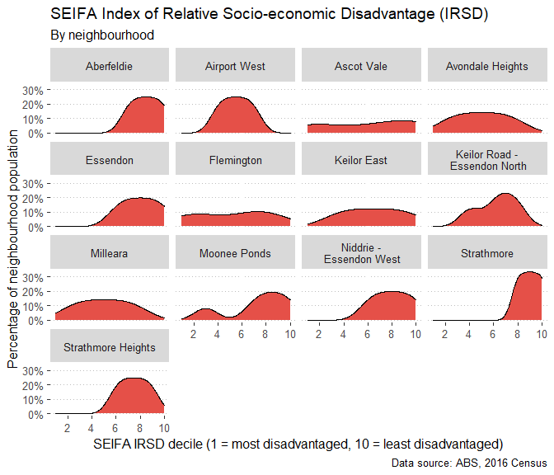

This disparity is shown on the map below. The greatest concentrations of disadvantage are one the public housing estates in Flemington and Ascot Vale.

!! perhaps make the maps in ArcGIS instead?



## Heat Vulnerability Index

* define then show map

<https://www.planning.vic.gov.au/policy-and-strategy/planning-for-melbourne/plan-melbourne/cooling-greening-melbourne/mapping-and-analysis-of-vegetation,-heat-and-land-use>

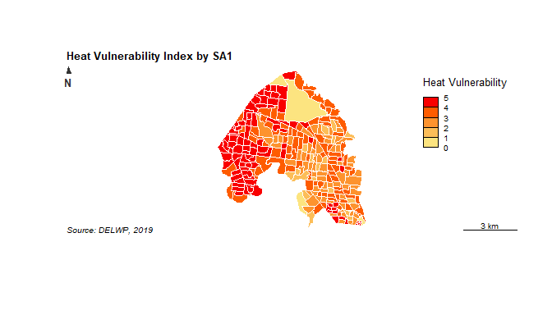

# Gender inequality

* some differences between genders from the Census and VPHS

# Employment

# Affordable housing

# Community Safety

# Health Status

## Oral health

## Healthy eating

## Chronic disease

| **Indicator** | **Percentage** | **Lower limit** | **Upper limit** |
| --- | --- | --- | --- |
| Anxiety or depression | 30.4 | 25.0 | 36.4 |
| Arthritis | 15.2 | 12.5 | 18.5 |
| Asthma ever diagnosed | 21.5 | 17.0 | 26.7 |
| Cancer | 8.0 | 6.0 | 10.7 |
| Type 2 diabetes | 3.3 | 2.0 | 5.2 |
| Heart disease | 6.6 | 4.8 | 9.0 |
| Osteoporosis | 4.8 | 3.5 | 6.5 |
| Stroke | 2.1 | 1.2 | 3.7 |
| Two or more chronic diseases | 23.0 | 19.0 | 27.6 |
| Source: Victorian Population Health survey, 2017 | | | |

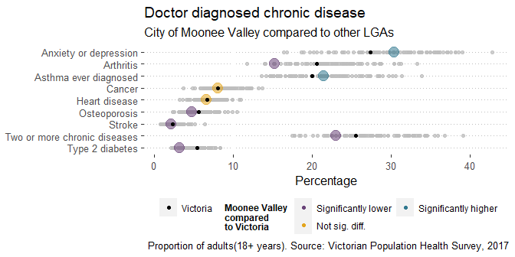

## Modifiable risk factors

### Tobacco

### Alcohol

### Drugs

### Gambling

### Physical activity

### Mental health

The graph below will need to be split up

| **Indicator** | **Percentage** | **Lower limit** | **Upper limit** |
| --- | --- | --- | --- |
| Obese | 12.5 | 9.3 | 16.8 |
| Overweight | 47.6 | 41.7 | 53.7 |
| Daily consumer of sugar sweetened soft drinks | 6.4 | 4.3 | 9.4 |
| Take away food consumed >1 day/week | 23.7 | 17.9 | 30.7 |
| Sedentary (inactive) | 4.7 | 2.3 | 9.3 |
| Insufficiently physically active | 36.7 | 31.0 | 42.7 |
| Complied with vegetable consumption guidelines | 4.4 | 2.8 | 6.9 |
| Complied with fruit consumption guidelines | 47.5 | 41.6 | 53.4 |
| Daily smoker | 9.3 | 6.3 | 13.6 |
| Current (i.e. daily or occasional smoker) | 15.3 | 11.2 | 20.7 |
| Increased lifetime risk of alcohol related harm | 64.2 | 58.5 | 69.5 |
| Incr. risk of injury from a single occ. of drinking | 46.6 | 40.7 | 52.7 |
| Fair or poor self reported health | 17.7 | 13.7 | 22.5 |
| Low or medium life satisfaction | 19.9 | 15.3 | 25.6 |
| High or very high levels of psychological distress | 12.4 | 8.9 | 17.1 |
| Doctor diagnosed hypertension | 23.8 | 19.9 | 28.3 |
| Source: Victorian Population Health survey, 2017 | | | |

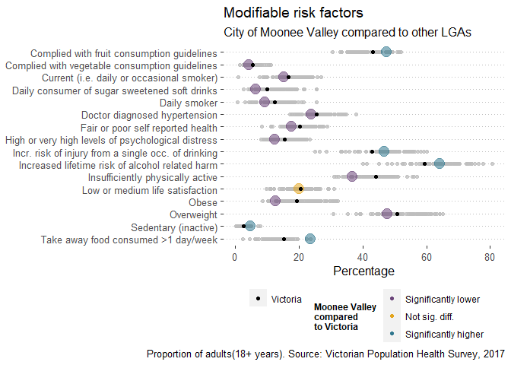

## Screening tests and treatments

| **Indicator** | **Percentage** | **Lower limit** | **Upper limit** |
| --- | --- | --- | --- |
| Had a blood lipids test in last 2 years | 55.6 | 50.0 | 61.2 |
| Had a blood pressure test in last 2 years | 78.2 | 72.6 | 82.9 |
| Had a blood glucose test in last 2 years | 47.6 | 41.8 | 53.5 |
| Had a faecal occult blood test 50 years of age | 61.2 | 52.6 | 69.1 |
| Had a bowel exam to detect cancer last 5 years | 41.2 | 34.6 | 48.1 |
| Had a mammogram to detect cancer in last 2 years | 83.5 | 74.5 | 89.7 |
| Source: Victorian Population Health survey, 2017 | | | |

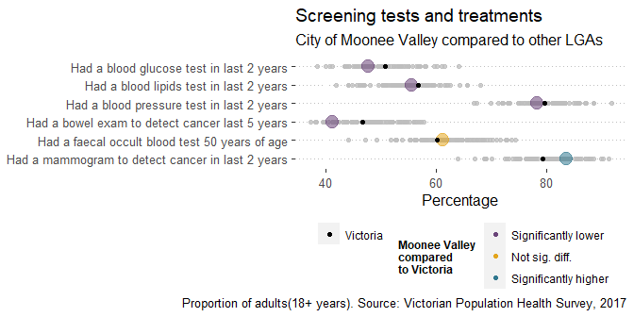

## Food security

## Sexual and reporductive health

## Family violence

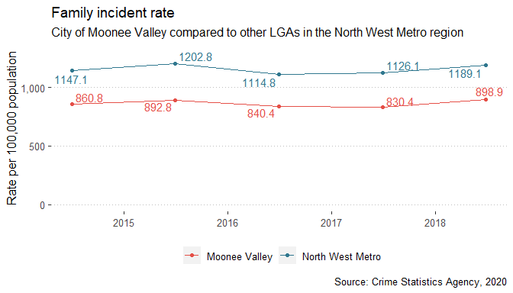

## Death

### Premature deaths

Premature deaths in Moonee Valley declined between 2014 and 2018[3]. There were 142.8 premature deaths per 100,000 in Moonee Valley in 2018, compared to 160.5 for Greater Melbourne.

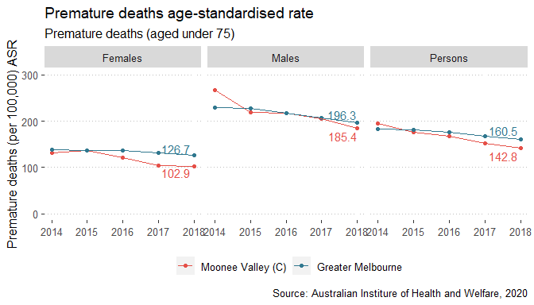

### Top causes of death

The most common causes of death in 2018 were Coronary heart disease, responsible for 289 deaths.

| **Cause** | **Deaths** | **Per cent of all causes** |
| --- | --- | --- |
| Coronary heart disease | 489 | 12.8 |
| Dementia including Alzheimer disease | 295 | 7.7 |
| Cerebrovascular disease | 241 | 6.3 |
| Lung cancer | 173 | 4.5 |
| Chronic obstructive pulmonary disease | 146 | 3.8 |
| Colorectal cancer | 145 | 3.8 |
| Diabetes | 122 | 3.2 |
| Accidental falls | 118 | 3.1 |
| Influenza and pneumonia | 83 | 2.2 |
| Prostate cancer | 76 | 2.0 |
| Source: Australian Institure of Health and Welfare, 2020 | | |

# To add

* aged care <https://gen-agedcaredata.gov.au/Topics/Services-and-places-in-aged-care/Explore-services-and-places-in-aged-care>
* ahpc
* vichealth indicators
* vcams
* family violence
* community survey

1. Australian Bureau of Statistics, 2020, *Regional Population Growth, 2018-19*, cat. No. 3218.0, <https://www.abs.gov.au/ausstats/abs@.nsf/mf/3218.0>
2. .id consulting, 2017, *Moonee Valley Population Forecasts*
3. Australian Institute of Health and Welfare, 2020, *Mortality Over Regions and Time (MORT) books*, 7 August 2020, Australian Government, Canberra.