William Wright

Lab3

* (1) what do the -v, -f, and -C do/what are they for?

-v will print the current version of make you have installed on your system

-f is to define where the fire is that you are using to make

-c is the working directory where it can find all of the files used to compile the program

(2) what do the flags -4 and -n mean?

-n is used to tell the program Do not do any DNS or service lookups on any specified addresses,

hostnames or ports.

-4 Forces nc to use IPv4 addresses only.

* (3) what do the options -ano do/what are they for?

-an is used to tell it not to do a reverse lookup and only display the values in text

-o wasn’t included with my Verizon of netstat

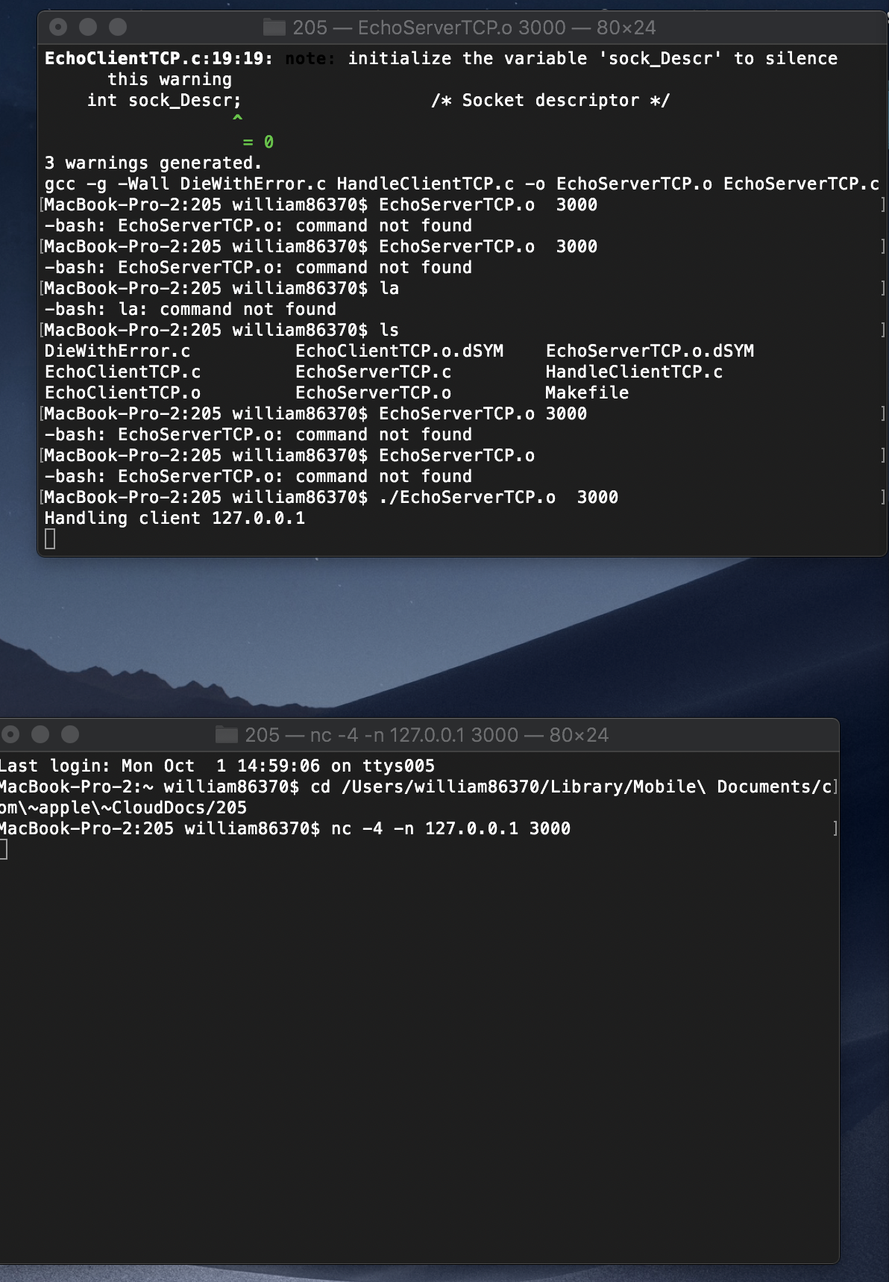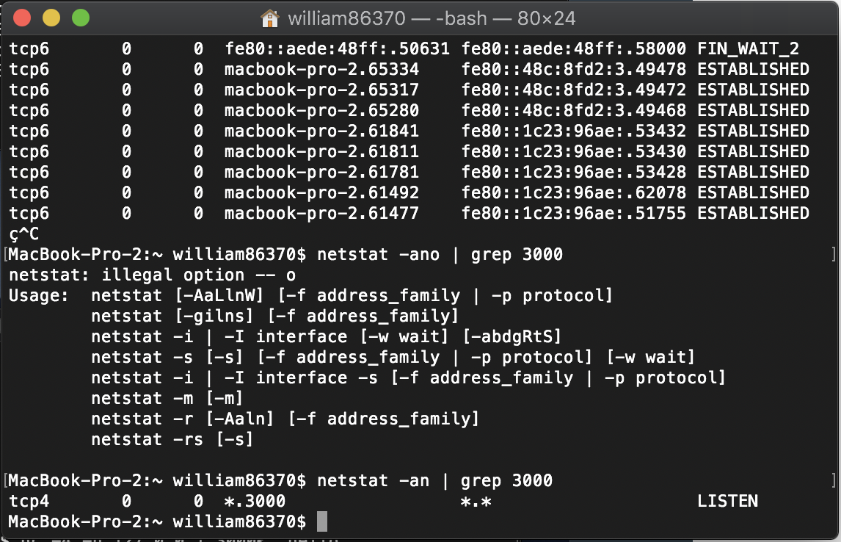

* Did you have make already installed?

Yes I am using osx and it is included with my command line xcode tools