William Wright

Lab 6

* (1) Did you get the same response that was sent between the Client and Server? What was the IP address used?

Yes, I did receive the same thing I sent to the server the ip address used was ::1

* (2) Running Wireshark what capture filter and options did you have to use

I had to capture on Loopback: lo0 and I had the filter “tcp.stream eq 0” on

* (3) Within Wireshark following TCP Stream – what was the source and destination port and what TCP flags were set?

The source was port 59917 and destination was the port I set 3000

The flags where 0x018 and tcp flags AP

* (4) using [https://test-ipv6.com (Links to an external site.)Links to an external site.](https://test-ipv6.com/) or similar online IPV6 IP check; do you have a routable IPV6 IP?

No I am on capitols internet and they do not currently have an ipv6 public address

* (5) what are the non-routable (private) IPV6 Ips?

The address block *fc00::/7*  is all the ipv6 addresses that a user can use for internal networks and those addresses cant be routed

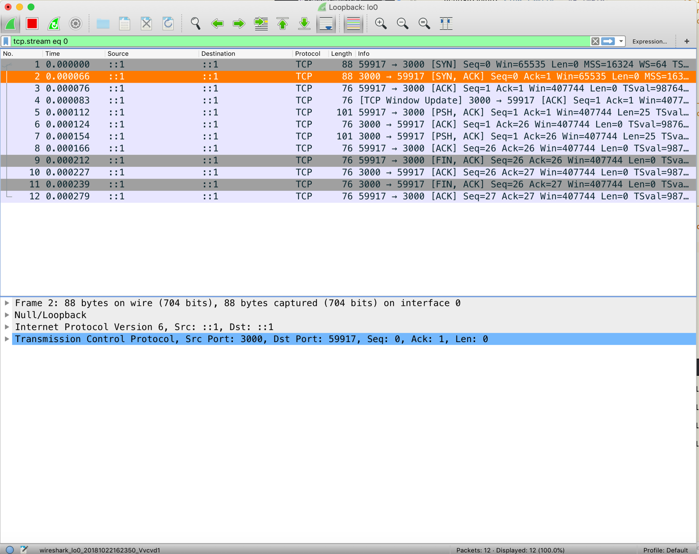

Here is the Screenshot of the Wireshark packet capture

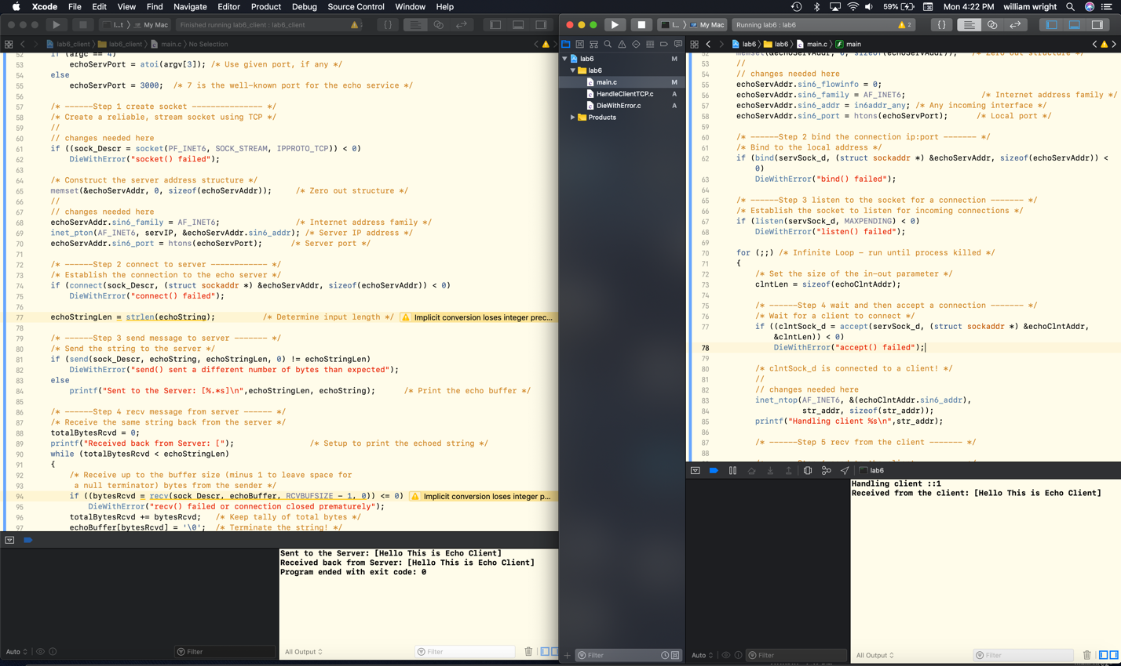

Here is a screenshot of the Server on the right and the client running in the left of lab 6 the output is at the bottom right of each of the projects.