William Wright

Lab 7 Part A

* (1)Did you get the same response that was sent between the Client and Server?

Yes the message I received was the same as sent

* (2)Running Wireshark what capture filter and options did you have to use

sctp.assoc_index==0

and ip.address=

* (3)Within Wireshark how did you follow the stream?

Right click one of the packets and click sctp and analyze stream

* (4)Un-comment the //#include <netinet/sctp.h> header and recompile. Did you get the cannot find the header error

I did not get that error because I modified the kernel of my MacBook with the sctp.h files to allow it to send and receive the packets

* (5)if following the gcc compile flag –lsctp did you get it to compile without the error?

Yes, it compiled without the error this time

* Did you have to install SCTP to get the same program to compile?

Yes if you don’t have the dev kit installed then the program will never compile

I used <https://github.com/sctplab/SCTP_NKE_HighSierra> to allow my mac to send and receive the packets you modify the kernel to use the new sctp.h files

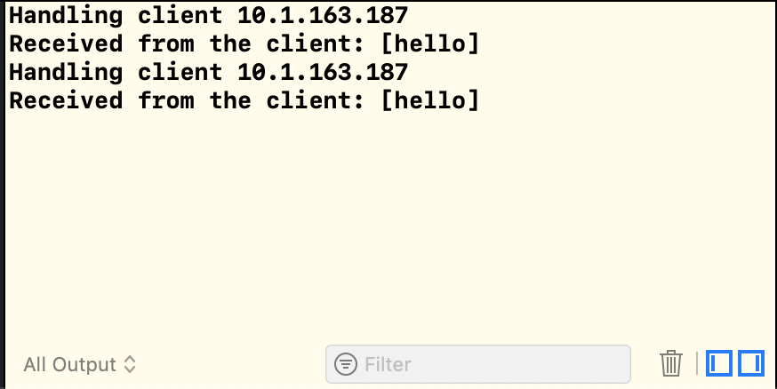

here is my server receiving the request

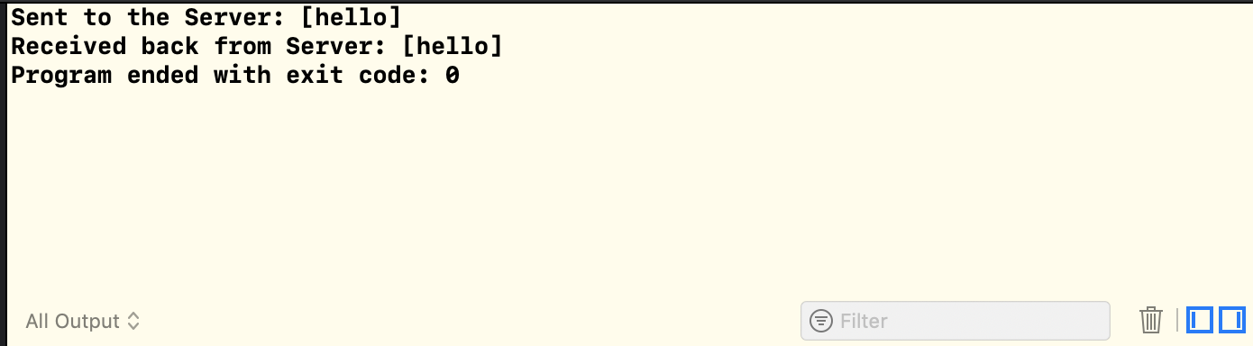

this is my client sending the message to the server

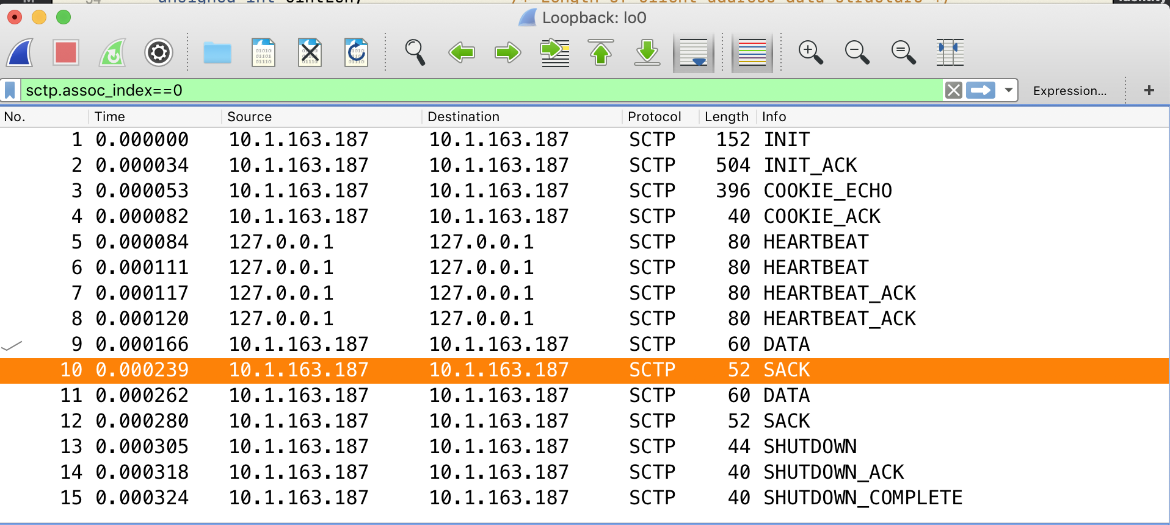

here is my Wireshark looking at the packets