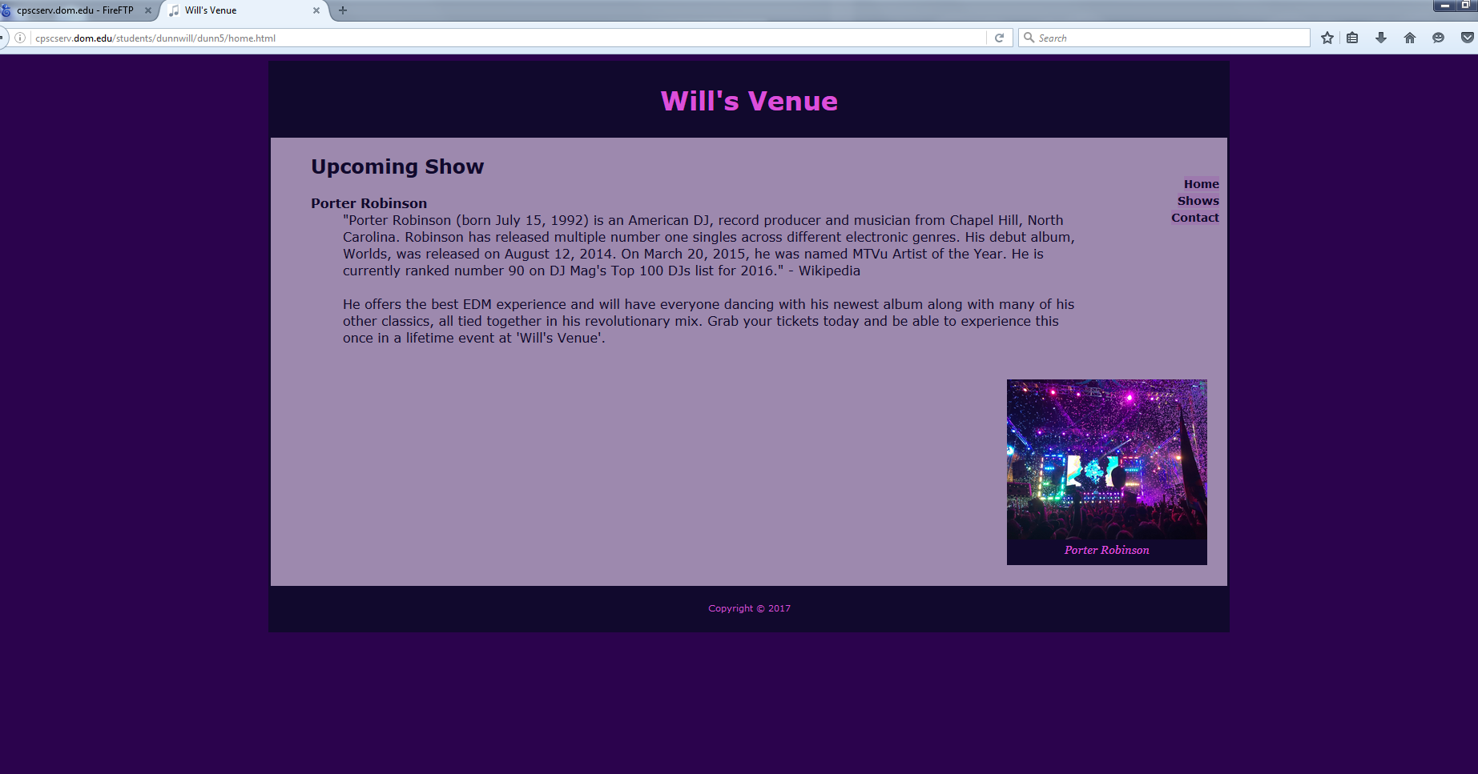

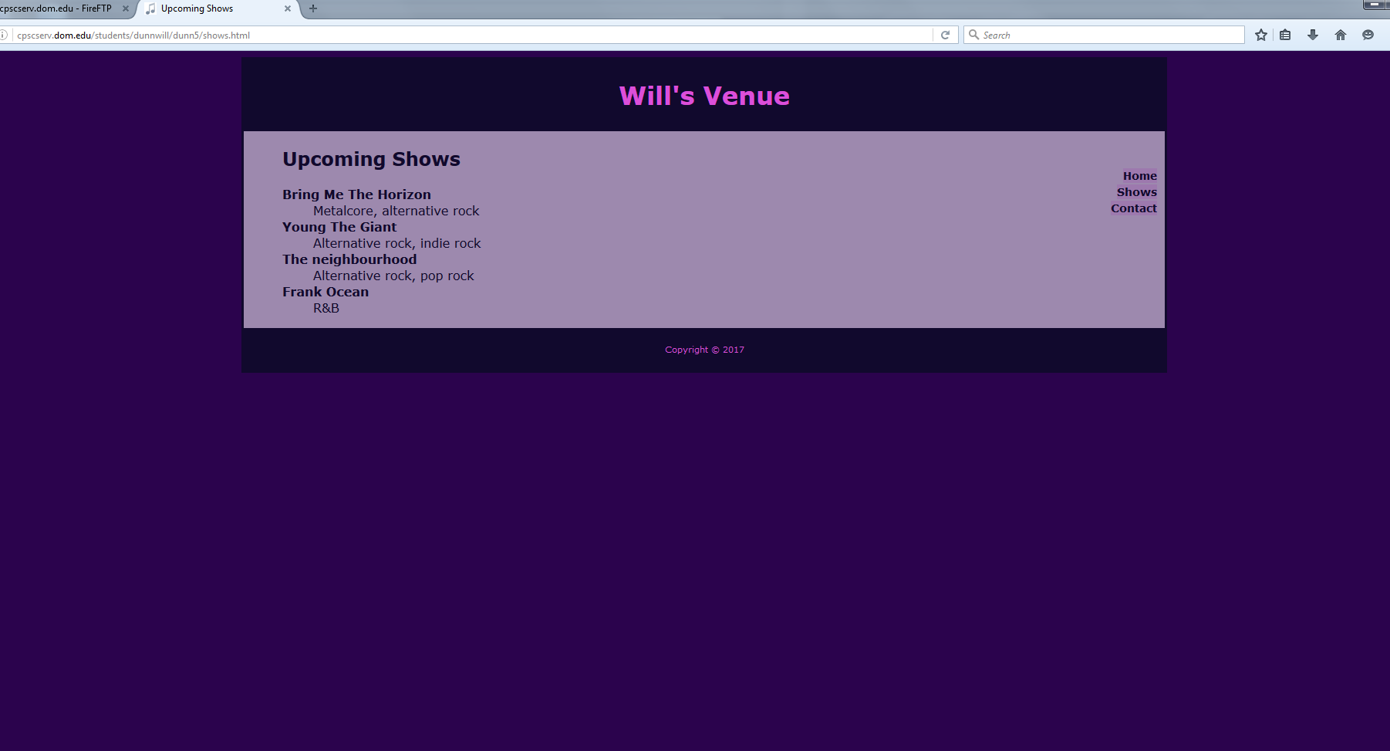

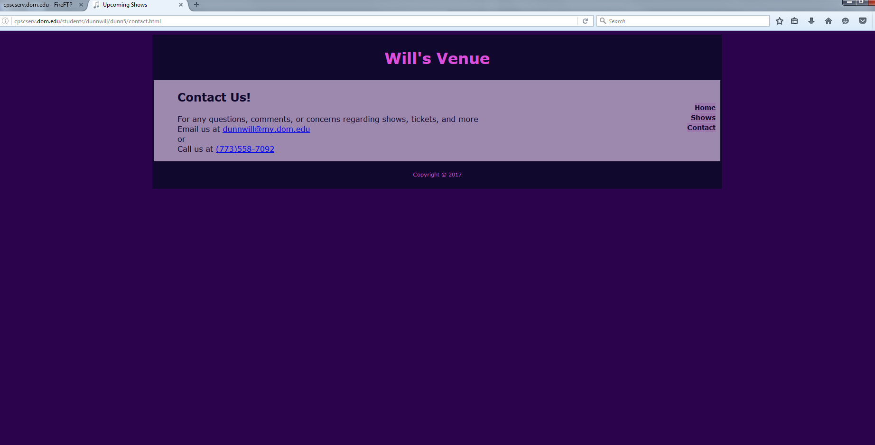

<http://cpscserv.dom.edu/students/dunnwill/dunn5/contact.html>

<http://cpscserv.dom.edu/students/dunnwill/dunn5/shows.html>

<http://cpscserv.dom.edu/students/dunnwill/dunn5/home.html>