CSCI 446 Exam 1 Coding Portion
William Franzen

Compiling
Compile the program by using the makefile. Run the “make” command in the directory where the files are located. This will create an executable file called “9Puzzle.bin”.

Running
In the terminal, execute 9Puzzle.bin.
The program will ask for the start state.
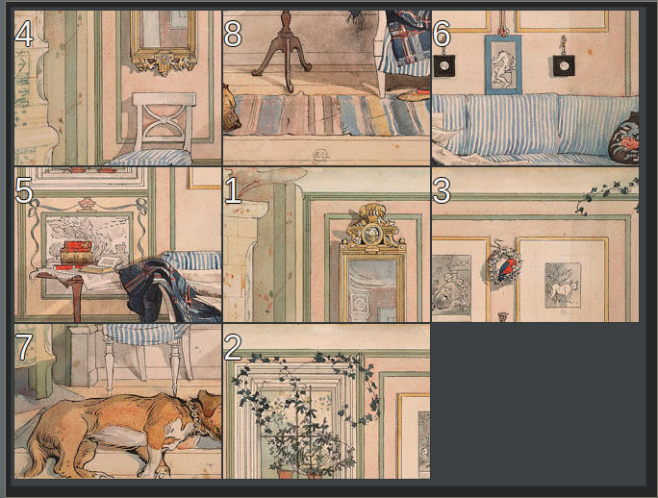
If the start state looks like this, then write this as your input:
48651372_
But replace the underscore character with a space, or it won’t work properly.
The program will then ask for the goal state. In this case, the user-input would be:
12345678_
Still replace the underscore with the space character.
Afterwards, the program will ask for another input. Type “b” to run the breadth-first-search algorithm, or “h” to run the heuristic algorithm.
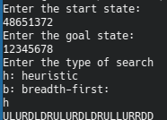
Note: There are Space Characters after the 2 and the 8 in the start and goal states in this input.

