William Franzen

Problem 1:

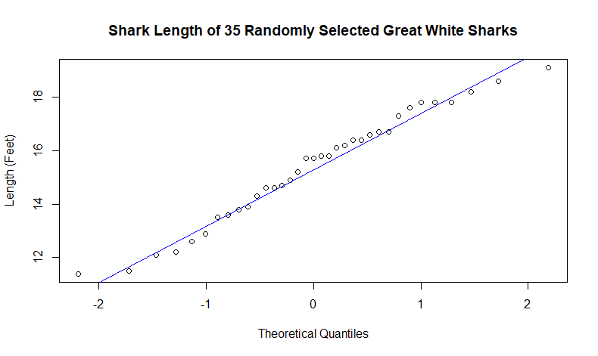

It looks like the shark length from this sample has a linear Q-Q distribution. The mean shark is about 14.5 feet long.

Problem 5:

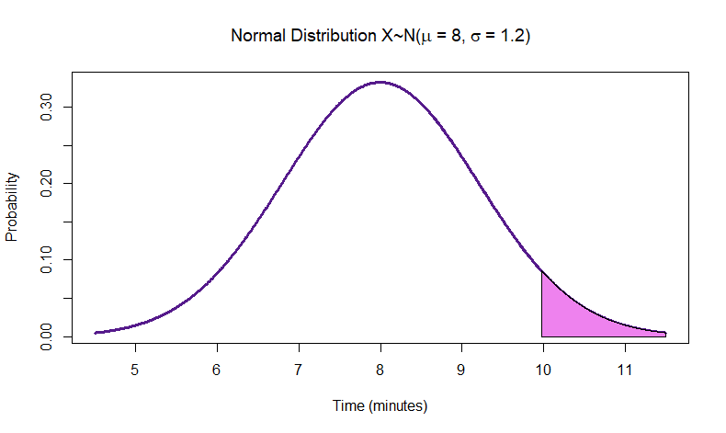

Problem 7: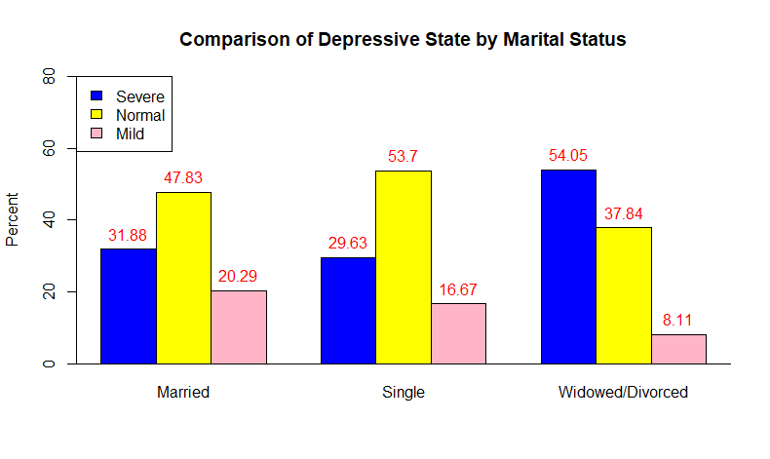

Based on this graph, it looks like widowed/divorced people seem to have the highest amount of severe depression, while single people have the lowest amount of severe depression.

Pearson's Chi-squared test

data: status

X-squared = 7.6256, df = 4, p-value = 0.1063