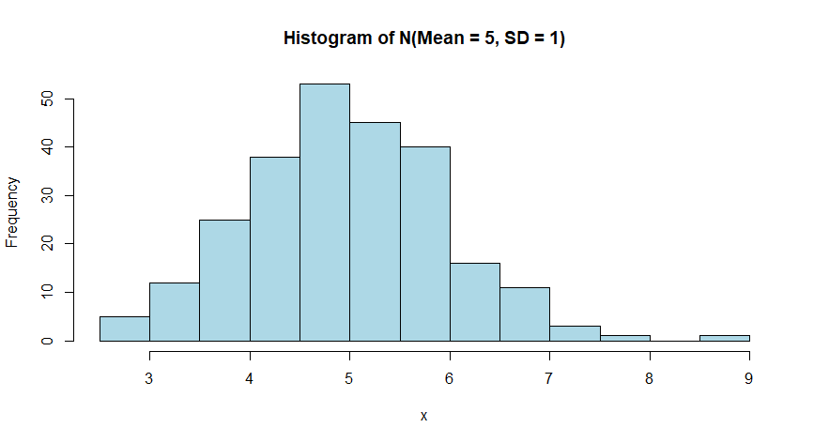

This is a random histogram with 250 entries with the mean = 5, and the standard deviation = 1.