Student to Fill

|  |  |
| --- | --- |
| Date: |  |
| Time: |  |
| Surname: | Thaw |
| First name: | Khant Min |
| ID number: |  |

Marker to Fill

|  |  |  |  |
| --- | --- | --- | --- |
| DELIVERABLE: | NOTES: | MARKS | |
| Deliverable 1 |  |  | out of 2 |
| Deliverable 2 |  |  | out of 4 |
| Deliverable 3 |  |  | out of 6 |
| Deliverable 4 |  |  | out of 2 |
| Assignment Submission |  |  | out of 1 |
| **Total of the above** |  |  | out of 15 |
| Deduction (i.e. late submission, plagiarism) |  |  |  |
| **Assignment Total** |  |  | out of 15 |

* **Deliverable 1 (Gantt Chart)**
* **Deliverable 2 (Report)**
* **Deliverable 3 (Resource Management)**
* **Deliverable 4(Final Gantt Chart and Budget resource)**

**Deliverable 1 (Initial Gantt Chart)**

Dates and duration for each task, leading to the new system.

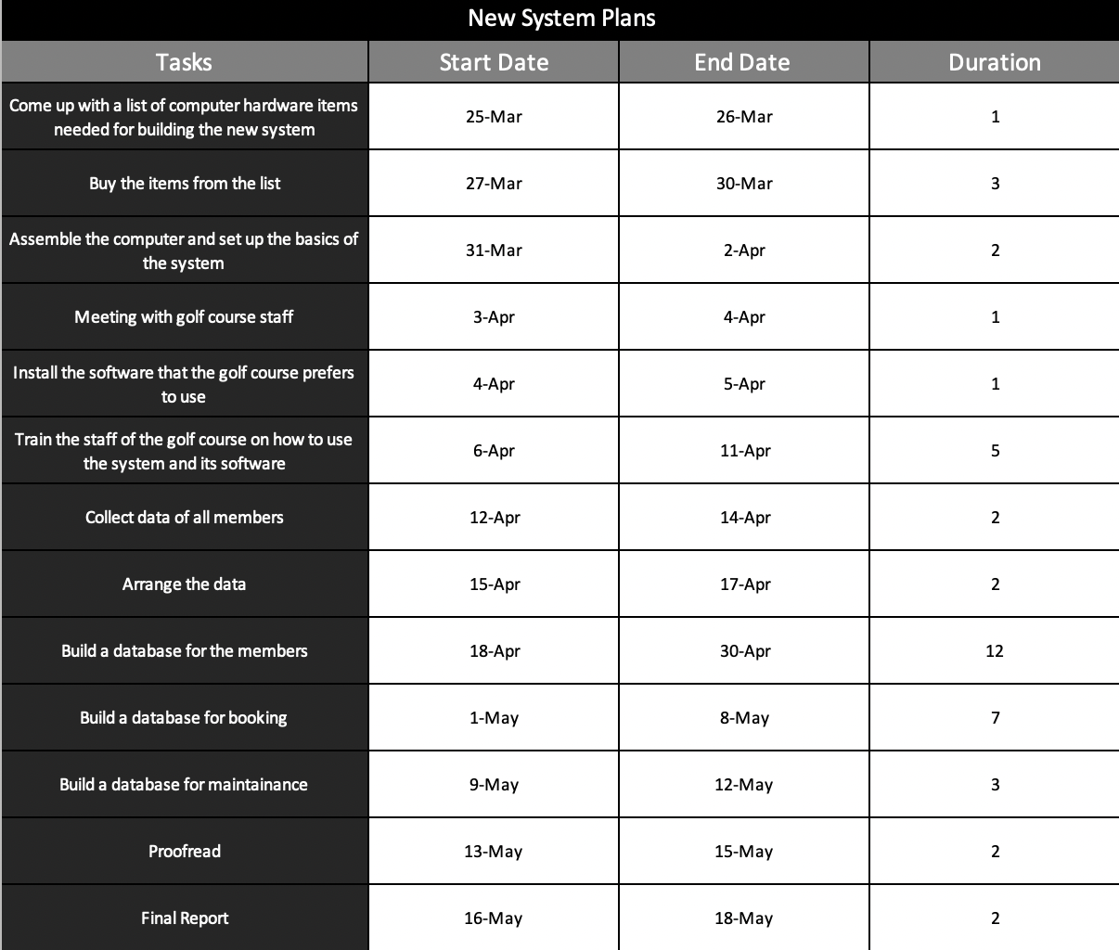

Deliverable 2( Report )

The project will commence on the 25th of March 2017. The first task of the project would be to discuss with the team members and come up with a list of computer components that’ll best suit the budget and the golf course necessities. In addition to that, the equipment that’ll be needed to assemble the components will also be discussed. Computer components that’ll allow efficient program running and components that have large storage space are the main necessities for building a database for the people participating in the golf course. This will take one day. Hence, the task should be done by the 26th March. Within the next three days, the components on the list from task1 are to be bought, whether it be ordered online or bought at a store. This task will be carried out from 27th march to 30th March. The third task is to set up the bought computer components and install operating systems and such. This should take 2 days and will be carried out from 31st March to 2nd Apr. The next activity is to have a meeting with the golf course staff to pick a software they feel the easiest to use, which will be carried out from 3rd to 4th Apr. This software will be used to build databases in the upcoming tasks. The software will then be installed on to the computer, which should take about 1 day; from 4th Apr to 5th Apr. Then a teacher will be called and classes will be set up so that the staff can learn about the software and the system they’ll be using in the future. This allows the staff to use it effectively and efficiently. Moreover, this will prevent future errors. Since this is a more important task, the classes will be carried out over 5 days; from 6th Apr to 11th Apr. After that’s completed, all data of the golf course members will be collected. This involves transferring the old data on paper to a newer and larger storage space. This is set to start by 12th Apr and finish by 14th Apr. It’s expected to finish by two days as the newly trained golf course staff members will help with this task, allowing more experience to be gained. In addition, it increases efficiency. The next task is to arrange the collected data from the oldest members to the newest members so it makes it easier to give gifts and promotions to the oldest members. Moreover, each member’s IDs, phone numbers, email address and etc. will also be arranged. This is scheduled to finish in 2 days; from 15th Apr to 17th Apr. Since the next task is the most important task of the project, it is scheduled to take 12 days as time should be spent carefully to avoid errors in building the database for the members. After this is the building of database for bookings which will be carried out from 1st May to 8Th May. This will include data like eventID, event name, event date, start time, end time and guests. The next task is to build a database for maintenance which will keep track of the roomIDs, room facilities and golf course area maintenance. This is set to start on 9th May and finish on 12th May. The second final task is to proofread the data which is set to take 2 days; from 13th May to 15th May. The final task is for the staff members to write a report which will take 2 days; from 16th May to 18th May.

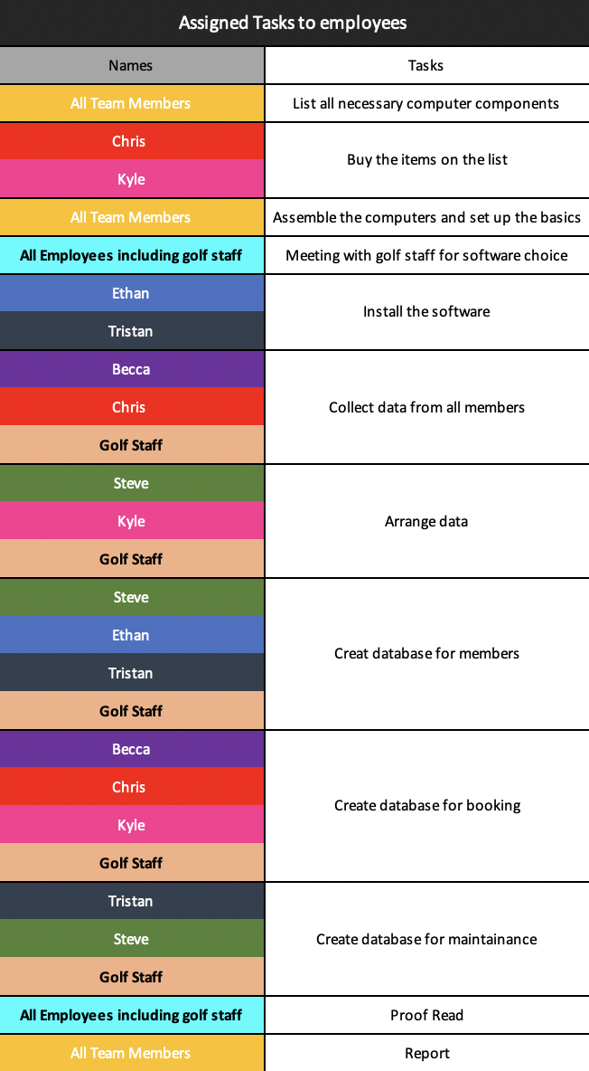**Deliverable 3 (Resource Management)**

I trust in the team members’ abilities to carry out this project efficiently and

effectively. However, I have assigned some team members to tasks that will help

them gain experience. Of course, I paired them with an employee who’s well

experienced for the task. You’ll see that I have asked all of the golf course staff,

mainly the ones who’ll be handling the new system in the future, for assistance

with the tasks. This will help them gain experience and avoid errors or mistakes

with the system in the future. Moreover, I have arranged a workshop, a van and

a meeting room. The assembly of the computer and its system will be carried

out in the workshop. The workshop is also to be used for building the databases

and other tasks that require space. I rented a van as it’ll help moving the

computer components and the employees easier. Finally, I’ve rented a meeting

room for the meeting with the golf staff. This meeting room will also be where

the classes and lectures from the teacher will be carried out. Any request for a

meeting in case a misunderstanding or an error has been made will also be held

in the room. The team members are familiar with some of the many database

software and so will suggest these software to the golf staff to help them make

a decision. Continuing on, the team members have participated in projects

before so I believe that there’ll be no miscommunication within the project.

**Deliverable 4(Final Gantt Chart and Budget Report)**

The final Gantt chart remain the same as no changes were necessary for the task start dates, end dates and duration. Completing the tasks accordingly to this Gantt chart and the tables shown above will result in a successful completion of the project by the 18th May 2022. The cost of the project is approximated to be around $100,000. The golf course has given a budget around $130,000. Each team member will be paid $5000. Since 7 computers will be built, the peripherals to those are to cost around $8000. High end peripherals are not needed as this project will mainly require storage space and fast processors. All the computers will be computers will be connected to one main computer which will house the storage space (HDD and SSD). The main computer, consisting of high-end components (CPU, GPU, motherboard, RAM, HDD, SSD, power unit) is to cost around $4000. $6000 are to be used for building the remaining 6 computers. The equipment needed to assemble these computers is expected to cost around $2000. The price of the software will depend on the golf course staff’s decision but I’ve estimated the database software to cost around $2000. Some software can’t be bought but have to be subscribed instead, which will cost around $100-$200 per month. So the total cost of this would be around $1500. Renting a meeting room is expected to cost $100 per hour. Hence, the total cost for renting meeting rooms should be around $1000. A van can be rent for $30 a day so assuming that the van should be rent for one day for transporting the components and for a few days throughout the entire project, it must cost approximately $1000. Hiring a teacher to train the golf course staff is expected to cost $2000, with training material costing an extra $2000. Renting a workshop during the entire project will cost $15,000. The final stage of the project, which is the launching of it is estimated to cost around $40,000. In total, its estimated to cost around $120,000 which leaves $10,000 to spare as the budget’s $130,000. Some of the extra money will be given to the best employee. The leftover money will be kept until the project is over, in case a problem occurs.