TECHNICAL MAPPING DOCUMENT

Oficina Project Mapping
Shared Client App and Mechanic App foundation
Field | Value
Purpose | Define business rules, UX flows, design system, data model, security, and technical contracts for a Mechanic App that shares core platform logic with the existing Client App.
Baseline | Current Expo/Supabase Client App in this repository, plus target extensions for service orders, quotes, payments, messaging, and reviews.
Date | May 17, 2026
Audience | Product, design, engineering, database, QA, and workshop operations.

Architecture rule: Client App and Mechanic App must use the same Supabase project, shared TypeScript domain models, shared design tokens, shared validation rules, and shared database-side state transitions. UI may differ by role; data truth must not fork.

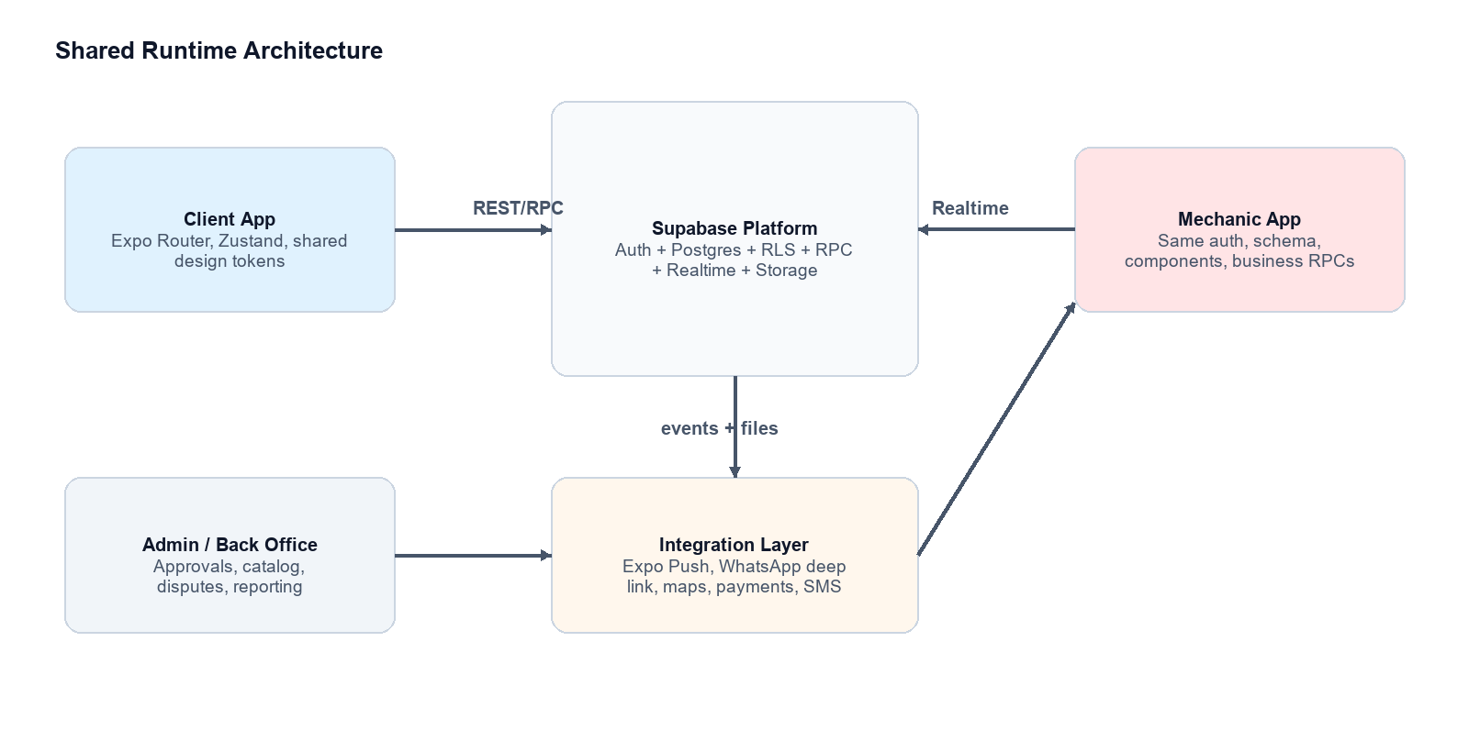
Figure 1. Shared runtime architecture for both apps.

Document Map
This map uses two labels throughout: Implemented baseline means behavior already visible in the current Client App or SQL files. Target shared model means the schema and logic needed before the Mechanic App can handle the full workshop workflow without diverging from the Client App.
Area | Implemented baseline | Target shared model
Authentication | Phone/email Supabase Auth, persisted sessions, profile roles. | Role-aware onboarding, mechanic approval, admin invitations, session policy.
Scheduling | Clients browse mechanics, choose available timeslots, create confirmed appointments. | Mechanics manage availability, accept work, view agenda, trigger order status updates.
Service order | Appointment carries vehicle_info and notes. | Dedicated service_orders, vehicles, diagnostics, attachments, quote, payment, review.
Communication | WhatsApp deep link from client appointment detail/success. | In-app threads, push notifications, read receipts, external WhatsApp fallback.
Design | Inter typography, dark charcoal surfaces, coral/orange action accents, reusable app components. | Shared component package/tokens consumed by both apps with role-specific navigation patterns.

Client/Mechanic Feature Mirror
Every client-facing surface below has a mechanic-facing owner, counterpart, or operational response. This table is the main parity contract for the companion app.
Client-facing feature | Client behavior | Mechanic App counterpart | Shared data/logic | Status
Login / register | Client registers with name, phone, password; signs in by phone. | Mechanic signs in with provisioned or approved mechanic role; profile loads specialty/credentials. | auth.users, profiles, mechanics, role checks, session refresh. | Baseline + extend
Browse mechanics | Search by name or specialty; open mechanic profile. | Mechanic profile controls own specialty, credentials, active state, avatar, contact info. | profiles + mechanics select/update policies. | Baseline + extend
Select date and timeslot | Client sees next 7 days and available slots only. | Mechanic creates, edits, deletes, blocks, or reopens own slots. | timeslots, unique mechanic/date/start/end, availability cache invalidation. | Baseline service exists
Create booking | Client submits slot, vehicle model, problem notes; appointment becomes confirmado. | Mechanic sees new assigned appointment on agenda and can prepare/triage. | book_client_appointment RPC locks slot, inserts appointment, flips availability false. | Baseline
Booking success | Client sees mechanic/date/service summary and WhatsApp CTA. | Mechanic receives notification and agenda update. | appointments row, profile phone, notification event. | Baseline + notify
Bookings list | Client toggles upcoming/history and opens details. | Mechanic toggles today/upcoming/history and opens work order. | appointments filtered by client_id or mechanic_id; sync_acabado_appointments. | Baseline service exists
Appointment details | Client sees status, mechanic contact, vehicle, notes, cancel action. | Mechanic sees client contact, vehicle, complaint, slot, status actions, order conversion. | appointments, profiles joins, status banner mapping. | Baseline + extend
Cancellation | Client cancels only confirmado appointments; slot reopens. | Mechanic cancels assigned confirmado appointments; slot reopens; reason required in target. | cancel_client_appointment and cancel_mechanic_appointment RPCs. | Baseline
Vehicle info | Current booking stores free-text vehicle_info. | Mechanic sees vehicle context; target app links to structured vehicle record. | vehicles target table; appointment.vehicle_id migration path. | Extend
Real-time tracking | Client follows status after request is created. | Mechanic drives status transitions with explicit workflow actions. | service_orders.status, appointment_events, notifications, Realtime subscriptions. | Extend
Quotes | Client reviews, approves, rejects, or requests revision. | Mechanic drafts quote from labor/parts/fees and submits revision. | quotes, quote_items, quote status RPCs, immutable accepted snapshot. | Extend
Payments | Client pays approved/final invoice and sees receipt. | Mechanic sees payment pending/paid and can release vehicle after paid. | payments, provider webhooks, service_order status lock. | Extend
Messaging | Client asks questions from request/order detail. | Mechanic replies in same thread; can attach photos and diagnostic notes. | message_threads/messages/attachments, read receipts, push events. | Extend
Reviews | Client rates completed paid work once. | Mechanic sees review summary; cannot edit client rating. | reviews unique service_order_id, moderation fields. | Extend
Profile | Client sees name/phone, logout, future data/notifications screens. | Mechanic manages public profile, availability, credentials, notification preferences. | profiles, mechanics, notification_preferences. | Baseline + extend

1. Business Rules

1.1 Roles and Permissions
Role | Owns | Can read | Can write | Cannot do
client | Own profile, own vehicles, own service requests, own messages/reviews/payments. | Public mechanic profiles, available slots, own appointments/orders/quotes/messages/payments. | Own profile, vehicles, bookings, quote decisions, payment attempts, messages, reviews. | Cannot edit mechanics, slots, pricing, order diagnostics, other users' records.
mechanic | Own mechanic profile, own timeslots, assigned service orders, quotes, diagnostics. | Assigned clients' minimum profile/contact data, assigned appointment/order data, own messages/reviews. | Own slots, assigned order statuses, quote drafts, work notes, attachments, message replies. | Cannot view unrelated client orders or approve payments/reviews.
admin | Operational policy, catalogs, disputes, role approvals, reporting. | All records needed for support and compliance. | Role assignment, mechanic activation, catalog rules, dispute status, corrections with audit trail. | Cannot bypass audit trail for financial or sensitive status changes.

1.2 Status Lifecycle
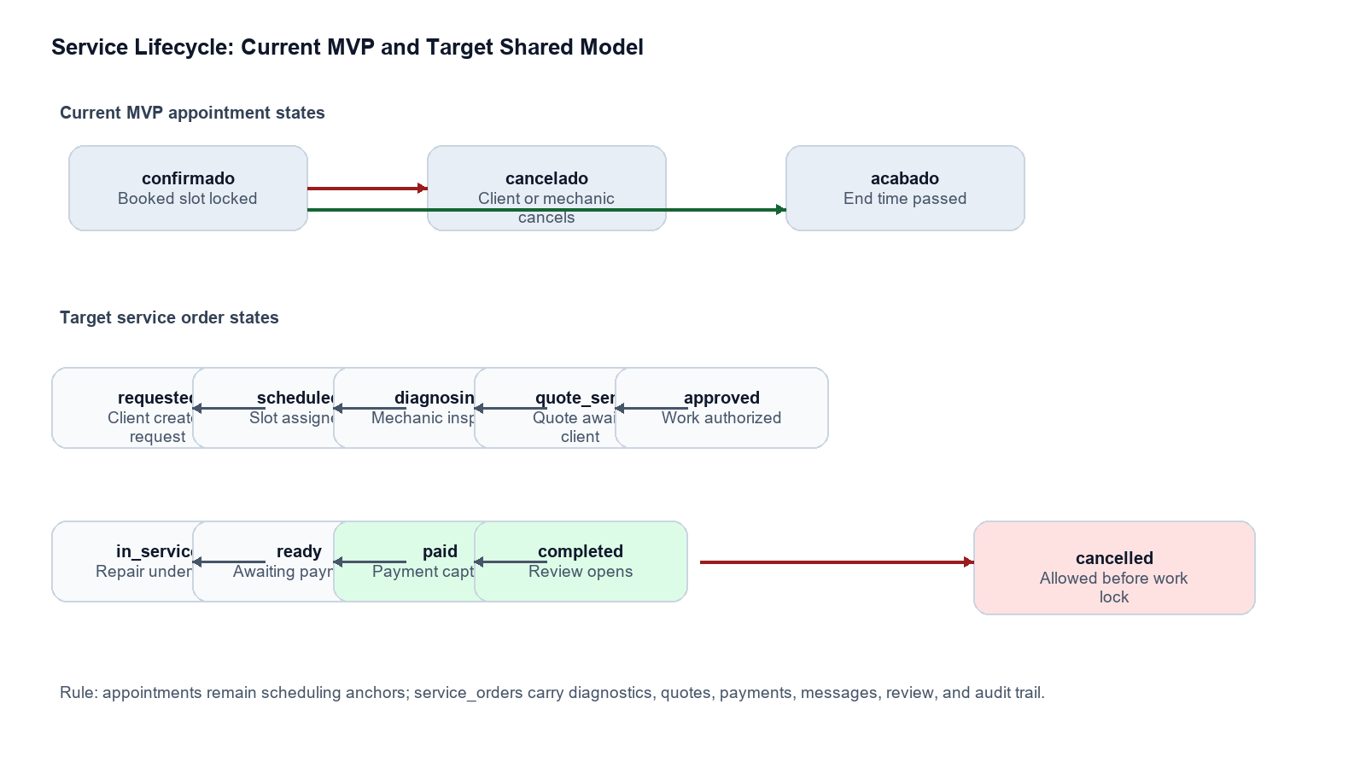
Figure 2. Current MVP states and target service order states.
Object | State | Entry rule | Exit rule | Client view | Mechanic view
appointment | confirmado | Created by book_client_appointment after slot lock succeeds. | Cancel by client/mechanic or automatic sync after end_time. | Upcoming booking. | Assigned agenda item.
appointment | cancelado | Only from confirmado; RPC reopens linked slot. | Terminal for appointment; new booking required to reschedule. | History item, no cancel CTA. | History/cancelled item; reason visible in target.
appointment | acabado | sync_acabado_appointments marks confirmed past end_time. | Target: becomes completed order only after payment/release workflow. | History item; review CTA in target. | Completed agenda/order history.
service_order | requested/scheduled | Created from booking or mechanic intake. | Mechanic starts diagnosis or cancels before work lock. | Request received / scheduled. | New job queue / agenda.
service_order | diagnosing | Mechanic opens order and records inspection. | Quote submitted or no-charge completion. | Inspection in progress. | Diagnostic checklist and attachments.
service_order | quote_sent | Mechanic submits quote with itemized total. | Client approves/rejects/requests revision or quote expires. | Approve/reject/payment preview. | Awaiting client decision.
service_order | approved/in_service | Client accepts quote; optional deposit captured. | Mechanic marks ready_for_payment after work. | Repair authorized / in progress. | Work execution checklist.
service_order | ready_for_payment/paid/completed | Work complete; invoice payment captured. | Completion opens review and archive. | Pay and review. | Release vehicle and close order.

1.3 Scheduling and Booking Rules
- Slots are owned by one mechanic and must have end_time greater than start_time.
- Current working-hours constant is 08:00-18:00 with one-hour SLOT_DURATION_MINUTES; target schedule UI should enforce the same default while allowing admin-configured exceptions.
- A slot can have at most one active confirmado appointment; database unique index enforces this by timeslot_id.
- Booking must be atomic: lock selected timeslot, reject unavailable/expired slots, insert appointment, then mark slot unavailable in one database transaction.
- Client cancellation and mechanic cancellation only apply to confirmado; cancelled appointments are idempotent and reopen the linked slot.
- Past confirmed appointments sync to acabado based on America/Sao_Paulo time. Target service_orders should use explicit timestamps for started_at, ready_at, paid_at, completed_at.

1.4 Pricing, Quotes, Payments, and Reviews
Domain | Rule | Client perspective | Mechanic perspective
Quote creation | Mechanic can draft quote only for an assigned diagnosing/scheduled order. Quote totals derive from quote_items and cannot be hand-edited without recalculation. | Receives itemized labor, parts, fees, taxes, discount, expiry. | Builds quote from parts/labor catalog or custom lines.
Quote revision | Only latest quote can be accepted. Rejected/expired quotes remain immutable for audit. | Can reject with reason or request revision. | Can revise and resubmit while order is not approved.
Approval | Client approval snapshots quote total into service_order.approved_total and locks accepted quote lines. | Approval confirms work authorization and payment expectations. | Approved state unlocks in_service workflow.
Payment | Payment can be created only against approved or ready_for_payment orders; final completion requires paid or admin override. | Pays by provider checkout; sees receipt and payment status. | Sees paid/pending/failed; release blocked until paid unless override.
Cancellation | Cancellation after quote approval may require admin policy: no fee, diagnostic fee, or deposit forfeiture. | Sees cancellation cost before confirming. | Sees cancellation reason and inventory impact.
Review | One review per completed service order by owning client. Rating 1-5, optional comment, moderation state. | Review CTA appears after completed/paid. | Review visible as feedback; no edit/delete rights.

1.5 Notification Triggers
Trigger | Client notification | Mechanic notification | Data event
Booking created | Confirmation, mechanic name, date/time. | New appointment assigned. | appointments INSERT; notification row.
Appointment cancelled | Cancellation confirmation and slot release. | Cancellation reason and schedule update. | appointments UPDATE status=cancelado; timeslots UPDATE.
Order status changed | Status banner update and push. | Team/owner audit event. | service_orders UPDATE; appointment_events INSERT.
Quote submitted | Review quote CTA. | Quote awaiting client. | quotes INSERT/UPDATE status=sent.
Quote approved/rejected | Decision receipt. | Work authorization or revision request. | quotes UPDATE; service_orders UPDATE.
Payment status changed | Receipt, failure, retry CTA. | Payment paid/failed indicator. | payments webhook; service_orders UPDATE.
New message | Message push and unread badge. | Message push and unread badge. | messages INSERT.
Review submitted | Thank-you receipt. | New review summary. | reviews INSERT.

2. UX Flows

2.1 Onboarding and Authentication
Step | Client App | Mechanic App | Shared implementation
1 | Open app; unauthenticated route redirects to login. | Open app; unauthenticated route redirects to mechanic login. | Root layout checks Supabase session and profile role.
2 | Register with name, Brazilian phone, password; role client inserted. | Mechanic account should be admin-invited or self-register as pending mechanic. | signUpWithPhone normalizes E.164 +55 and inserts profiles/mechanics.
3 | Sign in by phone/password; profile fetched. | Sign in by phone/password; mechanic details fetched via mechanics join. | supabase.auth.signInWithPassword, persisted session, getUserById.
4 | Authenticated user lands on browse mechanics. | Mechanic lands on agenda/dashboard. | Role router must branch by profiles.role.
5 | Logout clears local state and calls Supabase signOut. | Same logout behavior. | Shared auth-store action.

2.2 Vehicle Registration
Client flow | Mechanic flow | Data/write path
Add vehicle from profile or first booking: make, model, year, plate, VIN optional, notes/photos optional. | View vehicle history from assigned order; record odometer and inspection photos. | vehicles INSERT by client; service_orders.vehicle_id; attachments bucket vehicle_photos/service_photos.
Select registered vehicle during service request; free-text vehicle_info remains fallback during migration. | Confirm vehicle identity at intake; request correction if mismatch. | appointments.vehicle_id target plus current vehicle_info.

2.3 Service Request and Booking
- Client opens Browse, searches mechanic by name/specialty, and selects mechanic profile.
- Client chooses one of the next seven dates, selects an available timeslot, enters vehicle and problem description.
- Client taps Confirm. RPC validates role, slot availability, time not expired, input length, and uniqueness.
- Appointment is created as confirmado and slot availability flips false.
- Client lands on success screen; Mechanic App receives assigned appointment in agenda with client/vehicle/problem context.
Mechanic response state | Expected mechanic action | Client-visible result
New appointment | Review agenda item, contact client if needed, prepare bay/parts. | Booking remains confirmado.
Needs reschedule | Cancel with reason or propose alternate slots in target model. | Client receives cancellation/reschedule prompt.
Ready for diagnosis | Start service_order and move status to diagnosing. | Client sees inspection in progress.

2.4 Real-Time Status Tracking
Client sees | Mechanic does | System behavior
Confirmed | Booking appears on mechanic agenda. | Realtime subscription updates appointment/service_order changes; pull-to-refresh fallback remains.
Diagnosing | Mechanic starts inspection and can attach photos/notes. | service_orders status event creates notification.
Quote sent | Mechanic submits itemized quote. | Client quote CTA appears; push/email/SMS optional.
In service | Mechanic marks quote approved work as started. | Client status banner and timeline update.
Ready for payment | Mechanic marks work complete. | Client payment CTA appears.
Completed | Mechanic releases vehicle after payment. | Client review CTA appears.

2.5 Quotes, Payments, Messaging, Reviews
Journey | Client steps | Mechanic steps | Shared rules
Quote | Open quote, inspect line items, approve/reject/request revision. | Draft line items, submit, revise if requested. | Only latest sent quote can be approved; accepted quote immutable.
Payment | Open checkout, pay, receive receipt, retry failures. | See payment status, release after paid. | Provider webhook is source of truth for paid status.
Messaging | Send text/photo from appointment/order detail. | Reply in same thread; mark messages read. | Messages scoped to service_order and participants only.
Review | Rate completed paid order once. | Read review summary; flag if abusive. | Unique review per service_order; moderation via admin.

2.6 Screen Map
Client screen | Current route | Mechanic screen | Primary data
Login | app/(auth)/login.tsx | Mechanic Login | auth.sessions, profiles, mechanics.
Register | app/(auth)/register.tsx | Mechanic Invite/Approval | auth.users, profiles, mechanics.is_active.
Browse Mechanics | app/(client)/browse/index.tsx | Public Profile Editor / Active Toggle | profiles, mechanics.
Book Mechanic | app/(client)/browse/[mechanicId].tsx | Availability Manager + Appointment Intake | timeslots, appointments, vehicles target.
Booking Success | app/(client)/booking-success.tsx | New Job Notification | appointments, notifications.
Bookings | app/(client)/bookings.tsx | Agenda | appointments by client_id/mechanic_id.
Appointment Details | app/(client)/appointment/[id].tsx | Work Order Detail | appointments, service_orders target, messages, quotes.
Profile | app/(client)/profile.tsx | Mechanic Profile/Settings | profiles, mechanics, notification_preferences.

3. Design System
Both apps should consume the same design tokens from constants/theme.ts. Mechanic App may alter navigation density for operational use, but colors, type, spacing, radius, status badges, empty/loading states, and form controls stay shared.

3.1 Foundation Tokens
Token group | Values | Usage
Color | primary #181f21; primaryContainer #2d3436; secondary #a83639; secondaryContainer #ff7675; safetyOrange #ff6b00; whatsapp #25d366; background/surface #f9f9f9; error #ba1a1a. | Dark charcoal for core UI, coral/orange for action emphasis, neutral surfaces for forms/lists, green reserved for WhatsApp.
Typography | Inter 400/500/600/700/800 via @expo-google-fonts/inter. Headline XL 48/56, LG 32/40, mobile LG 24/32, MD 20/28, body 16/24, labels 14/20 and 12/16. | Shared scale across cards, headers, tabs, buttons. Mechanic dashboards should favor headlineMd/bodyMd over hero sizes.
Spacing | xs 4, base 8, sm 12, gutterMobile 16, marginMobile 20, md 24, lg 40, xl 64. | Consistent touch spacing, card gaps, list padding, fixed CTA separation.
Radius | sm 4, md 8, lg 12, full 9999. | Buttons/cards use lg, segmented controls use md/sm, avatars/fabs use full.
Elevation | light, medium, coral shadows. | Use light for lists/cards, medium for profile/summary cards, coral only for primary floating/confirmation emphasis.
Status | confirmado dark primary, acabado high surface, cancelado error container. | StatusBanner and badges must use the same statusTheme labels/icons.

3.2 Component Library
Component | Client usage | Mechanic usage | Design rule
PrimaryButton | Login, register, confirm booking, WhatsApp, cancel. | Start diagnosis, send quote, mark ready, cancel, save availability. | Variants: filled, outlined, whatsapp, secondary. Keep 56px min height and uppercase label.
InputField | Phone, password, vehicle model, problem description, search. | Slot fields, quote items, diagnosis notes, client search. | Left icon, label, validation error, multiline support.
TopAppBar | Profile/back actions on browse/details. | Back/search/filter/settings on agenda/order detail. | Same safe-area handling; title optional.
BottomNavBar | Explore, Bookings, Profile. | Agenda, Orders, Messages, Profile/Settings. | Same tab shape and active coral container.
Cards | Mechanic list cards, appointment cards, summary cards. | Agenda cards, order cards, quote cards. | White/lowest surface, 1px outline, lg radius, light/medium shadow.
Avatar | Initials for mechanic/client. | Initials plus optional photo upload. | Full radius, 48-80px sizes.
Badge/StatusBanner | Appointment status and filters. | Order/quote/payment status and workload indicators. | Use semantic color map; do not invent per-screen colors.
DateChip/TimeSlotButton | Select date/time while booking. | Create/disable slots, agenda date strip. | Selected state uses primary/coral contrast and fixed dimensions.
Modal | Cancel confirmation. | Cancel reason, quote submit confirmation, payment issue resolution. | Backdrop 40% black, card surface, no nested cards.

3.3 Layout Patterns
- Client App stays simple and guided: browse -> book -> track -> pay/review.
- Mechanic App is operational: agenda-first, dense but scannable, filters for today/upcoming/history, status actions close to order details.
- Use fixed bottom CTAs for irreversible or next-step workflow actions on mobile.
- Use segmented controls for mode switches such as Upcoming/History, Today/Week, Open/Closed.
- Use skeleton loading for list retrieval, empty states with one clear CTA, and pull-to-refresh on list screens.
- Shared forms must validate both client-side with Zod and database-side with constraints/RPC checks.

4. Data Architecture
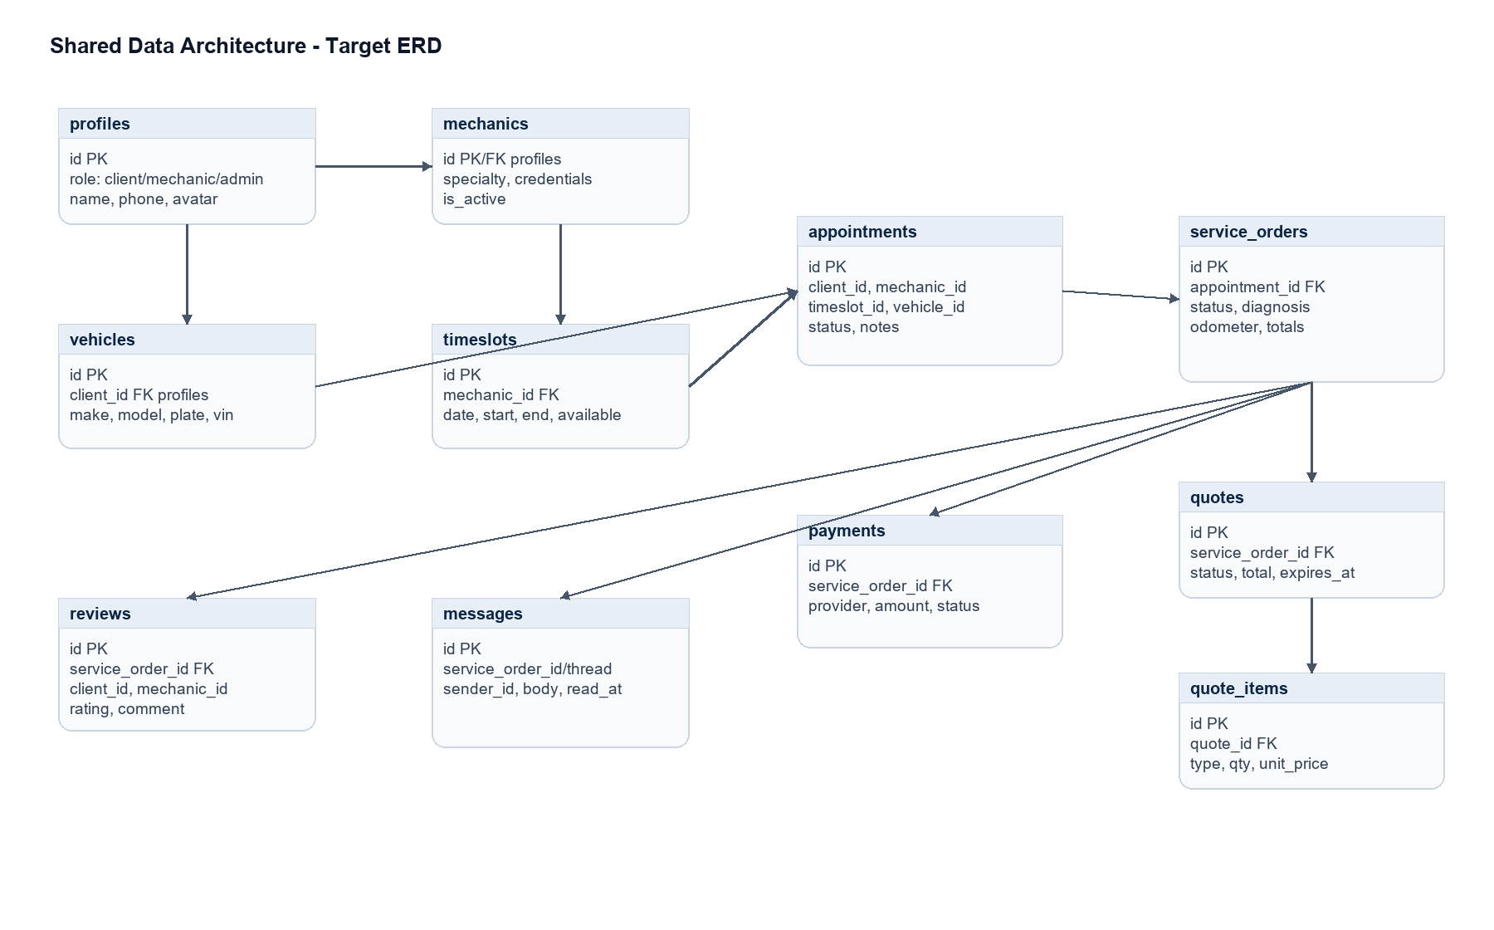
Figure 3. Target ERD. Existing MVP tables are profiles, mechanics, timeslots, and appointments; the rest are target additions.

4.1 Existing Shared Schema
Table | Key fields | Relationships | Current access
profiles | id uuid PK -> auth.users, name text, email nullable, role admin/mechanic/client, phone, avatar_url, created_at. | Base identity for all app roles. | Public SELECT; authenticated insert/update own profile.
mechanics | id uuid PK/FK profiles, specialty, credentials, is_active. | One-to-one with mechanic profile. | Public SELECT; mechanic insert/update own row.
timeslots | id uuid PK, mechanic_id FK, date, start_time, end_time, is_available, created_at. | Mechanic owns availability; appointment may reference slot. | Public SELECT; mechanic manages own slots.
appointments | id uuid PK, client_id, mechanic_id, timeslot_id nullable, date/time copy, status, vehicle_info, notes, created_at. | Scheduling anchor between client, mechanic, and slot. | Client reads own; mechanic reads assigned; admin reads all.

4.2 Target Additions for Mechanic App
Entity | Fields | Owner/write rules | Why needed
vehicles | id, client_id, make, model, year, plate, vin, color, notes, created_at, updated_at. | Client creates/updates own; mechanic reads vehicles on assigned orders; admin support can correct with audit. | Structured vehicle reuse instead of free-text vehicle_info.
service_orders | id, appointment_id, client_id, mechanic_id, vehicle_id, status, complaint, diagnosis, odometer, totals, timestamps. | Mechanic writes assigned workflow fields; client reads own and can approve/reject allowed actions. | Core shared workflow beyond scheduling.
appointment_events | id, appointment_id/service_order_id, actor_id, event_type, from_status, to_status, metadata, created_at. | Database triggers/RPCs append; users do not edit. | Audit trail for status, cancellations, quote/payment events.
quotes | id, service_order_id, version, status, subtotal, discount, tax, total, expires_at, submitted_at, decided_at. | Mechanic drafts/submits; client decides latest sent quote. | Price authorization and immutable accepted snapshot.
quote_items | id, quote_id, type labor/part/fee, description, qty, unit_price, total. | Mechanic writes until quote submitted; locked after sent/accepted. | Itemized transparent pricing.
payments | id, service_order_id, quote_id, provider, provider_payment_id, amount, currency, status, paid_at, receipt_url. | Provider webhook writes source-of-truth status; client initiates. | Payment tracking and completion lock.
message_threads/messages | thread/order ids, sender_id, body, attachments, read_at, created_at. | Participants write within own order thread. | In-app communication and notification badges.
attachments | id, owner_id, bucket, path, mime_type, size, service_order_id, visibility. | Uploader owns; participant visibility by order role. | Photos, documents, invoices, diagnostic media.
reviews | id, service_order_id unique, client_id, mechanic_id, rating 1-5, comment, moderation_status. | Client writes once after completion; admin moderates. | Feedback loop and mechanic quality signals.
notifications | id, recipient_id, type, payload, read_at, delivered_at, created_at. | System inserts; user marks read. | Push/in-app notification parity.

4.3 Read/Write Matrix
Table | Client App | Mechanic App | Admin/Server
profiles | Read public mechanic profiles; write own profile. | Read assigned client minimum data; write own mechanic profile fields. | Approve roles, support corrections.
mechanics | Read active mechanics. | Write own specialty/credentials/active state subject to approval policy. | Activate/deactivate and verify credentials.
timeslots | Read available slots. | Create/update/delete own slots; block/reopen. | Bulk schedule support.
appointments | Create through RPC; read/cancel own. | Read/cancel assigned; transition to service_order target. | Dispute/support updates with audit.
vehicles | CRUD own vehicles. | Read assigned order vehicles; add inspection metadata, not owner profile fields. | Merge/correct duplicates.
service_orders | Read own; approve allowed actions. | Write assigned workflow fields/status through RPCs. | Override exceptional cases.
quotes/items | Read own; approve/reject latest sent quote. | Draft/submit/revise assigned quotes. | Catalog/tax/discount policy.
payments | Create payment intent; read own status. | Read assigned payment state. | Webhook upserts, refunds, reconciliation.
messages | Read/write own order threads. | Read/write assigned order threads. | Moderation/export as needed.
reviews | Create once for completed own order. | Read own received reviews. | Moderate/hide abusive content.

4.4 Data Ownership Rules
- auth.users is identity source; profiles stores application role and public identity fields.
- Do not authorize from user-editable auth user_metadata. Store durable app roles in profiles or Supabase app_metadata if JWT claim use is required.
- appointments are immutable scheduling records except status cancellation/completion fields; service_orders carry operational workflow after intake.
- Financial records are append/update-by-webhook, not client-trusted. Client only initiates payment and receives provider result.
- Every status transition that affects money, work authorization, or customer communication must create an audit event.

5. Security

5.1 Authentication Strategy
- Use Supabase Auth with access JWT and refresh token sessions. Current client stores mobile sessions in AsyncStorage through supabase-js and refreshes while app is active.
- Phone login normalizes Brazilian numbers to E.164 (+55). Keep phone validation shared in auth service and Zod schemas.
- Only EXPO_PUBLIC_SUPABASE_URL and EXPO_PUBLIC_SUPABASE_ANON_KEY belong in mobile bundles. Service-role keys, admin tokens, payment secrets, and webhook secrets stay server-side only.
- Mechanic onboarding should use invite/approval workflow so public users cannot grant themselves trusted mechanic capabilities.
- Session-sensitive actions should re-check auth.uid() inside RPCs and rely on RLS for row access.

5.2 Authorization and RLS
Control | Required rule
RLS enabled | Every exposed public table must have RLS enabled before grants are available to anon/authenticated.
Least privilege grants | Grant only needed SELECT/INSERT/UPDATE/DELETE per role. RLS filters rows; grants determine object reachability.
Client writes | Clients should write appointments/quote decisions/payments/reviews through RPCs or tightly scoped policies, not broad table updates.
Mechanic writes | Mechanics can mutate only rows where auth.uid() equals mechanic_id or an assigned ownership relation exists.
Admin | Admin authorization must use trusted server-side role checks and audit events for override actions.
Security definer hardening | Current MVP uses public SECURITY DEFINER RPCs. Hardening target: move privileged implementation to a private schema or Edge Function, keep public callable surface minimal, set search_path='', revoke PUBLIC, grant only authenticated.
UPDATE behavior | Remember Postgres RLS UPDATE also needs SELECT visibility. Policies must include both USING and WITH CHECK where appropriate.

5.3 Privacy, Validation, and Secure Communication
- Minimize cross-role PII: mechanics see client contact only for assigned active or historical orders; clients see mechanic public contact/profile only.
- Validate all user text client-side and database-side: vehicle_info <= 120 today, notes <= 1000 today; target quote/message/review fields need explicit limits and profanity/abuse handling.
- Use HTTPS-only Supabase endpoints and payment provider APIs. Never transmit provider secrets to mobile clients.
- Use signed URLs or authenticated Storage policies for photos, invoices, and diagnostic attachments.
- Webhook handlers must verify provider signatures and be idempotent by provider event/payment id.
- Logs must not include access tokens, refresh tokens, service-role keys, card data, or full message bodies unless explicitly redacted.

6. Technical Details

6.1 Current Tech Stack
Layer | Choice | Notes
App runtime | Expo ~54, React 19.1, React Native 0.81, Expo Router 6. | Use same stack for Mechanic App unless intentionally split into separate package/app entry.
Language | TypeScript 5.9. | Shared types/models.ts should become a common package or workspace module.
State | Zustand 5 stores for auth, mechanics, timeslots, appointments. | Mechanic App can reuse stores with role-specific selectors/actions.
Backend | Supabase JS 2.105, Postgres, Auth, RLS, RPC. | Core business transitions should live in database RPCs or server functions.
UI | Inter fonts, MaterialIcons, reusable components under components/ui and components/app. | Consolidate duplicated component families before building companion app.
Utilities | date-fns, zod installed. | Move validation schemas next to shared domain models.
Build/deploy | EAS config, Expo web export, Vercel build script, README mentions Netlify env vars. | Choose deployment target per surface; env contract remains same.

6.2 Current API/RPC Contract
Operation | Request | Response | Rules
loginByPhone | phone, password | User or Mechanic profile | Normalize phone to +55 E.164; timeout 15s.
signUpWithPhone | phone, password, name, role | void after profile insert | Client register uses role=client; mechanic insert defaults specialty Geral, credentials PENDENTE when used.
getAllMechanics | none | Mechanic[] | profiles inner join mechanics where role=mechanic.
getAvailableSlotsByMechanic | mechanicId, optional date | TimeSlot[] | Filters is_available=true, ordered by start_time.
book_client_appointment | p_timeslot_id, p_vehicle_info, p_notes | appointments row | Requires auth client role, slot available, not expired, length checks, transactional slot lock.
getAppointmentsByClient | clientId | Appointment[] | Calls sync_acabado_appointments first; RLS restricts to own rows.
getAppointmentsByMechanic | mechanicId | Appointment[] | Assigned appointments with client profile join.
cancel_client_appointment | p_appointment_id | void | Only owner client; only confirmado; reopens slot.
cancel_mechanic_appointment | p_appointment_id | void | Only assigned mechanic; only confirmado; reopens slot.
sync_acabado_appointments | none | integer count | Authenticated; marks past confirmado rows acabado.

6.3 Target API Contract
Endpoint/RPC | Request shape | Response shape | Role
create_vehicle | make, model, year, plate?, vin?, notes? | vehicle | client
create_service_order_from_appointment | appointment_id, vehicle_id?, odometer?, complaint | service_order | mechanic/admin
transition_service_order | service_order_id, target_status, reason?, metadata | service_order + event | mechanic/client/admin depending transition
submit_quote | service_order_id, items[], discount?, tax?, expires_at | quote + quote_items | mechanic
decide_quote | quote_id, decision approved/rejected/revision_requested, reason? | quote + service_order | client
create_payment_intent | service_order_id, quote_id, method | provider checkout/client secret | client
payment_webhook | signed provider event | idempotent payment update | server
post_message | thread/service_order_id, body?, attachment_ids? | message | client/mechanic participant
submit_review | service_order_id, rating, comment? | review | client
mark_notification_read | notification_id | notification | recipient

6.4 Real-Time Layer
- Use Supabase Realtime Postgres Changes for appointments, service_orders, quotes, messages, payments, notifications, and reviews where low-latency updates improve UX.
- Add tables to supabase_realtime publication deliberately and keep RLS policies correct because each event is filtered through user access rules.
- Client subscriptions: own appointments/orders, own messages, own notifications, payment updates.
- Mechanic subscriptions: assigned appointments/orders, own timeslots, assigned messages, quote decisions, payment updates.
- Use Expo push notifications for background delivery; Realtime handles foreground state sync.

6.5 Storage, Environment, Integrations
Area | Contract
Storage | Buckets: avatars, vehicle_photos, service_attachments, invoices. Policies scope by owner_id or service_order participant. Use signed URLs for private files.
Environment | Public mobile env: EXPO_PUBLIC_SUPABASE_URL, EXPO_PUBLIC_SUPABASE_ANON_KEY. Server-only env: SUPABASE_SERVICE_ROLE_KEY, payment secrets, webhook secrets, SMS provider keys.
Maps | Use Google Maps or Mapbox only if workshop/mechanic location routing enters scope; store normalized lat/lng and address in workshop_locations.
Payments | Brazil-friendly provider recommended: Mercado Pago for Pix/card or Stripe where supported. Webhook status is authoritative.
SMS/OTP | Supabase Auth phone flow or Twilio-compatible provider. Rate-limit resend and avoid leaking account existence.
WhatsApp | Keep current wa.me deep-link fallback. In-app messaging should remain source of truth for order history.
Email/push | Expo Notifications for app push; email optional for receipts/quotes. Persist all notifications in notifications table.

Mechanic App Build Sequence
Phase | Deliverable | Acceptance checks
1. Shared core | Extract shared types, theme, auth API, status constants, validation schemas. | Client app still builds; role router supports client/mechanic redirects.
2. Schema extension | Add vehicles, service_orders, events, quotes/items, messages, notifications, reviews, storage policies. | RLS tests prove role isolation; existing Client App booking still works.
3. Mechanic MVP | Mechanic login, agenda, availability CRUD, appointment detail, cancel assigned appointment. | Mechanic can manage own slots and assigned appointments only.
4. Service workflow | Create order from appointment, status timeline, diagnosis notes/photos, quote submit/decision. | Client and mechanic see same status in real time.
5. Payments/reviews | Payment provider integration, receipt, completion gate, review flow. | Webhook idempotency, failure retry, one-review constraint.
6. Hardening | Private privileged functions, audit events, admin tools, notifications, monitoring. | Security review, advisor checks, e2e role tests, performance indexes.

Source Baseline
Repository files used: schema.sql; scripts/sql/*.sql; types/models.ts; constants/theme.ts; constants/config.ts; services/api.ts; services/auth-service.ts; services/appointment-service.ts; services/mechanic-service.ts; services/timeslot-service.ts; stores/*.ts; app/(auth) screens; app/(client) screens; components/ui controls; README.md; package.json; .env.example.
Supabase documentation checked for current security/auth/realtime guidance: Securing your API, Auth Sessions, Postgres Changes, and May 2026 changelog items relevant to platform/API changes.

