1) Even though the parent manipulates x in the code before the child does in lower lines, the child still thinks that the value of x is 100 before the child changes it to something else. Even though there is no wait() call in this program and both processes manipulate x, whichever process comes second thinks that x is 100 not what the other preceding process changed x to.

2) Both the parent and child process can access the file descriptor returned by open. Oddly sometimes either the parent or the child will write to the file, or they may both write to the file.
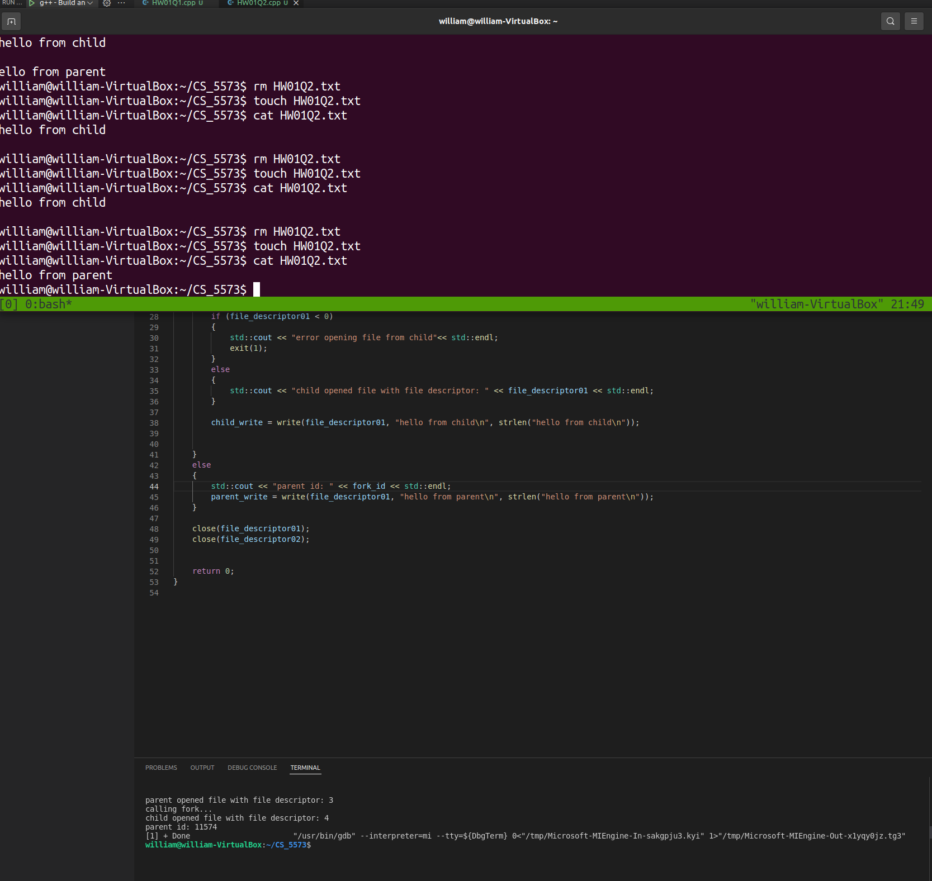

3) Without calling fork, any of the derivitive exec* functions will list all contents of the current working directory one time. Adding fork() simply just repeated the listing twice for execvp(), execv(), execvpe(), exec(), excecl(), execlp(),
All of the various exec functions behave the same way but some of them have different arguments. Execvpe operates identically to execve, but has an extra feature where the third argument will use the DOS PATH to continue the search for the executable. Also they are all libc wrappers to the same one and only exec system call.

