References

IEEE

<https://www.embs.org/pulse/articles/highlights-in-the-history-of-the-fourier-transform/>

Dr. Derek Muller

<https://youtu.be/nmgFG7PUHfo?si=qJOm1EPFBuK-ZqCJ>

CHM

<https://www.computerhistory.org/timeline/computers/>

IBM

<https://www.ibm.com/think/topics/quantum-computing>

Aalto University of Science

<https://aaltodoc.aalto.fi/server/api/core/bitstreams/0c552317-8e68-4563-8bbd-c77fd040f7c3/content>

Grant Sanderson

<https://youtu.be/spUNpyF58BY?si=NitDclt765f-1rAf>

[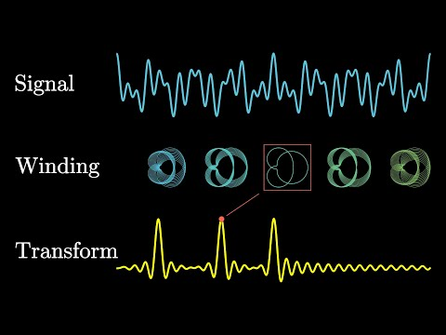](https://youtu.be/spUNpyF58BY?si=NitDclt765f-1rAf)