# PolyDraw user guide

## To Create a new canvas

To create a new canvas,

1. select the icon at the bottom left corner
2. Fill up the form by entering a desired height, width and background color
3. Select “submit”

## Change Tool

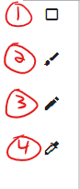You can select your drawing tool by clicking on the icons at the top left of the screen.

Here is the tool list:

1. Rectangle
2. Pain Brush
3. Pen
4. Color Applicator

## Change Color

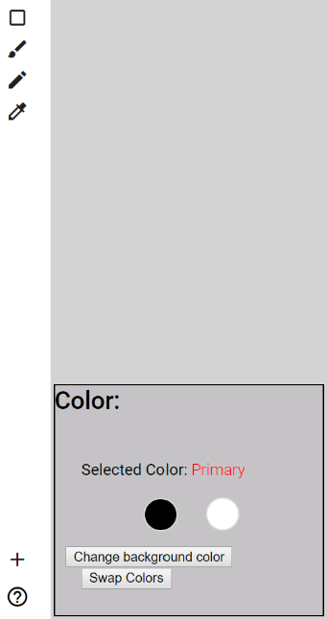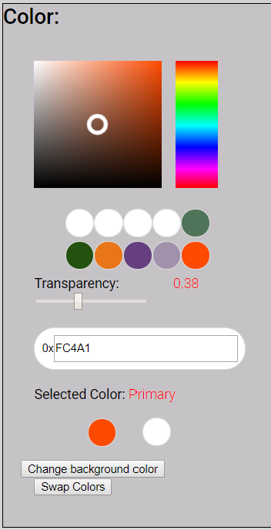You can view the currently selected colors (primary and secondary) in the “Color” box at the left of you screen.

To change a color, click on one of the color circle and a color palette will appear.

You can use the color palette to change color. Simply click in the color palette to select your color.

You can also input the hexadecimal value for the desired color.

Use the slider to change the transparency of the color.

### ShortCuts

|  |  |  |
| --- | --- | --- |
| Keys |  | Functions |
| C |  | Pencil |
| W |  | Paint Brush |
| 1 |  | Rectangle |
| R |  | Color Applicator |