**GUI Project Part 5 – User’s Manual**

DroneDogs User Guide

Prepared by William Blair

# INTRODUCTION

Welcome to the DroneDogs User Guide! This document exists to assist you in making the DroneDogs ordering experience as smooth, and pleasant as possible.

# DIRECTIONS

1. Double-click to launch the DroneDogs application.
2. Click the white box beside each # and choose the DroneDog you want to order. Take care to ensure that only 0 or any natural number is entered (No blank, negative numbers, or letters etc.)
3. Click the “Calculate Order” button when you have finished your selection. You must select at least one hotdog before the button will work.
4. Click “Get Customer Info”.
5. On the DroneDogs Customer Form, select or add your information to the Customer Form.
6. To add new customer, type First Name, Last Name, Email address and click “Add New Customer”.
7. Click to highlight your customer information, and the click “Select Highlighted Customer”

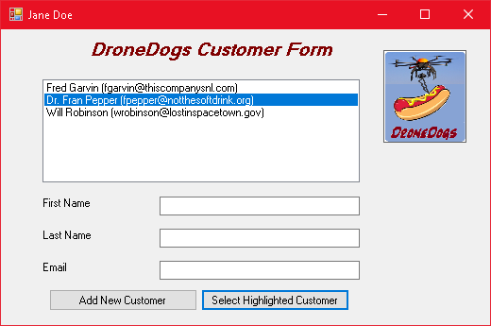

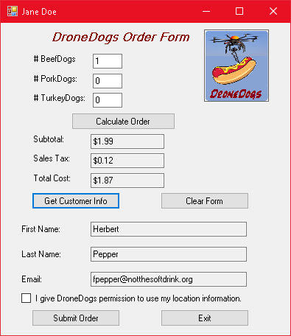

1. Click the checkbox to allow DroneDogs to access your location information.
2. Click the “Submit Order” button to complete your order.
3. Go back to Step 2 if you want to place more orders!
4. Click the “Clear Form” button to start all over.
5. Click the “Exit” button to quit the application.

# KEY TERMS

DroneDogs Order Form

|  |
| --- |
| * # BeefDogs: – Beef Dog orders go here. |
| * # PorkDogs: – Pork Dog orders go here. |
| * # TurkeyDogs: – Turkey Dog orders go here. |
| * Calculate Order – The order button after select hotdog quantities |
| * Checkbox – A checkbox that verifies customer agrees to allow DroneDogs to use customer location information |
| * Clear Form Button – A button that clears the entire form back to default settings |
| * Email – A read only field that shows the information selected from the Customer Form |
| * Exit – A button that exits and closes the DroneDogs application |
| * First Name – A read only field that shows the information selected from the Customer Form |
| * Get Customer Info Button – A button to bring up the Customer Form and choose customer information |
| * Last Name – A read only field that shows the information selected from the Customer Form |
| * Sales Tax – A read only field that shows the state sales tax |
| * Submit Order – A button that will submit the order after all conditions are met |
| * Subtotal – A read only field that calculates order subtotal |
| * Total Cost – A read only field that shows the order final cost |

Customer Form

* Add New Customer – A button that will add new customer to the list of existing customers
* Email – A field which allows entering new customer information
* First Name – A field which allows entering new customer information
* Last Name – A field which allows entering new customer information
* Select Highlighted Customer – A button that will take the customer information and apply it to customer information on the DroneDogs order form