|  |  |
| --- | --- |
| **Onsite Case** | Description: D:\logo binus baru.png |
| CH4 |
| **Periode Berlaku** Semester Genap 2014/2015  ***Valid on*** *Even Year 2014/2015* | **Software Laboratory Center**  **Assistant Recruitment 15-2** |

## Materi

*Material*

* Sorting
* Searching
* File

## Soal

*Case*

**Movie Media**

**Movie** **Media** is an application to get information about the all movie in the world. As a programmer, you asked to develop an application to manage database in **Movie** **Media**. In this program you must use **file to write and read the database**.

When the program started, it will show the movie list from “**movielist.txt**” file. If there aren’t movies, the program will show message “**There are no movies inserted**”. Otherwise, the program **show all movie lists** and **5 menus**:

1. **Insert Movie**
2. **Delete Movie**
3. **Search Movie**
4. **Sort Movie**
5. **Exit**

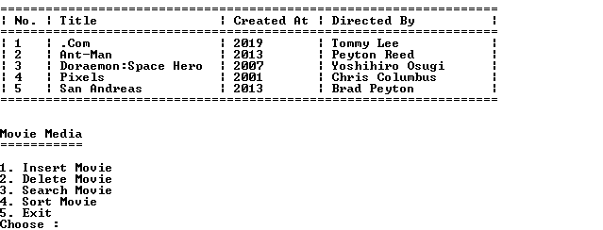

* If the user chooses “**Insert** **Movie**” (**menu** **1**):

The program will **ask** user to **input** :

* **Title movie**. Validate the **Title movie** **length** must be **between** **3** and **20 characters**.
* **Created Year**. Validate **the Created Year must** be **between 1990** and **2020**, and **Created Year** **must** be **odd number** and **can** be **divided by 3**.
* **Directed by**. Validate the **length** **of Directed by must** be **between 5** and **20** and must **contains** **minimal 1 space**.

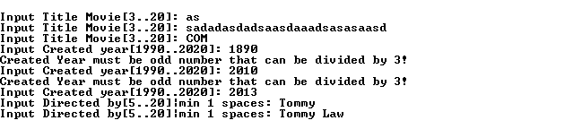

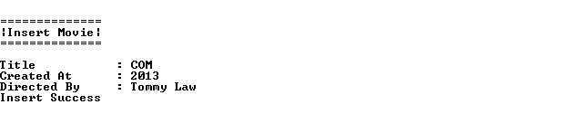

* If the user chooses “**Delete Movie**”(**menu 2**), it will:

The program will ask user to input:

* **Index of movie** **list** and validate **the index of movie must between 1 and total of movie list**. If the user input **wrong index** of movie list, the program will **show message** “**Number is invalid**”. Otherwise, the program will **delete the movie** and **show the information about the movie that delete** and show the message “**This movie has been deleted**”.

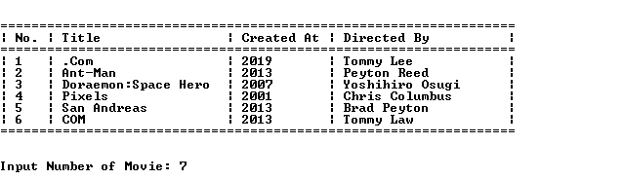

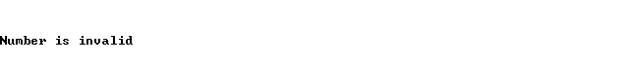

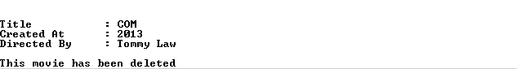

* If the user chooses “**Search Movie**”(**menu 3**), the program will **ask** the user to **input** the **title** **of movie.** After that, the program will **show the information about the movie** that **match with title** that user input.

7b.png

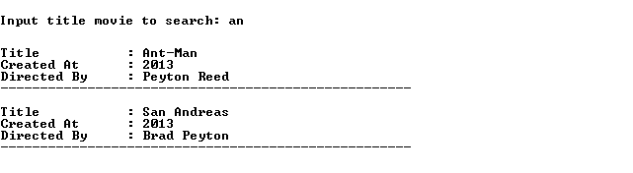

* If the user chooses “**Sort Movie**”(**menu 4**), the program show the submenu:

1. **Sort Title by Ascending**

If the user chooses this menu, the movie list will **sort based on Title** by **Ascending**

1. **Sort Title by Descending**

If the user chooses this menu, the movie list will **sort based on Title** by **Descending**

1. **Sort Created At by Ascending**

If the user chooses this menu, the movie list will **sort based on Created At** by **Ascending**

1. **Sort Created At by Descending**

If the user chooses this menu, the movie list will **sort based on Created At** by **Descending**

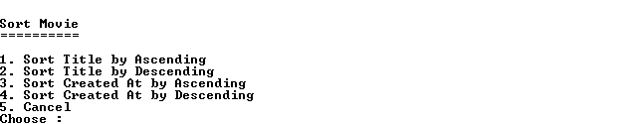

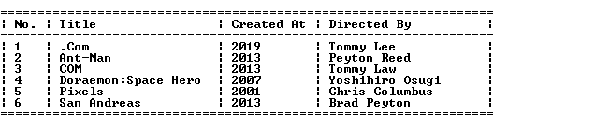

* If the user chooses “**Exit**” (**menu** **5**), the program will **terminate** and all movie list will be **saved** on “**movielist.txt**” file.

13.png