|  |  |
| --- | --- |
| **Onsite Case** |  |
| JavaIIH2 |
| **Periode Berlaku** Semester Ganjil 2015/2016  ***Valid on*** *Odd Year 2015/2016* | **Software Laboratory Center**  **Assistant Recruitment 16-1** |

## Materi

*Material*

* OOP Concept II (Inheritance)
* Inheritance Definition and Declaration
* Implementing Inheritance
* Single versus Multiple Inheritance
* Superclass and Subclass
* Super and Final

## Soal

*Case*

**Plant Ranny**

**Plant Ranny** is a simple game about how to take care a garden. This game is a console version and developed by using **Java Programming Language and Object Oriented Programming concept (please give class name that relates to the case – don’t give random class and attributes name)**. In this game, you as a gardener need to do gardening as you can and if you **run out of your money, game will be game over**.

* First, program will ask player to input **name**. **Validate name must be alphatbet** and the **length must be between 3 and 25**
* Program will show **splash screen, user’s initial money** and **Main Menu.** At the beginning**, user will get 5000 for initital money**
* **5 main menus are :**

1. **Start to plant**
2. **Water plant**
3. **View Garden**
4. **Sell Seed(s)**
5. **Exit**

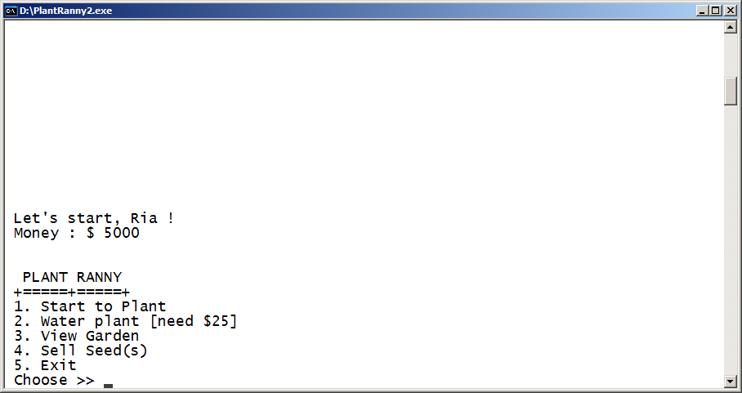

1. **Menu 1** (**Start to Plant**)

* Program will **show types of plant**, which are **Flower** and **Mushroom**. Program will **validate user can only input** ‘**Flower**’ or ‘**Mushroom**’ (**Case Sensitive**)
* After user has chosen **plant type**, program will ask user to **input** **plant’s** **name**. Program will **validate** **plant’s** **name** **must** **be** **alphabeth**, **length** **between** **3** **and** **15 and must be ended with the type of plant** (**Case Sensitive**)
* After that, user will choose **types of pot**. Program will **validate user can only input** ‘**Box’** or **‘Bottle’** (**Case Sensitive**)

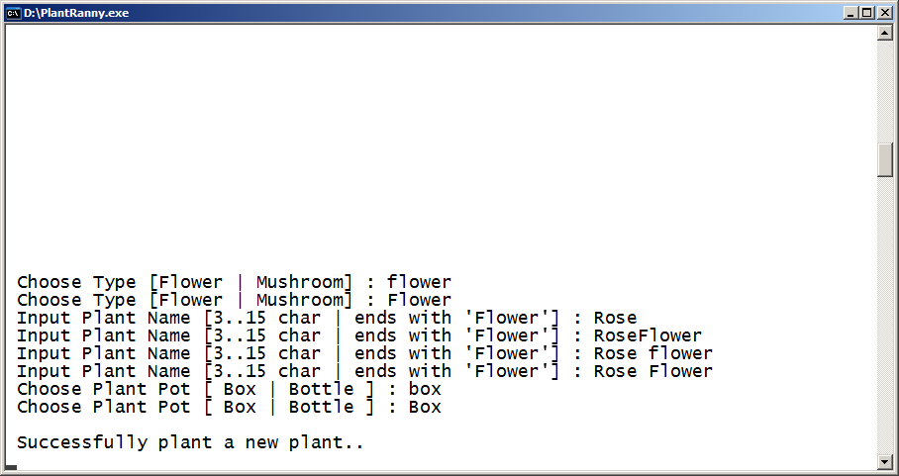

1. **Menu** **2** (**Water Plant**)

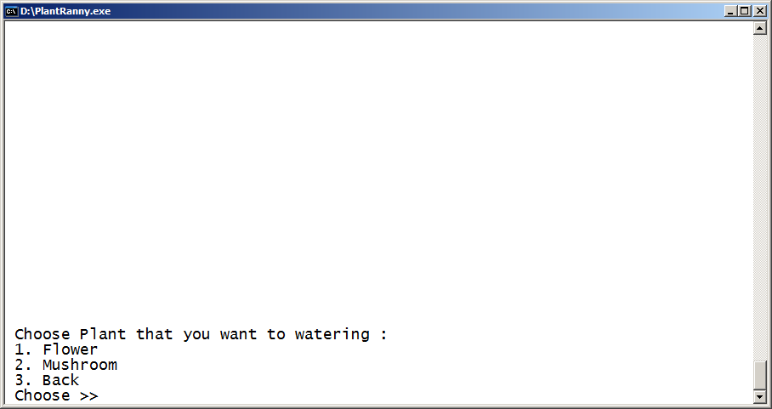

* Program will ask **user** to choose **type of plant** that **user** wants to water**.** If user **has not planted any flower or mushroom**, program will **show** **message** “**You don’t have any mushroom(s)**” or “**You don’t have any flower(s)**”. Otherwise, program will show **plant’s name, plant’s pot, plant’s type, plant’s level, water absorb, and**  **seed(s)** (for **Mushroom**).
* If **user’s** choose “**3**”, **user** will **go back to previous menu**.

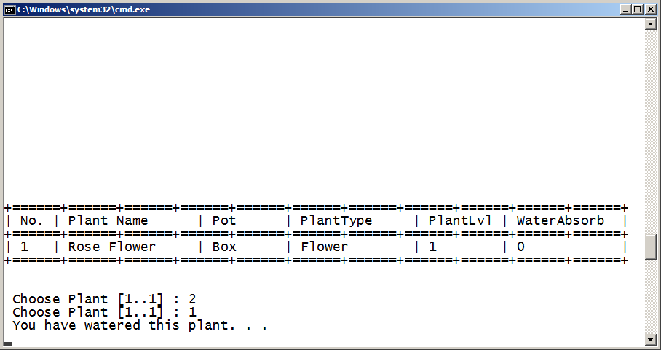

* Program will **ask player to choose plant to water.** Program will **validate user can only choose listed plant**
* **Every time player want to water the plant**, program will **deduct player’s money by $25.** Program will **validate player’s money may not less than $25**. Otherwise, program will show message “**You don’t have enough money**” and there will be **game over**
* **Every time plant is watered, program will random number of water absorbed, number must be between 25 and 50. Plant’s water absorbed will be increased**
* Each time, if **plant has reached maximum water absorbed**, **plant** will be **leveled up** and **water absorbed will be set to 0.** Program will **calculate** and **set new maximum water absorbed by following formula**

|  |  |  |
| --- | --- | --- |
|  | **Flower** | **Mushroom** |
| **Max Water Absorbed (Initial)** | 350 | 500 |
| **For Next Max Water Absorbed** | **Max Water Absorbed (Initial) * Plant Level** | |

* If **mushroom’s level are even number**, **player** will get **seeds calculated by following formula:**

**Seed increment = (Current seeds * level) + 3**

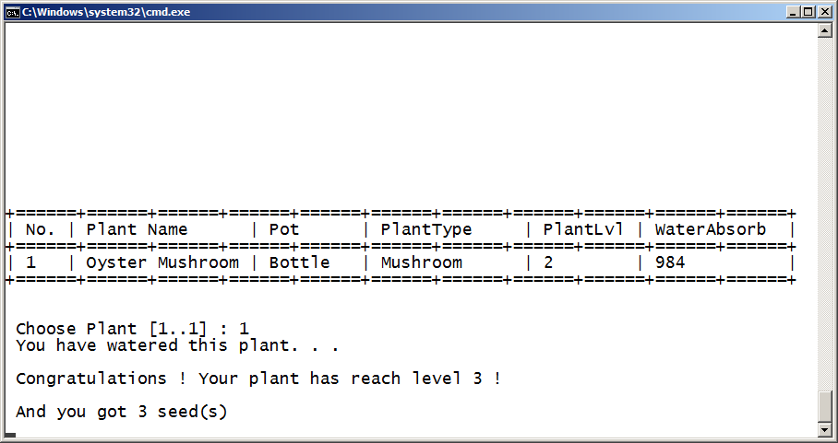

1. **Menu** **3** (**View Garden**)

* Program will validate if there’s no plant in garden, show an error message. Otherwise, show **player’s plant in the garden and group the view by plant’s type and player’s name, then program will sort the plants’ name ascending**:

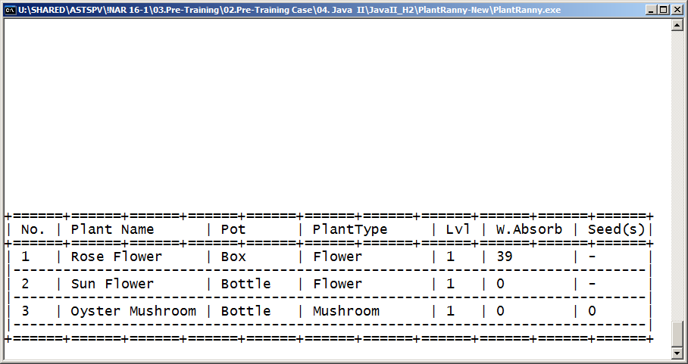

1. **Menu 4** (**Sell Seed(s)**)

* **User** will be asked to input how many **seeds** that user want to **sell. Program will validate sold seeds may not more than player’s seeds.**
* Program will **calculate seed selling price based on following formula**

**Selling price = number of sold seed * (random number between 50 and 100)**

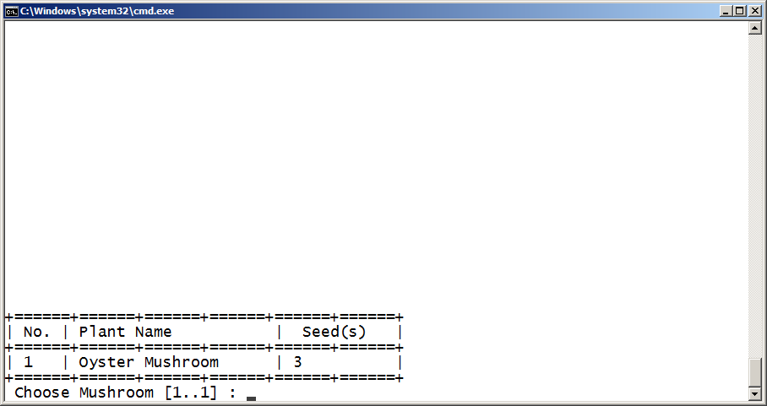

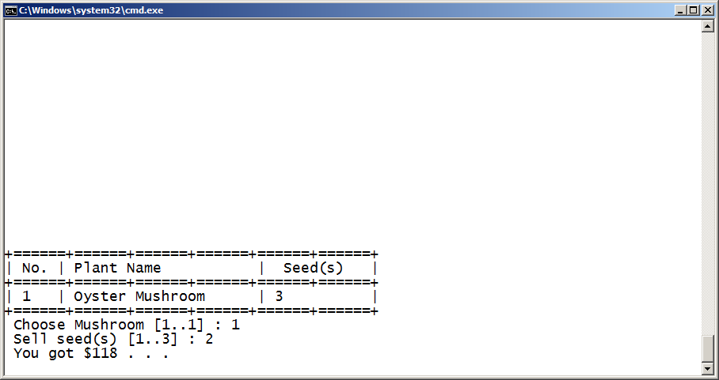

6. **Menu 5** (**Exit**)

* Program will **exit**.

**Please run the EXE file to see the sample program.**