|  |  |
| --- | --- |
| **Onsite Case** |  |
| JavaIH1 |
| **Periode Berlaku** Semester Ganjil 2014/2015  ***Valid on*** *Odd Year 2014/2015* | **Software Laboratory Center**  **Assistant Recruitment 16-1** |

## Materi

*Material*

## Mengenal IDE dan Java

## Meng-compile, run, dan debug program

## Mengenal tipe data primitf: boolean, byte, char, int, long, float, dan double

## Java keywords, identifier, Variable

## Mengenal tipe data abstract: String

## Penyimpanan data ke dalam variabel

## Type casting

## Membuat program dengan sintaks dasar I/O

## Format output

## Operator Aritmatika

## Operator Logika (AND, OR)

## Operator bitwise

## Shorthand operator

## Konstruksi if dan if-else

## Konstruksi nested if-else dan switch-case

## Perbandingan String

## Konstruksi while dan do-while

## Try and catch

## Konstruksi for

## Break, label dan continue

## Soal

*Case*

**Travel Center**

Travel Center is travel agency in Indonesia. As a programmer at **Travel Center**, you are asked to create an application by using **Java Programming Language** with these requirements:

* At the beginning, program will show **splash screen** and ask traveler to input **name.** Program will **validate traveler’s name must be between 3 and 20 characters**, **contain 2 words (first name and last name)**, **started with capital letter (for both first name and last name)** and **contain alphabet**. Otherwise, program will show error message
* Program will also **initiate traveler’s starting balance as much IDR.20.000.0000**

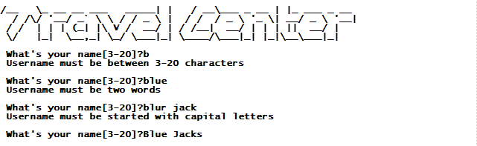

* Program consists of **3 main menus**:

**1. View Packet**

**2. Booking**

**3. Exit**

* Program will **validate menu input** must **be numeric and between 1 and 3**

1. **Menu 1 (View Package)**

**.**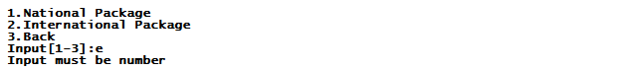

* Program will ask **traveler** to **choose** **travelling package**. Program will **validate** **input must be numeric and between 1 and 3**
* There are **2 types of travelling packages**, which are **National and International packages**
* If traveler **chooses** “**National Package**”, program will **show detail of information of Pari and Raja Ampat packages**
* If traveler **chooses** “**International Package**”, program will **show detail of information of Singapore and Australia packages**
* If **traveler** **chooses** “**Back**”, program will **back to main menu**

1. **Menu 2 (Booking)**

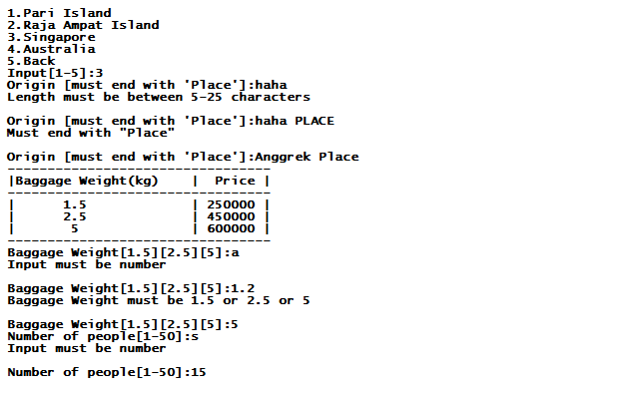

* Program will **show all** **travelling packages, which are Pari Island, Raja Ampat Island, Singapore and Australia**.
* Program will ask user to **choose a travelling package**. Program will **validate input must be between 1 and 4 and numeric**
* If **traveler has chosen travelling package**, program will ask **traveler to complete required information as following** :
* **Origin place**. Validate **origin place** must be ended with “**Place**” (**case sensitive)**. Otherwise, program will show error message
* **Baggage weight**. Validate input can only **1.5 or 2.5 or 5** and **may not contain alphabet.** Otherwise, program will show error message
* **Number of people**. Validate input **must be between 1 and 50** and **numeric.** Otherwise, program will show error message
* After **traveler has input all required information**, program will **calculate travelling cost by using following formula**:

**Travelling Cost = (| [X]-[Y] |* baggage price) + (package’s price * number of people)**

Description:

**X**: **Length of destination place** example “**Singapore**”, “**Australia**”, “**Pari Island**”, “**Raja Ampat Island**”.

**Y**: **Length of origin place** **exclude** “**Place**” word for example “**Jakarta**”, ”**Solo**”, etc.

**If** the **result of X – Y subtraction** is **minus, program must return it to positive number (absolute)**

* Here is the **package price list**

|  |  |
| --- | --- |
| **Package Name** | **Price** |
| Pari Island | 400.000 IDR |
| Raja Ampat Island | 1.400.000 IDR |
| Singapore | 3.350.000 IDR |
| Australia | 10.000.000 IDR |

* Here is the **baggage price list**

|  |  |
| --- | --- |
| **Baggage Weight** | **Unit Price** |
| 1.5 | 25.0000 |
| 2.5 | 45.0000 |
| 5 | 60.0000 |

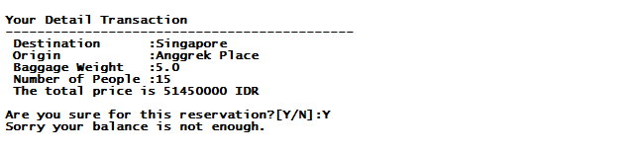

* After program **has calculated total of travelling** **cost**, program will **show the detail of transaction** and **ask** **traveler** to **confirm the transaction**. **Validate traveler can only input “Y” (yes – to confirm transaction) or “N” (no - to cancel transaction) (case sensitive).**
* If traveler **has confirmed the travelling book**, program **ask user to input the payment amount**. **Program will validate payment amount may not more than traveler’s current balance and also less than total travelling cost.**
* If **travel has committed transaction successfully**, program will **deduct travelers’ current balance with total of travelling cost**
* Program will **show traveler’s remaining balance** and **generate the booking code from this format:**

**Booking Code = [A][B][C]**

**A: First character of user first name.** For example if the **first name** is **Blue**, **A** will be ‘**B**’.

**B: First character of user last name.** For example if the **last name** is **Jack, B** willbe **‘J’**

**C: The first three digits of the total price.** For exampleif the **total price** is **14600000**, C will be 146.

**So, the booking code will be ‘BJ146’.**

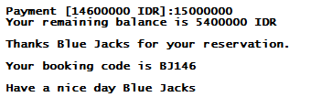

1. **Menu 3 (Exit)**

* Program will show the **ending splash screen** and **exit** from this application.



**Please run the EXE file to see the sample program.**