Onsite Case | 
CH1
Periode Berlaku Semester Ganjil 2015/2016  Valid on Odd Year 2015/2016 | Software Laboratory Center  Assistant Recruitment 16-1

Materi
Material
- Input Output
- Arithmetic operation
- Looping
- Selection

Soal
Case

ROMAWI CONVERTER
Romawi Converter is a program made for converting integer into romawi format. You, as a programmer are asked to make this program using C Programming Language, Follow the instructions below:

- Validate integer input between 1 and 1000.
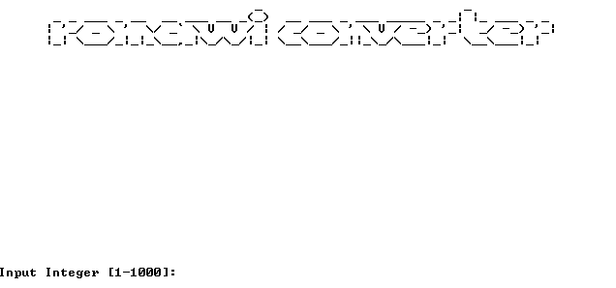

- Convert the input to romawi format.
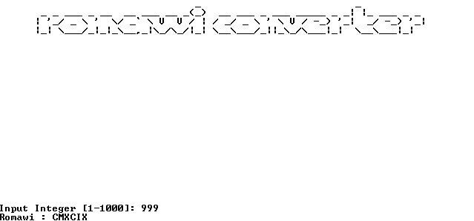

You can use this table as reference.
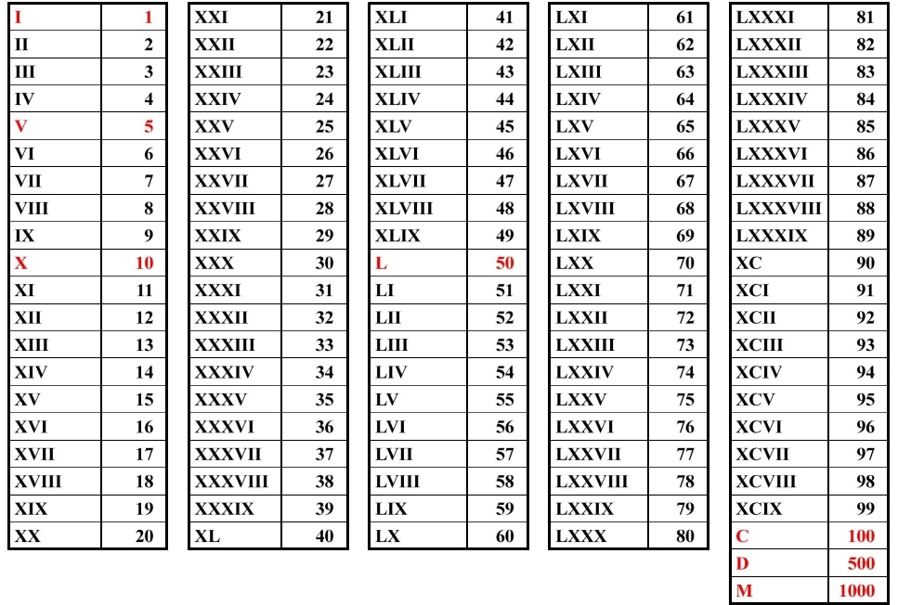
Please run the EXE file to see the sample program.

