Onsite Case | 
CH2
Periode Berlaku Semester Ganjil 2015/2016  Valid on Odd Year 2015/2016 | Software Laboratory Center  Assistant Recruitment 16-1

Materi
Material
- Array
- Pointer

Soal
Case

JVPedia

JVPedia is a simple application to store words like a dictionary. You, as a programmer are asked to develop this application using C programming language. Here are the requirements :
- At first launch, program will show splash screen. Program will ask user to input max phrases per alphabet with condition must be numeric and minimum 1. Max phrases per alphabet is used to define the maximum number of phrases that can be inputted into each alphabet.
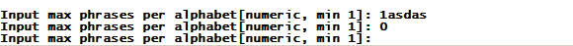

- At home menu, program will show max phrases per alphabet and 4 menus :
- Insert New Phrase
- View All Phrases
- Search Phrases
- Exit
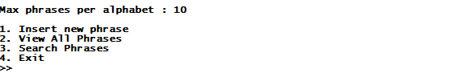

- Menu 1 (Insert New Phrase)
- If number of phrases is equals to the max phrases per alphabet, show message ‘Word ‘[alphabet]’ inventory is full..’. Otherwise, program will ask user to input new phrase with conditons:
  - Must be in alphabet
  - Length must be between 5 and 30 characters
  - Cannot be inserted if there’s already the same phrase in the inventory.
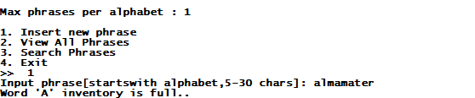

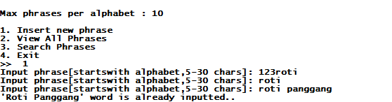

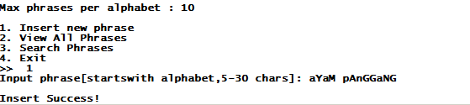
- After success input new phrase, format the phrase with proper-case-format, Example: ‘sePEdA’ become ‘Sepeda’.

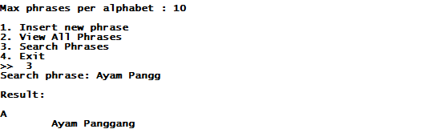

- Menu 2 (View All Phrases)
- Program will display the total phrases that has been inputted group by alphabet [A-Z].
- If there’s no phrases in particular alphabet, then show message ‘[EMPTY]’. Otherwise, show all of the inputted phrases.
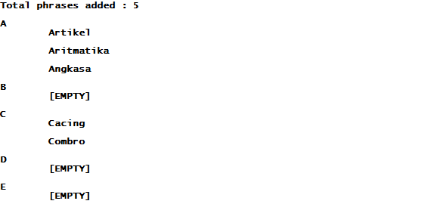

- Menu 3 ( Search Phrases )
- If the number of phrases is empty, then show message ‘Inventory is empty’. Otherwise :
- Program will ask user to input the search phrase. Validate the length of the search phrase minimum 1.
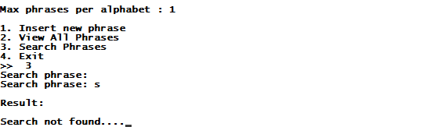

- After input the search phrase, program will search that phrase from inventory that contain the phrase (case insensitive):
- If there’s no phrases found, then show message ‘Search not found…’. Otherwise, show all the phrases that match.
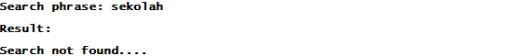

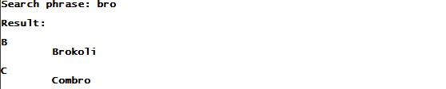

- Menu 4 (Exit)
- Program will show Bluejack 15-1 splash screen, and exit.

Please run the EXE file to see the sample program.

