Onsite Case | 
CH3
Periode Berlaku Semester Ganjil 2015/2016  Valid on Odd Year 2015/2016 | Software Laboratory Center  Assistant Recruitment 16-1

Materi
Material
- Function
- Built-in Function
- Recursive

Soal
Case
Noi Noi
Noi Noi is a game application which can help you to understand the Hanoi tower. You, as a programmer are asked to make this game using C Programming language and the program is developed by implementing recursive. First time the program’s launch, display splash screen.

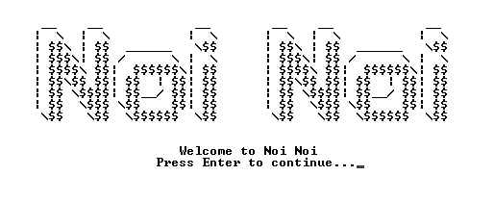
There are 3 Main Menus:
- Play
- About
- Exit

- Menu 1 (Play)
- Ask player to input name. Validate name must between 3 and 20, must be contains 2 word and must be alphabetic
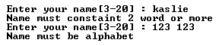

- After input name, program will display player level and “Hello <player name>”


- Ask player to :
  - Input number of plates for the first tower. Validate plate must be numeric and between 1 and 9.
  - Input number of minimum steps to move all the plate from the first tower to last tower. Validate input must be numeric.
- Program will display the steps to move all the plate from the first tower to last tower then show the number of minimum steps, player score, player level (if player is leveled up).
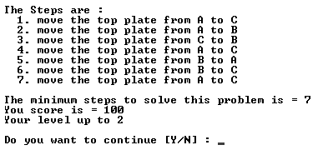

Score formula :
Level 1 : the score obtained from 100 – (different between the number of minimum steps that user inputed and the number of real minimum steps)
Level 2 : the score obtained from 100 – (different between the number of minimum steps that user inputed and the number of real minimum steps)*2
Level 3 : the score obtained from 100 – (different between the number of minimum steps that user inputed and the number of real minimum steps)*3.

Level formula :
Level 1 : if player score is more than 64, player will level up
Level 2 : if player score is more than 74, player will level up
Level 3 : if player score is more than 84, game will stop, display player score at all level and the total all score, and back to main menu.

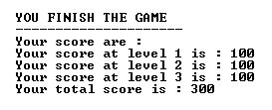

- Menu 2 (About)
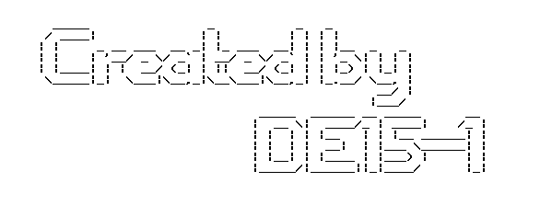
- Program will display following splash screen

- Menu3 (Exit)
  - Program will display following splash screen and exit.
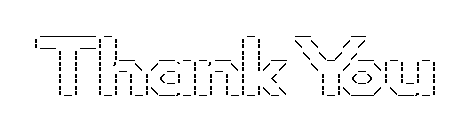

Please run the EXE file to see the sample program.

