LevelUp Case | 
CLevelUpVar2
Periode Berlaku Semester Ganjil 2015/2016  Valid on Odd Year 2015/2016 | Software Laboratory Center  Assistant Recruitment 16-1

Soal
Case
Blue Ojeg
Blue Ojeg is an application made in C Programming Language. The application is used to order food and ojek to Blue Ojeg group. This project application is given to you as a trial to be promoted in Blue Ojeg as an Project Leader.
This application consists of 3 authentication menus :
- Login
- Register
- Log out
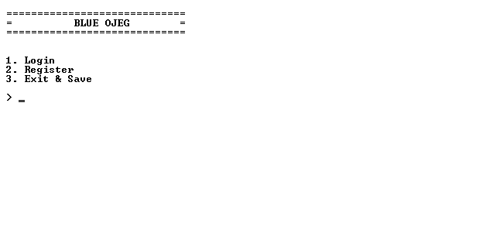
- If the user choose menu 1 (“Login”) :
  - The application will ask the user to input username and password. If the username and password are correct, the application will go to main menu.
  - The username and password are loaded from .txt file.
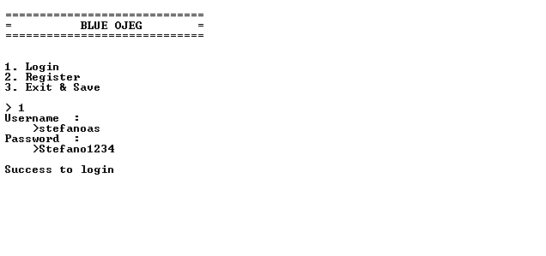
The main menu consists of 4 options:
- Order
- View Order
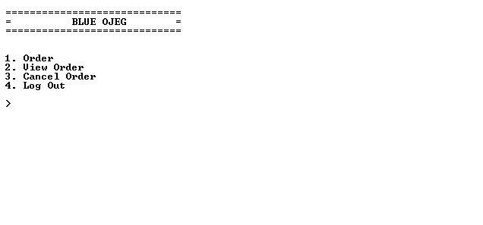
- Cancel Order
- Log out

- If the user choose menu 1 (“Order”), the program will go to Order Menu.
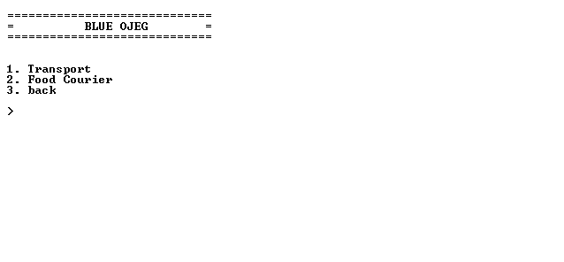
  - If the user choose menu 1 (“Transport”):
    - The program will ask user to input destination. Destination must start with uppercase letter.
    - Next, the program will ask user to input Address. Address must contains ‘Street’.
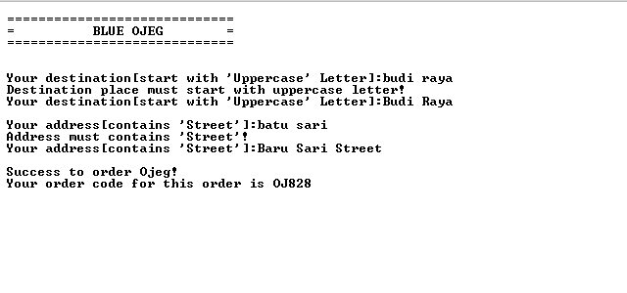
    - In the end, the program will generate the order code with following format: OJXXX with ‘X’ is a random number.
  - If the user choose menu 2 (“Food Courier”):
    - The program will ask user to input dish’s name. Dish’s name must be min. 2 words.
    - Then the program will ask user to input restaurant’s name. Restaurant’s name must be min. 5 characters long.
    - Then the program will ask user to input address. Address must contains ‘Street’.
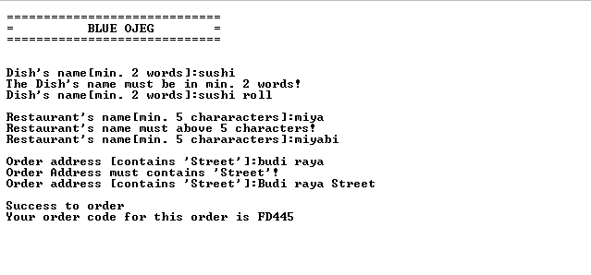
    - Last the program will generate the order code with following format: FDXXX with ‘X’ is a random number.
  - If the user choose menu 3 (“Back”), the program will redirect user back to main menu.
- If user choose menu 2 (“View Order”). The program will show the ordered Ojeg and Food then, the Program will ask user to input the order code. If the program do not find the data , the program will show a message.

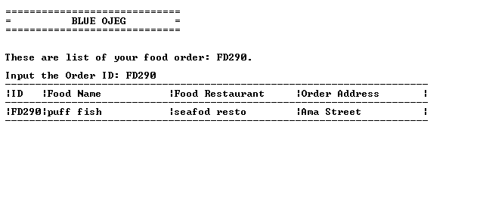
- If user choose menu 3 (“Cancel Order”). The program will show all available order descending by code and all cancelled order.
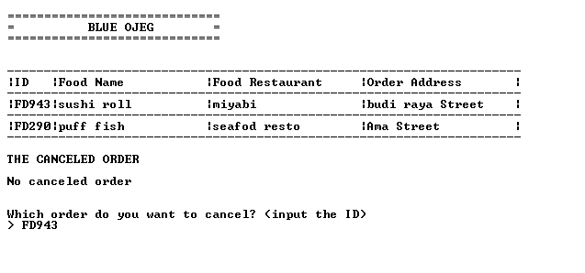
- Then the program will ask user to input the order code which is wanted to be cancelled.
- Cancelled order will be displayed.

- If user choose menu 4 (“Log out”), the program will redirect user to authentication menu and save all user activities in a .txt file as following format.
  - Username_food.txt for ordered food.
  - Username_ojeg.txt for ordered ojeg.
  - Username_c_food.txt for cancelled food.
  - Username_c_ojeg.txt for cancelled ojeg.
  - The data in first column and second column must be separated by ‘@’ and the rest is separated by ‘-‘.
- If the user choose menu 2 (“Register”) :
  - The program will ask user to input username. Username must be between 8 and 25 characters.
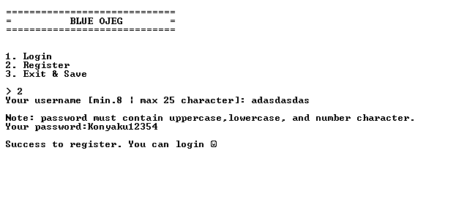
  - Then the program will ask user to input password. Password must contains uppercase, lowercase, and numeric characters.

- If the user choose menu 3 (“Exit & Save”) :
  - The program will save the registered username and password to user.txt.
  - The data format for user.txt is username#password.
  - After that the program will show splash screen animation.

Please run the EXE file to see the sample program.

